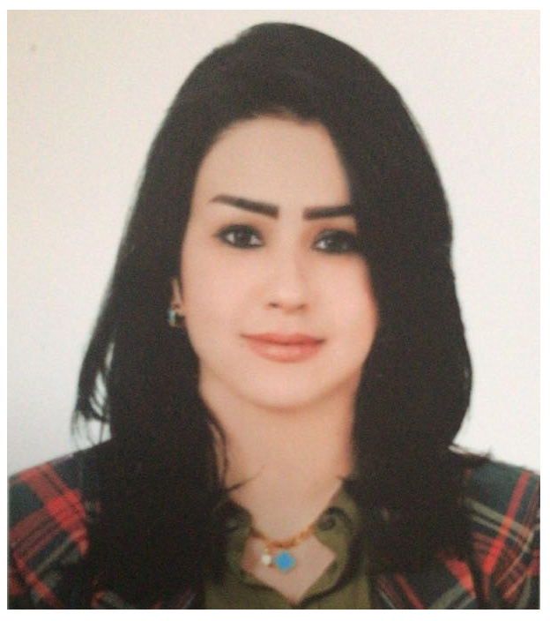
Curriculum Vitae

Personalia:
Name: Noor Jabbar Hassani
Date of birth: 20-5-1988
Gender: Female and single
Address: Baghdad, Alghadeer, district 704, house nr. 5
Mobile: 07717771088
E-mail address: noor.altimeme@yahoo.com

Education:
Sep 2006 – Jun 2011: Bachelor in Mass media
Communications, Department of Public Relations (Baghdad University).

Work Experience:
- 1-12-2017 to 1-10-2018: Administration Assistant in HR in Al- Taif Company for Insurance and Money Transfer.
- 2014-2017: Administration Assistant & Sales employee in
The sales center of Asia cell for telecommunication.
- 2012-2014: Call center employee in Asia cell for
Telecommunications.

Skills:
Office: Word, Excel (advanced), PowerPoint, Access (basic).
Other programs: Achievement, Win cash system.
Car license available.

Languages:
Arabic: Native language.
English: Good conversation, reading and writing.

