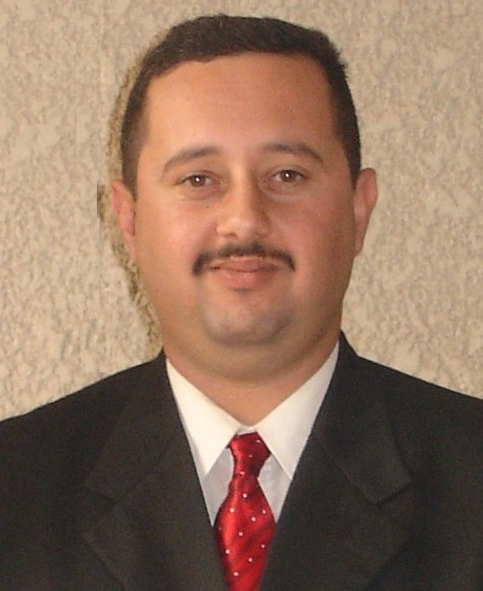

CURRIEULUM VITAE

- LAST NAME  Isaa | - FIRST NAME  Zydoon |  | 3. MIDDLE NAME  Tark |  | 4. PLACE& DATE OF BIRTH  22 / 9 / 1975 - Baghdad
5. PRESENT ADRESS ANDINDICATE WHERE YOU  NORMALLY REISED.  Baghdad |  |  |  |  | 6. CONTACT INFO.-  Mob 07801287650
7.CITY  Baghdad | 8.COUNTRY  Iraq |  | 9.SEX  Meal |  | 10.MARTIAL STATUS  Married with one daughter
11. EDUCATION.  Diploma, Computer Since |  |  | 12. COLLAGE& UNIVERSITY ATTEND DATAS
A./ NAME  Administration Institute |  | B./ MAJOR  Computer Since |  | C. / DEGREE RECIVED  Diploma ( 2 years )
13. COMPUTER SKILLS

WORD | Very good |  | POWER POINT |  | Very good
EXCEL | good |  | FORMATTING & RECORDING |  | Very good
ITERNET | Very good |  | TRANSELATING |  | Very good
WORK PLEASES & EXPERIENCE

- / Kama Al – Samarai Hospital – Contract  - Control & Management Network Computer Medical System by Network Programming By Window NT & Microsoft Access.  - Supervision and Management the international Medical Conference using data show Machine by Power point. |  |  |  |  |  | Feb 2000  Jan 2001
B. / Dr. Munther Medical Laboratory- in the evening.  - Control Laboratory Medical System by fox pro under dos.  - Interring Laboratory result and save and sort the information. |  |  |  |  |  | Mar 2000  Dec 2000
C. / Al – Rand for Computer Services.  - Control and manage the office with all Contain from Seal to Manage.  - Give Lecture about Computer Program for beginner and middle step.  - Handling the software Program problem in Microsoft Office program. |  |  |  |  |  | Apr 2001  Oct 2001
D. / The Ministry of Culture – Contract.  - Processing Ancient manuscript with special Scanners.  - Using digital Camera to take High resolution for manuscript which their old more than 500 years.  - Editing the Manuscript Picture by Photo Programming Editing like Photo Editor and Photo Shop.  - Controlling data sending to Main Server and save in a Privet CDs. |  |  |  |  |  | Jan 2002  Feb 2003
E. / Science &Technology Ministry: Proceeding Dept – Contract.  - Monitoring the interior Net work Related with Dept & other Dept.  - Computer & network maintenance. |  |  |  |  |  | Aug 2003  Jun 2004
F. / AES Express Cargo.  - Responsible on Iraq branch Internet & Update for all Data Needed.  - Sending - Receive E –Mail.  - Management & Translating Conversation Between the Company Members & the foreign Delegations. |  |  |  |  |  | Aug 2004  Jun 2005
G. / Al – Fadox company for General Contracting LTD.  - Responsible for Maintenance to all Computer Co.  - Sending – Receive E – mails.  - Network Controlling Between Company HQ & Their Branch. |  |  |  |  |  | Aug 2005  Aug 2006
H. / Dubai for Photograph & Computer Equipment.  - Photography by Several Kind Digital Cameras.  - Picture Editing & Change Background.  - Computer Conservancy. |  |  |  |  |  | Sep 2006  Dec 2006
I. / Stamp Company for General Trading.  - Assistants Administrator Controlling Warehouse Dep.  - Supervision the General Why on Item Arranging.  - Entering all date which Relating To Company& Warehouse Item.  - Making the Warehouse Report to Company Item in the Market and There Moving. |  |  |  |  |  | Jan 2007  Dec 2007
G. / Titan for Commutations  - Responsible for the Proper Translation of the Information That Received Through the Hotlines for Reporting on Terrorist and Criminal Activities.  - Simultaneous Translation between the Leaders and the Joint Operations between the Rebuilding Contractors and Infrastructure Companies.  - Details of Phase Control Rebuilding for Many Projects and Reporting about Them in the Field. |  |  |  |  |  | Jan 2008  Dec 2008
K. / L-3 Global for Commutations  - Monitor Internal Networks of the System and Gather Accurate Information and Sending it Immediately to the Headquarters of the Joint Operations Center.  - Effective Presence in Many Conferences between the Leaders of the Coalition forces and Iraqi Security Forces.  - Field Giving Advice on the Effectiveness of Security and the Routes the Security of the Company and the Wheels through Surveillance Via Satellite. |  |  |  |  |  | Jan 2009  Dec 2009
L. / Gant Al Farah for Computer Co.  - Sale of all Types of Computer Supplies in one of the Branch the Company.  - Computer Maintenance Company in any Problems of the Software and Other Hardware.  - Provide Computational Inventories Daily and Weekly.  - Following-up to the Needs of the Local Market of Computer Equipment and Reporting by the Public Administration. |  |  |  |  |  | Jan 2010  Dec 2010
M. / Company (Emitac (Service Center for HP Products Branch Iraq in Cooperation with the Commission Joy for Computers Inc.  - Member Direct Link between the Company's Headquarters in Dubai and the Company's Branch in Baghdad POC.  - Direct Management of the Service Centre in Terms of Sales, Marketing and Accounts.  - Direct Supervision of Queries and the Mechanism of Receiving Maintenance Work.  - Direct Supervision of Maintenance Engineers and Needs of Spare Parts. |  |  |  |  |  | Jan 2011  Jun 2012
N. King Teeth Lab for Dental Industry.  - Management Mechanism of the Receipt of Cases by Dentists and Archived Them Throw Special Computer System.  - Supervision of the laboratory Technician and Follow up the Work Mechanism and Ensure the Completion of Cases of Patients According to Deadlines.  - Account Management Assistant to the Laboratory.  - Periodic Maintenance of Digital Dental Laboratory Devices.  - Action Monthly Inventories of Cases of Patients and their Doctors.  - Action Monthly Inventories for the Laboratory Technician and the Mechanism of the Distribution of Salaries Related to their Salaries.  - Send and Receive E-Mails Among Medical Laboratory and between Specialized Medical Companies.  - Page Social Networking Administration Admen Face Book Laboratory. |  |  |  |  |  | May 2012  Till Now

