OMAR EHSAN

PHONE
07807713098

EMAIL

omarehsan91@gmail.com
My Name Is Omar Ehsan Ali, I Have bachelor’s degree in Mechanical Engineering (Automotive).
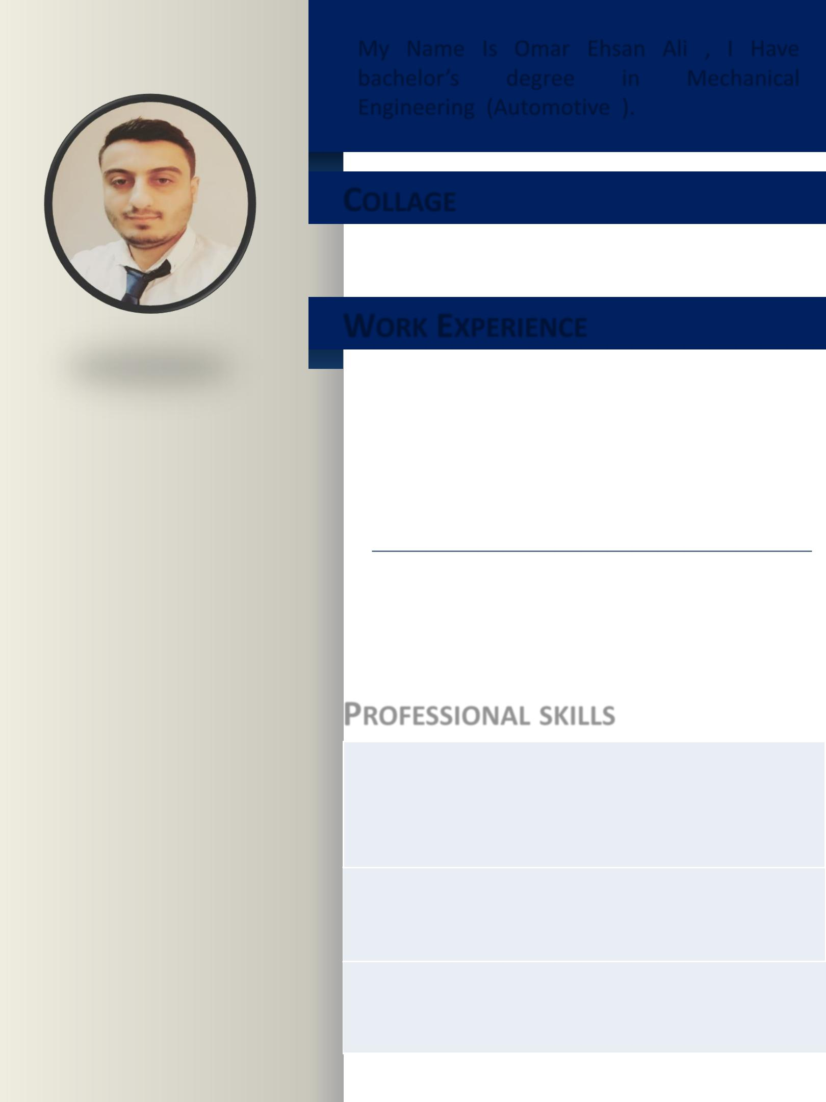

COLLAGE

MIDDLE TECHNICAL UNIVERSITY
AUTOMOTIVE ENGINEERING

WORK EXPERIENCE

Volvo Truck Company | 2013- 2014

I work in Volvo Company as engineering workshop and work customer relationship management

GK Hyundai Auto 2014– present

ADDRESS | I work in Hyundai company as a Team
ADDRESS | leader and also as a warranty supervisor
Iraq , Baghdad | leader and also as a warranty supervisor
Iraq , Baghdad | PROFESSIONAL SKILLS

Date of Birth: December, 8, 1991
Place of Birth: Baghdad
Nationality: Iraqi
Marital Status: Single

 I have experience in working on all computer systems and work on the Microsoft office word & PowerPoint & excel and AutoCAD program and DTC program

Insert of information and data in Arabic and English as well as working on internet and speak very good English

I have Iraqi certificate of computer skills and warranty training course


JOB DUTIES
GK Hyundai Auto (Team Leader)

– Ensure distribution of job orders to technicians are immediately and evenly

– Ensures that customer vehicles are fixed right from the first time.

– Ensures that repairs are carried out within promised delivery time.

– Avoids unnecessary replacement of spare parts.

– Ensure all Technicians are appropriately dressed and ready for work on time

– Submit Quality Information Report for any quality repeated issue.

– To keep Service Advisors constantly informed of delays and additional work found

– Orders and follows up parts orders with Parts Department

– Ensures technicians record jobs done on back of Job card.

– Ensures that replaced parts are kept in plastic bags in vehicle luggage compartment & customer vehicle is cleaned before delivery.

– Inspects & test drives vehicle on which repairs are performed if needed.

– Come back vehicles must be returned to the Master technician and deduct the repair hours from the technicians who performed the work before.

– Advises management regarding technician job performance, training needs, & other specific areas as requested by management.

– Conducts on Job Tanning for his group technicians, special for their returned jobs.

– Proper utilization of service facilities e.g. equipment, Service Special Tools. Manuals, testers, etc.

– Ensure to go on the right track by following up the company policy,
Slandered operation process and working process to achieve the
Company vision and mission.

JOB DUTIES
GK Hyundai Auto (Warranty Supervisor)

• Perform research on warranties and prepare customize warranty papers for work.

• Review all warranty claims and administer it with warranty awarded.

• Coordinate with manager and prepare repair order for authorization as per warranty requirement.

• Assist various departments and fulfill all warranty requirements.

• Assist customers with all warranty service and prepare associate documents.

• Monitor all customer inquiries and requests on all warranty issues.

• Supervise all information and update database and prepare require filling documents.

• Maintain knowledge on various warrant programs by active participation in education programs.

• Ensure customer satisfaction and ensure compliance to all warranty specifications.

• Evaluate databases and complete all data entry for warranty claims and filings.

• Prepare and maintain all warranty documents according to distributor and manufacturer requirement.

• Monitor defective products and withdraw specific batch of products if required.

• Manage all warranty claims, resubmit claims of required and ensure appropriate action.

• Monitor all body shop applications and monitor all outstanding applications.

• Coordinate with account departments and settle all warranty claims. • Prepare documents for all warranty papers and mention repair
JOB DUTIES
Volvo Company (Workshop Engineering)

- Monitor and the activities and work quality of subordinates in the workshop to ensure that all work within the section is carried out in an efficient and procedurally compliant manner

- Coordinate outsourcing requirements to meet additional workloads and specialized jobs.

- Coordinate action for replacements or obsolete equipment and develop repair strategies for corrective action.

- Provide technical advice on development proposals involving modifications or additions to existing systems .

- Review on going workshop maintenance and repair projects and provide engineering support for their completion.

- Participate in the procurement activities through Technical Review, order finalization and follow up for timely delivery & availability.

- Schedule daily workload and generates work schedule plans.

- Prepare requisitions for the issue of correct materials, tools and safety equipment.

- Ensure upkeep of facilities, equipment, tools etc. as per the requirement of the workshop to meet set Company standards and service objectives.

- Monitor usage of materials, spares, and consumables to ensure that consumption is consistent with budgeted assumptions. Report deviation to Section Head.

- Coordinate issue of equipment with Material Management Department, to ensure required stock availability.

