Mechanical Engineer

Over 10 years experience as operation engineer in power plant operation and maintenance.

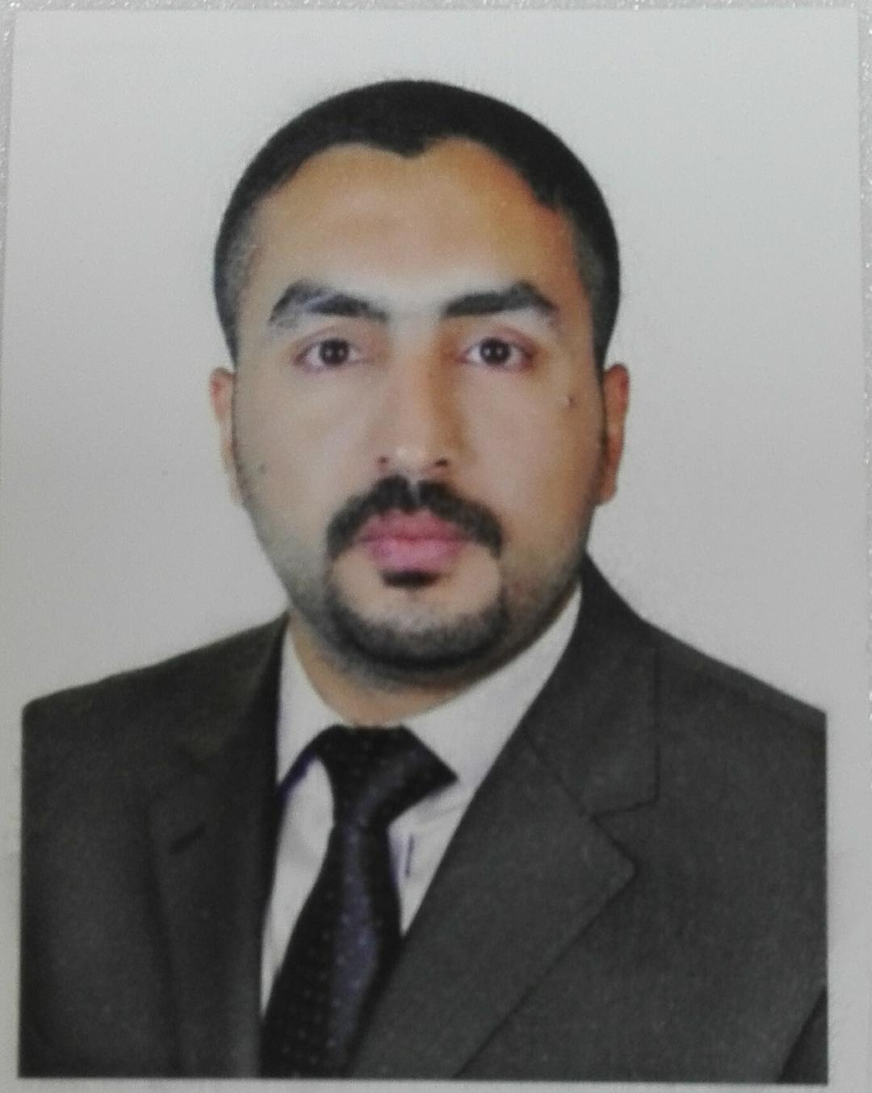

PERSONAL DATA

Name : Ali Qasim Mnati

Birth Date : 1984

Gender :Male

Nationality : Iraqi

Mob. No. : 009647719273573 ---07804811454

E mail : aliqasem5000@yahoo.com

EDUCATION

• GENERAL DEPARTMEN .MECHANICAL ENGINEERING

• BSc. Material Engineer

YEAR OF GRADUATE

2005-2006

LANGUAGES

Arabic : Native Language

English : Good

TRAININGS

- Training by Baghdad Company (125MW GAS TURBINE FRAME 9)
- Training in elsewedy (PSP) company 125MWGAS TURBINE FRAME 9E aldiwanya power plant
- Training by MOE in alquds power plant frame9e
- HSE. Induction training By GE Company
- PTW training by GE Company
- Confined space training by GE Company
- Compressed Gas Safety By GE Company
- EHS Overview for Field Services - Module By GE Company
- Excavations & Trenching By GE Company
- Extreme Temperature Awareness By GE Company
- Fall Protection Advanced By GE Company
- Hand & Power Tools By GE Company
- Overhead Cranes and Rigging for Level 1 Operators By GE Company
- Portable Fire Extinguishers By GE Company
- Radiation Safety Awareness By GE Company
- Respiratory Protection Awareness By GE Company
- Scaffolding Awareness By GE Company
- Noise at work to potentially exposed people By GE Company
- Welding, cutting and brazing By GE Company
- Asbestos Awareness By GE Company
- Awareness of hazardous waste By GE Company
- Develop a risk assessment By GE Company

CHRONOLOGICAL EXPERIENCE RECORD

• From Jul 2020 to till Now
• Employer: GE (general electric company)
• Commissioning Engineer_ Mechanical
AL Zubair power plant Alstom (COMM, Zubair PPGP)

Job Description:

- Reporting to Commissioning Manager
- Perform periodic on-site safety audits and observations
- Establish clear expectations for safety and safe work practices
- Liaise and interact with Project Contractor teams
- Support with the compilation, review of Handover completions dossiers
- Provide input to progress measurement and reporting information to Commissioning Manager as required
- Ensure compliance with project management of change (MoC) process during commissioning stage of the project
- Assist the delivery teams to achieve maximum degree of completion
- Assist in the commissioning and start up interfaces between project delivery teams and proactively look for synergies and prepare contingencies
- Perform system walkdowns and punch list clearance for associated (sub) systems as per project requirement.
- Oversee all necessary commissioning preparation work (monitoring preservation) monitoring of mechanical completion and pre- commissioning activities.
- Review commissioning dossiers and associated drawings and support with any technical support to the project on commissioning, troubleshooting and operating procedures.
- Oversee specialist contractors / vendors in the execution of specific commissioning related tasks.
- Carry out site execution of required Commissioning test Procedures (CTP) as per project requirements.
- Witness testing and commissioning of works.
- Coordination with local Site Engineers & contractor support focusing on delivery of multiple projects, whilst adhering to the HSE policies and procedures.
- To promote a positive attitude within the team and motivate all team members to achieve the best possible work performance.
- Demonstrate a pragmatic approach and risk-based approach to solving interface deficiencies.
- Assist with Projects Risk management and facilitate appropriate planning and actions accordingly
- Input to all aspects of planning the works and manage the risk register in conjunction with the Commissioning Manager
- Participation in weekly project / commissioning update meetings
- Attending Factory Acceptance Tests (FAT’s).
- Compilation of all necessary reports as/when required.

• From Feb 2020 to July 2020
• Employer: GE (general electric company)
• power plant operator supervisor
• DHI QAR project frame 9e mark6e combine cycle power plant

Job Description:

• Adjust controls to generate specified electrical power, or to regulate the flow of power between generating stations and substations.
• Control and maintain auxiliary equipment, such as pumps, fans, compressors, condensers, feedwater heaters, filters, and chlorinators, to supply water, fuel, lubricants, air, and auxiliary power.
• Control generator output to match the phase, frequency, and voltage of electricity supplied to panels.
• Monitor and inspect power plant equipment and indicators to detect evidence of operating problems.
• Open and close valves and switches in sequence upon signals from other workers, in order to start or shut down auxiliary units.
• Operate or control power generating equipment, including boilers, turbines, generators, and reactors, using control boards or semi-automatic equipment.
• Place standby emergency electrical generators on line in emergencies and monitor the temperature, output, and lubrication of the system.
• Regulate equipment operations and conditions such as water levels, based on data from recording and indicating instruments or from computers.
• Start or stop generators, auxiliary pumping equipment, turbines, and other power plant equipment, and connect or disconnect equipment from circuits.

• From Jan 2018 to Nov 2019
• Employer: ESGT COMPANY
• O&M project Baghdad
• Maintenance &service engineer

Job Description:

• Rehabilitation of gas turbine LM6000 GE.
• Rehabilitation of electricity generation for FRAM 9E units
• Construction and installation of stations and electricity distribution networks
• Supply of cable types
• Supply of control materials
• Supply filters gas systems
• Supply filters for air purification inside the obstetric units
• Supply oils for motor engine.
• Install fire alarm systems
• Rehabilitation of power transformers
•

• From January 2017 until des 2017
• Work with construction company civil and mechanical field.
Dates :from Aug 2015 to Jul 31- 2016

employer : Al sewedy power
Project :O&M, diwaniya power plant \diwaniya
Job title : shift team leader

Job Description:

• Adjust controls to generate specified electrical power, or to regulate the flow of power between generating stations and substations.
• Control and maintain auxiliary equipment, such as pumps, fans, compressors, condensers, feedwater heaters, filters, and chlorinators, to supply water, fuel, lubricants, air, and auxiliary power.
• Control generator output to match the phase, frequency, and voltage of electricity supplied to panels.
• Monitor and inspect power plant equipment and indicators to detect evidence of operating problems.
• Open and close valves and switches in sequence upon signals from other workers, in order to start or shut down auxiliary units.
• Operate or control power generating equipment, including boilers, turbines, generators, and reactors, using control boards or semi-automatic equipment.
• Place standby emergency electrical generators on line in emergencies and monitor the temperature, output, and lubrication of the system.
• Regulate equipment operations and conditions such as water levels, based on data from recording and indicating instruments or from computers.
• Start or stop generators, auxiliary pumping equipment, turbines, and other power plant equipment, and connect or disconnect equipment from circuits.
• Completion of courses in the department of self-control to fix the faults in the mark system and continue to run the unit by logic force and ring
• -Training course for MOE staff in operation sequence and mechanical maintenance 2015 with elswedy
company with experience certificate

Dates :from mars 2014 to Jun 2014
Employer : sub-contractor Basra
Project :O&M, GE Power plant shatt al-basra station
Job title : Field operator

Job Description:

• Works outside in the plant and is in constant communication with the Panel Operator and Lead
Operator directly and/or by radio in field operations such as making manual adjustments to
valves and equipment etc.
• Observe local instruments, gauges, and meters to verify conformance to standard operating
practice.
• Start and stop pumps, compressors and other equipment based on the direction of the panel
operator.
• Patrol the plant and ensures that the equipment is operating normally and that no unusual
conditions exist.
• Responsible for preparing equipment for maintenance including isolation, draining, steaming,
and other procedures as required.
• Responsible for preparation such as plant isolation etc., for day-to-day maintenance work.
• Perform daily check and minor maintenance based on the check list etc.
• Take appropriate actions in accordance with Control Room Operator and Lead Operator in case of
emergency.
• Work directly with the foreign experts in the transfer of technical advice during the initial period
of operation.
• Receive fire fighting training based on fire fighting training program preparing for emergency.

Dates from 2012 to 2014
Employer : daily contract with MOE
Project : O&M – AL quds 3 power plant Baghdad
Job title : CRO operator 4 unite frame 9e markvi e

Job Description:

•
Control and maintain auxiliary equipment, such as pumps, fans, compressors, condensers, feedwater heaters, filters, and chlorinators, to supply water, fuel, lubricants, air, and auxiliary power.
• Control generator output to match the phase, frequency, and voltage of electricity supplied to panels.
• Monitor and inspect power plant equipment and indicators to detect evidence of operating problems.
• Open and close valves and switches in sequence upon signals from other workers, in order to start or shut down auxiliary units.
• Operate or control power generating equipment, including boilers, turbines, generators, and reactors, using control boards or semi-automatic equipment.
• Place standby emergency electrical generators on line in emergencies and monitor the temperature, output, and lubrication of the system.
• Regulate equipment operations and conditions such as water levels, based on data from recording and indicating instruments or from computers.
• Start or stop generators, auxiliary pumping equipment, turbines, and other power plant equipment, and connect or disconnect equipment from circuits.
• Take readings from charts, meters and gauges at established intervals, and take corrective steps as necessary.
• Coordinate between field operator and shift team leader.
• The training of technical staff to run the washing process units and try to fix any problems
• Writing faults in case of a problem and to identify the type of imbalance and follow-up with the maintenance department competent
• Work within the mechanical maintenance team for two months on the maintenance of the turbine unit No. 3
• Running water production system for industrial purposes( dime water)
• Operation and follow-up diesel and re-run the station in the case of total shutdown
• check and isolate and energize the feeders to units and oil treatment, water treatment, boilers ,unloading pump and buildings for 6.6kv,400vac,220vac and DC system for 125vdc,24vdc,12vdc and batteries and high voltage 400kv (breaker , isolator, ct, pt, main transformer and export lines).
• work as monitoring form DCS and locally in TCC

Dates from 2010 to 2011
Employer : Baghdad company
Project : O&M alquds power plant frame 9 unite no 9 and no10 Baghdad
Job title : construction & operator engineer

Job Description:

• The training of technical staff to run the washing process units and try to fix any problems
• work on washing units and complete all sequence for GE washing
• I have enough information in mechanics part and control logic force
• work as commissioning test on oil treatment system
• installation the fuel oil unloading pumps
• Operation frame 9 mark(vi) units in al-quds power plant from 2010 to 2011 with AURUK company and pass training successfully from 2010 to 2011as team leader operation
• working on operation the boiler for 6month
• . operate the black start 6.6kv and emergency diesel generator 400v and synchronizations with units and grid (in total shutdown and for test).
• write report about problem when we want maintenance any part in unit

Dates :from 2008 to 2009
Employer : Forth dimension company
Project : alamal water project at alhosanya city
Job title : Site Engineer

Job Description:

Instating pumps ,pipes ,tanks, sand filters, submersible pumps and foundations and power supply on its.

Computer knowledge

- AutoCAD
- excel
-power point
- Microsoft word

Graduation Project

Gas turbine

