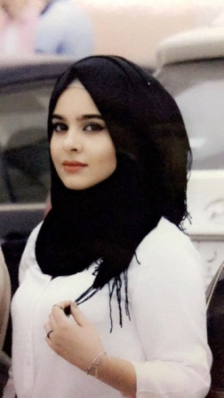**Deena hussien**

Baghdad , Iraq

[Deena.kendeel@gmail.com](mailto:Deena.kendeel@gmail.com)

009647736544330

**Skills**

English – fluency

A little bit of french

Knows how to deal with MS office

Beginner in ccna and networking communication

Optical communication

Handle the responsibilities

Work under pressure

Time management

Easy to learn and focus

**Education**

2018 al ma'amoon university college

Bachelor of telecommunication engineering

**Additional information**

Trained in korek company about BSS , GSM and transmission