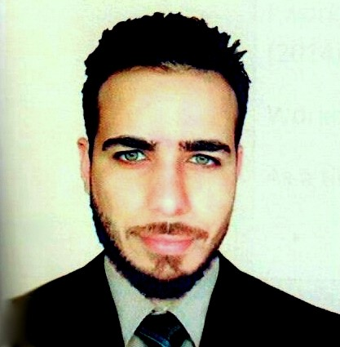

|  |
| --- |
|  |
| Mohanad A-Ahmed  **Baghdad- Shaab** **•** 07705779613 **•**  Mohanad908070@yahoo.com |
|  |
| ▼ Objective Seeking new challenges career opportunity in a successful organization that requiring intelligent employees where I can use my skills expertise in management and recruitment and solving the work related problems |
| ▼ Experience JUl2012-APR2013  (Accounting)**•** (First accouter) **•** (Pepsi CO. Al Shaab branch )  APR2013–AUG2014  (Sales)**•** (Ticketing Agent) **•** (Al Azeez tourism )  Issuing tickets  JAN2015–JAN2017  (Logistic)**•** (store keeper) **•** (Fontana Food AB.)  Turk driver and Storing goods, warehouse organization ,Barcode system, inventory  JUN2017–Till NOW  (HR)**•** (HR Officer) **•** (Mettco for communications)  Recruitment , filing , attendance , social security ,hiring management, |
| ▼ Education AL Markazya High school, Baghdad   * B.Sc. Degree in Chemistry since form university of Baghdad 2008-2012 * Blood and body analysis training at university of Baghdad JUL2012-SEP2012 * Galileo ticketing system APR2013 |
| ▼ Communication Very good communication skills and leadership ,teamwork, dedicated worker plus I have time respect convening skills |
| ▼ Computer Skills: ▼ Languages: 1.Microsoft Office-**Good** Arabic – Native language  2.Windows Management- **Very good** English-- Very Good(Speaking,writing,reading)  3.Photoshop- **Good** Swedish-- Good |
|  |