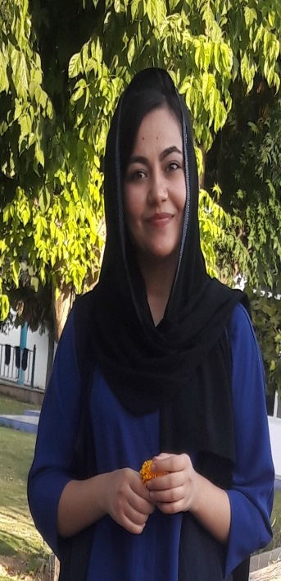 **Personal Information**

**Full name**: kajin Jamil Amin

**Gender**: Female

**Date of Birth:** 14th.April.1995 .

**Address:** Shekhan .duhok.iraq.

**Phone Number:** 07507811561

**Email:** kajin.golden11@gmail.com

**Marital status:** Single

**Religion:** Muslim

**Previous Work Experience**

Worked in Shekhan technical collage and institute As Education assistant Oct 2017-June 2018

**Education**

B.Sc. Degree in medical laboratory sciences. .School of Health Sciences. University Of Duhok (2016-2017)

**Traning:**

Worked in Duhok Central Public health lab for month.

-Worked in Heevi pediatrics hospital lab for month.

-Worked in Azadi teaching hospital lab in duhok for month.

-worked in Duhok Emergency teaching hospital lab for month

-Worked in AL-Shekhan General Hospital for four months

**Languages:**

|  |  |  |  |  |
| --- | --- | --- | --- | --- |
| **Languages** | **Understanding** | **Speaking** | **Reading** | **Writing** |
| **English** | Very Good | Very Good | Very Good | Very Good |
| **Kurdish (native)** | Fluent | Fluent | Fluent | Fluent |
| **Arabic** | Fluent | Fluent | Fluent | Fluent |

**Skills:**

**-Computer skills**:

-Microsoft Office Skills; (MS Excel skills,MS Word Skill,MS Powerpoint Skills)

-Create spreadsheets.

-Microsoft Access.

-Email.

-Web and Social Skills.

-Graphic and Writing Skills.

-**personal skills**

-Adaptability & Flexibility

- Time Management

- Communication Skills

- Leadership & Management.

- Collaboration & Teamwork

--Work Ethic

- Problem Solving & Analytical Thinking

Attention to Detail-

-Strategic Planning and Organizing.

Supervisory Skills-

Job Details.-

networking-

-Creativity & Innovation

Independence-

Professionalism.-

Handle pressure-

-Interpersonal Skills

-energetic.