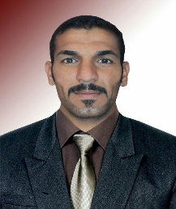**Name waad sami Hammad  
Housing: Kirkuk / Haweeja  
Nascent : 01/01/1982  
Graduation : Institute of Technical Department of ambushes and equipment  
Previous work  
1 - supervision of the neighborhood cleanups Revolution Haweeja  
2 - Hold Manager Rashad conclusively  
3 - Manager Rashad Tndavat boycotted the organization ird  
4 - Director of the Department categorically redundancy in cleanups ird 2007  
5 - Director of Generation Organization for Human Development 2009  
7 - Director relations department for seven months in the organization a good development for the development of  
8 - Lecturer cycle computer that Qamtha Organization irxs to M_ government departments and representatives of civil society organizations  
9 - Department official missions and Foreign Relations of the Organization of good  
10 - worked coordinator of relations between the organization and government departments and international organizations in the Organization of the light of hope for people with disabilities  
Courses**

I **worked for Logistic in Taiba Development for a year_11**

**1 - management cycle works and how to deal with foreign visitors in the organization vocalist  
2 - cycles in the heaviest network fiercest  
3 - learning course in Computer Technical Institute Haweeja  
4 - cycle for Agricultural Development Company summit truthfulness Organization Development  
5 - cycle writing projects organization part**

**6 - learning course on the computer system and word excel**

**The system power point in the organization irks**

**7 - to connect to the internet cycle and amyl and beautiful Alblukr and straining , YouTube and Facebook**

**8 - worked Manager Generation Organization for Human Development**

**الشهادات**

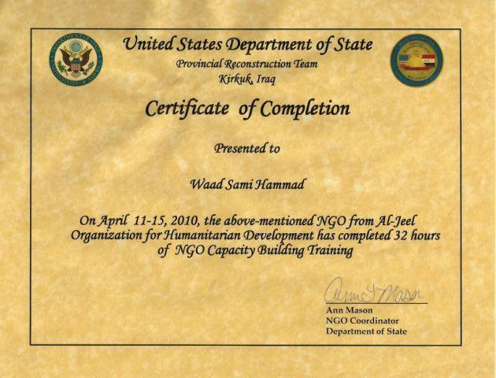

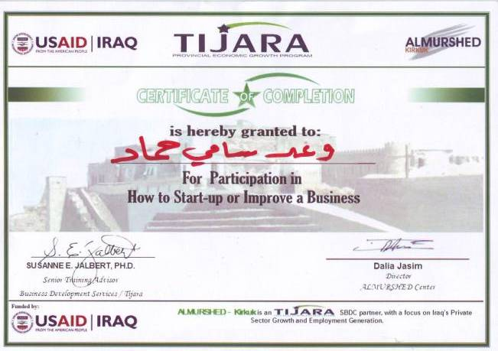

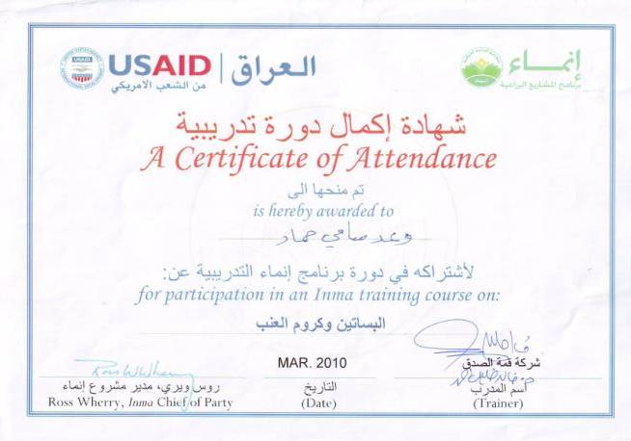

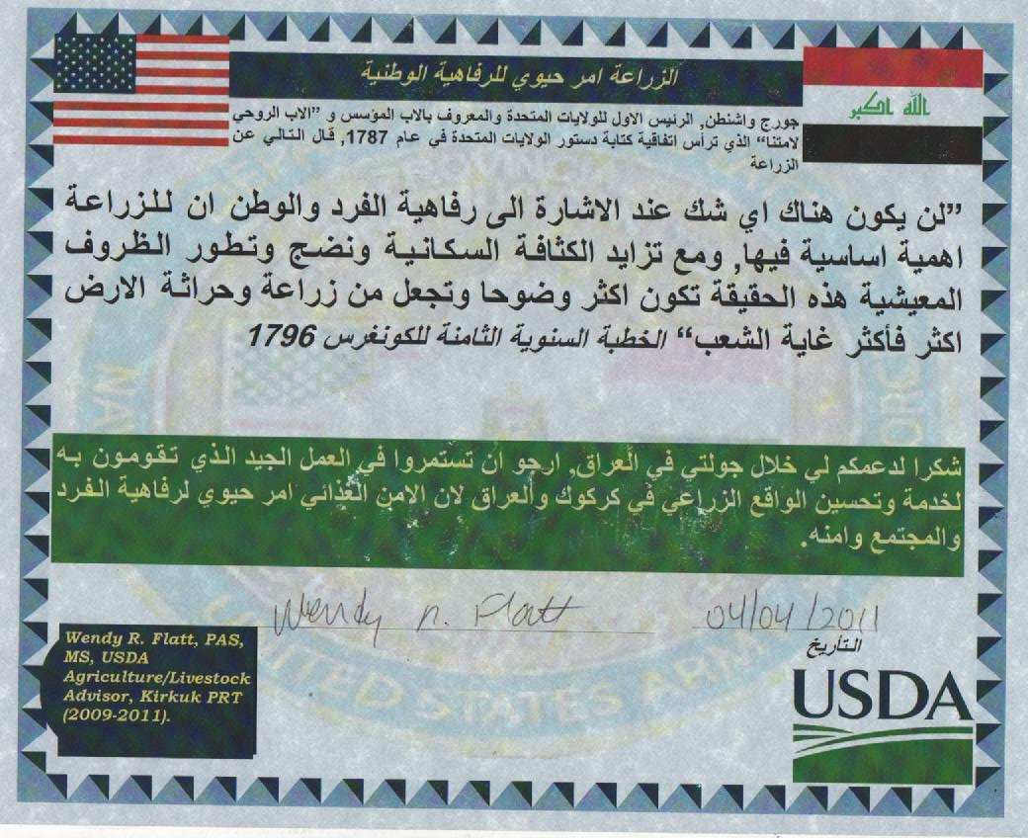

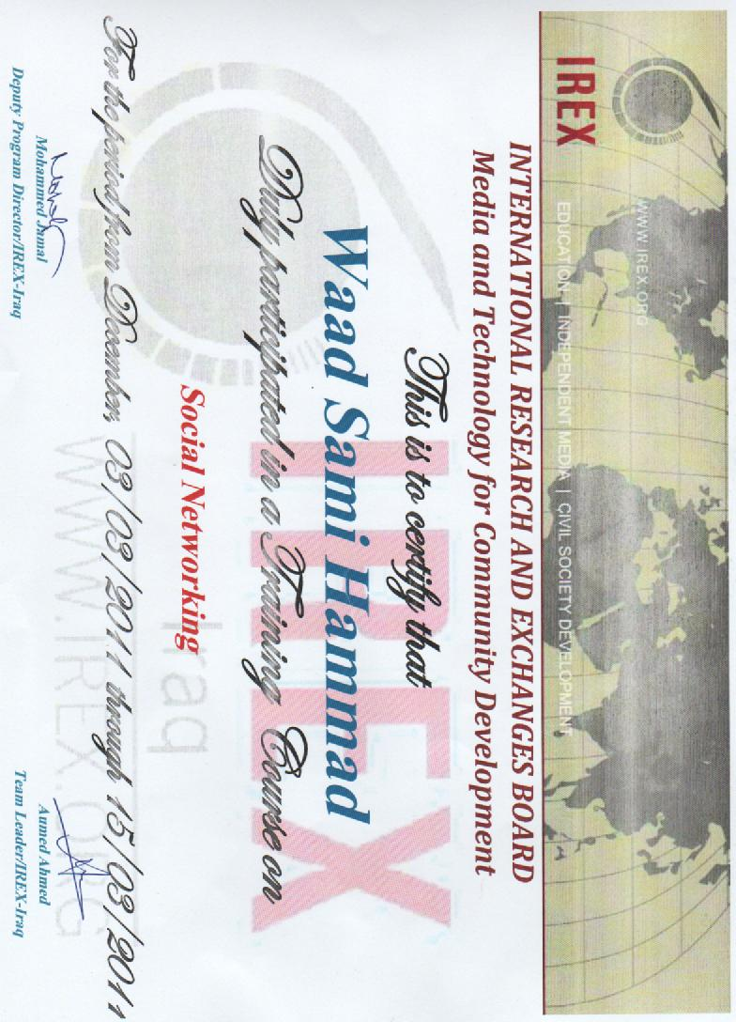

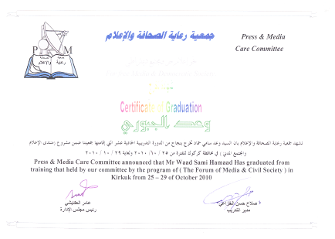

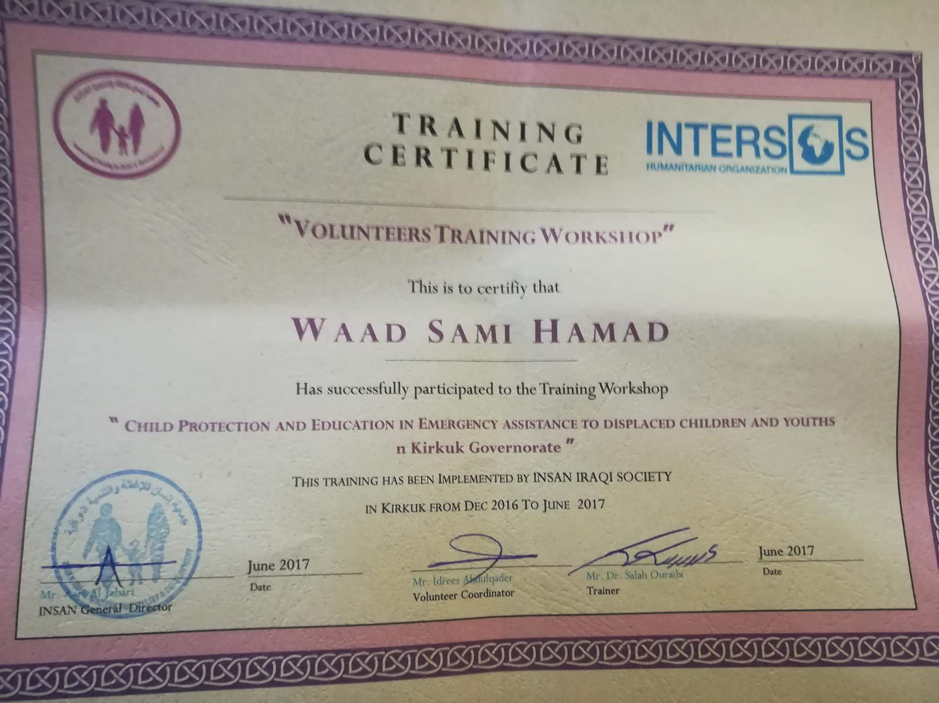

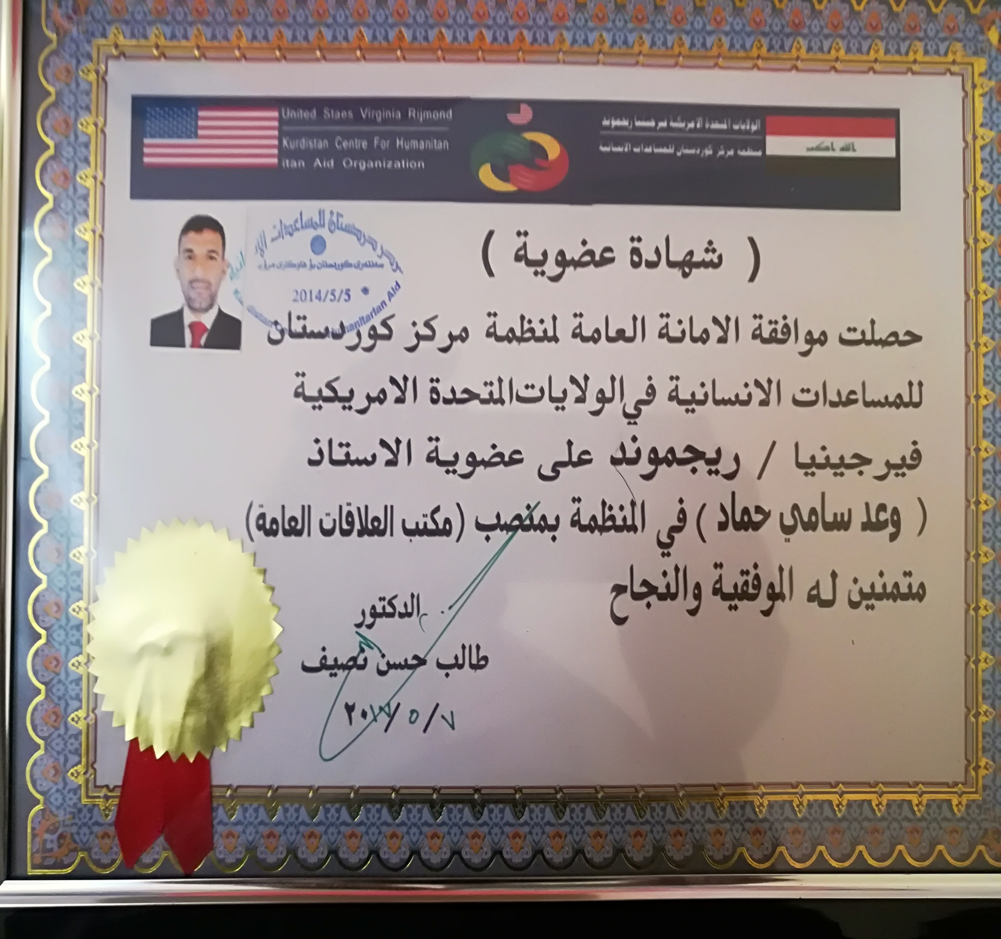

هاتف 07702396326