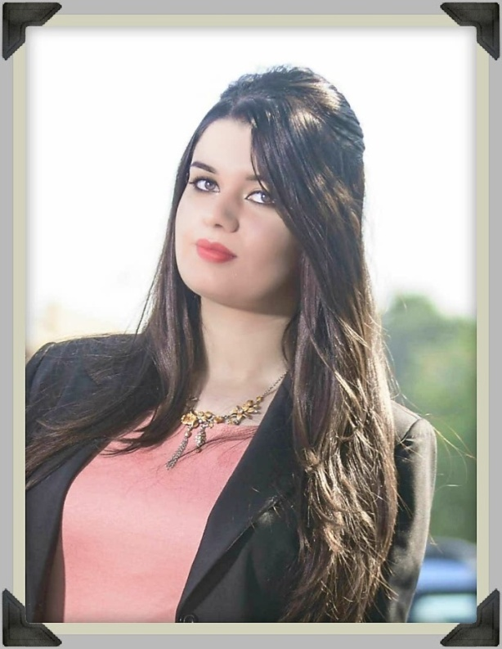

**CONTACT**

**EDUCATION**

**EXPERIENCE**

**PROFILE**

Skilled in all aspects of chemical engineering including process computer simulation, development, equipment sizing and specification. Also have hands-on experience in making sure that standards of quality are met while production costs are kept as low as possible. Proven ability to use applied research and problem-solving skills for establishing the root cause of any chemical-related failure, as well as heading any investigations.

****

* **Computer skills**

Microsoft office ( word , Excel , PowerPoint , Outlook )

MATLAB 2010

HYSYS

VBA Excel

* **Personal skills** Good in English conversation

Photographer and designer

I have participated in many graphic and handmade exhibitions.

* **Additional Information**

Training at Ministry of industry (Industrial R & D Authority)

Graduation project : production of MTBE (Methyl tertiary butyl ether).

another project : production of ammonia

.

* **As a chemical engineer**

I am a new graduate engineer so I am a **novice engineer**

Knowledge of research **methodologies**

good in **MATHS** and analytical MATHS and **problems solver**

I was in contact with **chemical processing** in the laboratoryof chemical ENG. Department and I visited the **DOURA refinery** in more than one scientific visit and got to know the equipment very closely.

**B.Sc. in chemical Engineering – University of Baghdad – 2018**

**✉**

Shamsalhaider42@gmail.com

+96407709700758

****

Drawing

****

Photograph

Traveling

****

Reading

****

**HOBBIES**

**Shams Harith**

**Chemical Engineer**