**SHAROZ QAYYUM KHAN**

**Address: Saudi Arabia, Dammam**

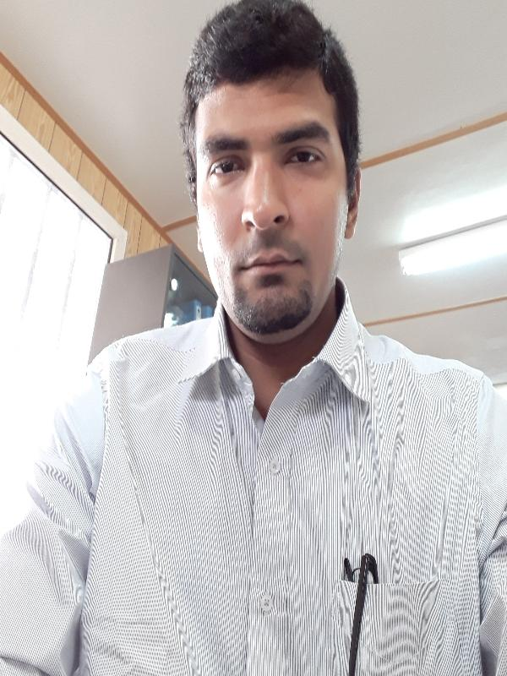 **Mobile # +966593526311 & +923213634475**

**Email:sharozqayyumkhan@yahoo.com**

**OBJECTIVE**

To seek a progressive organization that provides a professional working

Atmosphere and opportunities for advancement of bringing my abilities

To the organization’s growth. My task is to acquire new challenges

Which will effectively utilize my professional experience and exposure as

Well as becoming a significant force within it in the service oriented industry

**QUALIFICATION**

* **Bachelor Of Technology in Electronic 2011**

From Indus Institute of Higher Education Karachi

* **Diploma Associate of Engineer in Electronic 2008**

From Govt Jamia Millia Polytechnic Institute Karachi

* **Technical School Certificate in Computer Science 2005**

From Govt Jamia Millia Vocational Institute Karachi

# JOB EXPERIENCE

* **Aramco Moderisation Project Of Amhec (KSA)**

**Maintenance Supervisor**

(From October 2016 to till to Date)

* **Role & Responsibilities:**
* I am working on below earth moving machinery & heavy equipment
* Crane Tadano GR 60T, 70T, 80T
* Crane Liebherr LTM 50T, 70T,100T,150T,200T,300T,500T
* Loader Doosan Mega 400,420 8T
* Loader Caterpillar 966 10T
* Tower light, Generator Perkin`s, Olympian, Caterpillar,

Cummins capacity range 100kva to 1250kva

* Truck Mercedes Benz, Man, Trailer, and also Light vehicle
* Looking & manage Routine, break down & Maintenance team
* Planning of equipment PMS schedule and also manage the team
* Attend the equipment diagnostics fault and troubleshooting
* Preparing daily and monthly maintenance report
* Analyst of spare parts old, new & wear
* Collect directly Spare parts quotation from vendor & also monitoring of spare parts quality
* Planning to arrange the spare parts for equipments
* Direct, manage and coordinate all aspects of operations of rental and leasing of construction and oil and gas equipment across Saudi Arab
* Responsible for Store, ensuring adequate supply of spare parts / consumables and workshop equipment
* Improving maintenance and reducing breakdowns through analysis of site and service reports
* Strong technical knowledge of diesel engines and pump Supervision and Execution of Dewatering Projects for the Rental Division
* Prepare schedules for repair, overhauling, and maintenance of all equipment and machinery
* Provide technical support and guide line to all workshop employees
* Manage over 50+ employees from maintenance departments workshops, paint & fabrication and asset control departments
* Implemented & designed onsite mobile tool stores across multiple sites utilizing “Tool hound” barcoding system
* Routinely visit customers to ensure service level satisfaction and promote new technical products
* Followed to HSE rules & regulation during working in critical sites and also workshop
* **DIYAR CONTRACTING COMPANY LLC (IRAQ)**

**Ministry of Electricity Power Station (MOE)**

**Electrical Engineer O&M** (From March 2015 to September 2016)

**Role & Responsibilities:**

* Power Plant total capacity 136 MW
* Work on wartsila 18v46 Diesel Engine & ABB Generator
* 11 kv/132 kv transmission and distribution lines
* Routine check of SF-6 type circuit breaker, protection system and various control system and equipment
* Substation medium voltage, LV and control panel
* HT/LT motor & switch gear
* Condition monitoring of motors, generator & purifiers prepared various report for maintaining record and to acknowledge authorities in case of any abnormality isolation and tripping
* Performed Routine & break down Maintenance
* Performed diagnostics fault and troubleshooting
* Synchronization of several units
* Load management as per the demand and production
* I have hand on experience of major maintenances and good troubleshooting good skills on gas /diesel system.
* **ARTISTIC MILLINERS DENIM MILL**

**Shift Incharge** (From May 2010 to January 2015)

**Role & Responsibilities:**

* Caterpillar G-3500 Series Engines Total Capacity Plant 5.7 MW
* Focus of Artistic Milliners Denim Mill power plant operation and maintenance and plant erection
* Services all equipment as CAT & Cummins Generator Waste Heat Recovery Boiler (D.D.F.C & GARION) Capacity 1 to 2 ton, compressor, R.O plant
* Maintain all records and manage all PPM & top and major overhauling
* All power plant Equipment and auxiliaries such as cooling tower, circulating pumps section, Heat exchanger and softener plant independently preventive maintenance
* Supervise to all team members and participate with them in all troubleshooting maintenance team.
* Assigned the tasks of diagnosing problems, disassembling engines, and replacing excessive wear engine parts
* Prepare several type report just like consumption, daily, monthly
* I can operate independently gas booster
* I have work done both engine gas & diesel
* **Allied Engineering & Services limited.**
* Generator Technician (From March 2008 to April 2010)

**Role & Responsibilities:**

* Working on Caterpillar 3500,3400 & 3300 series Gas & Diesel Sector
* Pre Delivery Inspection, start-up and Load test activities.
* Verification of engine protection safeties.
* Reading of product manual & schematic diagram
* Using diagnostic tools ET (Electronic Technician), DDT (Digital Diagnostic tool) megger, multi meter etc.
* Installation, configuration, adjustment, and also trouble shooting on genset control panel, Like EMCP 2 & 3.2

Voltage regulator VR6 & VR3

Speed controller Woodward governor 2301, 2301A

LVAC/DC Loop Testing of control wiring.

CT & VT Circuit Testing.

HV Equipment testing (Auto/Power Transformers, Circuit breakers,

Testing of Rectifier Bridge, diode assembly, control relay, actuator battery charger, self-starter and dynamo.

* Analyst of spare parts old, new & wear.
* Followed HSE rules & regulation during working in critical sites
* Performed Routine & break down Maintenance
* Performed diagnostics and trouble shooting on customer complain
* Performed Generator Upgrading, Top end & Major overhauling of engines with Electrical & Mechanical team
* Working on utility all equipment
* Work on different operating panel Terberg Panel & Deep Sea
* Cable Tray installation, Cable Glanding.

**Skills**

* Knowledge of P.L.C, HMI & SCADA Panel
* Machine Shop Routines
* Electrical knowledge
* Typing & Talking skills of Urdu English Arabic and Hindi
* Knowledge to run different types of Managing Software and also Computer Hardware. Familiar with basic operating systems like
* Microsoft Word, Excel, Outlook and PowerPoint, Oracle, Sap
* (MS-Dynamic 2012 ERP Software) creating experience of PR & PO

# PERSONAL INFORMATION

Father’s Name : Abdul Qayyum Khan

Date of Birth : 30-11-1990

Passport No : NV4128901

Skype ID : sharoz.khan77

Nationality : Pakistani

Marital Status : Single

Religion : Islam

**REFERENCE**

Will be furnished upon request