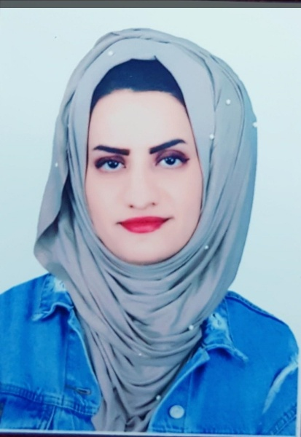Curriculum vitae

**RUSUL MOHAMED ALI**

MOBILE NO. 07724557647

E-MAIL: [rouslmohamed4@gmail.com](mailto:rouslmohamed4@gmail.com)

**Personal Information:**

Gender: female

Nationality: Iraqi

Birth date: 1994

Address: Baghdad

**Objective:**

To work in company/organization where I can utilize my skills and thus contribute to its continuous growth.

**Languages:**

Arabic: Mother language

English: fluent

**Education:**

Bachelor Degree in Environmental Engineering. College of Engineering. University of Baghdad.

**Work Experience:**

-Officer at Alsco software Company.

**Rewards:**

-I have a certification of English language proficiency course

-Appreciation letter from Baghdad University for attending the annual college conference

-I did many Researches during my study, it was all successful

-PFA certificate and trainer assistant

**Qualification & skills:**

-management & planning course.

-course in: fluids Mechanic, Microbiology, Water Supply, Sewer and Soil pollution, Occupational Safety , economy.

-A very good ability to translate from English to Arabic & vice versa.

-Good communication skills.

-computer skills: MS office, Word, Excel, Power Point, Photoshop , outlook, visual-Basic & Graphic.

-Keyboard skills (25 words per min).

--Reporting & correspondence.

**Professional Skills:**

-water Treatment Plants (WTP).

-Waste Water Treatment (WWTP).

**Training:**

-Computer Training Course

-English Language Professional Course