**Ahmed Jawad Jasim** 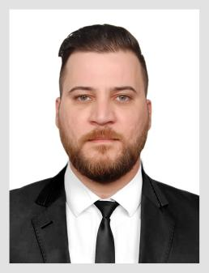

Baghdad , Al mashtal street

Mobile: +9647714287616 | [alhashmyahmeed@gmail.com](mailto:alhashmyahmeed@gmail.com)

**Work Experience**

**Freelancer Nov 2011- 201**7

* Computer maintenance office
* Internet provider

**Skills**

* **Microsoft Office ( World , Excel )**
* **English ( write , read , conversation )**
* **Java script**
* **Web design by HTML**
* **C ++**
* **SQL**

**Note:im fresh graduate and have the basic only in language above**

**Education**

* **Bachelor Degree in Network Engineering Al-Iraqia University , 2017**
* **MTCNA** **Certified** **2017**

**Language**

* **Arabic**
* **English**