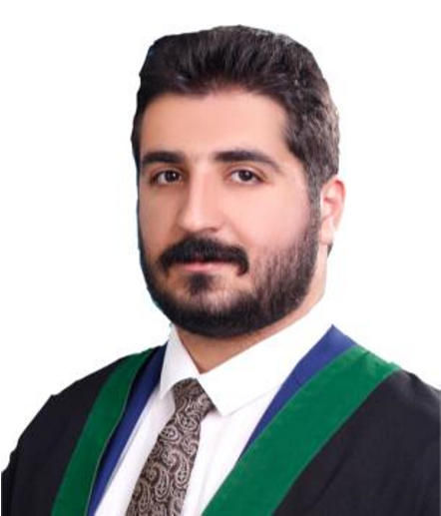 **CURRICULUM VITAE**

***Name*** : Mohammed Abduljalil Abdulrahman

***Gender*** : Male

***Nationality*** : Iraqi

***Place and Date of birth*** : Baghdad / 20-1-1992

***Marital status*** : single

***Languages*** : Arabic ( mother language ) , English ( fluent )

***Address*** : Iraq , Baghdad , Al-Mansour

***E-mail*** : mhmd.abduljalil92@gmail.com

***Mobile No*** : +964 7802355451 / +962 797406482

**Education** : •

Bachelor Degree of Business Administration from Applied Science University (Amman / Jordan)

Year of graduation : 2016 – 2017

**Computer skills** : •

Microsoft Office (Word , Excel , Powerpoint, and Outlook)

**Experience** : •

* worked as data entry employee in Abu Dhabi Group Company

(Amman , Jordan) from September 2015 to October 2016

* worked as HR officer in Jaber Bin Hayan Ltd. (Amman , Jordan)

since april 2017 and transferred to their bureau in “Omega Scientific Bureau” (Baghdad , Iraq)