**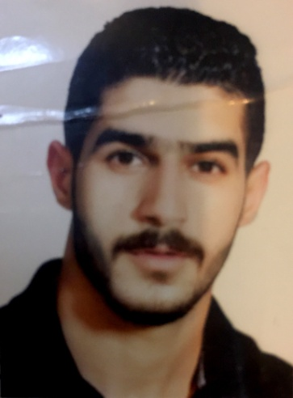  
name:sajad jasim jaafar**

**E-mail: alshamari1994@gmail.com**

**Mobile number: 07714337693-**

**Profile**

During the past years, working during studying, many skills gained and improved as a reliable trustable and dependable person. A good time-manager, good communicator, have good initiative spirit and great team player; Always have the keen to learn and get new skills to improve.

Born:1994

**Relationship status**: Single   
  
**Language**: Arabic _ English (Read, Write and Talk)

**Education**:diploma (lnstitute of finearts)

**Graduation Year**: 2014  
**Address:** Iraq -Baghdad

**Qualifications:**

* Well developed skills in time management, decision making, meeting deadlines, and organization.
* Good communication and interpersonal skills.
* Self-supervision skill.
* Reliable and able to work under pressure.
* Good MS Office skills.
* Professional in internet and commercial mailing
* **Skills**:
* Able to identify and qualify potential new clients.
* Experience of and able to communicate effectively with key decision makers i.e. Heads of Departments and senior managers.
* Ability to recognize buying & closing signals.
* The ability to research potential corporate clients in detail.
* Familiar with risk assessment, asset class analysis, ratings and forecasts and rigorous benchmarking of the business environment.
* Conversant with Microsoft office applications and CRM database systems.
* Identifying cross-selling opportunities.
* Preparation of tenders for new business.
* the database.
* Can speak fluently more than one language.
* B2B sales exposure.
* Meet and exceed new business targets and KPI's.
* Promotion compliance and implementation.
* Experience of working to targets.

**work experience** :

* **Sales &preparation at pharmaceutical warehouse**
* **Sales at charnaga for clothes(2year)**
* Al- Kattan for furnishings

(admin)