|  |
| --- |
| **C.V** |

|  |
| --- |
| **Personal information** |

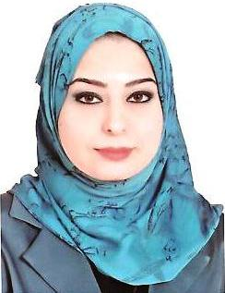

**Name : Duaa Jalal Abdul-kareem Mohammed.**

**Mobile No. : 009647711607192**

**Nationality: Iraqi**

**place of birth : Baghdad**

**Date of Birth : 22/11/1989**

**Marital status : married**

**E-MAIL : eng.duaa2015@gmail.com**

|  |
| --- |
| **Education** |

* **Educational Qualification : BSC. from university of Technology in Laser and optoelectronics engineering department.**
* **Date of graduate: 2010-2011.**
* **Grade of graduate: High grade with estimate.**

|  |
| --- |
| **Experience** |

* **Effectively writes and speak Arabic.**
* **Effectively writes and speak Engilish.**
* **She holds a certificate ( IC3 ) .**
* **Practical & scientific knowledge in Windows .**
* **Practical & scientific knowledge in Pc applications Micro-soft office ( Word , Excell , Outlook ).**
* **Citrix program.**

|  |
| --- |
| **Job positions** |

* **AL-NABA’A CO. for general trading in Correspondence and installation of laboratory equipment since 2011 .**
* **AL-BUNNIA group as an accountant since 2012 until now.**