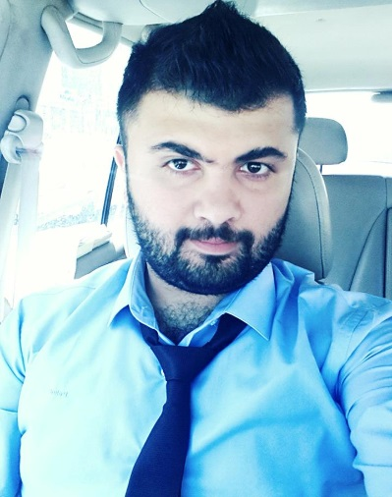**Basic information:-**

Name: Hasan Farouk Hashim

Address: - Baghdad / al resafa

Phone: - 07706287816

Email: - [hasanfarouk094@gmail.com](mailto:hasanfarouk094@gmail.com) [hasanfaroukhashim@gmail.com](mailto:hasanfaroukhashim@gmail.com)

Work Email: - Hassan.farouk@mercyhands.org

LinkedIn: - Hassan farouk

Education: - university of Baghdad /Bachelor's degree, Biochemical Engineering · (2013 - 2016)

Languages: - Arabic / native English/ very good Kurdish/medium

**Experience:-**

1-Mercy hands (NGO)

Project Officer on ACE Center (April 2019 – current)

2-Al –wand co Ltd for Oil Transportation

Administrative Manager (July 2018 - Mars 2019)

3-Amico Group

Business Development Specialist (Mars 2017 - June 2018)

4-AGMEST Group Investment and Development

Sales and Marketing Specialist (June 2016 - January 2017)

**Skills:-**

1- Experience in administration management, logistics support and coordinator

2-Write work reports in Arabic and English

3-Ability to promote products and analyze new marketing and sales strategies which includes Researching and selecting media outlets for advertising/promotion, seeking out stakeholders and reaching out to beneficiaries and customers.

4-Facilitate and coordinate all the procedures and preparations of workshops, trainings and conferences, and make sure to successfully implement these events in professional & timely matters.

5-Excellent negotiation and communication skills.

6-Leadership and management skills, which includes providing feedback, mediating interpersonal conflicts, and implementing organization’s procedures and policies.

7- Administration and promoting of Websites/ and Pages on Social media..

**Computer Skills**:

Microsoft Office Applications – full professional competency

**Awards, Certificates and Courses**

-Certificate of participation in "Advanced Sales Skills Training sessions with AMICO group- Erbil (2017)

-Certificate of participation in "Product Management” workshop with Share AMICO group – Beirut, Lebanon (2017)

-Certificate of participation in Marketing Skills Workshop with AGMEST CO. LTD (2016)

.

# References

|  |  |  |
| --- | --- | --- |
| Name | Relations | Contact information |
| Ahmed Pasha | Project Manager/Mercy Hands | ahmed.pasha@mercyhands.org‬ |
| Mohamed Dagstany | Sales Manager/ Amico | m.dagestany@amicogroup.com |