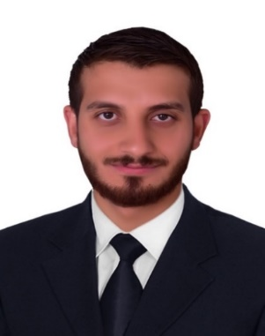

Curriculum Vitae

**Personal Information:**

**Name**: Omar Abdulkhaleq Abdulkareem

**Date of birth**: 28-10-1990

**Nationality**: Iraqi

**Current location** : Iraq- Baghdad

**Gender**: Male

**Marital** **Status**: Single

**Mobile**: + 7724 638 945

**E-mail** : [omarabd1970@gmail.com](mailto:omarabd1970@gmail.com)

**Education:**

**-** **B.Sc. degree in Computer Techniques Engineering from Al-Yarmouk University College (2013).**

**-Master degree in Computer Engineering especially wireless communication from Erciyes university in turkey (2017).**

**- PhD student in computer enigineering especially neural network and - artificial intelligence (until now).**

**Work:**

* I worked in the Roturng German company in the gas station in Baiji for installation and operation of the fuel processing (2011).
* I worked in Uruk General Contracting Company to Establishment station Almansouryah gas station (2012).
* I worked in AlMaheed Company to set up a water station Almmansoria socket (2013).
* I worked in Turkcell telecommunication company in Turkey as a cell vendor, and also worked in internet provider as a trainee (2015-2016).
* I worked with turktelecom telecommunication company in Turkey in marketing and also in my beginning in the call center (2017-2018).
* I worked in cukurova university in the teknoket building in Turkey to designing and implementing and advisor to programing the forecasting and prediction data in the future.
* I don't have any problem to work under any situation the work it needs. I can bear long work hours, and I can work with the group.
* Iam work now with chaina mechenery engineering company (CMEC) in the project plant in SALAH AL-DIN samara as a engineering in the outside working to monitering the lighting and instalation works.

**Skills:**

* Microsofit Office (Word , excel , Power Point ).
* Different Operating System Win 10 & Linux.
* Computer Maintenance.
* C#, Microsoft SQL Server.
* Hardware computer, and CISCO Networking Academy.
* I have the ability to interact with long hours for the work.
* I have a good scale in CISCO devices to make the configuration the Router and Switch.
* Good experience programing in python.

**Acadimic writing :**

1. Measuring IEEE 802.15.4 protocol performance over embedded control systems.
2. Implementing and activate routing protocol EIGRP and OSPF protocols by using packet tracer.
3. Comprehend the behavior of IEEE 802.15.4 protocol performance over embedded control systems in wireless sensor network.

**Hobbies:**

* Books, Travel, Swimming, and Football.

**Languages:**

**-** Arabic (Mother Language).

**-** English (Native).

-Turkish (average).

