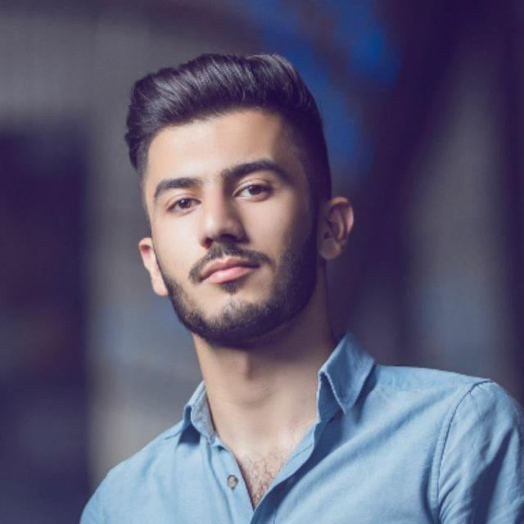

Name: Ali Dawood  
Birth Date: 1995  
Address: Baghdad, Sha’ab  
Tele: 07716497567  
Email: grandzeus55@gmail.com

**Skills and Achievements:**Fluent English speaker, professional Photoshop skills, technical photography skills. Expert Premiere editor, structuring video sequence, sound engineering, Articles Writer, good translator. Patience and concentration, Strong networking skills, team work skills, attention to detail, organization and managing skills.

**Work Experience**

AL- Anwar Photography Studio 2014-2015 (shooting and editing), Deco Studio 2015-2017(Experienced Photography and editing, married couple’s sessions and montage editing), Yalla 2017 (Professional video editing and Advertisements), Baghdad legal translation office 2018- 2019( legal translator).

**Education**

Baghdad University, College of Arts, English Department 2016-2019