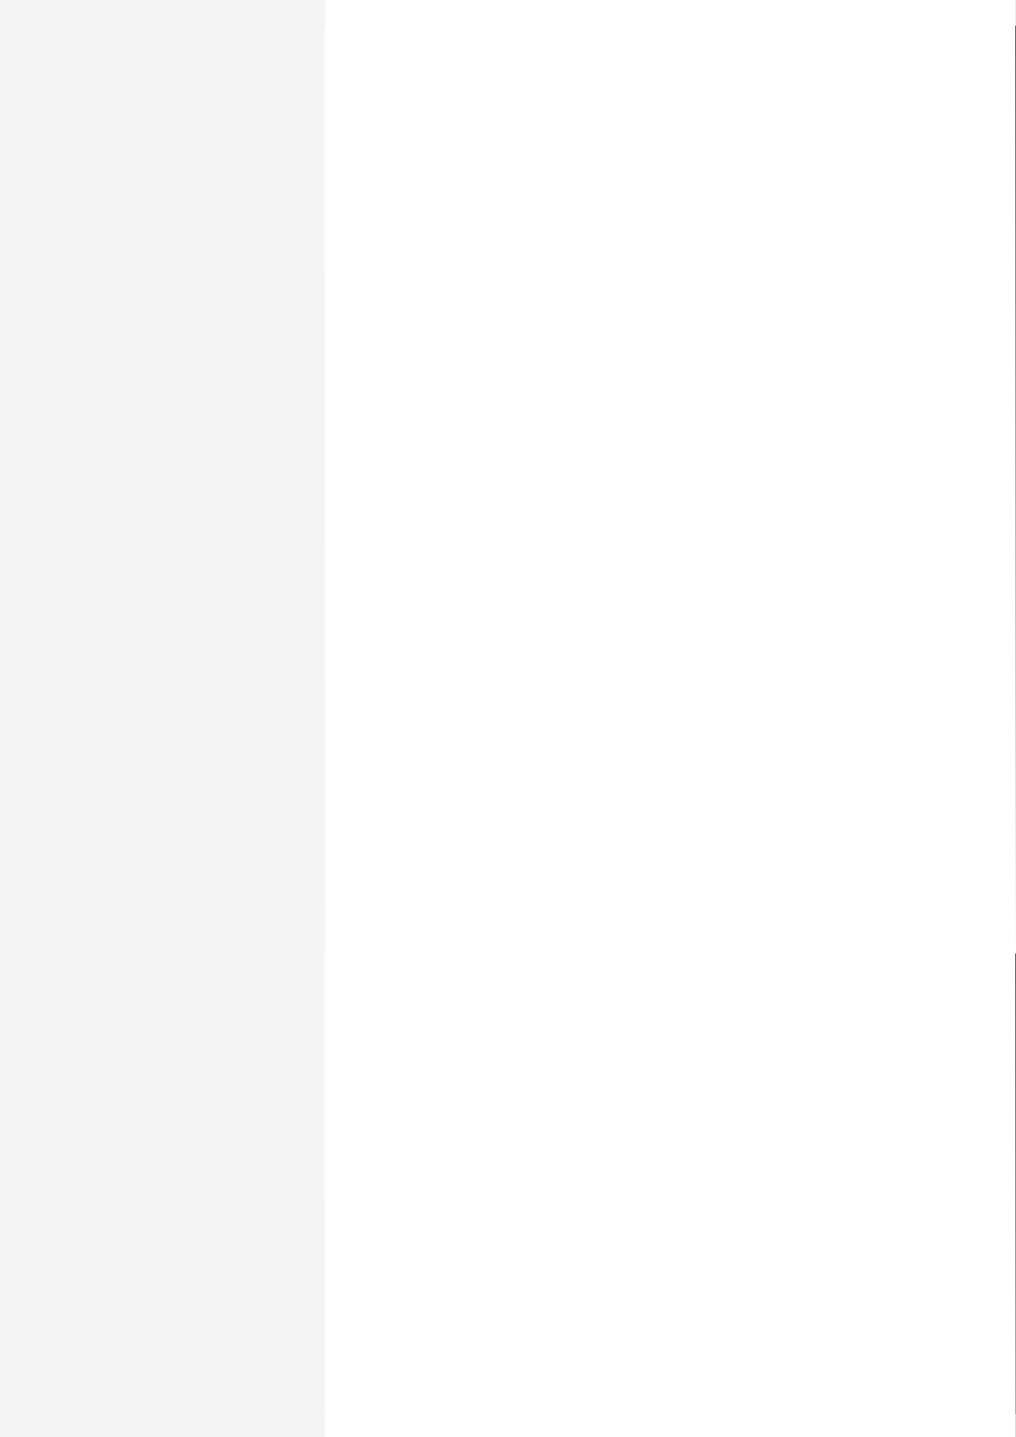

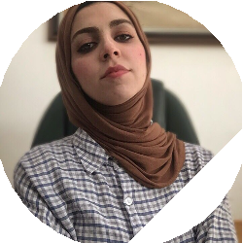

**Ayat Alnedawi**

**Date of birth:** 08/11/1994 **Nationality:** Iraqi **Gender:** Female

**CONTACT**

 Iraq

→ [ayatghalib14@gmai.com](mailto:ayatghalib14@gmai.com)

 (+964) 07708588998

**LinkedIn:** [linkedin.com/in/](http://linkedin.com/in/ayat-ghalib-648171104) [ayat-ghalib-648171104](http://linkedin.com/in/ayat-ghalib-648171104)

# ABOUT ME

I was a team leader for several years in an airline company and I achieved success with it, I have curious to experience multiple ﬁelds of work to discover new frontiers.

# WORK EXPERIENCE

**15/11/2015 – 01/12/2021** – Iraq



**Reservation Officer**

Sita System, Galileo System & Amadeus System

**15/11/2019 – 30/11/2021** – Iraq

**Accountant**

TAJMAYSAN COMPANY

EDUCATION AND TRAINING

**01/11/2013 – 01/11/2015**



**surveyor**

I graduated from the Technical Institute Survey Department

**Field(s) of study**

* Arts and humanities

**01/04/2019 – 01/12/2021** – Iraq

**HR**

IRAQI AIRWAYS

**15/06/2020 – CURRENT** – Iraq

**Freelance**

## STAX SYSTEM

**30/11/2015 – 30/11/2017** – Iraq

**DATA ENTRY**

QIcard

LANGUAGE SKILLS

**MOTHER TONGUE(S):** Arabic

**OTHER LANGUAGE(S):**

**English**

**Listening Reading Spoken Spoken Writing**

B2 B2 **production interaction** B2

B2 B1

# DIGITAL SKILLS

Microsoft Word / Microsoft Excel / Power Point / Autocad 2d e 3d / Team-working skills / Problem solving (problem analisys) / -Customer Service