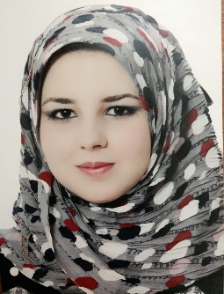***Astbrk Awf Abdulrhman C.V***

**Personal Details:**

**Full Name** Astbrk Awf Abdulrhman **Gender** Female

**Date of birth** february 14, 1996

**Nationality** iraq

**Religion** Muslim

**Address**  Iraq- Baghdad Ghazaliyah 649, street 17, home 4

Mobile: +964 –7901430559

+964_7713330336

E-mail: astabrkalkadi95@gmail.com

**Language** Arabic (Mother tongue), good in English (written and spoken)

**Interest** computer maintenance, internet, and network

**Goals** being part of a team, and working together as a group to achieve the higher benefit of the company.

**Hobbies** internet, Computer , Study and education in my specialty

**Academic Qualifications**

University of Baghdad / Faculty of Management and Economics Department of Statistics

**Professional Experience**

Working in the company Himalaya Enterprise Investment Management .

I have experience in many programs including Word, PowerPoint, Excel , spss, Matlab, Qsb .