**24 Volt DC-DC Buck converter**

**Designed by Electronics Team**

**Student Chapter DRISHTI-SVNIT,Surat**

**Abstract**

Now a days electronics are used every where from Industrial applications to home appliances. At different places different DC voltage levels are required as per the use. Most of the circuits and ICs work at 5v voltage levels but many circuits require a different voltage level such as 3.3V for low powered MCU. In most of the project labs batteries are used instead of AC supply for powering electronics circuits. Most common batteries which are available in the market are Li-Po, Li-Ion,Lead-Acid, Ni-Cd etc. which have different voltages. The circuit in this documentation was tested at voltages upto 24V to give a constant 5-22V DC.

**Introduction**

This documentation is about DC-DC buck converter circuit. The main purpose of this circuit is to convert 12/24 volt to any desired voltage requirement below them which can deliver upto 5A of current if value of components be chosen correctly. For 5V regulated power supply 7805 is also used but it gets heated up on an output current of 1A. Hence, for larger current application either multiple 7805 circuits have to be implemented or we can replace them with a buck converter circuit.

This circuit uses MOSFET as voltage controlled voltage source along with LC filtering circuit and a free wheel diode.

**Prerequisite knowledge**

1. Exploiting the Transfer Characteristics of MOSFET

By basic knowledge of MOSFETs we know that it acts as a constant current source if it is operated in **saturation region**.

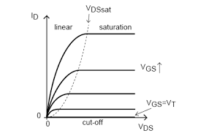

Fig1 : Transfer Characteristics of a MOSFET

Also the **channel width changes as we change Vgs** which will be the **limiting factor for current Id** which is also our load current.

Also for MOSFET the gain is

**Av = rd x gm**

2) **Filtering Circuit**

Capacitor and Inductor have very special properties. Capacitor has voltage inertia i.e. capacitor will tend to maintain the same voltage across it. Inductor has current inertia i.e. it will tend to maintain same amount of current to flow through it.

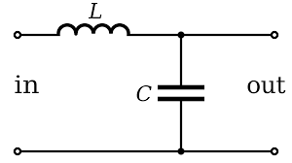

Fig2 : LC filtering circuit for providing voltage and current inertia.

Hence when we apply an LC filtering circuit it gives a voltage as well as current inertia to the circuit(or the load).

3)Fly back/ Free wheel diode

Freewheel or Fly back diodes are used across inductive components such as coils to prevent voltage spikes when the power is turned off to the devices.

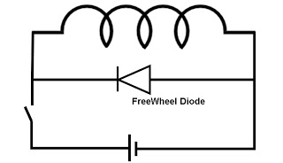

Fig3 : Free wheel diode to prevent voltage spikes

When power to inductive loads such as coils and inductors is turned off, there is a sharp voltage spike. The direction of this voltage is opposite to the applied voltage in accordance with Lenz’s Law.

When current flows through the inductor it stores magnetic energy in it. When power is suddenly cut off the current through it decreases and the magnetic field discharges causing a surge in the voltage. A diode is connected in reverse bias with the source voltage which makes the inductor discharge across itself and not causing the voltage surge.

**Implementation**

Let us see the step wise implementation of the circuit

1. Voltage Divider

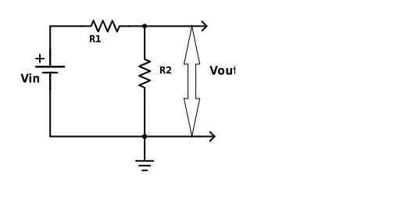

Fig 4 : Voltage Divider Circuit

In the above circuit we can get stepped down voltage   
Vin x R2 / (R1 + R2). The voltage is stepped down on the expense of losses. Suppose we want a 50% stepped down voltage we set   
R1 = R2 .

2) Lossless DC-DC step down

Suppose R1 is our load, and we introduce a switch S1. If we flip this switch on and off very quikly(assume that this is possible). If we keep switch in on state for 50% of the time and off it 50% of the times then we will get a 50% average voltage. This method is lossless since all the power is consumed by load only.

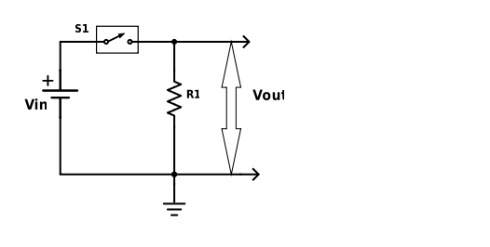

Fig5 : Lossless Stepping down of DC voltage

3) Making output voltage stable

Keeping our assumption of flipping the switch very quickly and keeping it on half the time and off the other half. As discussed earlier the capacitor gives voltage inertia, hence to get a constant voltage output we add a capacitor in parallel with load.

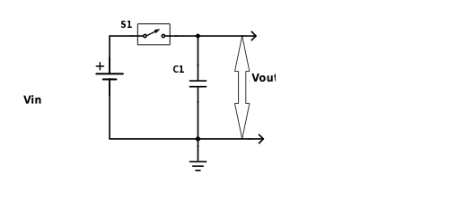

Fig6 : Voltage stabilization using capacitor

4) **Increasing current stability of the circuit**

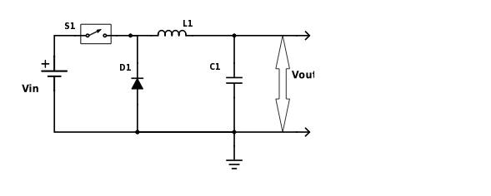

Fig7 : LC filtering circuit along with free wheel diode

Considering our current requirement is less than 2A, we take an inductor which has current rating of at least 2A. As the inductor is in series it will decide the current rating of our buck converter.

Hence after connecting the inductor and capacitor as shown above our circuit will bear a voltage as well as current fluctuations. And we already discussed why we added a free wheel diode.

5) Another hypothetical

Suppose in the previous figure we keep the switch on all the time then Vout = Vin. (As Vcap  = Vin and VL1 = 0 after some time).



Fig8

Now replace the hypothetical switch with a black box which can vary the voltage Vin from its max value to zero volt. Let us now modify our circuit according to our new hypothetical.

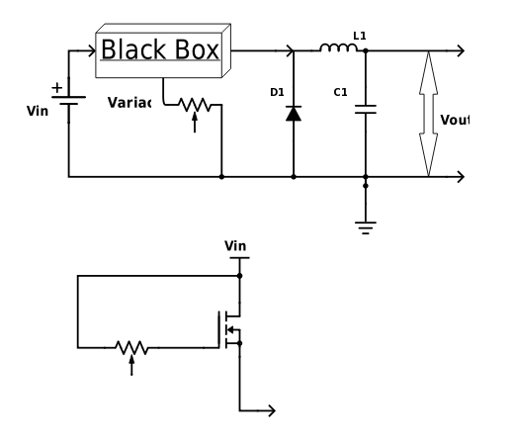

Fig9 : Final Circuit

What if we can also vary our output voltage of black box with the help a variac.

By using a mosfet we make a voltage controlled voltage output device. We already know the gain formula, it depends on the drain resistance and transconductance. But first of all what does these two quantities refer to.

Transconductance is the slope of the Id vs Vgs curve. And drain resistance is the inverse of the slope of the Id vs Vds curve. By transfer characteristics of the MOSFET we know that drain resistance comes out to be very large. From the datasheet of IRFZ44 min gm is 6.7. Hence, the value of Av is quite high. But practically the output voltage doesn’t reach a very high value.  
Practically by keeping Vd constant and changing Vgs we change rd and we can set the output voltage between 0v to Vin. This justifies our black box hypothetical.

All that is left is to connect the dots get a buck converter which can provide us a constant output voltage and current.

The above circuit was tested from 9V to 25V for any constant desired voltage between 5v to 22V.   
The current however was limited below 2A. By selection of correct component values we can the increase the current capacity.

The circuit was designed using Diptrace 2.4.0.2 freeware edition.

The above documentation can be found on github of DRISHTI-SVNIT along with the Circuit Diagrams in DipTrace.

**Components Used**

However no research is being done on the value of inductor, capacitor and diode only MOSFET is chosen wisely.

The circuit used the following components

1. Inductor – 4.3 mH.
2. Capacitor - a) Input – 2200 uF, 25V.  
    b) Output – 1000 uF, 25V.
3. Diode – 1N4007
4. MOSFET – IRF244
5. Screw Connector – Detachable screw connectors
6. GCB.
7. 100k Potentiometer.

Total cost was below 100 rupees.

References

1)Buck Converter Design Infineon Technologies North America(IFNA) Corp.

2)Datasheet of IRFZ44

3)Ned Mohan power electronics

4)<http://www.electrotechnik.net/2009/09/freewheeling-or-fly-back-diodes-and.html>

Note : All the figures shown were drawn in SchemeIt :*free* *online schematic drawing tool.*

Have queries mail us at

drishti.nitsurat@gmail.com