Breast Cancer Classification
Model Training & Evaluation Summary
Muhammad Shaheer Zahid
1. Objective
To train and evaluate machine learning models on the Breast Cancer Wisconsin dataset, in order to benchmark model performance on a dataset where the features are strong, direct predictors of the target outcome.
2. Dataset
The Breast Cancer Wisconsin dataset (built into scikit-learn) contains 569 patient records with 30 numeric features derived from digitized images of breast tissue (e.g. cell radius, texture, perimeter, smoothness). The target variable classifies each case as Malignant or Benign.
- No missing values found.
- No duplicate rows found.
- Class distribution: 357 Benign, 212 Malignant.
3. Train/Test Split
The dataset was split into 80% training data (455 rows) and 20% testing data (114 rows). Features were standardized using a scaler fitted only on the training set to avoid data leakage.
4. Models Trained & Results
Three models were trained on the training set and evaluated on the unseen test set:
- Logistic Regression
- Random Forest
- Gradient Boosting

Model | Accuracy | Precision | Recall | F1 Score
Logistic Regression | 98.2% | 0.99 | 0.99 | 0.99
Random Forest | 95.6% | 0.96 | 0.97 | 0.97
Gradient Boosting | 95.6% | 0.95 | 0.99 | 0.97

Best model: Logistic Regression, achieving 98.2% test accuracy, with 0.99 precision and 0.99 recall — misclassifying only 2 out of 114 test cases.
5. Confusion Matrices
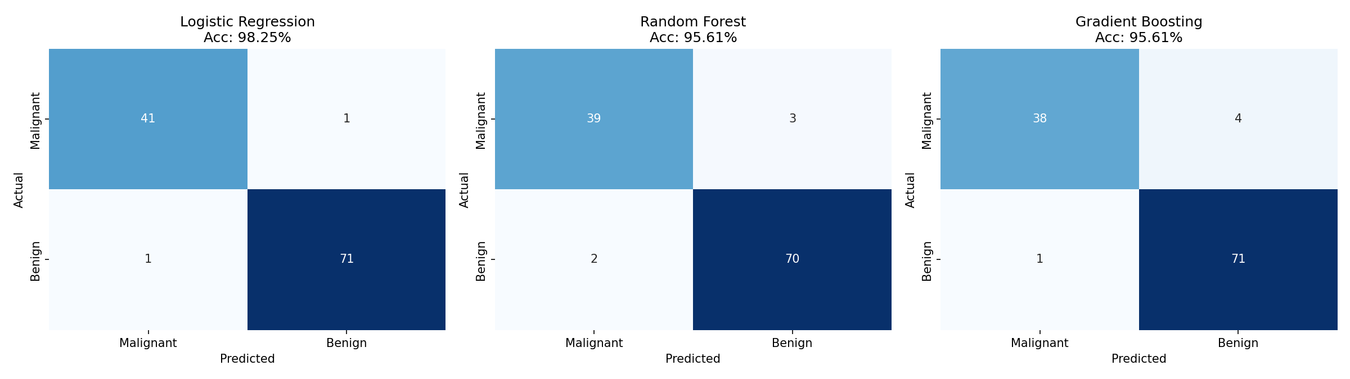
6. Conclusion
All three models performed strongly on this dataset, reaching 95–98% accuracy. This confirms that when the input features have a direct, well-established relationship with the target variable (as medical measurements do with tumor classification), standard machine learning models can achieve high accuracy with minimal tuning. Logistic Regression performed best overall, suggesting the relationship between the features and the outcome is largely linear.

