**DSA Semester Project**

**Instructor: Dr Yasir Faheem**

**Abdul Manan | 303323**

**Tafheem Ul Islam | 321906**

**BSCS 9A**

***Dataset:*** Research Publication Database

***Data Structures Used:*** AVL Trees, Graph, Linked Lists, Arrays.

***Functionalities:***

1. Total number of articles published by an author

2. Total number of publications per year by an author

3. Number of coauthors per publications of an author

4. Number of papers for each position of an author

5. Print name of journals of each article by an author

6. Print name of authors at distance d of given author

7. Check if given authors have worked together

8. Print coauthors of given author

9. Number of Articles given authors have coauthored

10. Print name of all articles by an author

11. Print names of all authors

***Brief Description:***

* Our project stores the data in following way.
* All of the articles are stored in article AVL tree.
* Each article has list of author in Linked List form.
* All of the authors are stored in AVL tree.
* Each author has list of articles in Linked List form.
* Each author has year wise tree in AVL form.
* Each year wise node has articles published in that year stored in a linked list.
* A graph is created for Authors.

We have used an AVL tree to insert an edge between two vertices.

***Why we chose that data structure?***

* We used Linked Lists when we had to do only insertions. Using insert at front, the complexity for this operation is O(1).
* We used AVLs where search was required (log(n)).
* AVL tree instead of list were used in graph representation to reduce search time complexity.
* All of the insertions in AVLs are made using recursion.

***Project Diagram***

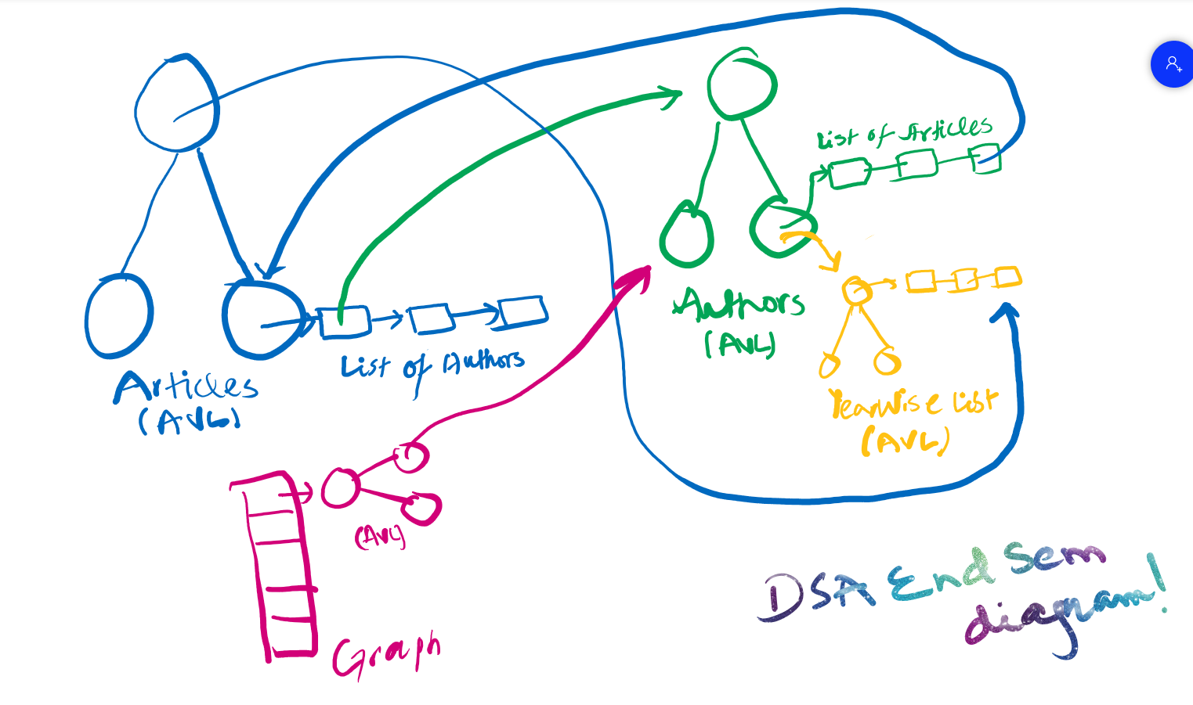

To run the program, run the finalproject.cpp file. Data is given in data.csv