**SOFTWARE DESIGN AND ARCHITECTURE**

Name : Usman Ali

Reg No : FA21-BSE-159

Instructor :Sir Mukhtiyar Zamin

Date : 01/Oct/2024

**Online Food Delivery System**

**Use Case Diagram**

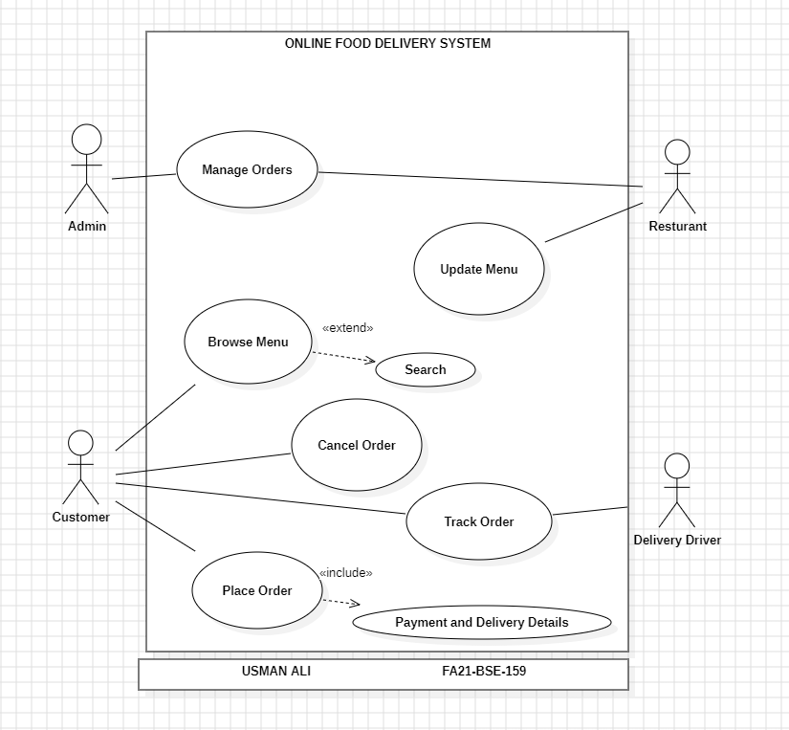

**Actors:**

* **Customer**
* **Restaurant**
* **Delivery Driver**
* **Admin**

**Use Cases:**

* Browse Menu
* Place Order
* Track Order
* Cancel Order
* Manage Orders (for Admin)
* Update Menu (for Restaurant)

**Use Case: Place Order**

**Fully Dressed Use Case for "Place Order"**

**Use Case Name:** Place Order  
**Actor:** Customer  
**Goal:** To successfully place an order for food from a restaurant.  
**Preconditions:**

* The customer is registered and logged into the system.
* The customer has selected items from the restaurant menu.

**Post conditions:**

* The order is recorded in the system.
* The customer receives an order confirmation.

**Main Success Scenario:**

1. The customer browses the menu or searches for specific item..
2. The system displays the food items.
3. The customer selects items and adds selected items to the cart.
4. The customer reviews the cart and proceeds to checkout.
5. The customer enters delivery details and payment information.
6. The customer confirms the order.
7. The system processes the payment.
8. The system notifies the restaurant of the new order.
9. The system sends an order confirmation to the customer.

**Alternative Flow 1: Payment Failure**

* If the **payment fails** during the payment processing, the system will alert the customer about the payment issue.
  + **Action**: The system prompts the customer to choose a different payment method (e.g., credit card, PayPal, etc.).
  + **Outcome**: If the customer chooses a new payment method and the payment is successful, the flow continues from step 7. If the payment still fails, the customer is notified, and the order process is terminated.

**Alternative Flow 2: Order Cancellation**

* If at any time **the customer decides to cancel the order**, they can select a "Cancel Order" option.
  + **Action**: The system will cancel the current order, and any payment will be reversed if applicable.
  + **Outcome**: The customer will receive a cancellation confirmation, and no order will be processed.

**Extensions:**

* 3a. If the customer wants to modify the cart:
  + The customer can add or remove items before confirming the order.
* 4a. If payment fails:
  + The system alerts the customer and prompts for a different payment method.

**Special Requirements:**

* The system must ensure secure handling of payment information.
* The system must provide real-time inventory updates to reflect available items.

**System Sequence Diagram for Place Order:**

This diagram shows the main successful flow of the system which includes:

* The customer browses the menu or searches for specific item..
* The system displays the food items.
* The customer selects items and adds selected items to the cart.
* The customer reviews the cart and proceeds to checkout.
* The customer enters delivery details and payment information.
* The customer confirms the order.
* The system processes the payment.
* The system notifies the restaurant of the new order.
* The system sends an order confirmation to the customer

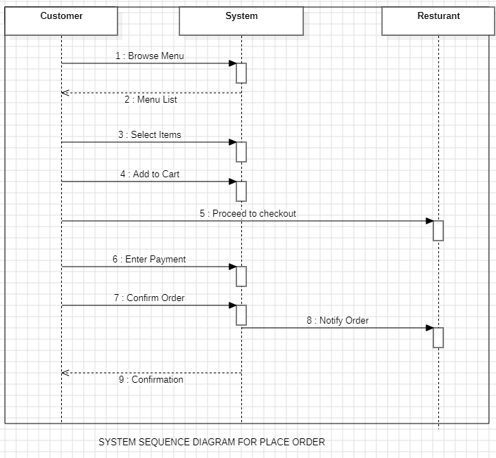

* .

**APPLICATION OF GRASP PRINCIPLES**

**INFORMATON EXPERT:**

• This principle will help assign responsibility for managing and processing information to the objects that contain the relevant data. Let's look at where this applies in the communication diagram.

• Customer: The **Customer** is the expert for their own details (e.g., delivery address, payment method). So, **Customer** is responsible for providing this information to the system.

• Inventory: **Inventory** holds the information about the availability of items. It is the natural expert in checking if a certain food item is available or not. Therefore, **Inventory** is responsible for determining the availability of the items.

• Payment **Gateway**: This component knows how to handle the transaction (i.e., payment processing). It is the expert for **payment processing** and therefore responsible for verifying and confirming the payment.

• Restaurant: The **Restaurant** is the expert for the items on the menu. It holds the knowledge about which items are available and can confirm that an order has been received.

**CONTROLLER:**

* **System** will act as the **Controller** in the **"Place Order"** use case. It is the component that manages the sequence of actions that need to be performed and delegates tasks to the appropriate components (like checking the inventory, processing payment, notifying the restaurant, etc.).
* The **System** will handle all the **system-level events** such as:
  + Browsing the menu
  + Adding items to the cart
  + Checking inventory
  + Processing the payment
  + Sending notifications (to the customer and the restaurant)
  + Confirming the order

**COMMUNICATION DIAGRAM :**

