**CS 2010 Program 1 – Carol & Company Monthly Sales Tax Report**

**20 Points (Due 11:59 p.m. Wednesday, 9/25)**

**Problem:** Carol & Company, a retail store, must file a monthly sales tax report listing the sales for the month and the amount of sales tax collected. Assume that the state sales tax rate is 6 percent and the local sales tax rate is 2 percent.

Write a program that asks for the month, the year, and the total amount collected at the cash registers (total receipts) for that month. This will include the amount of product sales plus sales tax collected.

HINT: If the total receipts is known, and the total sales tax is 8 percent, the amount of product sales can be calculated as:

**S** is the product sales.

**T** is the total receipts (product sales plus sales tax.)

S = T

-----

1.08

*How can you write this formula without “hard coding” the numeric literal, 1.08?*

*How can you determine the amount of total tax collected and the separate state and local tax amounts?*

**Example Output**

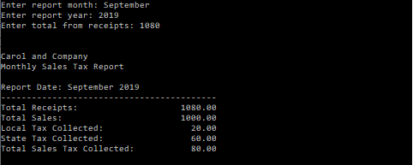

# Tips

1. Complete Assignment 1 questions 8-10 before you start!
2. See the *Ch3_Steps to Create a Program* handout for help getting started with your design.
3. See Gaddis pp. 110-119 & the Input/Output presentation for help using stream manipulators.
4. See the *Program Documentation Style* handout for help with your comments.
5. Review the *Lab 1* instructions for help creating and saving your C++ project.

# Zip & Submit

1. **Zip** & submit your top level **LastnameProgram2** solution folder.

# Grading

(1) Project Name

1. Documentation & Style

Program Identifying Comments

Inline Comments

White Space

1. Variable & Constant Declarations

Appropriate Data Types camelCase Names for Variables UPPER_CASE Names for Constants

(4) Input

Prompts

Assignment statements

(4) Processing

All Necessary Calculations Performed

All Calculations Produce Correct Results

(4) Output

Required Results Displayed

Output is Appropriately Formatted   
(Including a report heading, white space, and 2 decimal precision, right-aligned sales & tax values.