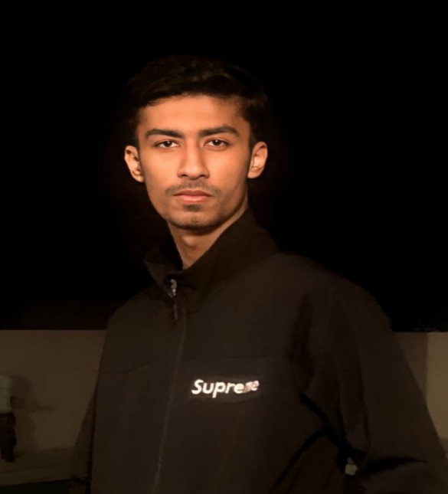



**MALIK WASSAM SHABBIR**

NO SUCH EXPERIENCE RIGHT NOW BUT HAVE KEY ACHIEVEMENTS AND HAVE SIGNIFICANT MILESTONE IN MY WHOLE STUDENT LIFE.

CONTINUE--

BACHELOR IN SOFTWARE ENGINEERING

BAHRIA UNIVERSITY KARACHI

2023

INTERMEDIATE (A)

BAHRIA COLLEGE KARASAZ

2021

MATRIC (A+)

BAHRIA COLLEGE KARSAZ

Programming Languages: Proficient in JAVA and PYTHON and also have knowledge about [C# and C++]

Web Development: Extensive experience in building responsive and scalable web applications using HTML, CSS and Node.js.

**EXPERTISE**

**EXPERIENCE**

* ***Communication skills***
* ***Teamwork and collaboration***
* ***Problem-solving***
* ***Adaptability***
* ***Time management***
* ***Leadership***

**EDUCATION**

* ***URDU***
* ***ENGLISH***

**LANGUAGES**

**SKILLS**

***0333-9111173***

***malikwassam25@gmail.com***

***Karsaz-Karachi***

**I am currently completing my BSE from Bahria University Karachi and I am known for my analytical mindset and problem solving approach.**