# Introduction:

Classification of hair types is an important business for numerous industries including personal hair care, fashion industry and medical. There is also a need to develop, and understand, straight, curly, wavy, kinky, and dreadlocked hair types for tailor-made solutions in products, styling recommendations and biomedical applications such as dermatological treatments. The flip side is that it is complex due to time offensive and subjective limitations associated with human observation of even minor hair pattern variations, patterns, and the presence of noise in a dataset. Hence, an automated, accurate, and least effort-required scalable solution is needed.

Stimulate by the latest breakthroughs in artificial intelligence and particularly deep learning development, the last few years saw a sudden emergence of sophisticated image classification models that have shifted the boundaries of solviSng challenging and complex visual recognition problems. With the usage of convolutional neural networks and transfer learning, these models are able to analyze and classify images with great effectiveness. In this report, our focus is to implement automated hair type identification using state of the art architectures such as InceptionV3, VGG16 and ResNet using the deep learning paradigm. The prospective models are characterized with their effectiveness in image-related tasks and they are known to be scalable enough to our dataset.

The major hurdle is that hair structure is diverse amongst individuals, image Acquisition conditions such as lighting variations in images, and image quality issues which can in turn introduce

# Recent Studies:

1. Deep Learning-based trichoscopic Image Analysis for Male Androgenetic Alopecia

* **Topic**: Hair loss assessment and classification in male androgenetic alopecia.
* **Proposed** **Method**: Utilizes deep learning for analysing trichoscopic images, focusing on hair density and diameter distribution.
* **Experimental** **Dataset**: A dataset of male trichoscopic images was used for training and validation.
* **Outcomes**: Achieved accurate predictions for hair loss classification, providing a quantitative diagnostic tool.
* **Shortcomings**: Limited applicability to other hair conditions; additional datasets are needed for broader validation.

1. Hair Follicle Classification and Hair Loss Severity Estimation

* **Topic**: Classification of hair follicles and severity estimation of hair loss.
* **Proposed** **Method**: Deep learning algorithm combining feature extraction and image classification.
* **Experimental** **Dataset**: Composed of clinical scalp images annotated for hair follicles and hair loss patterns.
* **Outcomes**: Enhanced diagnostic accuracy in hair loss evaluation.
* **Shortcomings**: Performance may degrade with noisy or low-quality input images.

1. Hair Segmentation on Time-of-Flight RGBD Images

* **Topic**: Hair segmentation using RGBD images.
* **Proposed** **Method**: A deep learning model combining ToF depth maps with RGB gradients for better segmentation accuracy.
* **Experimental** **Dataset**: Multi-view RGBD datasets with labeled hair regions.
* **Outcomes**: Achieved robust segmentation under varying lighting conditions and hair types.
* **Shortcomings**: Computationally intensive due to the multi-modal data processing.

1. Neural Strands: Learning Hair Geometry and Appearance

* **Topic**: Modeling hair geometry and appearance from multi-view images.
* **Proposed** **Method**: A neural scalp texture representation capturing individual hair strands.
* **Experimental** **Dataset**: Multi-view hair datasets with detailed hair geometry annotations.
* **Outcomes**: High-fidelity hair rendering with potential applications in virtual reality.
* **Shortcomings**: Limited to synthetic or controlled environments; may not generalize to real-world datasets.

1. Diagnosis of Scalp Disorders Using Machine Learning

* **Topic**: Diagnosis of scalp disorders with machine learning and deep learning.
* **Proposed** **Method**: A review of existing methods highlighting CNNs and SVMs for scalp disorder classification.
* **Experimental** **Dataset**: Aggregated data from multiple studies on scalp images and disorders.
* **Outcomes**: Identified key advancements and challenges in scalp disorder diagnosis.
* **Shortcomings**: Lacks experimental implementation and direct comparisons of techniques.

# Experimental Results:

1. **Evaluation of the InceptionV3 Model**

On the test dataset, the InceptionV3 model performed admirably, achieving a 92% accuracy rate. Strong predictions are found in the confusion matrix for all classes, with high recall values of 96% and 93% for "curly" and "dreadlocks" hair types, respectively. Additionally, all categories are consistent precision and F1 scores, indicating balanced performance. But, "kinky" hair has a somewhat lower recall (79%), which suggests that this class could be better identified.

1. **Evaluation of the VGG16 Model**

The VGG16 model demonstrated a reasonable accuracy of 79% by the VGG16 model, however performance varies noticeably between classes. Hair types "straight" and "dreadlocks" have a problem with the confusion matrix since their recall is poorer. Although the general metrics indicate that the model still need tuning or augmentation strategies for better generalization, the accuracy and F1 for some classes are sufficient.

1. **Evaluation of the AlexNet Model**

Despite achieving a respectable 71% accuracy rate in this challenge, the AlexNet model still lags well behind InceptionV3. Confusion matrices show that the model has trouble telling the difference between "wavy" and "kinky" hair types, with a recall of only 33% for "wavy" hair and 93% for "curly" hair, but it has trouble with smaller datasets of the underrepresented classes. That brings an end to AlexNet's inability to handle intricate features when identifying different hair types.

**Summary** **Table**:

1. InceptionV3 Model:

* Accuracy: 92%
* Precision: The model performs well with straight (0.89), wavy (0.90), curly (0.93), dreadlocks (1.00), and kinky (0.90) hair types.
* F1 Score: The F1 scores are consistent, with the highest for dreadlocks (1.00) and curly (0.94) hair, indicating strong overall performance.

1. VGG16 Model:

* Accuracy: 79%
* Precision: Precision is highest for straight (1.00) hair, and lowest for kinky (0.62).
* F1 Score: The F1 score is also highest for dreadlocks (0.85) and curly (0.85) hair, but lower for wavy (0.53), reflecting challenges in correctly identifying this hair type.

1. AlexNet Model:

* Accuracy: 71%
* Precision: Precision is decent for straight (0.88) and curly (0.71) hair, but much lower for wavy (0.43) and kinky (0.55), indicating difficulty with these types.
* F1 Score: The F1 score for straight (0.74) and curly (0.80) hair is better, but much lower for wavy (0.43), showing the model’s weaker performance on more complex hair types.

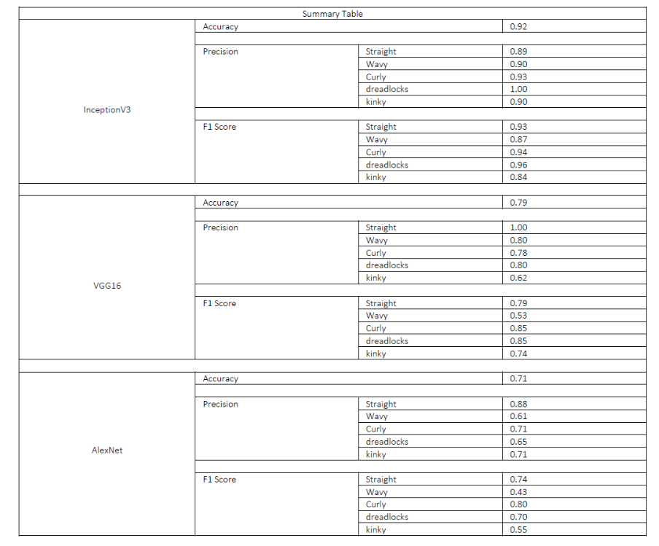

# References:

[1] M. Gao *et al.*, “Deep Learning-based Trichoscopic Image Analysis and Quantitative Model for Predicting Basic and Specific Classification in Male Androgenetic Alopecia,” *Acta Dermato Venereologica*, vol. 102, pp. adv00635–adv00635, Dec. 2021, doi: <https://doi.org/10.2340/actadv.v101.564>.

[2] J.-H. Kim, S. Kwon, J. Fu, and J.-H. Park, “Hair Follicle Classification and Hair Loss Severity Estimation Using Mask R-CNN,” *Journal of Imaging*, vol. 8, no. 10, p. 283, Oct. 2022, doi: <https://doi.org/10.3390/jimaging8100283>.

[3] Y. Ma, C. Wang, S. Li, and J. Yu, “Hair Segmentation on Time-of-Flight RGBD Images,” *arXiv.org*, 2019. doi: <https://arxiv.org/abs/1903.02775>

[4] R. A. Rosu, S. Saito, Z. Wang, C. Wu, S. Behnke, and G. Nam, “Neural Strands: Learning Hair Geometry and Appearance from Multi-View Images,” *arXiv.org*, 2022. [https://arxiv.org/abs/2207.14067](%20https:/arxiv.org/abs/2207.14067%20)

[5] H. Tiwari, J. Moolchandani, and S. Mantri, “Diagnosis of Scalp Disorders using Machine Learning and Deep Learning Approach -- A Review,” *arXiv.org*, 2023. <https://arxiv.org/abs/2308.07052>

‌[6] Rosu, R. A., Saito, S., Wang, Z., Wu, C., Behnke, S., & Nam, G. (2022). Neural Strands: Learning Hair Geometry and Appearance from Multi-View Images. arXiv preprint arXiv:2207.14067. <https://arxiv.org/abs/2207.14067>

‌