JOBSHEET 8
LOOPS 2

- Objectives
- Understand the concept of nested loops in algorithms
- Students are able to draw flowcharts of nested loops
- Become familiar with the syntax of nested loops
- Be able to apply nested loops to solve problems
- Lab Work
  - Experiment 1: Review of Loops 1
Experiment Time: 30 minutes
- This experiment is intended to review the loops covered in the previous meeting. In Experiment 1, you will create a program that displays * n times in a horizontal direction.
- Create a new file StarAttendanceNo.java
- Create the function/method main() inside it.
- Because the program needs keyboard input, you need to import the Scanner class. So add the import statement at the very top of the program.

import java.util.Scanner;

- Inside the main() function you have created, declare a Scanner object named sc.

Scanner sc = new Scanner(System.in);

- On the next line, display an instruction to enter the value that will be stored in the variable n.

System.out.print("Enter the value of n = ");
int n = sc.nextInt();

- On the next line, create a loop using for as shown below.

for(int i=1; i<=n; i++){
System.out.print("*");
}

Note: make sure to use the print command, not println, because we want to display the output without a new line
- Compile and run the program.
- Observe the result. It should look similar to the display below.

Enter the value of n = 5

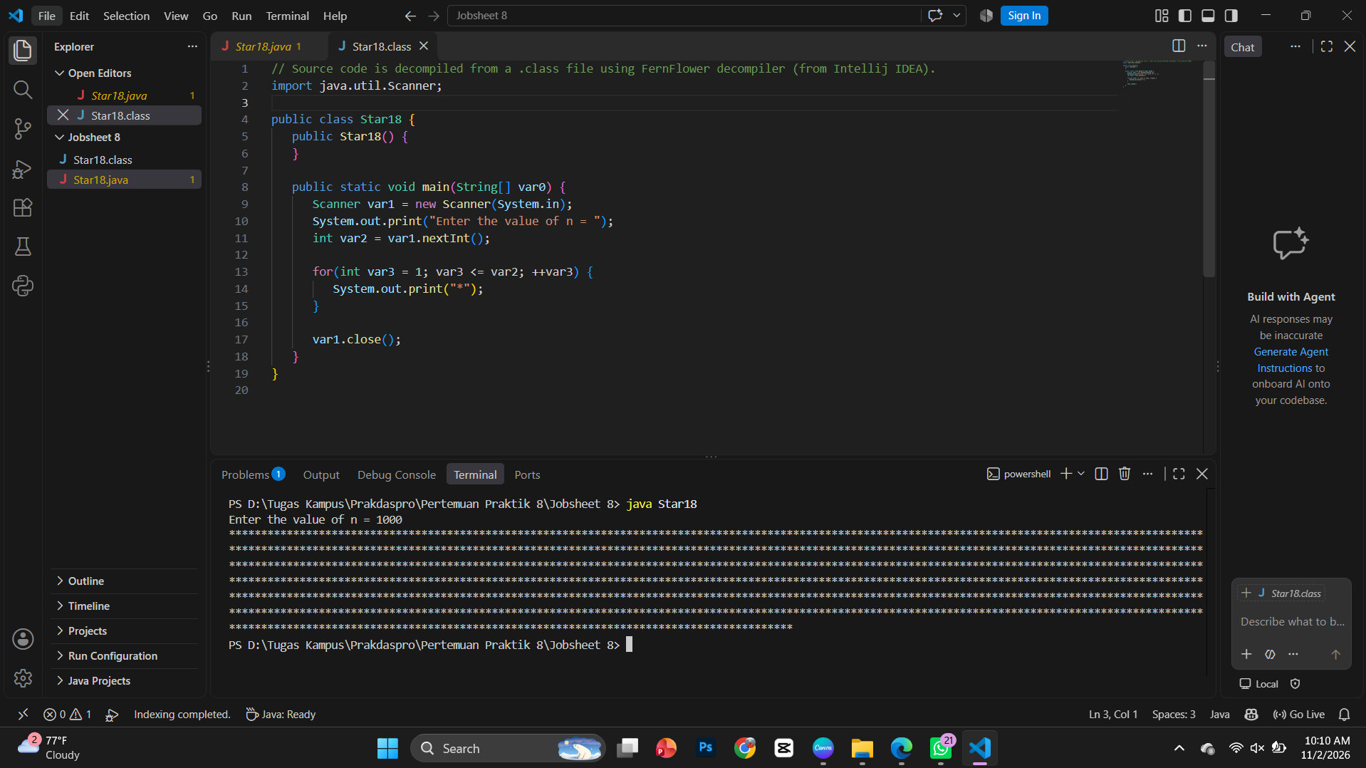

Questions
- In a for loop, if the initialization i=1 is changed to i=0, what is the result? Why does this happen? i=0: Prints $n+1$ stars because the loop starts from 0 instead of 1.
- In a for loop, if the condition i<=n is changed to i<n, what does the output look like when the input is n = 5? Why is the result different? i<n ($n=5$): Prints 4 stars (****) because the condition excludes the value of $n$.
- In a for loop, if the condition i <= n is changed to i > n, what is the result? Why does this happen? I > n: Prints nothing because the initial condition is already false.
- In a for loop, if the step i++ is changed to i--, what is the result? Why does this happen? i--: Causes an infinite loop because $i$ moves away from $n$, making the condition permanently true.
- In a for loop, if the step i++ is changed to i += 2, what is the output pattern when the input is n = 6? What causes this change? i += 2 ($n=6$): Prints 3 stars (half the amount) because the step increments by 2 each iteration.

  - Experiment 2: Square of Stars
Experiment Time: 30 minutes
- In Experiment 2, you will practice nested loops. The case to solve is displaying a square of *, with a side length of n. For example, if n is entered as 5, the result is:
- Looking more closely, this is actually similar to Experiment 1. If in Experiment 1 the input n is 5, the output is ***** (this can be seen as an inner loop that prints 5 stars *****), so for Experiment 2, the result of Experiment 1 only needs to be repeated n times. This is done by adding an outer loop to repeat the inner loop n times.
- Create a new file SquareAttendanceNo.java
- Because the program needs keyboard input, you need to import the Scanner class. So add the import statement at the very top of the program.

import java.util.Scanner;

- Create the main() method, and fill it with the same code as the main() method in Experiment 1.

Scanner sc = new Scanner(System.in);
System.out.print("Enter the value of N = ");
int N = sc.nextInt();
for(int i=1; i<=N; i++){
System.out.print("*");
}

- Compile and run the program. Make sure the program works the same as it did in Experiment 1.
- Look at the loop syntax used to print * n times horizontally. In step 8 above, the for code (red box) is used as the inner loop.
- The inner loop runs n times to produce the output shown in point 1. So an outer loop needs to be added (outer loop).

for(int iOuter=1; iOuter<=n; iOuter++){
for(int i=1; i<=n; i++) {
System.out.print("*");
}
System.out.println();
}

- Save the changes, compile, and run the program.
- Observe the result. It should look similar to the display below.

Enter the value of n = 5
*****
*****
*****
*****

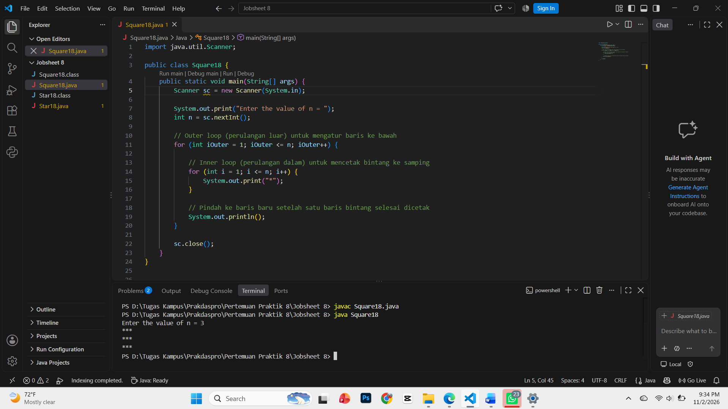

Questions
- Look at the outer loop. In the for syntax, if the initialization iOuter=1 is changed to iOuter=0, what is the result? Why does this happen? iOuter=0 in outer loop: Prints $n+1$ rows because the outer loop starts from 0, increasing the total row count by one.
- Restore the original program, where the initialization is iOuter=1. Then look at the inner loop. In the for syntax, if the initialization i=1 is changed to i=0, what is the result? Why does this happen? i=0 in inner loop: Prints $n+1$ stars per row because the inner loop starts from 0, adding an extra star to each line.
- What is the difference in purpose between the outer loop and the loop inside it?
Difference in purpose: The outer loop controls the rows going downwards, while the inner loop prints the stars horizontally across each row.
- Why does the statement System.out.println(); need to be added below the inner loop? What happens if that statement is removed? System.out.println() function: Moves the cursor to a new line after each row is printed. If removed, all stars will merge into a single horizontal line.
- Please commit and push to your repository. Commit and push: Run git add ., git commit -m "...", and git push origin main in the terminal.

  - Experiment 3: Triangle of Stars
Experiment Time: 45 minutes
- In Experiment 3, you will practice with a right triangle of *, with a height of n. For example, if n is entered as 5, the result is:
*
**
***
****
*****

- Create a new file TriangleAttendanceNo.java
- Because the program needs keyboard input, you need to import the Scanner class.
- Create the main() method, and enter the following code into the main() method.

Scanner sc = new Scanner(System.in);
System.out.print("Enter the value of n = ");
int n = sc.nextInt();
int i = 0;
while(i <= n) {
int j = 0;
while(j < i) {
System.out.print("*");
j++;
}
i++;
}

- Compile and run the program. Observe what happens.
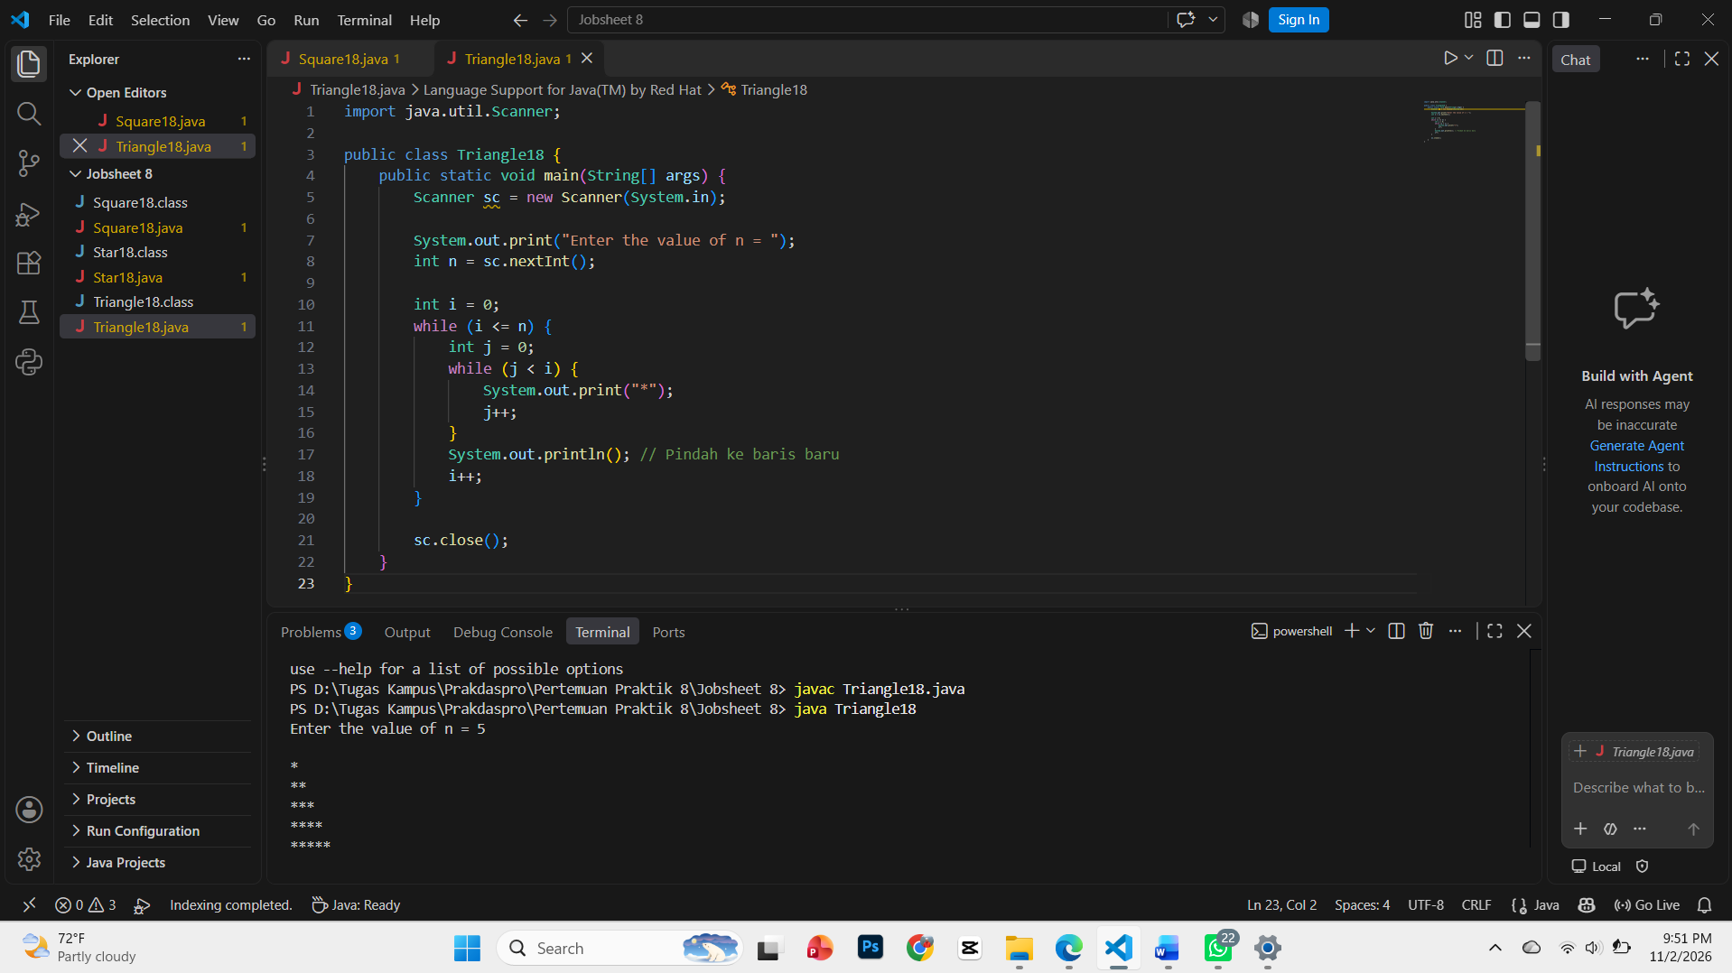

Questions
- Observe: does the output produced with n = 5 match the following display?
*
**
***
****
*****

Yes, it matches and correctly displays a right triangle of stars from 1 to 5 rows.
- If it does not match, which parts need to be corrected or added? Explain each part that needs to be corrected or added. Add System.out.println() below the inner loop to move the cursor to a new line after each row of stars is printed.
- Please commit and push to your repository. Run git add ., git commit -m "...", and git push origin main in the terminal.
- Explain the roles of the variables i and j in this program. Why is j reset to 0 at the start of each iteration of the outer loop? What would happen if j were not reset?
i controls the outer loop (rows), and j controls the inner loop (stars per row).
j resets to 0 so the star count restarts for every new row.
If not reset, stars would only print on the first row because j would remain at its final value.

  - Experiment 4: Case Study of Group Project Scores
Experiment Time: 75 minutes
In collaborative learning, the lecturer applies a peer review system to assess group assignments. Each group is assessed by several other groups as a form of peer feedback. In this experiment, the program will process the scores for a class of 6 groups. Each group will be rated by the 5 other groups on a scale of 1–100. The program will calculate each group's final score as the average of all raters. The following flowchart shows the algorithm for solving this problem.
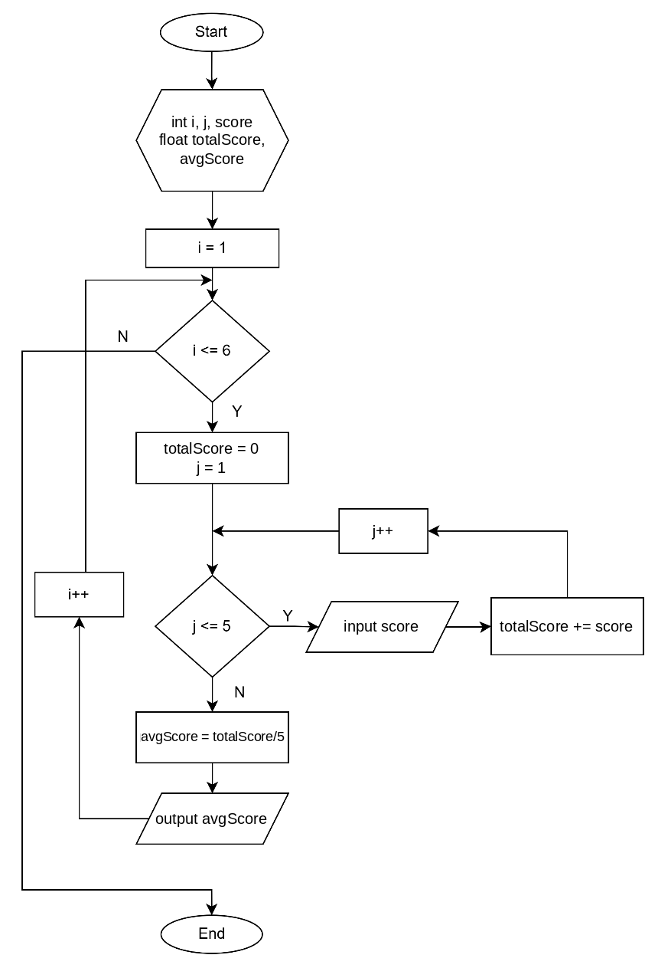

Based on the flowchart, create a program using the Java programming language.

Experiment Steps
- Create a new file GroupScoreAttendanceNo.java
- Create the basic structure of a Java program consisting of the main() function.
- Add the Scanner library at the top (outside) of the class
- Declare a Scanner with the variable name sc inside the main() function
- Declare the variables as shown in the flowchart
- Create the loop structure for the inner loop using for to enter 5 scores from each rating group
for (j=1;j<=5;j++) {

}

- Inside the for loop, add the command to enter 5 scores from the rating group and calculate the total score. Do not forget to set the initial value of totalScore to 0 before the loop.
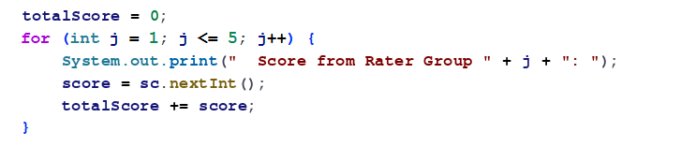

- After the loop that enters 5 scores finishes and the total score is obtained, calculate the average score using the formula
avgScore=totalScore/5;

- Next, repeat the process of entering scores for 6 groups. Create the loop structure for the outer loop using while.
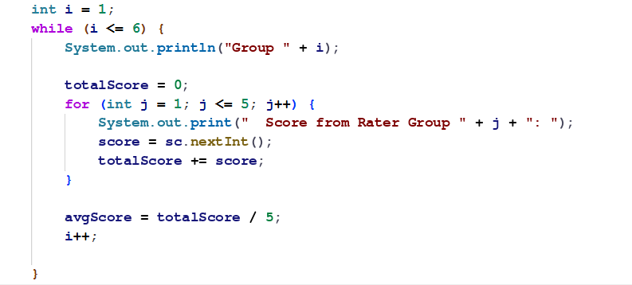
- Add descriptive narration for the input and output prompts
- Compile and run the program.
- Observe the result: does the program carry out the command to enter 5 scores for 6 groups, with a display similar to the one below:
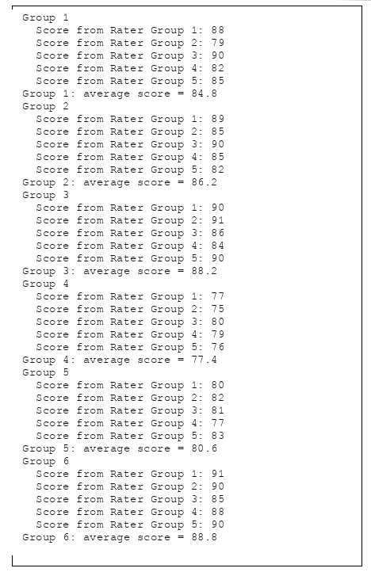
- Commit and push the program code to GitHub

Questions
- Explain what happens to the variable totalScore in each iteration of the outer loop and why its initialization (total = 0) is inside the outer loop, not outside it.
- Modify the program above so that it can find the group with the highest average score and display that group's number.
- Assignments
Assignment Time: 120 minutes
- Write a program to calculate and display the sum of squares of the numbers from 1 to n. Use nested loops. The expected output when n ranges from 1 to 5 is shown below.
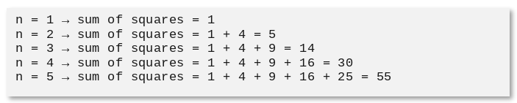

- Write a program to print a square of numbers like the one below based on input n (the minimum value of n is 3). Examples: n = 3 and n = 5
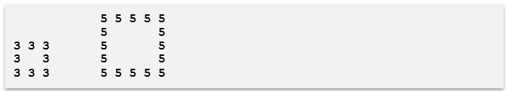
- A cafe chain, “Kopi Senja,” has several branches at various locations across the city. To monitor daily operational performance, management needs simple data on sales activity at each branch. Every day, each branch serves a number of customers, and each customer orders one or more items, either food or drinks. Write a program to record and calculate the number of customers and the total number of items sold at each branch. Because the system is still simple and does not store historical data, the program only needs to directly record how many customers were served and how many items were sold in total at each branch, without storing customer names, menu types, or other details. The program first asks for the number of branches. Then, for each branch, the operator enters the number of customers who came today. Next, for each customer, the operator enters the number of items ordered. The program then calculates and displays a sales summary per branch, as well as the grand total across all branches at the end of the session. Below is an example of the program's input and output:


