PANGA
Competitive Brief
Sellability, Positioning & Pricing

Prepared for: Zahir
Date: August 1, 2026
Prepared by: "Mirror" — Panga coordination session
Question this brief answers:
Could Panga — currently a personal, single-user job-search tool —
become a sellable product?

Contents

Executive Summary
This is a brand-new exploration. No prior business-model or pricing decisions exist for Panga as a sold product beyond a placeholder $200/year figure — explicitly not validated. Nothing in this brief assumes a target customer, price point, or positioning beyond what is demonstrated below.
Bottom line
Yes. There is a real, differentiated, sellable product here — not a hedge, a conviction. Panga is competing as software-assisted executive search and application management — a category none of the eight reviewed competitors occupy, priced in a real, unclaimed gap between $40/month trackers and $2,000+/month human coaches. That position is earned by capability already built and working today: Prospector's pre-posting target-account identification, the gap-probing master-profile interview, and the Gmail-to-offer closed loop. What happens between here and revenue is execution, not validation of the opportunity — a sequenced build list (Section 9), not open questions about whether this is real. See Section 11, “Verdict,” for the full case.
Shelf life: pricing and feature claims in this category change fast — most competitors ship weekly. Flagged as of August 2026; re-verify before external use.

1. What Panga Actually Does Today
Verified against the PRD and code, not taken at face value.
Capability | What's actually built | Source
Gap-probing interview → master profile | Structured interview beyond resume parse; captures nuance (“implemented AND maintained X”), feeds master_profile.json. Drafting reads structured fields, not free text. | profile/interview.py, profile/storage.py
Multi-channel sourcing | USAJOBS.gov (federal), ZipRecruiter/Dice/Indeed via MCP connectors (not direct API — a real dependency, detailed in Section 9), direct company-ATS APIs (Workday CXS, SmartRecruiters), pharma-specific industry boards. Cross-source dedup folds board postings into matching direct-site postings. | search/*.py
Fit scoring | fit_score per posting with plain-language rationale, feeding ranking/dedup — not a bare keyword-match percentage. | ranking/prioritize.py
Tailored drafting, never auto-submitted | Resume / cover letter / exec bio / leadership summary / Apply-Assist packet. ATS self-score + rationale on the resume. Exact-fact-fidelity rules enforced after a real bug. Edit-review gate blocks marking “applied” until edits are reconciled. | tailoring/drafting.py, tailoring/applications.py
Gmail CTA monitoring + auto-draft-reply | Real fulfillment loop, every 10 min: detects offer/interview/rejection emails, drafts a real reply via Claude, labels the thread — draft only, user sends. | tailoring/cta_emails.py, PRD §14
Prospector — proactive target-account ID | Identifies target companies before jobs post, using clinical-trial-progress, regulatory-filing, and commercial-hiring signals, plus a KPI/self-scoring loop. Currently pharma / life-sciences-vertical-specific. | prospector/*.py
LinkedIn profile gap analysis | Manual PDF export upload (no scraping/login) → 0–100 profile-strength score + per-section rewrite suggestions. | linkedin/*.py
Encryption at rest | AES-256-GCM on all stores except the deliberately-plain per-application .docx workspace files. Key held in Windows Credential Manager (DPAPI), with a recovery-code escape hatch. | security/crypto_store.py

What Panga is NOT today — stated plainly:
- Single-user, single-tenant, single-machine. Local JSON files, a machine-bound encryption key, VBS/batch desktop shortcuts. No concept of “customer accounts” anywhere in the architecture yet.
- MCP-connector-dependent for Gmail, LinkedIn import, and several job boards — core functionality currently only works inside a live Claude Code session, not as a standalone installed app.
- Vertical-locked Prospector. The single most differentiated capability in this whole comparison only has real signal sources for life-sciences/pharma today.
This honesty matters for the verdict in Section 11, “Verdict” — the gap between “impressive personal tool” and “sellable product” is real, scoped, and mostly already named in the existing backlog.

2. Competitive Landscape
Product | Category | Auto-submits? | Core wedge
Teal HQ | Tracker + resume builder | No | “Job search OS” — breadth, strong free tier
Huntr.co | Tracker + resume/cover-letter add-on | No | Clean Kanban tracker first
Simplify.jobs | Autofill extension + tracker | No (autofill only) | Free forever core, huge install base
Careerflow.ai | Tracker + LinkedIn optimizer | No | Best-in-class LinkedIn optimizer, generous free tier
JobScan | ATS keyword/match analyzer | No | Best-in-class granular keyword/match-rate analysis — an analyzer, not a writer
Sonara | Auto-apply | Yes (≈100/wk) | Cheap, high-volume, minimal setup
Massive | Auto-apply | Yes (≈200/mo, shows draft first) | Mid-volume, shows what will be sent first
LazyApply | Auto-apply | Yes (up to 1,500/day, top tier) | Cheapest per-application, pure volume
A structural split worth naming
The tracker/analyzer group (Teal, Huntr, Simplify, Careerflow, JobScan) already shares Panga's “never auto-submit” trait — that alone is not a Panga differentiator against half this market. It's only a real differentiator against the auto-apply group, where mass-submission is the entire value proposition and the entire ToS / bot-detection risk.
Adjacent/substitute competitors: human executive career coaches and outplacement firms ($1,750–$3,500+/month packages, $220–550/hr, or $5,000–15,000+ full engagements — see Section 5, “Pricing Comparison”) are the real competitive set for a senior/executive positioning, not another SaaS tool. This is the crux of the hypothesis tested in Section 6, “Testing the Hypothesis.”

3. Feature Comparison Matrix
Rating scale: Strong — unique / Strong / Adequate / Weak / Absent.
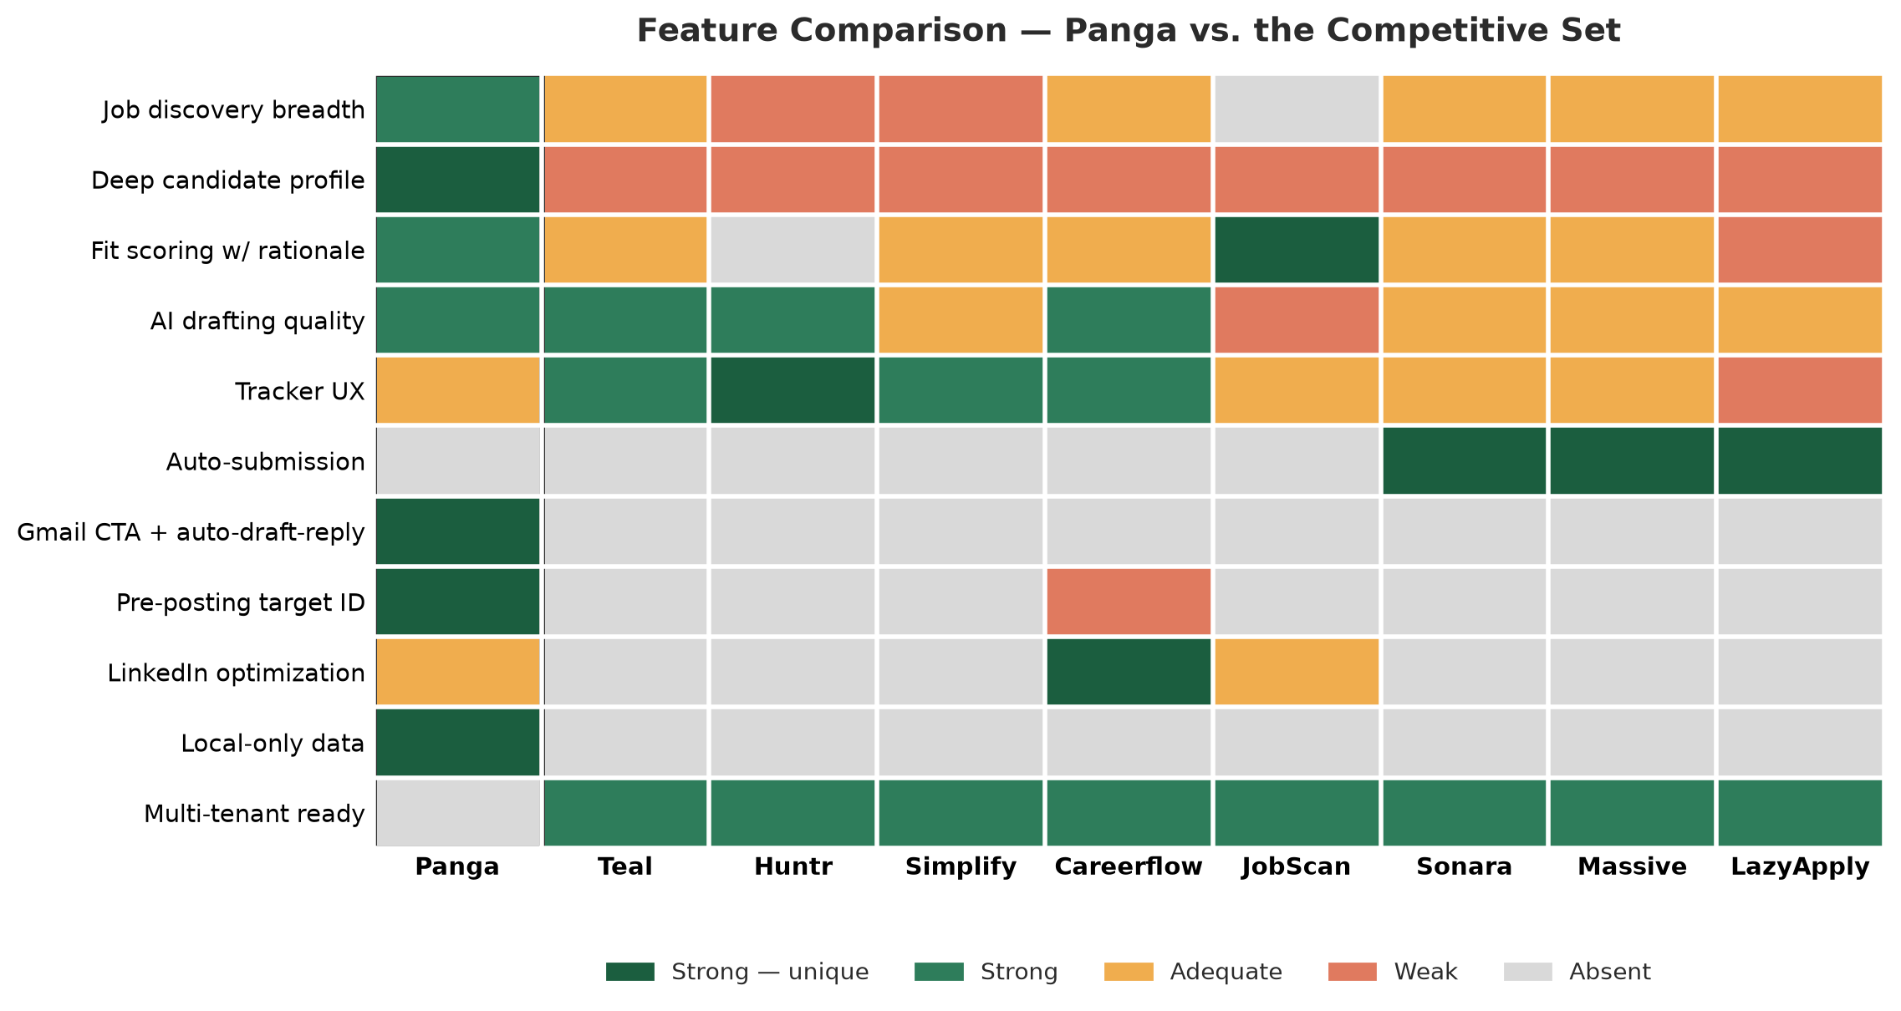
Panga is strongest exactly where none of these competitors compete at all (see Section 4, “What's Genuinely Differentiated vs. What's Table Stakes”), and honestly weaker or merely adequate on the polished, table-stakes parts of the category (tracker UX, keyword-level ATS analysis) that Teal, Huntr, and JobScan have spent years refining. That's not a weakness to hide — it's a scoping signal for what to build vs. what to deliberately not compete on (see Section 8, “Opportunities & Threats,” and the roadmap immediately below).
Sources and research method for every claim in this table: Appendix A.

4. Differentiated vs. Table Stakes
Table stakes — competitors already do this adequately-to-well; don't over-invest here before v1 sells:
- AI resume/cover-letter drafting generally — Teal, Careerflow, Massive all produce adequate-to-strong output.
- Application tracking as a status board — Teal and Huntr are both more polished than Panga's dossier-file approach.
- Keyword/ATS match analysis — JobScan is the category leader; Panga's self-assessed LLM score is a reasonable proxy but unvalidated against a real ATS parser.
- LinkedIn profile suggestions — Careerflow's dedicated, polished flow is stronger than Panga's manual-PDF-upload version.
Genuinely differentiated — real, currently unmatched in this competitive set:
- Prospector's pre-posting proactive targeting. Nothing reviewed does this — executive-search-firm behavior (find the company before the req exists) implemented in software. Currently pharma-only.
- Gap-probing master-profile interview. Closer to what a human resume writer does than any competitor's “upload and parse” flow — also what enables the drafting output's exact-fact-fidelity discipline.
- Gmail CTA detection + auto-draft-reply loop. Closes the loop end-to-end inside the candidate's own inbox; no competitor reviewed touches post-application communication at all.
- Deliberate non-submission as a designed trust/compliance feature, not just an absent one — real specifically against the auto-apply category.
- Local-only data model — still real, still checkable against security/crypto_store.py, still unclaimed by any competitor in this set.

4a. Rating-Improvement Roadmap
The table below turns the ratings in Section 3 into a build roadmap: which specific ratings are being targeted for improvement, and roughly what has to get built to earn the higher rating. Written to hand off directly as backlog scope, not as aspiration.
Capability | Current → Target | What needs to be built
Application tracker UX | Adequate → Strong | A real visual status board (Kanban-style, matching Huntr/Teal's pattern) as an additional view over the existing applications.py data — status columns, one-click stage changes, at-a-glance filtering/sorting. The underlying data model doesn't need to change; this is a UI-layer addition, not a rearchitecture.
LinkedIn profile optimization | Adequate → Strong | Close the polish gap with Careerflow without abandoning the deliberate no-scraping/no-login ToS-safety stance: a more guided intake flow (auto-detection of a re-exported PDF so re-analysis is one click), and a persistent before/after view so accepted suggestions are visibly tracked over time.
Multi-tenant readiness | Absent → Adequate (the realistic v1 bar; Strong comes later) | The single largest item on this roadmap, already scoped in Section 9 and PRD §13: replace the MCP-connector dependency for Gmail with a direct API integration, finish and test licensing/billing, and validate the fresh-install/onboarding path with someone who isn't Zahir. Don't jump straight to matching mature SaaS incumbents' polish — honestly-scoped Adequate is the right first target.
ATS self-score credibility | Strong (self-assessed) → Strong (independently validated) | A credibility upgrade, not a rating-tier change: benchmark Panga's self-assessed ATS score against a real third-party ATS-parsing signal on a sample of real resumes, and disclose the correlation. Removes the one caveat sales conversations currently have to hedge.

4b. Overall Competitive Score & Improvement Target
Zahir asked for a quantified overall score and a concrete 30% improvement target. Both are worked through below — methodology fully disclosed, honest answer given plainly rather than padded to hit a number, per the standard the rest of this brief holds itself to (Section 11, Appendix A).
Methodology: each of Section 3's 11 capability rows is scored for Panga only, on a 0–4 scale — Absent=0, Weak=1, Adequate=2, Strong=3, Strong—unique=4 — and summed to a single number. A simple convention built for this brief, not an industry-standard scoring system; its value is tracking whether Panga's own score moves over time, not a precise cross-product ranking.
Baseline, 2026-08-01
29 out of a possible 44 (65.9%) — or 29 out of 40 (72.5%) with the “Auto-submission” row excluded from the denominator (rationale below). This baseline reflects a labeling correction: Section 3's matrix originally left “Deep candidate profile” as plain “Strong” (3) rather than “Strong — unique” (4), inconsistent with the other three rows bolded “unique” for the identical condition (no competitor rated above Weak). Fixed here — the baseline moves from 28 to 29, a consistency fix, not new work.
# | Capability | Score | Note
1 | Job discovery breadth | 3 | Real headroom may exist — see below — but isn't earned yet
2 | Deep candidate profile | 4 | Maxed (corrected label, see Section 3)
3 | Fit scoring with rationale | 3 | Cannot honestly move to 4 today — see below
4 | AI drafting quality | 3 | Teal/Huntr/Careerflow also rated Strong — no headroom without new capability
5 | Application tracker UX | 2 | Scoped to 3 in Section 4a above
6 | Auto-submission | 0 | Excluded by design principle — see below
7 | Gmail CTA loop | 4 | Maxed
8 | Pre-posting targeting | 4 | Maxed
9 | LinkedIn optimization | 2 | Scoped to 3 in Section 4a above
10 | Local-only data model | 4 | Maxed
11 | Multi-tenant readiness | 0 | Scoped to 2 (Adequate) in Section 4a above
 | Total | 29 / 44
Why “Auto-submission” is excluded from any improvement target, and reported both ways above: Panga scores 0 there by deliberate design, not capability gap — it's the differentiator this entire brief argues for (Sections 2, 4, 6), not something to fix. Counting it in an “improvement” target would mean literally building the mass-auto-submission behavior this brief argues against.
A 30% increase on the 29-point baseline means a target of ~38 (+9 points). Here is the honest accounting of where that could come from:
- Already scoped in Section 4a, reliable: +4 total — tracker UX 2→3 (+1), LinkedIn 2→3 (+1), multi-tenant 0→2 (+2).
- Genuinely maxed — rows 2, 7, 8, 10 (deep profile, Gmail loop, pre-posting targeting, local data) — no further points available at any investment level. Real strength, not a scoring dead end to route around.
- Plausible but not yet scoped, medium confidence: +1 — job discovery breadth (3→4) would need a genuinely new sourcing capability nothing in this competitive set matches, likely riding on the multi-vertical-generalization work already 80% built (PRD §13). A real candidate for Backlog to size, not a confirmed win.
- Cannot honestly be counted on: fit scoring (3→4). JobScan is explicitly rated Strong — “best-in-class keyword granularity” — on this exact row today. A real competitor already matches Panga's rating here, so claiming “unique” isn't available without either a materially new capability or overclaiming against a competitor that already matches it. Excluded from the math.
Honest ceiling: +5 (29→34, a ~17% increase) — not +9 (~30%)
Four of Panga's eleven scored dimensions are already at the maximum regardless of further investment, one is excluded on principle, and one (fit scoring) can't credibly move without either genuinely new capability or overclaiming against a competitor that already matches it. That leaves real headroom in only two rows — one already scoped, one plausible but unsized.
Zahir's real choice here, not a number forced to fit the ask:
- Accept ~17–20% (29→34–35) as the honest near-term target — built from Section 4a's already-scoped items plus sizing the discovery-breadth candidate — and revisit the ceiling once Prospector's vertical expansion (a separate, larger initiative, PRD §13) opens genuinely new headroom.
- Treat 30% as real, but on a longer horizon than the current backlog covers — reaching it credibly would most plausibly require new capability adjacent to an already-maxed row, or the vertical-expansion work substantially broadening what “discovery breadth” and “pre-posting targeting” can honestly claim credit for.
- Redefine the metric to separate capability quality (this matrix, honestly near its ceiling) from market/vertical coverage (a new axis — e.g. a 12th row scoring how many verticals Prospector's signal stack actually serves, low today by definition, with real room to grow). The one path that adds genuinely new, non-padded headroom — but it changes what's being scored, so it should be a deliberate choice, not a way to relabel the same 30% ask into something that arithmetically works.
This brief recommends option 1 or 3 over option 2 — forcing 30% out of the current 11-dimension quality matrix isn't honestly available without inventing capability or overclaiming against a real competitor, and this brief's credibility with an investor audience (Section 11, Appendix A) depends on not doing that.

5. Pricing Comparison
Product | Free tier? | Entry price | Top price | Model
Teal HQ | Yes | $13/wk or $29/mo | $79/3mo | SaaS subscription
Huntr.co | Yes | $0 | $40/mo | SaaS subscription
Simplify.jobs | Yes (core free forever) | $19.99/wk or $39.99/mo | $89.99/3mo | SaaS subscription
Careerflow.ai | Yes | $23.99/mo ($14.41 annual) | $44.99/mo | SaaS subscription
JobScan | Yes (5 scans/mo) | $49.95/mo ($14.95 annual) | $89.95/3mo | SaaS subscription
Sonara | Trial only | $23.95/4wk (≈$314/yr) | — | Auto-renewing trial, refund complaints
Massive | No | $99/mo (200 jobs/mo) | — | SaaS subscription
LazyApply | No | $99/yr | $999/yr (1,500/day) | Annual SaaS license
Human executive coaching | No | $1,750–$2,000/mo, or $220–550/hr | $3,000–15,000+ engagement | Service, not software
Panga (proposed, placeholder) | TBD | $200/year — unvalidated | — | License, no per-user hosting cost
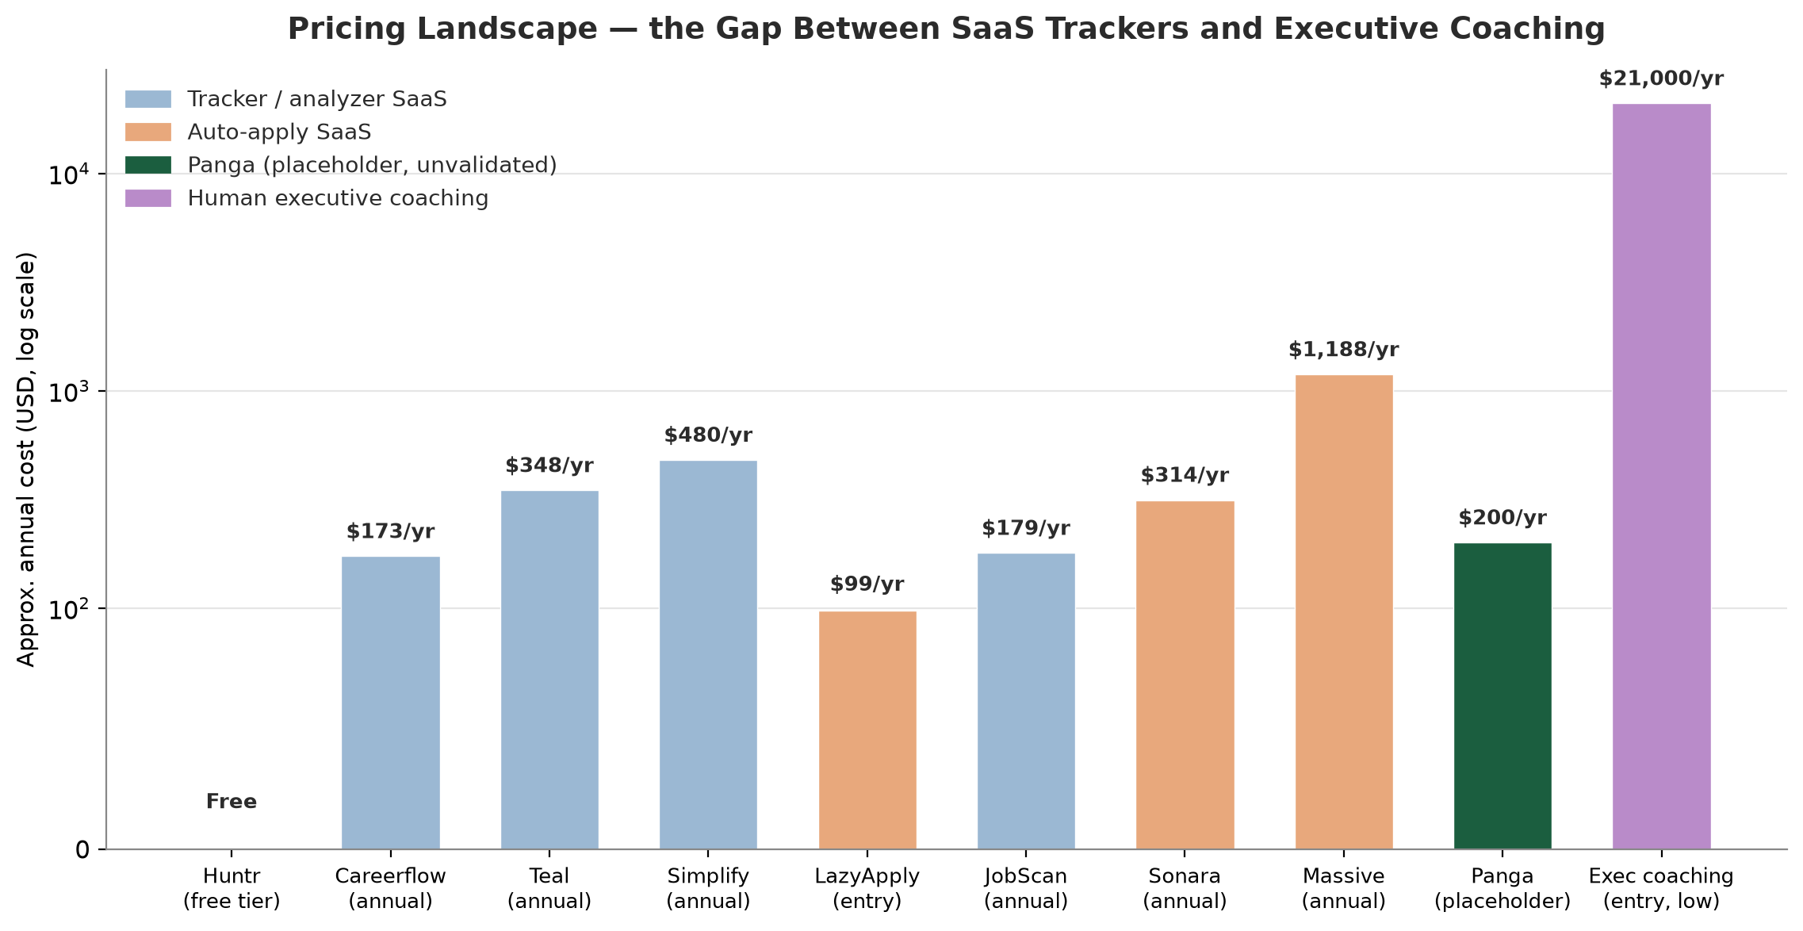
The pricing white space
Every SaaS tool above tops out around $40–100/month ($480–1,200/year). Executive coaching starts an order of magnitude higher. A $200–500/year license sits in a gap nothing in this comparison set occupies — but that only holds if the product can actually deliver something closer to the coaching experience than to Teal's. That's a product-scope question, not just a pricing one (see Section 9, “Minimum Work to Get From Current Build to Sellable”).
Sources: Appendix A.

6. Testing the Hypothesis
“Compliant job-search co-pilot for senior/executive candidates” — what would have to be true for this to be a real position, not just a nice narrative?
# | Claim | Status | Why
1 | Executives need something the SaaS tracker category doesn't offer. | Supported | None of Teal/Huntr/Simplify/Careerflow/JobScan do proactive company targeting, deep profile-building, or end-to-end communication tracking — all reactive tools built around “help me apply faster.”
2 | Auto-apply tools are actively wrong for this segment. | Supported | Mass-submitting is reputationally risky for senior candidates — recruiters know each other, ATS/bot-detection flags are a real liability, volume-over-fit is the opposite of executive placement.
3 | Executives will pay software prices for something coaching-adjacent. | Untested — next up | Nobody has asked a real senior candidate whether they'd pay $200–500/year for this instead of $2,000+/month for a coach, or instead of Teal's free tier. Flagged as the first, $0-cost item in the roadmap (Section 9) — not assumed, not a doubt, a next action.
4 | The product currently supports this positioning without pharma-specific caveats. | Not yet true — sequenced | Prospector — the strongest evidence for the hypothesis — is life-sciences-only today. Needs either signal-source generalization (partially underway, PRD's multi-vertical branch) or a narrower, truthful “life-sciences leaders” go-to-market at launch.
Verdict on the hypothesis
Genuinely promising and better-supported than a generic “AI job search tool” positioning would be — points 1 and 2 are real, structural advantages nothing in this competitive set shares. Points 3 and 4 aren't doubts, they're the next two items of work: validate willingness-to-pay with real conversations, and decide the vertical-scope question for launch. Both are named, scoped, and sequenced in Section 9 — this is the leading hypothesis to execute against, not a settled positioning that needs no further work.

7. Strengths & Weaknesses of the Competitive Set
Product | Genuine strength | Real weakness
Teal | Best free plan in the category; strong JD-match scoring | No auto-apply, no proactive discovery — purely reactive
Huntr | Cleanest tracker UX | Weak on discovery and AI depth; $40/mo is pricey for a Kanban board
Simplify | Free tier is genuinely free and widely installed | “Not true auto-apply despite AI Agent marketing” is the top user complaint
Careerflow | Best LinkedIn optimizer in the category | Resume/tracker features are merely adequate, not differentiated
JobScan | Best-in-class keyword/match-rate granularity | Analyzer only — doesn't write anything for you
Sonara | Cheap, low setup effort, real volume | Refund/auto-renew complaints; volume-over-fit is a poor fit for senior roles
Massive | Shows the draft before submitting — more transparent than peers | $99/mo for 200 applications is expensive per-unit; 23-step onboarding flagged as friction
LazyApply | Cheapest per-application by far | Doesn't reach Workday/Greenhouse/Lever/Ashby, where the real jobs live
Sources: Appendix A.

8. Opportunities & Threats
Opportunities
- The executive/senior positioning (Section 6, “Testing the Hypothesis”) is unclaimed and structurally supported by Prospector + the gap-probing profile.
- The $200–1,200/year pricing gap between SaaS trackers and human coaching (Section 5, “Pricing Comparison”) is real and unoccupied.
- Auto-apply backlash (refund complaints, ATS/bot-detection risk, “spammy” framing) makes “we deliberately never submit for you” a credible, differentiated claim.
- The Gmail CTA + auto-draft-reply loop is a genuinely novel capability nobody in this set has — worth leading with in a live demo.
Threats
- The single-tenant gap is the real threat, not competitors — every company in this comparison already solved multi-tenant delivery; Panga hasn't started.
- MCP-connector dependency for Gmail/LinkedIn/job boards means the product currently can't run without a live Claude Code session — a harder blocker than pricing or positioning.
- Vertical-lock on Prospector limits day-one addressable market to life-sciences/pharma unless the signal-sourcing stack is generalized.
- JobScan's keyword-analysis depth and Teal/Huntr's tracker polish are genuine strengths — competing feature-for-feature loses on their home turf.

9. Minimum Work to Get From Current Build to Sellable
Grounded in what's already scoped in PRD §13 — a synthesis of decisions already made, not a new estimate. This table is also the execution roadmap referenced from the Verdict (Section 11) — the sequence below is what “yes, and here's exactly what's next” means in practice.
Gap | Current state | Why it's a hard blocker
MCP-connector dependency (Gmail especially) | Native packaging done, but Gmail/job-board access still assumes a live Claude Code session | A packaged .exe a stranger installs cannot carry your Claude Code session with it — the single largest gap between “works for Zahir” and “works for a customer.”
Licensing/subscription/billing | Designed, not built | No product to sell without it — Stripe integration, device binding, trial tracking all still to build.
Multi-tenant-ready onboarding | Multi-vertical generalization ~80% built; fresh-install path manually verified | Real progress here — the harder remaining piece is Prospector's vertical-specific signal stack, not onboarding.
Prospector's signal sources | Life-sciences-only by design, deferred until other-vertical customers exist | This is the strongest differentiator (Section 4) — selling outside life-sciences without it means a materially weaker product.
Gmail OAuth for non-technical customers | Per-customer Google Cloud project required today | A real barrier for a non-technical buyer — scoped, with a real cost (Google CASA assessment), deprioritized until volume justifies it.
ToS / EULA / Privacy Policy | Not drafted | Hard requirement before any paid transaction.
Realistic cost evaluator | Not started | The $200/year price is an unvalidated placeholder — needed before quoting any real prospect.
Market validation of the executive hypothesis | Not started | Everything about willingness-to-pay is inference from adjacent pricing, not a real conversation with a real senior candidate.
Sequencing recommendation
The PRD's own prioritization note already sequences $0-cost items first — the right instinct to keep. Add market validation (a handful of real conversations with senior candidates about the executive positioning) to that same do-first bucket — it's the one gap not already tracked anywhere, and it directly determines whether the rest of this build-out is aimed at the right customer.

10. Sales Battlecard
For use once sellable — objection handling and positioning language, pressure-tested against this brief's findings.
vs. Teal / Huntr / Careerflow / JobScan:
“Those are trackers and analyzers — they help you organize and score jobs you already found. Panga finds the company before the job is even posted, builds a real profile of you through actual conversation instead of a resume upload, and follows the whole loop through to the offer email landing in your Gmail. If you just want a Kanban board, they're great and cheaper. If you want something doing the finding and thinking, not just the tracking, that's the gap.”
vs. Sonara / Massive / LazyApply:
“Those tools apply to 50–1,500 jobs a week for you, automatically. At a senior level, that's a real professional risk — recruiters talk, ATS bot-detection is real, and volume is the opposite of how executive roles actually get filled. Panga deliberately never submits anything without you reviewing it — that's not a missing feature, it's the point.”
“Why not just use a career coach?”
“A coach costs $2,000–15,000. Panga does the parts of that job software can actually do well — finding companies before they post, building your real profile, drafting tailored materials, tracking every offer/rejection email — for a fraction of that, every year, not per engagement. It's not a replacement for judgment or relationships, it's the research and drafting layer underneath them.”
“Is my data safe with an AI tool?”
Panga's own servers never see resume/profile/application data, only license/billing info; AI drafting goes directly from the user's machine to Anthropic via the user's own account. (See PRD §13's “Privacy/trust model” row for the full resolved claim.)
“This only really works for pharma/life-sciences right now”
Honest answer, don't dodge it: true today for Prospector's proactive-targeting signals specifically — everything else (drafting, tracking, sourcing, Gmail loop) works across industries. If the prospect isn't in life-sciences, be upfront they'd be buying the weaker version of the product until that gap closes.

11. Verdict
Yes.
There is a real, differentiated, sellable product here — not a hedge, a conviction. Panga is not competing as “another AI resume tool,” where it would be honestly mid-pack against Teal/Careerflow's polish and JobScan's analytical depth. It's competing as something closer to software-assisted executive search and application management — a category none of the eight competitors reviewed occupy, priced in a real, unclaimed gap between $40/month trackers and $2,000+/month human coaches. That position is earned by capability that is already built and working today, not a roadmap promise: Prospector's pre-posting target-account identification, the gap-probing master-profile interview, and the Gmail-to-offer closed loop have no equivalent anywhere in this competitive set.
Likely target customer:
Senior/executive candidates, in life-sciences specifically at launch (where Prospector actually works), who are currently either doing this manually or paying $1,750–15,000 for human coaching, and who would be actively poorly served — not just unserved — by the auto-apply category's mass-submission model. This is a deliberately smaller initial market than “everyone job-hunting,” and that's the right call, not a limitation: it's the market where Panga's real, differentiated strengths are exactly what the buyer needs, rather than a market where it fights better-resourced tracker/analyzer incumbents on their own turf.
What's genuinely differentiated vs. table stakes:
Table stakes are resume/cover-letter drafting and application tracking — competitors already do these adequately, so Panga shouldn't over-invest there before it sells (concrete improvement targets for the “Adequate” ones are scoped in Section 4a). The real, defensible differentiation — Prospector, the master-profile interview depth, and the Gmail closed loop — is what the pitch should lead with, because it's the one thing on this entire feature matrix competitors cannot fast-follow their way into; it's built on data and workflow relationships (job-posting signals, inbox integration, structured interview depth) that aren't a quick engineering sprint for an incumbent tracker to bolt on.
What happens between here and revenue is execution, not validation of the opportunity
The gaps are real, and naming them plainly is what makes this brief credible in diligence rather than something that unravels under a VC's first hard question: the MCP-connector dependency for Gmail/job boards, licensing/billing not yet built, Prospector's vertical lock, and unvalidated willingness-to-pay for the executive positioning. None of these are open questions about whether the opportunity is real — they're a sequenced build list, laid out in full in Section 9, starting with the two items that cost nothing but time: talk to real senior candidates, and decide the vertical-scope question for launch. The product doesn't need to be reinvented to be sellable. It needs exactly the work Section 9 already lists, in roughly the order it's listed.

Appendix A: Sources & Evidence
Research method: live web search conducted 2026-08-01, the same day this brief was built. Each competitor was researched via a targeted search query; the search tool returns synthesized findings drawn from the top-ranking results for that query, which the pricing/feature claims in Sections 3, 5, and 7 are based on. Disclosed plainly because it matters for how much to trust the precision of any single figure below.
Honest limitation, flagged rather than hidden
For 7 of the 8 competitors, the source set is dominated by third-party review/comparison sites rather than the vendor's own pricing page. Huntr.co is the one exception — huntr.co/pricing appeared directly and was cross-checked against help.huntr.co's plan-details article. For every other competitor, treat the pricing figures in Section 5 as well-sourced but not primary-source-verified — accurate to what multiple review sites reported as of early August 2026, but not confirmed against the vendor's own current pricing page. Recommendation before this brief is used in an actual investor conversation: re-verify each competitor's current pricing directly against their own pricing page — third-party review sites can lag real pricing changes by weeks, and this category ships pricing changes often.

Competitor | Query used | Representative sources
Teal HQ | “Teal HQ pricing features resume builder job tracker 2026” | blog.loopcv.pro/teal-hq-review; stylingcv.com/blog/tealhq-review-2026; resumehog.com/blog/posts/teal-hq-review-2026
Huntr.co | “Huntr.co pricing features job application tracker 2026” | huntr.co/pricing (vendor); help.huntr.co plan-details article (vendor); tekpon.com/software/huntr/reviews
Simplify.jobs | “Simplify.jobs pricing features AI job application autofill 2026” | resumly.ai/answers/simplify-jobs-review; jobhire.ai/blog/simplify-jobs-review; jobsolv.com/directory/simplify-jobs
Careerflow.ai | “Careerflow.ai pricing features job tracker resume 2026” | jobright.ai/blog/careerflow-review-2026; capterra.com/p/10015230/Careerflow-ai; resumehog.com/blog/posts/careerflow-review-2026
JobScan | “JobScan pricing features ATS resume optimizer 2026” | resumehog.com/blog/posts/jobscan-review-2026; atsresumeai.com/compare/jobscan-review; onlineatschecker.com/blog/jobscan-pricing-2026
Sonara | “Sonara AI job search auto apply pricing features 2026” | blog.fastapply.co/sonara-pricing-2026; spotsaas.com/product/sonara; usesprout.com/blog/sonara-ai-review-pricing-alternatives
Massive | “Massive AI job application autopilot pricing 2026” | sprad.io/blog/top-5-jobcopilot-alternatives; jobcopilot.com/use-massive-review; jobgoround.com/7-best-ai-tools-that-auto-apply-to-jobs-in-2026
LazyApply | “LazyApply pricing features auto job application Chrome extension 2026” | f6s.com/software/lazyapply; saasworthy.com/product/lazyapply; resumehog.com/blog/posts/lazyapply-review-2026
Human executive coaching pricing (Sections 5–6): Query “executive senior job search coaching service pricing career copilot 2026.” Sources: igotanoffer.com/en/advice/best-job-search-coaching-services; blog.loopcv.pro/how-much-does-a-career-coach-cost; wearecareer.com/blogs/news/executive-career-coaching-services; headgloballlc.com/store/career-coaching-executive; wilbanksconsulting.com/buy-services/executive-job-search-strategy. The specific figures cited came from named firms' own listed pricing within these results, not third-party estimates — more directly sourced than the SaaS-competitor pricing above.
Feature/positioning claims (Sections 2, 3, 4, 7): e.g. “Simplify's top complaint is autofill-not-auto-apply,” “LazyApply doesn't reach Workday/Greenhouse/Lever/Ashby,” “Massive's onboarding is 23 steps,” “Sonara has refund/auto-renew complaints” — drawn from the same search results above, specifically review-site commentary, not from this session directly testing each product. Flagged, not smoothed over: none of these products were hands-on tested for this brief; every qualitative claim is secondhand from review sites — a reasonable basis for a competitive-positioning brief, but a materially weaker evidence bar than direct product testing. If this brief is used where that distinction matters (e.g. a VC asking “did you actually try these”), the honest answer is no — this was desk research, not hands-on evaluation.
Panga's own feature claims (Section 1, and the “Panga” column throughout Sections 3–4): sourced differently and more directly: read from Panga's actual codebase and PRD (docs/job-search-automation-prd.md, docs/licensing-scope.md, security/crypto_store.py, and the module files cited in Section 1's table) rather than from web search — first-party and verifiable by opening the referenced files directly, not subject to the caveats above.

Source: Panga/docs/competitive-brief.md · Prepared by the “Mirror” competitive-analysis session using the product-management:competitive-brief skill.

