Lab 3  
Muhammad Zohaib  
125546  
1  
  
install.packages(“ggplot2”) //Installing library   
attach(mtcars) // Accessing all columns

plot(hp, mpg, main = "Horsepower vs Mileage", xlab = "Horsepower", ylab = "Mileage",

pch = 15, col = "green") //Plotting graph

text(hp, mpg, row.names(mtcars), cex = 0.6, pos = 4, col = "blue")// Displaying car names  
  
  
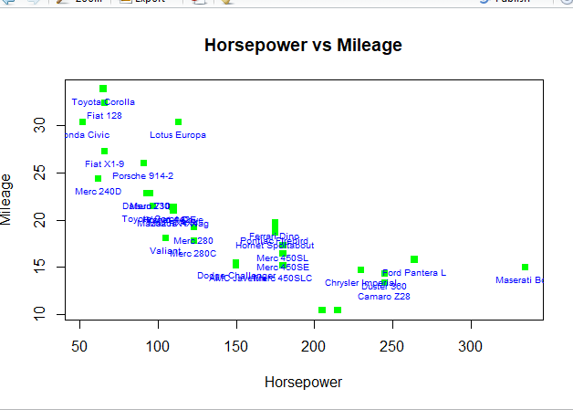  
  
  
  
  
  
2  
  
  
attach(mtcars)

plot(disp, wt, main = "Displacement VS Weight", xlab = "Displacemnt", ylab = "Weight",

pch = 15, col = "red")

text(disp, wt, row.names(mtcars), cex = 0.6, pos = 4, col = "blue")  
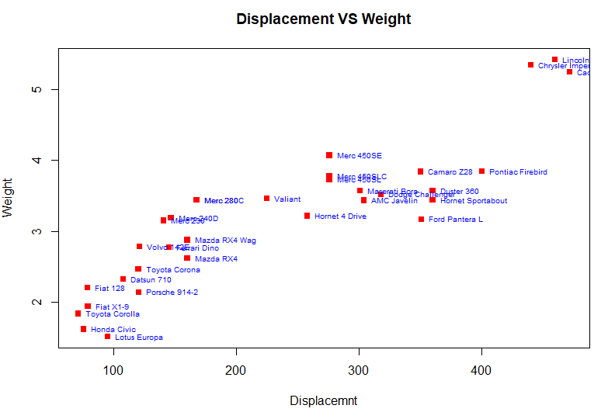  
  
3  
attach(mtcars)

plot(qsec, gear, main = "Quatersecond VS Gears", xlab = "Displacemnt", ylab = "Weight",

pch = 15, col = "blue")

text(qsec, gear, row.names(mtcars), cex = 0.6, pos = 4, col = "blue")  
