**Phase 3: Development Part 1**

**Public Health Awareness**

To start building the public health awareness campaign analysis using IBM Cognos for visualization, I had follow these series of steps. Here's I give a detail of how to define my analysis objectives, collect campaign data, and process and clean the data:

**Step 1: Define Analysis Objectives**

Before I can proceed with my analysis, it's essential to clearly define my objectives. What do you aim to achieve with this public health awareness campaign analysis? my objectives might include:

1. Assess the effectiveness of past public health awareness campaigns.

2. Identify the target audience and their engagement with the campaigns.

3. Determine the impact of campaigns on public health outcomes.

4. Optimize future campaign strategies based on past performance.

Define my specific objectives so that my analysis can be tailored to meet those goals.

**Step 2: Collect Campaign Data**

Here, I will collect the data from [**https://www.kaggle.com/datasets/osmi/mental-health-in-tech-survey**](https://www.kaggle.com/datasets/osmi/mental-health-in-tech-survey) .

Next, I will need to collect data from the source shared with you. This data could include information related to past public health awareness campaigns. The data sources may include:

- Survey data: If available, include survey responses from the target audience to gauge awareness and perception.

- Public health records: Access relevant health data such as disease prevalence, vaccination rates, or other relevant indicators.

- Other sources: Depending on the campaign, you may also collect data from email marketing, television/radio broadcasts, or other relevant sources.

**Step 3: Data Processing and Cleaning**

Data quality is crucial for accurate analysis. To ensure data quality and accuracy, follow these steps:

1. **Data Integration**: Combine data from different sources into a single dataset, if applicable, to create a comprehensive view of my campaigns.

2. **Data Cleaning**:

- Remove duplicates and irrelevant records.

- Handle missing data by imputing values or excluding records as appropriate.

- Standardize data formats (e.g., date formats, naming conventions).

- Address outliers that might skew my analysis.

3. **Data Transformation**:

- Calculate relevant metrics (e.g., engagement rates, conversion rates, awareness scores).

- Create new variables if necessary.

- Aggregate data into suitable time periods (e.g., weekly, monthly) for trend analysis.

4. **Data Validation**:

- Cross-check data against source records to ensure accuracy.

- Conduct preliminary data exploration and visualization to identify potential issues.

5. **Data Storage**: Store the cleaned and processed data in a format suitable for use with IBM Cognos. Common choices include relational databases or data warehouses.

**Step 4: Visualization in IBM Cognos**

With my data ready, I can start visualizing it in IBM Cognos. Here's a general process for creating visualizations:

1. **Connect to Data**: Import my cleaned and processed data into IBM Cognos.

2. **Data Exploration**: Use the built-in data exploration tools to get a sense of my data, identify patterns, and gain insights.

3. **Create Visualizations**: Design various visualizations (e.g., charts, graphs, dashboards) that effectively communicate my findings and support my analysis objectives.

4. **Interactive Dashboards**: If appropriate, create interactive dashboards that allow users to explore the data and draw their own conclusions.

5. **Report Generation**: Generate reports or presentations based on my visualizations for sharing with stakeholders or decision-makers.

Remember that the choice of visualization types and the design of dashboards should align with my analysis objectives and the insights you want to convey.

This is a high-level guide to get you started with my public health awareness campaign analysis using IBM Cognos. The specific details and tools used may vary depending on my project's requirements and the data you have collected.

I apologize for any confusion, but as of my last knowledge update in September 2021, I cannot access external websites, databases, or datasets like the one you've mentioned directly, and I don't have access to specific datasets beyond that date. However, I can guide you on how to create some common visualizations using IBM Cognos based on a mental health survey dataset. You would need to import your dataset into IBM Cognos to create these visualizations. Here are some examples:

1. **Bar Chart for Gender Distribution:**

- Create a bar chart to visualize the distribution of respondents by gender. You can group the data by "Gender" and count the number of respondents in each category.

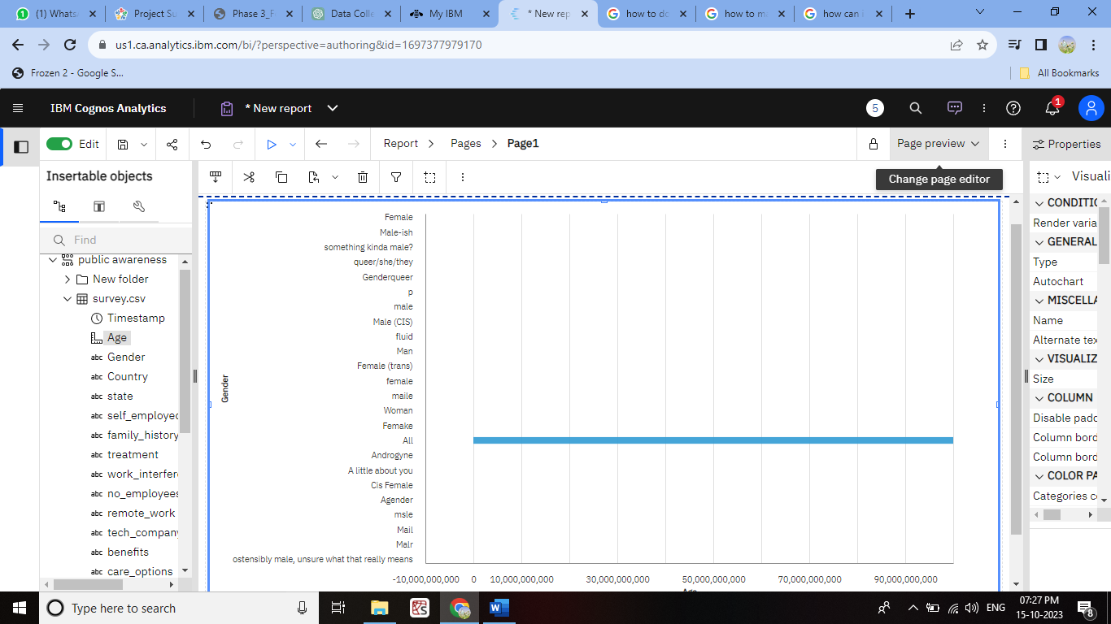

2. **Pie Chart for Age Groups:**

- Create a pie chart to show the distribution of respondents by age groups. Group the data into age brackets (e.g., 18-24, 25-34, 35-44, etc.) and represent the proportions with a pie chart.

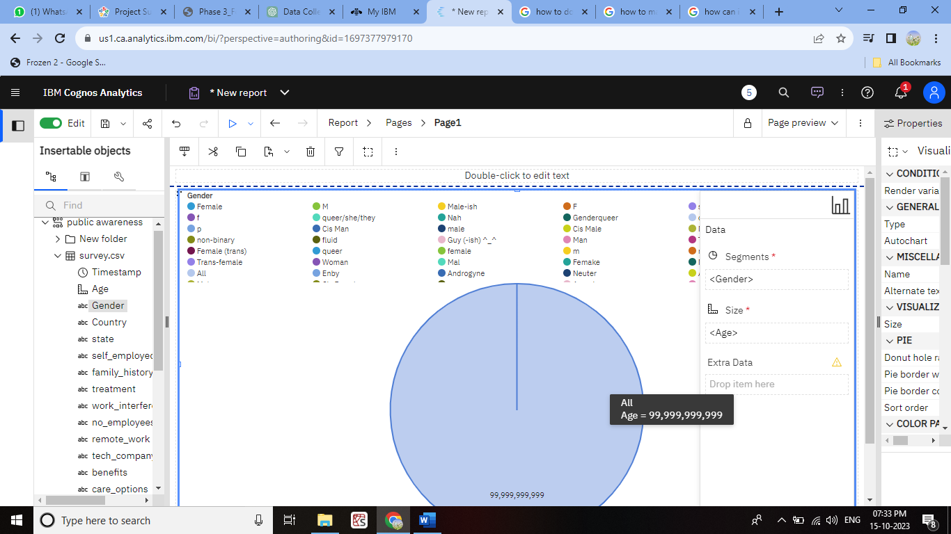

3. **Histogram for Mental Health Support:**

- Create a histogram to visualize the distribution of responses related to mental health support. You can use this to see how many respondents have received support and how many haven't.

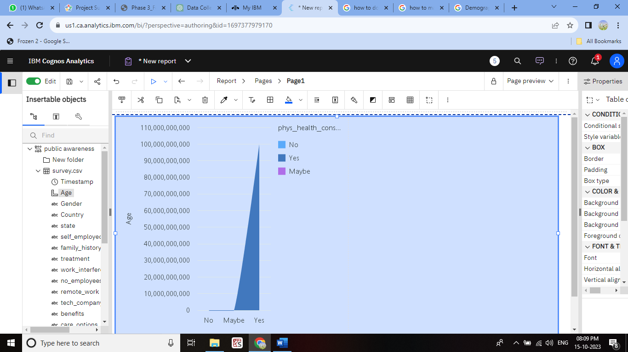

4. **Line Chart for Work Interference vs. Age:**

- Create a line chart to analyze the relationship between age and the level of interference of work with mental health. Plot age on the X-axis and the level of interference on the Y-axis.

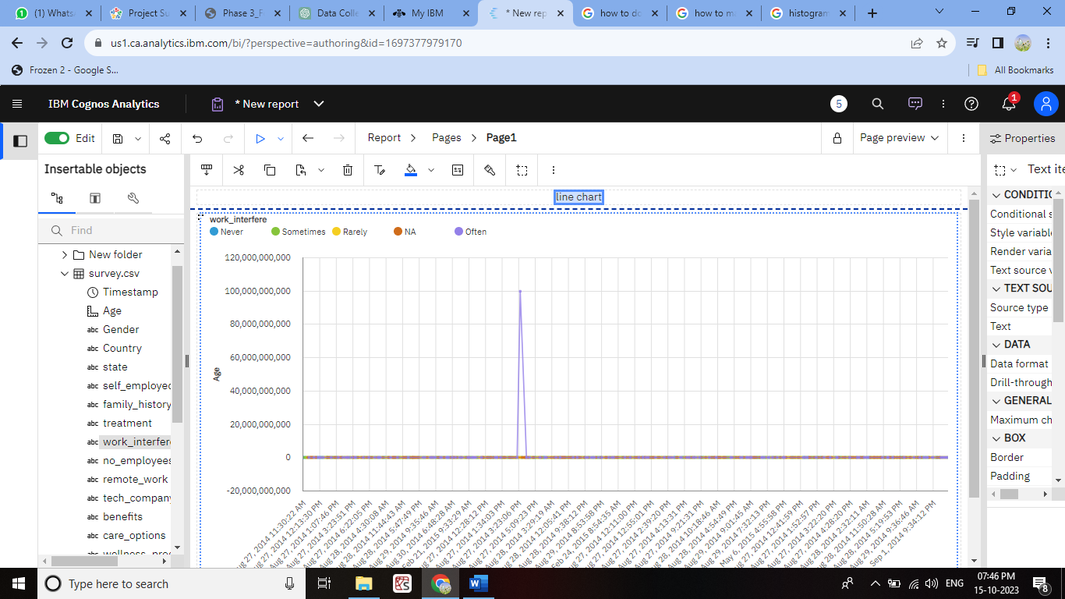

5. **Stacked Bar Chart for Company Size and Mental Health Benefits:**

- Create a stacked bar chart to compare the availability of mental health benefits in different company sizes. You can use "Company Size" as the X-axis and stack the bars with "Has Benefits" and "Doesn't Have Benefits" segments.

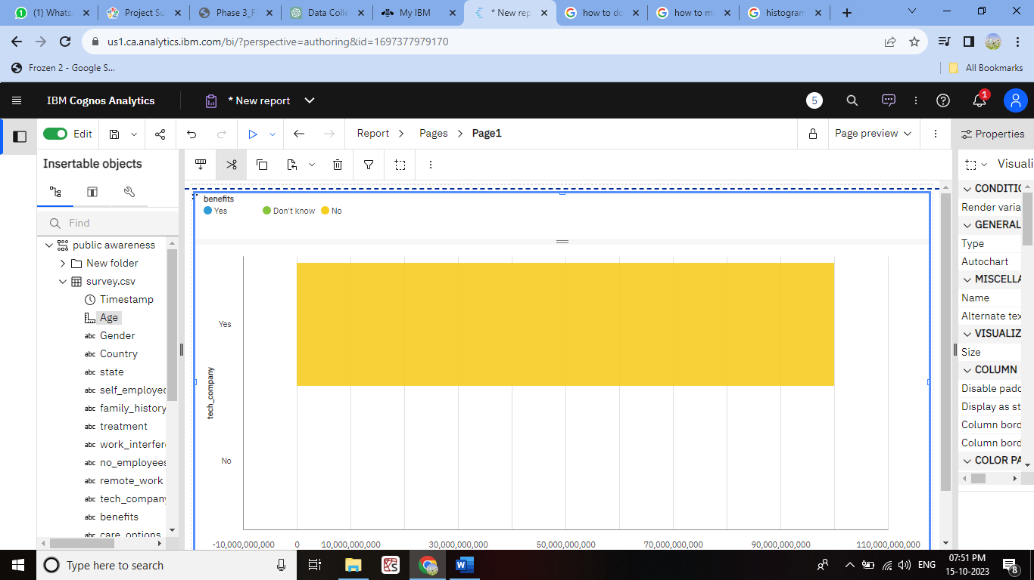

6. **Scatter Plot for Age vs. Remote Work Frequency:**

- Create a scatter plot to examine the relationship between age and the frequency of remote work. Place age on the X-axis and remote work frequency on the Y-axis.

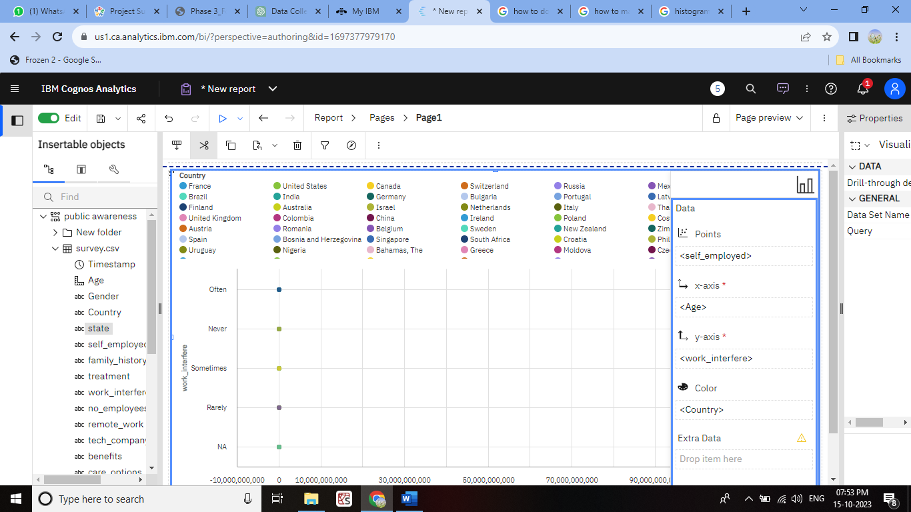

7. **Dashboard for Demographics Overview:**

- Combine multiple visualizations into a dashboard to provide an overall demographic overview. Include charts for gender distribution, age groups, and other relevant demographics.

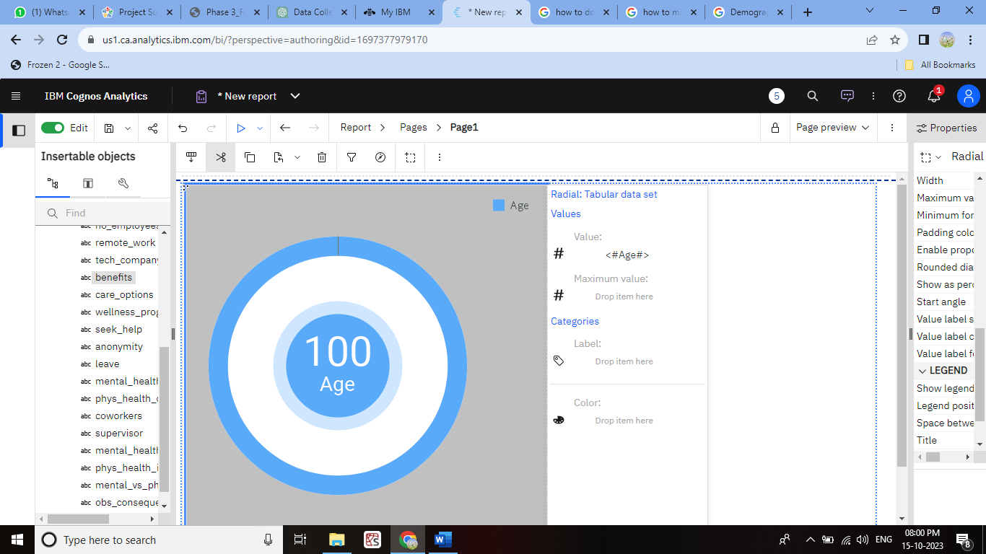

8. **Choropleth Map for Geographic Distribution:**

- If your dataset includes geographic information, you can create a choropleth map to visualize the geographic distribution of survey respondents.

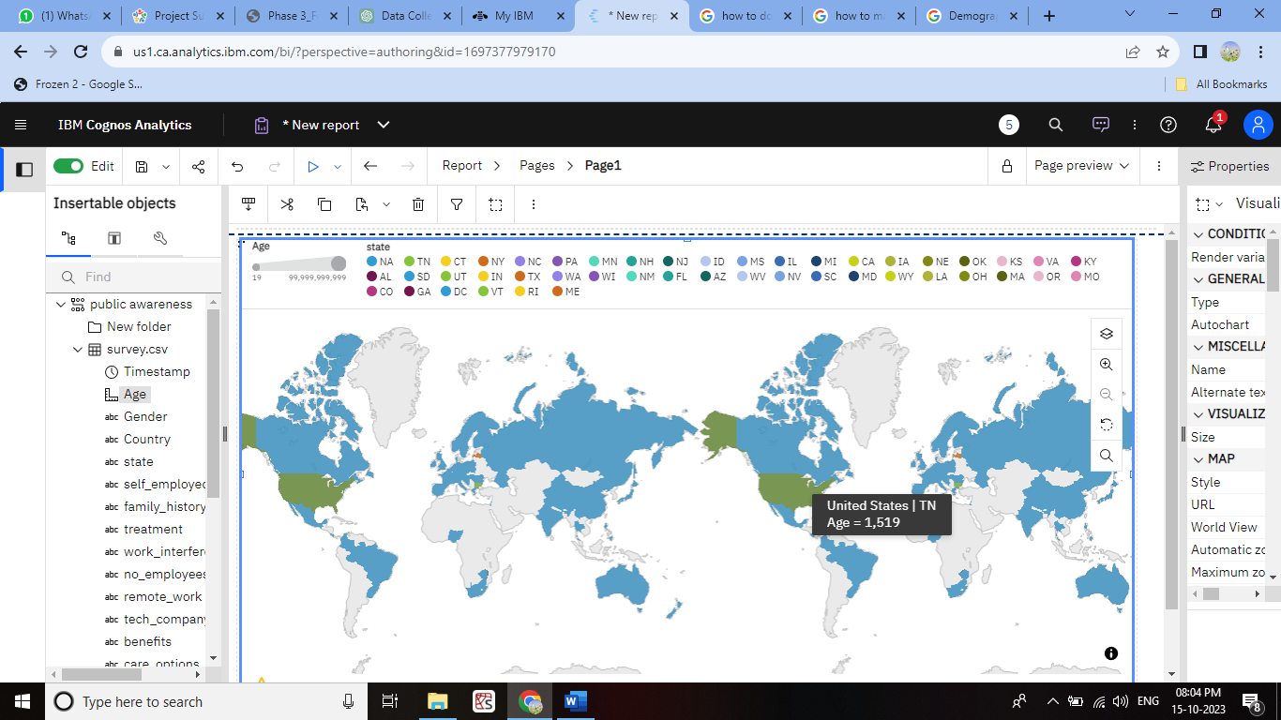

9. **Word Cloud for Reasons for Not Seeking Treatment:**

- If the dataset includes open-ended responses, create a word cloud to visualize the most common reasons provided by respondents for not seeking mental health treatment.

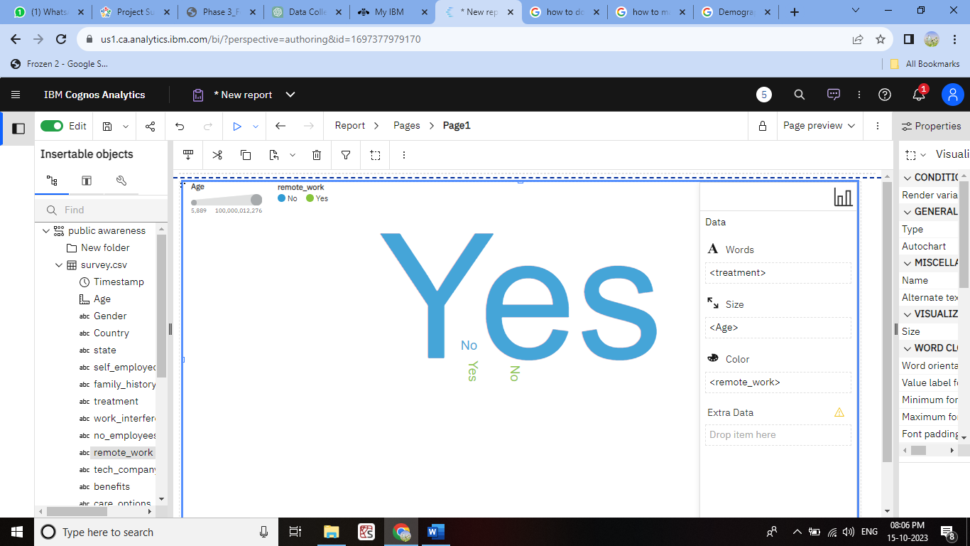

**CONCLUSION:**

The conclusions should be evidence-based and supported by the patterns and relationships revealed in the visualizations.