# PROJECT WORK NAME: HATSUN AGRO PRODUCTS LIMITED

Hatsun Agro Product Limited (HAP), established in 1970, is a prominent private-sector dairy company in India, headquartered in Chennai. The company offers a diverse range of dairy products, including milk, curd, ice creams, ghee, paneer, and dairy whitener, under well-known brands like Arun Icecreams, Arogya Milk, and Ibaco. HAP has also established a global footprint, exporting to over 42 countries, primarily in America, the Middle East, and South Asia.

# DIGITAL MARKETING STRATEGY OF HATSUN AGRO PRODUCTS LIMITED:



## Social Media Engagement:

HAP maintains an active presence on platforms such as Facebook, Instagram, and Twitter. The company utilizes these channels to share regular updates, high-quality visuals, and engaging content, including recipes and cooking tips, to connect with consumers on a personal level. This strategy not only keeps followers informed about new products and promotions but also fosters a strong relationship with the audience.

## Localized Marketing Initiatives:

To enhance brand recognition in new regions, HAP has implemented localized marketing tactics. In the fiscal year 2021-22, the company allocated approximately ₹150 crores towards branding and promotional activities tailored to regional tastes and customs. This approach includes leveraging local festivals to promote dairy products effectively, contributing to a 30% increase in brand engagement in targeted campaigns.

## E-Commerce Integration:

Recognizing the growing trend of online shopping, HAP has ventured into e-commerce by making its products available on platforms like BigBasket and Amaon. This move has resulted in a 25% growth in online sales during the last fiscal year, with a focus on metropolitan cities. The company aims to increase its online market share to 10% by 2025.

## Mobile Application Developed:

It has developed a mobile application available on Google Play, designed for authorized users to access information about the company’s brands and services. This app serves as a tool for better communication and service delivery to stakeholders.

## Influencer Collaborations:

The company has engaged in influencer marketing by associating with Indian actress Simran for the promotion of Arun Icecreams. This collaboration includes various brand promotions and television advertisements, aiming to enhance brand visibility and appeal.

## Search Engine Optimization (SEO):

HAP’s website has approximately 2,339 organic keywords, indicating a moderate SEO strategy. To improve online visibility and attract more organic traffic, the company could enhance its SEO efforts by targeting additional relevant keywords and optimizing website content.

## Recommendations for Enhancing Digital Marketing:

### Expand Social Media Presence:

While HAP has a presence on major social media platforms, increasing engagement through interactive content, user-generated content campaigns, and regular updates could further strengthen its digital footprint

### Content Marketing:

Developing a robust content marketing strategy, including blogs, videos, and infographics related to dairy products, health benefits, and recipes, can position HAP as an industry thought leader and attract a wider audience

### Email Marketing:

Implementing targeted email marketing campaigns to inform subscribers about new products, promotions, and company news can enhance customer retention and drive sales.

### Online Advertising:

Investing in online advertising, such as Google Ads and social media ads, can increase brand visibility and reach potential customers more effectively.

By adopting these strategies, Hatsun Agro Product Limited can further strengthen its digital marketing efforts, enhance brand recognition, and drive business growth in the competitive dairy industry.

## Advertisement Ad’s:

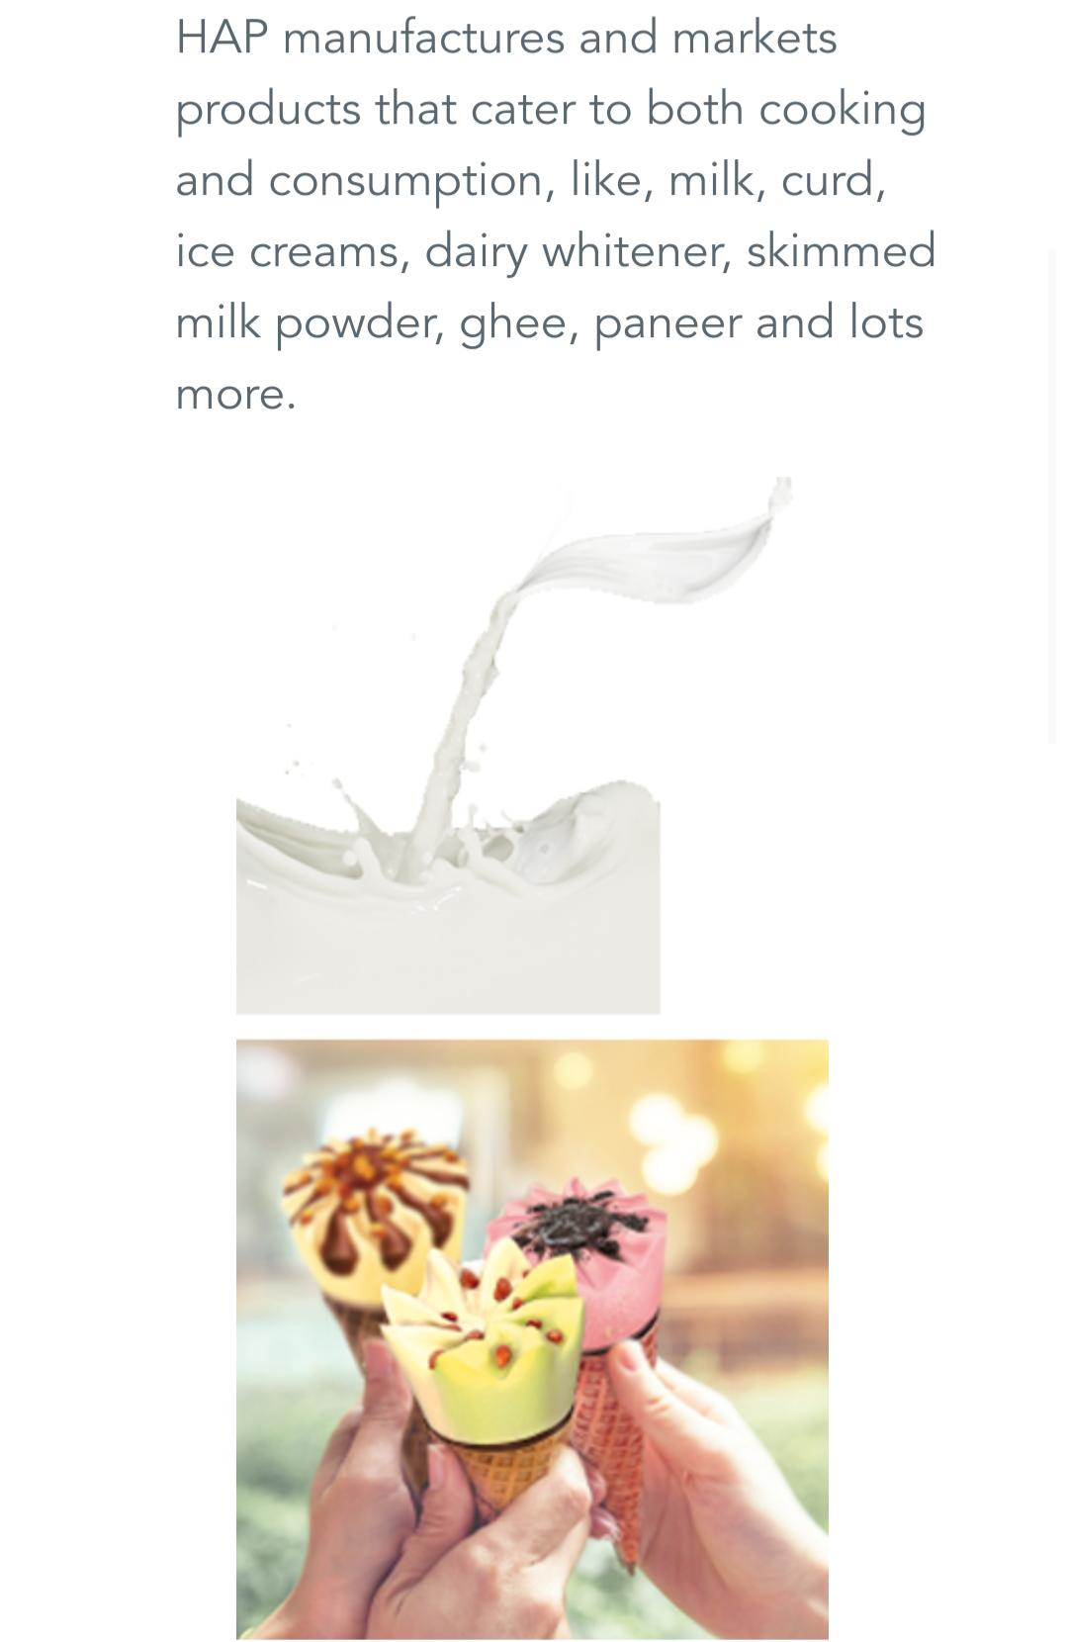

# BRAND STUDY, COMPETITOR ANALYSIS AND BUYERS /AUDIENCES PERSONA:

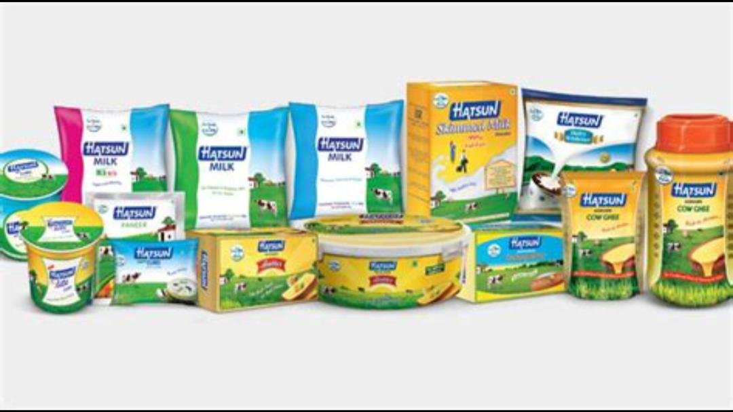

## Brand Study

Hatsun Agro Products Limited (HAP) is a leading dairy company in India, known for its strong presence in the dairy and ice cream segments. The company is recognized for its quality dairy products, strong distribution network, and innovative marketing strategies.

### Key Highlights of the Brand:

Founded: 1986

Headquarters: Chennai, Tamil Nadu, India

Major Brands: Arun Ice Creams, Arokya Milk, Hatsun Dairy Products, Ibaco, and Santosa

Market Position: One of the largest private-sector dairy companies in India

USP (Unique Selling Proposition): Focus on fresh, high-quality dairy products with strong farmer relationships

## Brand Perception & Strengths:

Quality & Freshness: Known for delivering fresh and hygienic dairy products.

Wide Product Range: Offers milk, curd, butter, ghee, paneer, ice creams, and milk-based beverages.

Strong Rural & Urban Presence: Extensive distribution network covering both rural and urban areas.

Farmer-Centric Approach: Works directly with farmers to ensure high-quality milk sourcing.

Innovation & Expansion: Continuous innovation in dairy processing and expansion into new markets.

## Competitor Analysis

Primary Competitors:

Hatsun Agro competes with major dairy companies in India, including:

Competitive Advantages of Hatsun Agro:

Strong South India dominance compared to national players like Amul and Mother Dairy.

Efficient supply chain with direct milk procurement from farmers, reducing dependency on intermediaries.

Brand Loyalty in its home market, particularly in Tamil Nadu, Karnataka, and Andhra Pradesh.

Expanding retail footprint with exclusive retail outlets for Arun Ice Cream and Hatsun Dairy.

## Challenges & Threats:

Intense competition from Amul, which is expanding aggressively in South India.

Price sensitivity in the dairy market, where competitors may offer lower prices.

Supply chain disruptions due to climate change, affecting milk production.

1. Buyer’s/Audience Persona

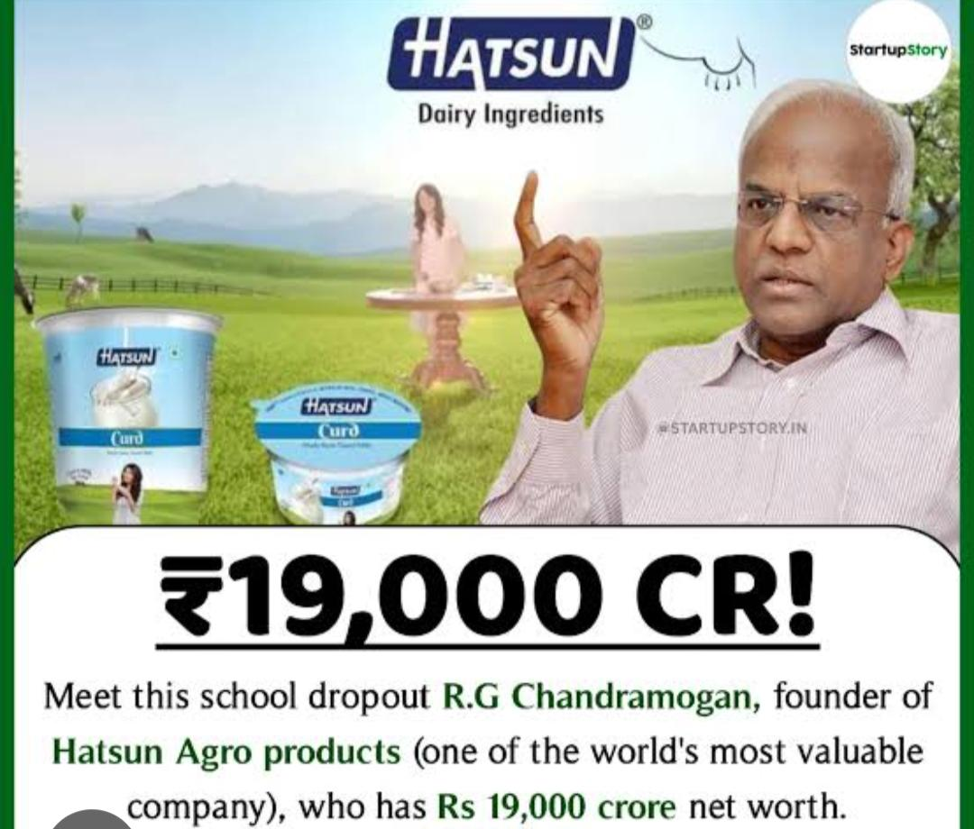

Hatsun Agro caters to a diverse consumer base, from daily milk consumers to ice cream lovers. Here’s a breakdown:

Primary Buyer Personas:

2.Urban Families (Middle-Class & Upper-Middle-Class Households)

Age Group: 25-50 years

Income Level: ₹4-12 lakhs per annum

Needs: Fresh milk, curd, paneer, ghee, and premium dairy products.

Buying Habits: Prefers hygienic, branded dairy products over loose milk.

Marketing Channels: Supermarkets, branded outlets, e-commerce.

3.Rural Households & Farmers

Age Group: 30-60 years

Income Level: ₹2-6 lakhs per annum

Needs: Affordable and fresh dairy products, bulk milk purchase.

Buying Habits: Prefers locally available, fresh dairy from known brands.

Marketing Channels: Local retail shops, Hatsun exclusive outlets.

4.Youth & Ice Cream Lovers

Age Group: 15-30 years

Income Level: Students & working professionals

Needs: Variety in flavours, premium ice creams (Ibaco), and quick snacks.

Buying Habits: Spends on impulse buys at parlors and supermarkets.

Marketing Channels: Ice cream parlors, convenience stores, social media ads.

5.Health-Conscious Consumers

Age Group: 25-45 years

Income Level: ₹5-15 lakhs per annum

Needs: Organic, low-fat dairy products, high-protein beverages.

Buying Habits: Prefers value-added dairy (Greek yogurt, fortified milk).

Marketing Channels: Online grocery stores, premium supermarkets.

Hatsun Agro Product Limited (HAP) is a prominent Indian dairy company that manufactures and markets milk, milk products, ice creams, and cattle feeds. To enhance its online presence and reach, implementing a robust SEO strategy and conducting comprehensive keyword research are essential.

## SEO AND KEYWORD RESEARCH:

### SEO Strategy for Hatsun Agro Product Limited:

### Website Optimization:

Mobile-Friendly Design: Ensure the website is responsive and provides a seamless experience across all devices, as a significant portion of users access websites via mobile devices.

Page Speed Optimization: Improve loading times by optimizing images, leveraging browser caching, and minimizing code. Faster websites enhance user experience and are favored by search engines.

### Content Development:

Blogging: Create informative blog posts about dairy farming, nutritional benefits of dairy products, and recipes using HAP products. This positions HAP as an authority in the dairy industry.

Product Descriptions: Develop detailed and engaging descriptions for each product, highlighting unique selling points and benefits.

### Local SEO:

Google My Business (GMB): Claim and optimize the GMB listing to appear in local searches, providing accurate information about locations, hours, and contact details.

Local Citations: Ensure consistent NAP (Name, Address, Phone number) information across all online directories and platforms.

### Social Media Integration:

Engagement: Maintain active profiles on platforms like Facebook, Instagram, and Twitter to engage with customers, share updates, and promote products.

User-Generated Content: Encourage customers to share their experiences and feature this content on social media channels to build community and trust.

Keyword Research for Hatsun Agro Product Limited:

### Brand-Specific Keywords:

“Hatsun milk products”

“Arun ice cream flavors”

“Ibaco ice cream cakes

### Product Categories:

“Buy dairy products online”

“Fresh paneer suppliers”

“Best ghee brands in India”

### Local Keywords:

“Dairy products in Chennai”

“Ice cream parlours “

“Milk delivery in Hyderabad”

### Long-Tail Keywords:

“Health benefits of consuming Arokya milk”

“Where to buy natural paneer in Bangalore”

“Arun ice cream parlor locations”

### Competitor-Based Keywords:

Analyze competitors like Amul and Mother Dairy to identify potential keyword opportunities.

### Seasonal Keywords:

“Summer ice cream flavours 2025”

“Festive offers on dairy products”

## Implementation Steps:

1. Keyword Integration: Incorporate identified keywords naturally into website content, meta descriptions, headers, and image alt texts.
2. Content Calendar: Develop a content calendar to regularly publish blogs, articles, and updates targeting specific keywords.
3. Monitor Performance: Utilize tools like Google Analytics and Search Console to track keyword rankings and organic traffic, adjusting strategies as needed.

By adopting this comprehensive SEO approach and conducting meticulous keyword research, Hatsun Agro Product Limited can enhance its online visibility, attract a broader audience, and reinforce its position as a leader in the dairy industry.

CONTENT IDEAS AND MARKETING STRATEGY OF HATSUN AGRO PRODUCTS :

Hatsun Agro Products Limited (HAP) has established itself as a prominent player in India’s dairy industry through a combination of strategic marketing initiatives and an extensive product portfolio. Below are content ideas and marketing strategies that reflect HAP’s approach and can be leveraged to enhance brand presence and consumer engagement:

### Emphasize Product Quality and Innovation

Highlight Technological Advancements: Showcase HAP’s investment in advanced technologies, such as state-of-the-art packaging and production lines, to ensure product

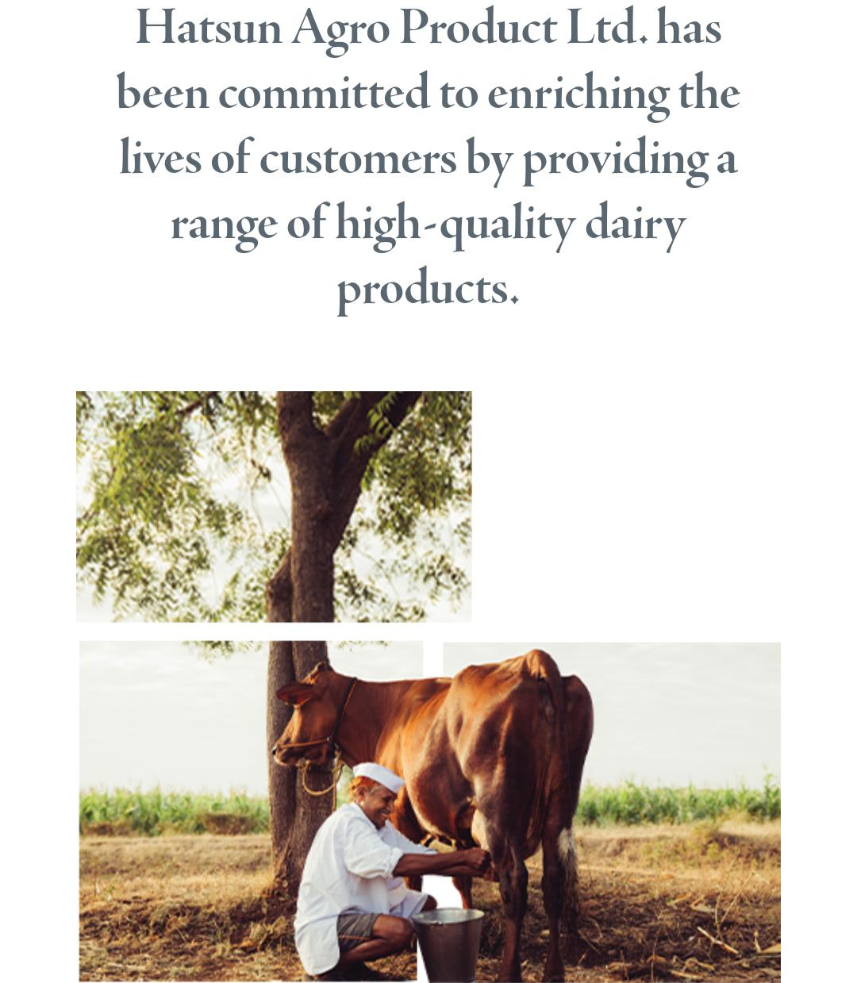

quality and freshness. This could include behind-the-scenes content or virtual tours of manufacturing facilities to build consumer trust.

Introduce Unique Product Lines: Develop and promote innovative products that cater to evolving consumer tastes, such as new ice cream flavors or dairy-based beverages, to keep the brand relevant and exciting.

## Expand Digital and Social Media Presence

Engage Through Visual Content: Utilize high-quality images and videos on platforms like Instagram and Facebook to showcase products, share recipes, and provide cooking tips, thereby enticing consumers and encouraging them to incorporate HAP products into their daily lives.

Leverage Influencer Partnerships: Collaborate with food bloggers, chefs, and nutritionists to create authentic content that highlights the versatility and health benefits of HAP’s dairy products, expanding reach and credibility.

## Strengthen Distribution Channels

Enhance Retail Presence: Continue expanding HAP Daily outlets and Ibaco ice cream parlors across various regions to increase product accessibility. As of February 2021, HAP operated over 3,600 outlets nationwide, indicating a robust retail strategy.

Adopt E-commerce Platforms: Partner with online grocery platforms to offer consumers the convenience of purchasing HAP products digitally, catering to the growing trend of online shopping.

## Implement AI and Data Analytics

Optimize Supply Chain: Utilize AI-driven predictive analytics to forecast demand and streamline logistics, ensuring timely delivery and reducing operational costs.

Personalize Customer Experience: Analyze consumer purchasing patterns to offer tailored recommendations and promotions, enhancing customer satisfaction and loyalty.

## Engage in Community and Sustainability Initiatives

Support Local Farmers: Highlight partnerships with local dairy farmers to promote sustainable sourcing practices and community development, strengthening brand reputation.

Promote Environmental Responsibility: Implement eco-friendly packaging solutions and energy-efficient processes, and communicate these efforts to consumers who value environmental sustainability.

1. Utilize Celebrity Endorsements

Leverage Familiar Faces: Partner with celebrities and influencers to promote HAP products, emphasizing nutritional value and freshness, and creating a strong emotional connection with consumers.

By integrating these strategies, Hatsun Agro Products Limited can continue to enhance its market presence, foster consumer trust, and drive growth in the competitive dairy industry

Hatsun Agro Products Limited (HAPL) is one of India’s largest private dairy companies, known for its wide range of dairy and ice cream products. Founded in 1970, Hatsun has built a strong reputation for quality dairy offerings under well-known brands like Arokya, Hatsun, Arun Ice Creams, and Ibaco. The company is committed to delivering fresh and nutritious dairy products sourced from thousands of farmers across India.

# Content Creation: Blog, Social Media & Marketing

## Blog Post Ideas

“The Journey of Milk: From Farm to Table with Hatsun” – Highlighting Hatsun’s sourcing process, quality control, and fresh delivery.

“The Secret Behind Arun Ice Cream’s Popularity” – Exploring the flavors, innovation, and consumer love for Arun Ice Cream.

“Why Arokya Milk is a Household Favorite” – Discussing the purity, freshness, and benefits of Arokya milk.

“Sustainable Dairy Farming: Hatsun’s Commitment to Farmers & Environment” – Focusing on Hatsun’s support for dairy farmers and sustainable practices.

## Social Media Content Strategy

Instagram & Facebook

Engaging reels and short videos showcasing the production process.

Customer testimonials on why they love Hatsun products.

Contests like #MyHatsunMoment where customers share experiences with Hatsun products.

Twitter (X)

Quick dairy nutrition tips using hashtags like #HatsunHealthyLiving.

Company news, partnerships, and farmer success stories.

LinkedIn

Thought leadership articles on the Indian dairy industry trends.

Behind-the-scenes insights on Hatsun’s quality control and innovation.

## Marketing Campaign Ideas

“Pure & Fresh Everyday” – A digital campaign showcasing Hatsun’s commitment to delivering fresh dairy products.

“Summer with Arun Ice Cream” – A promotional campaign featuring limited-edition summer flavors.

“Hatsun Farmer Stories” – Videos highlighting the company’s support for dairy farmers.

Content Curation: Industry News & Trends

Sharing dairy industry insights, including sustainability practices and new government policies.

Featuring consumer trends related to dairy consumption and changing food preferences.

Highlighting innovation in dairy technology and how Hatsun stays ahead of competitors.

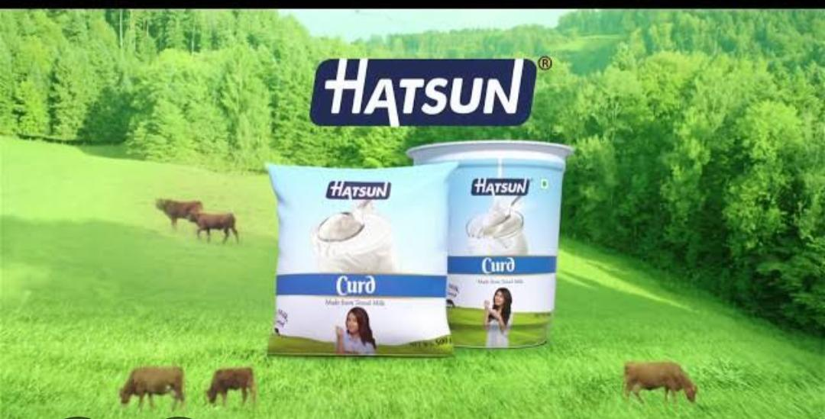

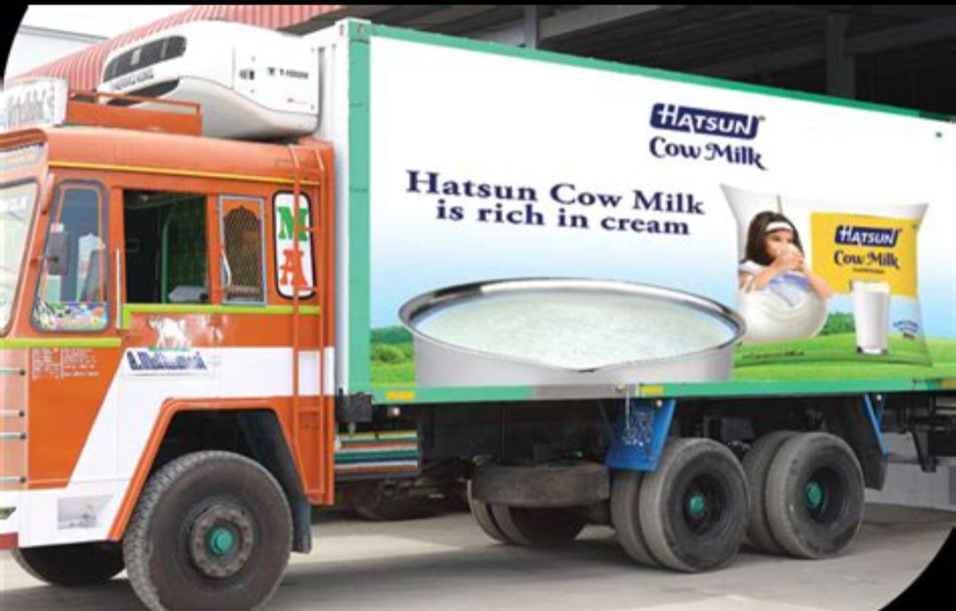

Hatsun Agro Products Limited is one of India’s leading dairy companies, known for its strong presence in milk and milk-based products. The company has built a robust distribution network, diversified product portfolio, and a solid brand reputation with names like Arokya, Hatsun, Arun Ice Creams, and Ibaco.

# Conclusion:

Hatsun Agro has demonstrated consistent growth through innovation, expansion, and market penetration. Its focus on quality dairy products, strong supply chain management, and increasing rural outreach has helped it maintain a competitive edge. Despite industry challenges such as fluctuating milk prices, supply chain disruptions, and changing consumer preferences, Hatsun continues to invest in technology, sustainability, and market expansion to strengthen its position.

Going forward, the company’s ability to adapt to consumer trends, enhance operational efficiency, and expand internationally will be key to its long-term success.

Hatsun Agro Product Ltd. Has been committed to enriching the lives of customers by providing a range of high-quality dairy products.

HAP manufactures and markets products that cater to both cooking and consumption, like, milk, curd, ice creams, dairy whitener, skimmed milk powder, ghee, paneer and lots more.

Our brands have become household names in over one million Indian houses. Arun Icecreams, Arokya Milk, Hatsun Curd, Hatsun Paneer, Hatsun Ghee, Hatsun Dairy Whitener and Ibaco have become popular choices across the country. We also have a healthy global presence with dairy ingredients exported to 42 countries around the world — primarily in America, the Middle East and South Asian markets.

