AUTOPSY DISK FORENSICS
INVESTIGATION REPORT
Investigator: Malini
Case ID: CASE-001
Date: 23 September 2026
Tool: Autopsy | OS: Windows

1. Objective
To perform a basic digital-forensics investigation using Autopsy by analyzing a disk image, examining files and deleted files, reviewing browser artifacts, and documenting relevant forensic findings.

2. Evidence
Evidence Name | Malini_Evidence.vhd
Evidence Type | Virtual Disk Image
File System | NTFS
Evidence Location | C:\Forensics\Malini_Project
Evidence Nature | Controlled training evidence / fictional data

3. Methodology
- Created a controlled virtual disk image for the investigation.
- Added fictional files and test browser activity.
- Deleted selected test files.
- Created a new case in Autopsy.
- Added the VHD as the evidence source.
- Ran relevant ingest modules.
- Examined the file system and deleted-file artifacts.
- Reviewed browser activity, metadata, timestamps, and hashes.
- Recovered relevant deleted files where available.
- Tagged important evidence and generated the forensic report.

4. Key Findings
File System: Documents, Downloads, Desktop and browser-related artifacts were examined. Important files: [invoice.txt,meeting_notes.txt, project_notes.txt,readme.txt].
Deleted Files: Deleted files identified: [3]. Recovered files: [3]. Recovered file(s): [invoice.txt].
Browser Activity: Browser history/search/download artifacts reviewed.
Metadata: File names, file types, sizes and available creation/modification/access timestamps were reviewed.

5. Evidence Screenshots
- Autopsy case creation
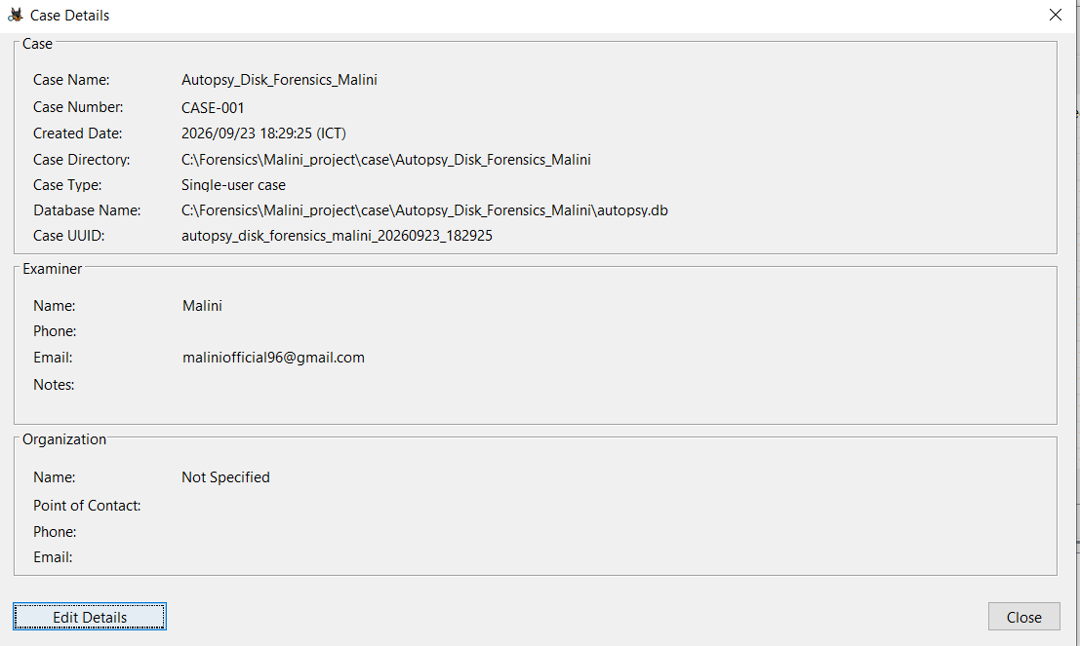

- VHD/disk image added to the case
- File-system analysis
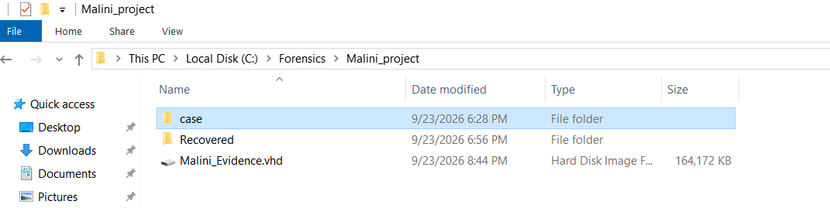

- Deleted files
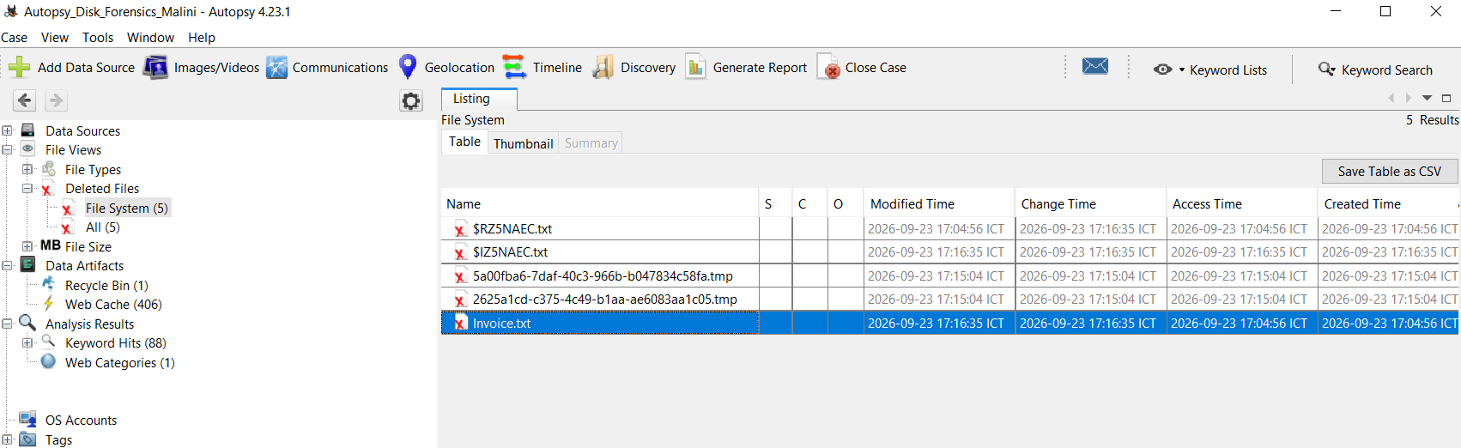
- Recovered file
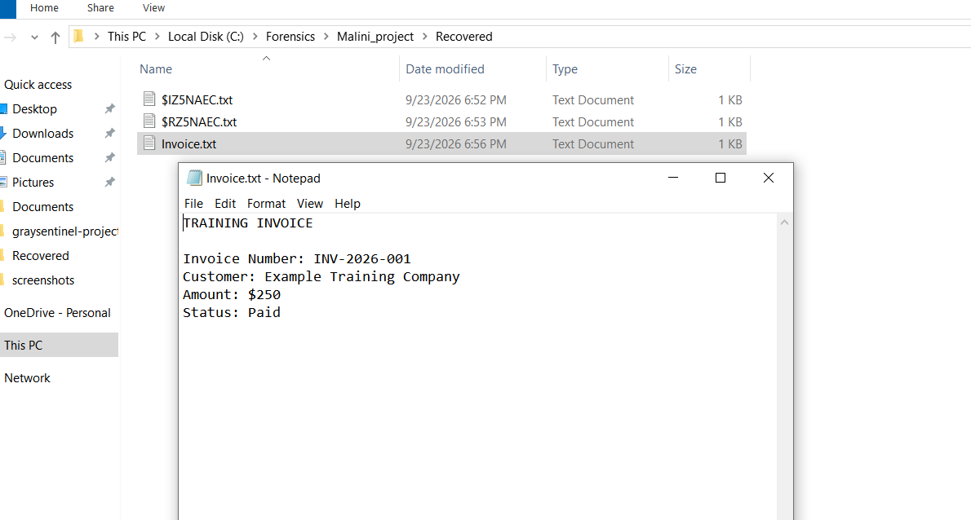
- Browser history/web artifacts
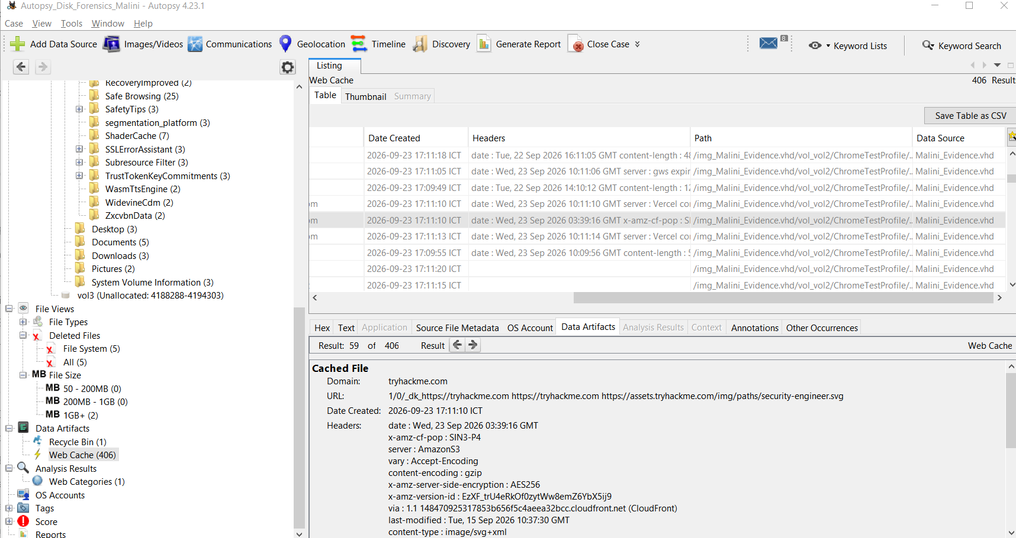

- Metadata information
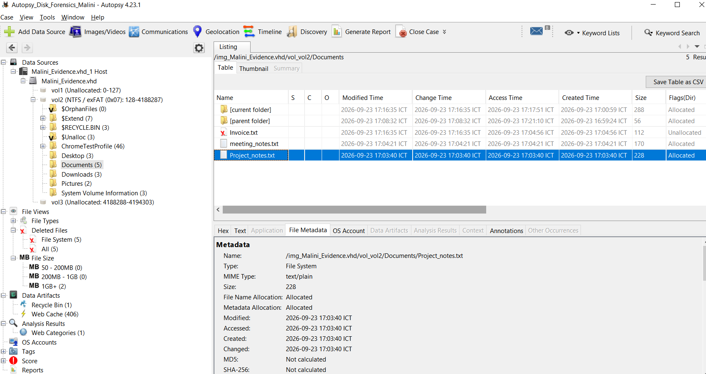

6. Conclusion
The investigation demonstrated the basic digital-forensics workflow using Autopsy. The disk image was examined for file-system artifacts, deleted files, browser activity, metadata, and hashes. Relevant artifacts were documented and included in the final report.

7. Limitations
This was a controlled training investigation using fictional evidence. The findings are intended for educational/project purposes and do not represent real-world evidence.

