# **SORT and MEANS Procedures Using Diabetes Data**

## **SAS Code**

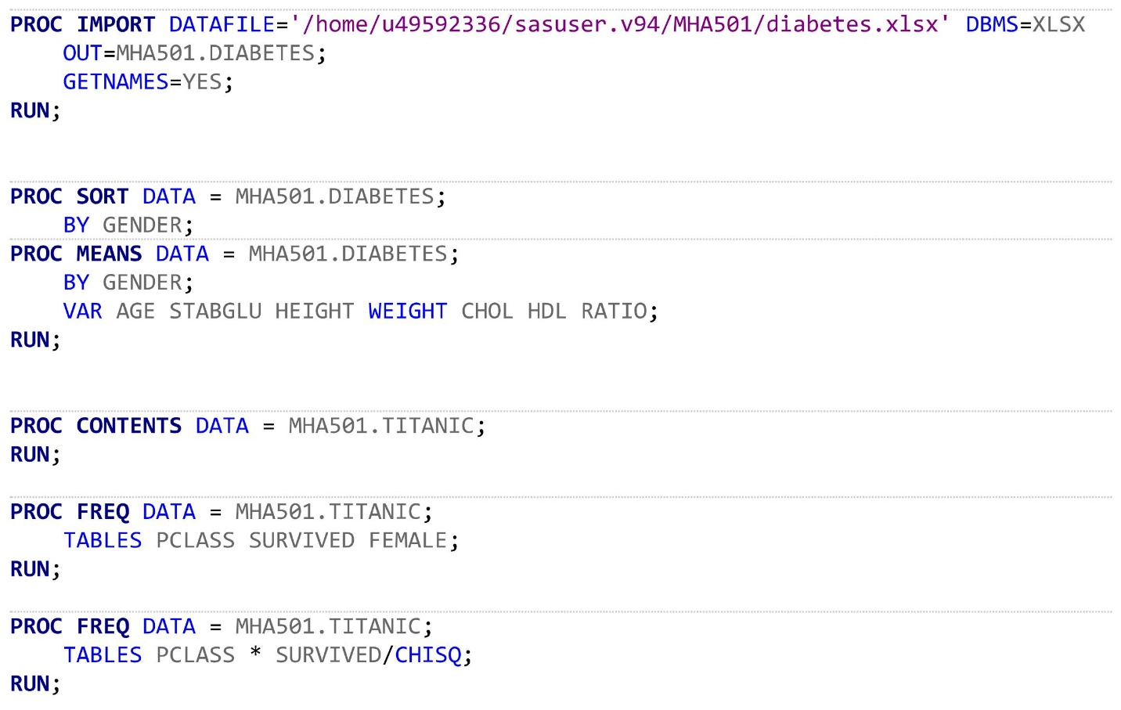

## **SAS OUTPUT**

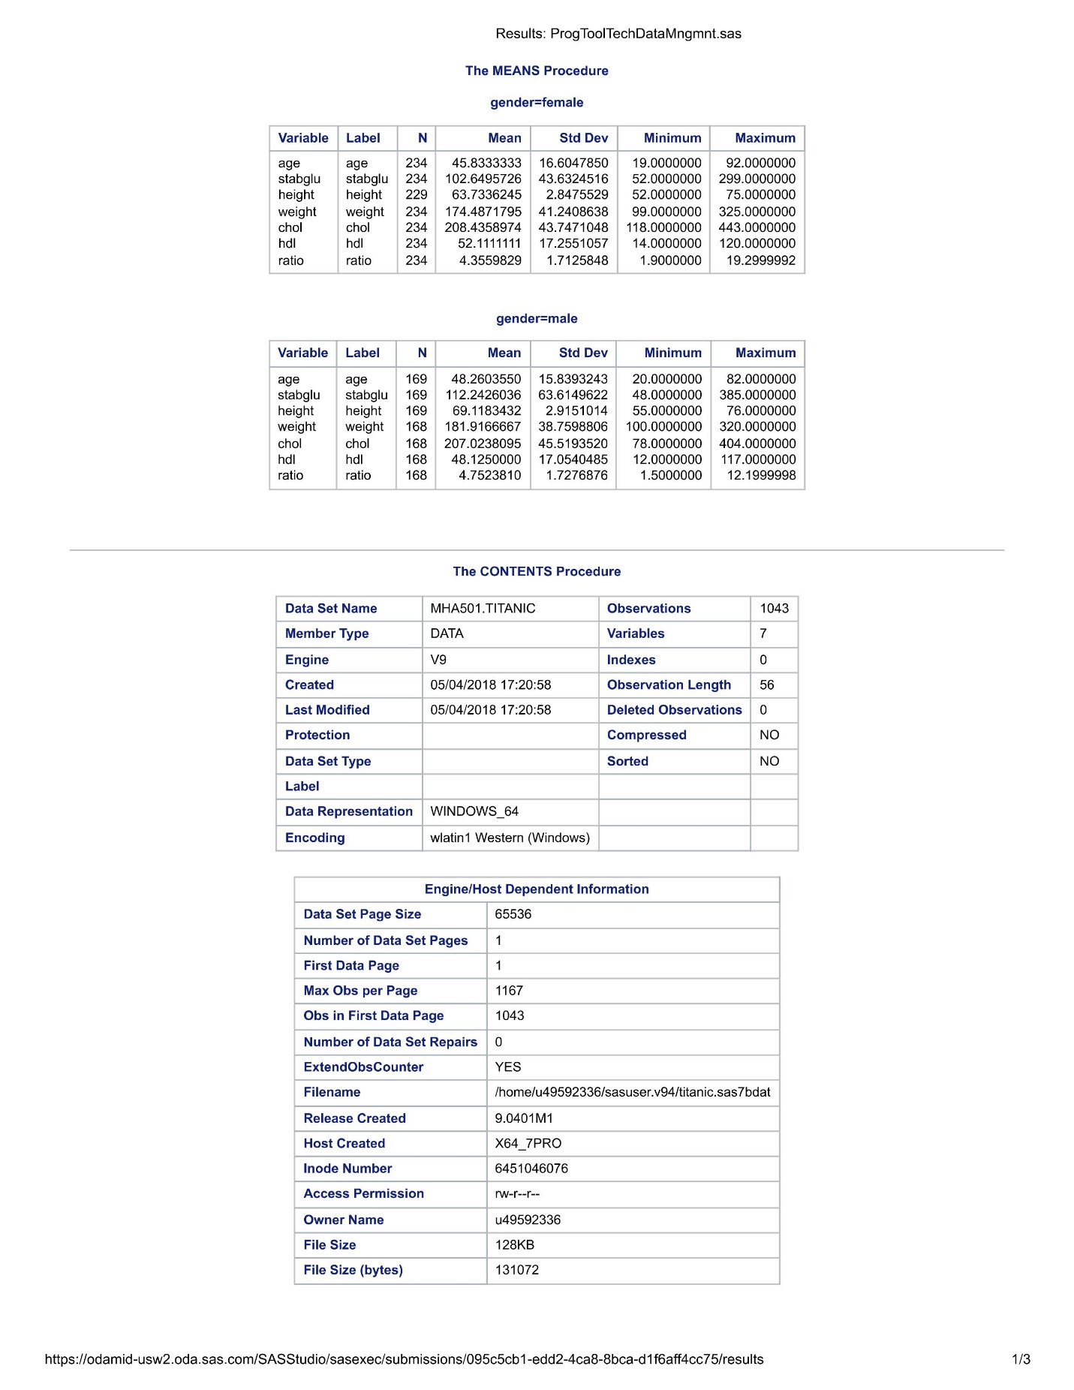

## **Conclusion**

Examination of the output produced by PROC SORT and PROC MEANS shows that females have a younger mean age, shorter mean height, lower mean weight, higher mean cholesterol, lower mean stable glucose, higher mean HDL, and lower mean ratio (bodyfat ratio) when compared to the male group. A MANOVA should be conducted to further compare the means between the two groups.

# **Frequency Tables and Chi-Square Test for Titanic Data**

## **SAS CODE**



## **SAS OUTPUT**



# 

## **Conclusion**

The frequency tables produced by PROC FREQ for the variables **pclass**, **survived**, and **female** reveal a distribution that does not appear to be uniform. The tables indicate this by showing that the majority of passengers were in pclass 3, were males, and did not survive.

Based on the information presented by the second frequency table, survival does not appear to be independent of passenger class. According to the two-way frequency table, passengers in class 1 were more likely to survive than not survive (survived = 63.48% vs. did not survive = 36.52%). Passengers in class 2 were slightly more likely to survive than not survive (survived = 55.94% vs. did not survive = 44.06%). Finally, passengers in class 3 were less likely to survive than die (survived = 26.20% vs. did not survive = 73.80%). This is further supported by the chi-square statistic for the data which has a *p*-value = < .0001 – indicating that the variables **pclass** and **survived** are not independent of each other.

**References**

Hind, P. (n.d.). Titanic [Data set]. Encyclopedia Titanica. <http://www.encyclopedia-titanica.org/>

Johnson, R.W. (1996). Fitting percentage of body fat to simple body measurements [Data set]. *Journal of Statistics Education, 4*. http://jse.amstat.org/v4n1/datasets.johnson.html

Willems, J.P., Saunders, J.T., Hunt, D.E., Schorling, J.B. (1997). Prevalence of coronary heart disease risk factors among rural blacks: A community-based study [Data set]. *Southern Medical Journal,* *90*.