# **Hypothesis**

The data being analyzed has been sampled from the 1967-1980 Evans County study (Schoenbach et al., 1986). The sample includes data on survival time (in years) for two chronic disease diagnosis groups (CHR = 0, CHR = 1). Each diagnosis group contains non-repeated measures for 25 participants. To test whether survival times differ between the two groups, the following hypotheses were set:

* H0: The mean survival times for groups 1 and 2 are not significantly different.
* H1: The mean survival times for groups 1 and 2 are significantly different.

The indicated hypotheses will be tested by generating survival curves for each group and performing a log-rank test to determine whether either group carries a greater risk of death.

# **Survival Curves with Log-Rank Statistic**

## **SAS Code**

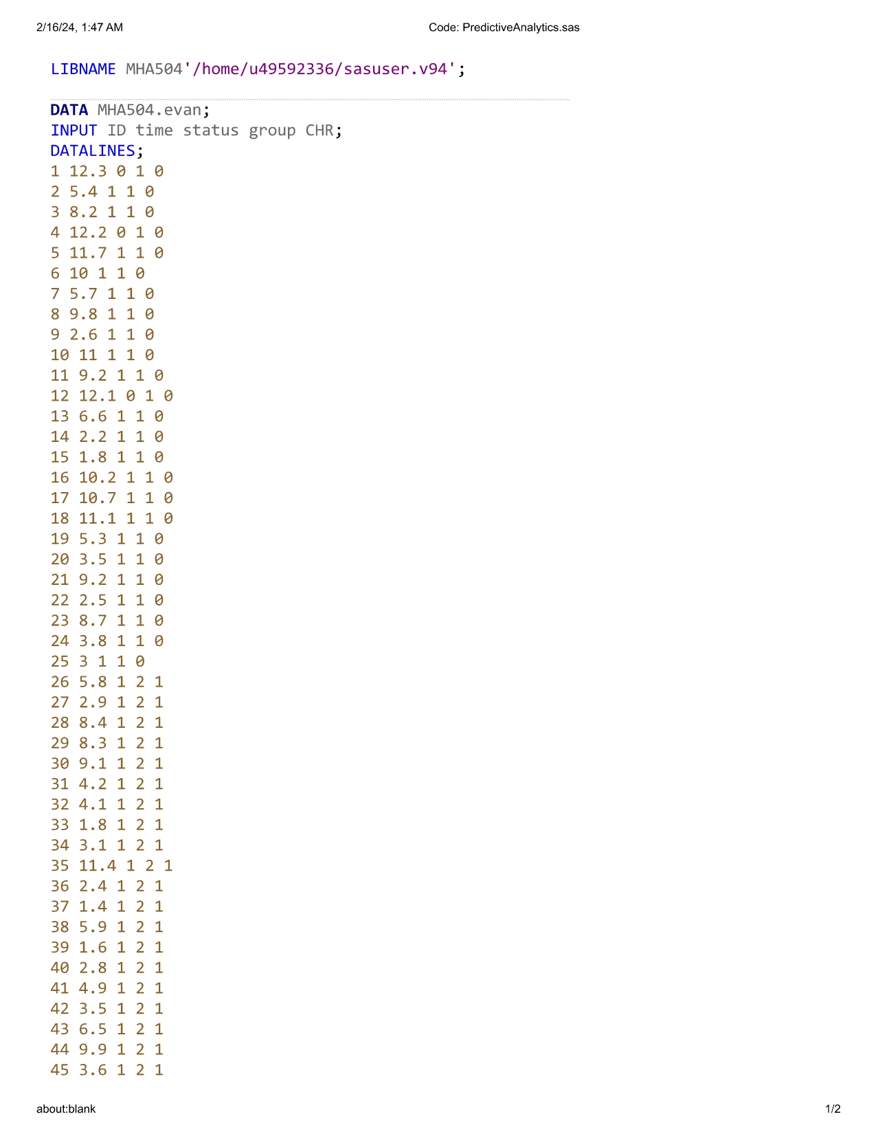







## **SAS Output**

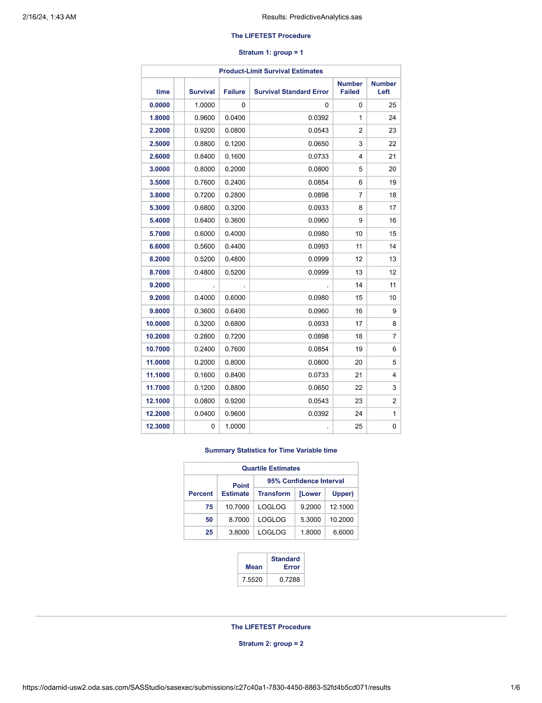

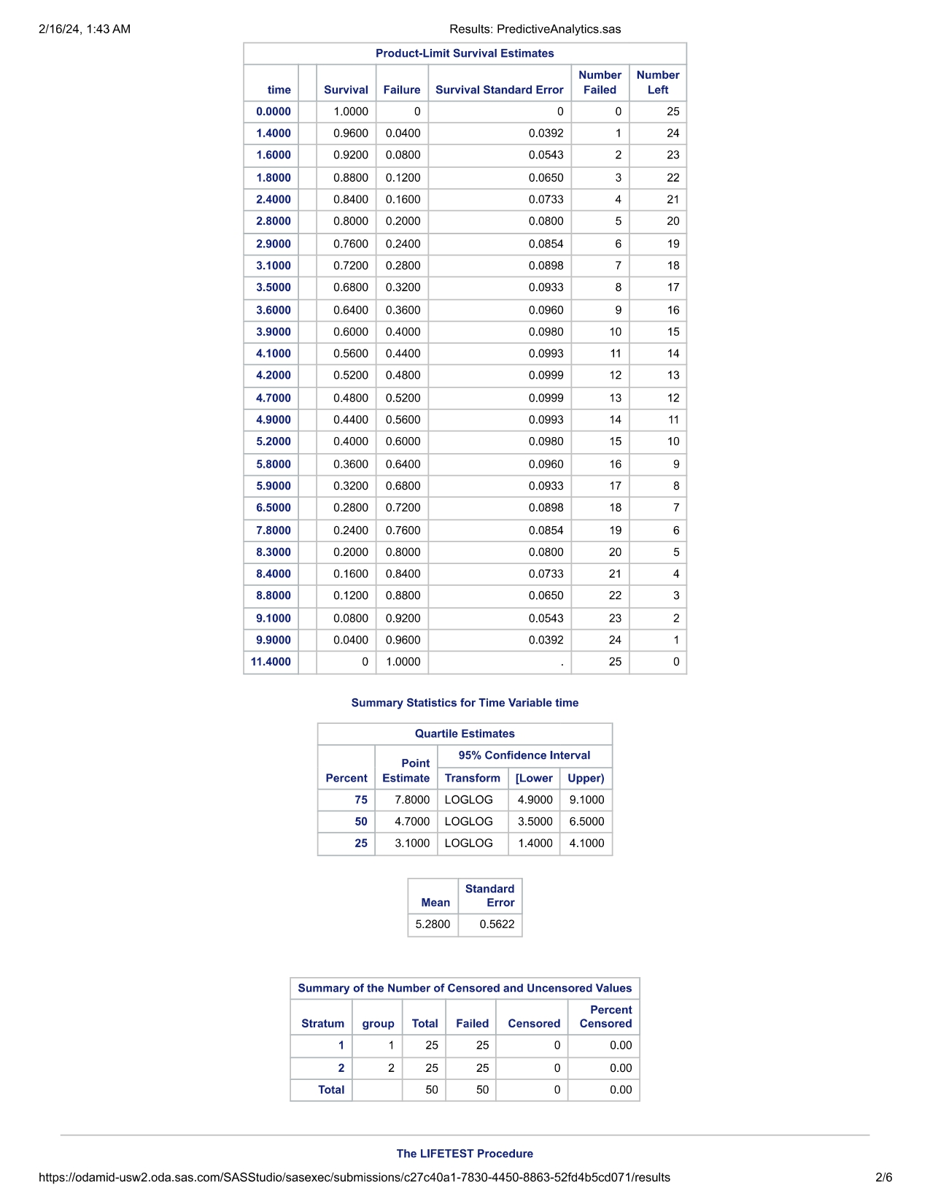





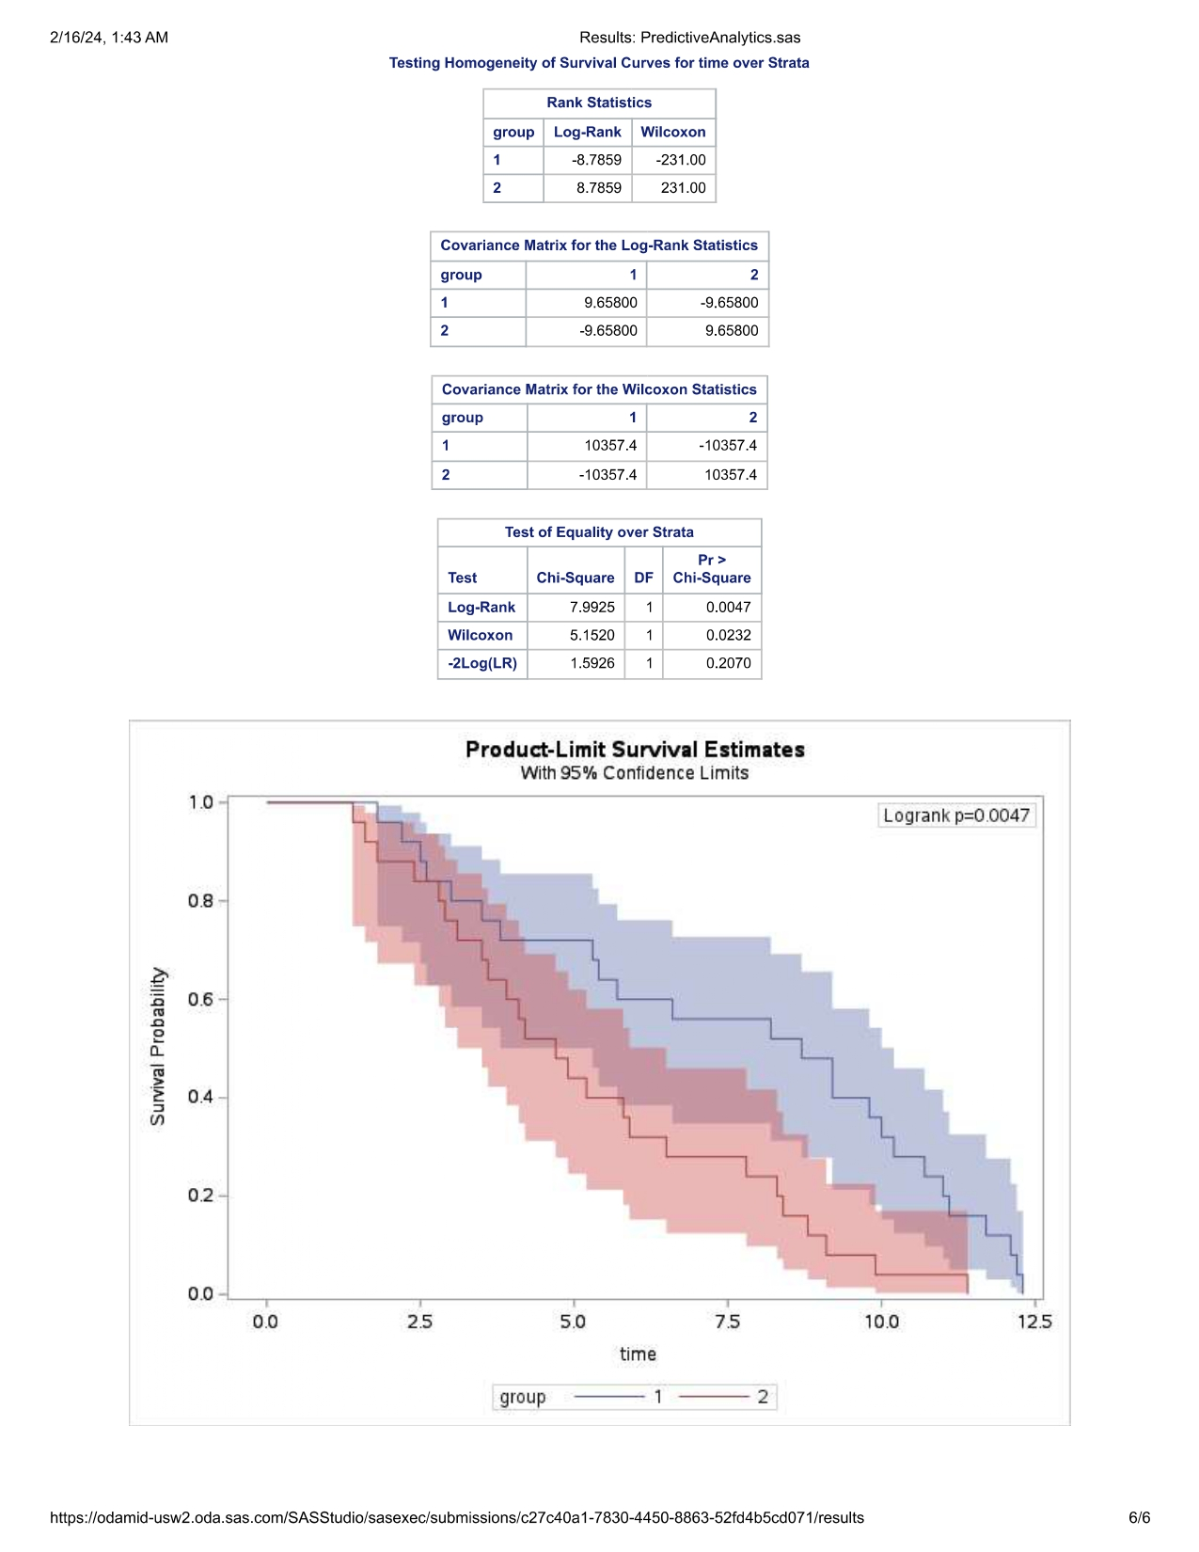

## **Output Conclusion**

Initial examination of the survival curves appears to indicate that group 1 participants possess a higher mean survival time when compared to group 2. Based on the graph, the mean survival time (where 50% of participants or observations are still surviving) for group 2 occurs around 5.0 for the measured time variable. Meanwhile, the means survival time for group 1 occurs between 7.5 and 10.0.

The observations described above are corroborated by the p-value (*p* = 0.0047) generated for the log-rank test. As a result, the null hypothesis is rejected and indicates that mean survival times differ between groups 1 and 2.

**References**

Schoenbach, V. J., Kaplan, B. H., Fredman, L. & Kleinbaum, D. G. (1986). Social ties and mortality in Evans County, Georgia [Data set]. *American Journal of Epidemiology, 123*(4). https://doi.org/10.1093/oxfordjournals.aje.a114278