SPORTY SHOES BOOKING engine

Author- Malini.Murthy

SPORTY SHOES booking engine screen shots

Author- Malini.murthy

Project- Sporty Shoes booking

DESCRIPTION

**Project objective:**

As a Full Stack Developer, complete the features of the application by planning the development and pushing the source code to the GitHub repository. 

**Background of the problem statement:**

Sporty Shoes is a company that manufactures and sells sports shoes. They have a walk-in store, and now, they wish to launch their ecommerce portal sportyshoes.com.

You’re asked to develop a prototype of the application. It will be then presented to the relevant stakeholders for budget approval. Your manager has set up a meeting where you’re asked to do the following:

● Presenting the specification document which has the product’s capabilities, appearance, and user interactions  
● Setting up Git and GitHub account to store and track your enhancements of the prototype   
● Explaining the Java concepts used in the project   
● Discussing the generic features of the product:  
● There will be an admin to manage the website. An administrator login will be required to access the admin page.

**The admin should be able to change his password if he wants, he should be able to:**

● Manage the products in the store including categorizing them  
● Browse the list of users who have signed up and be able to search users  
● See purchase reports filtered by date and category

Intelij steup and tomcat running;

https://github.com/malinimurthy123/sportyShoes/tree/master

1. Sporty Shoes Application running and H2 tables being created

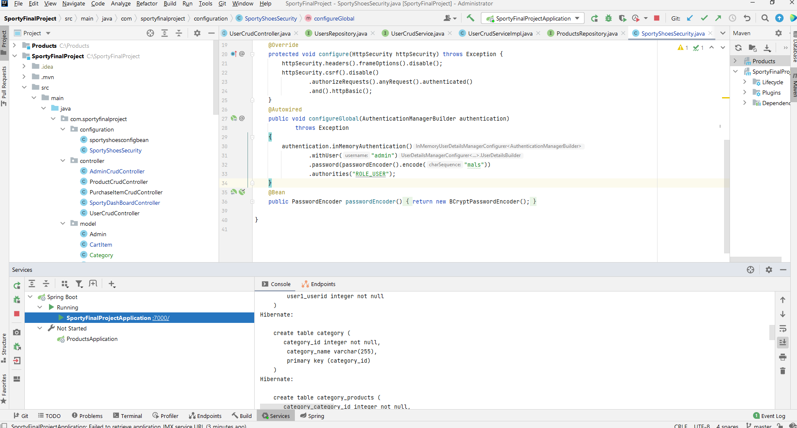

1. Security to application:

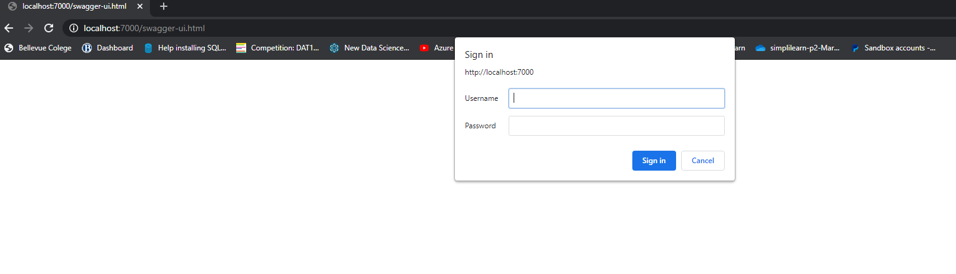

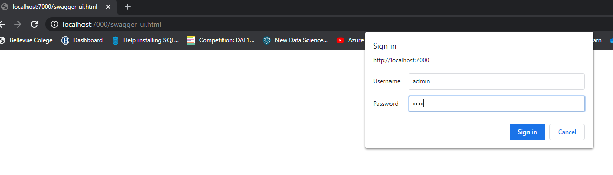

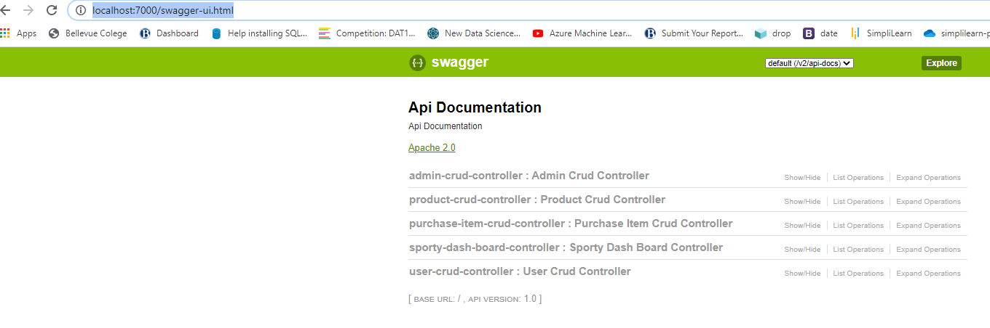

<http://localhost:7000/dashboard> - Postman

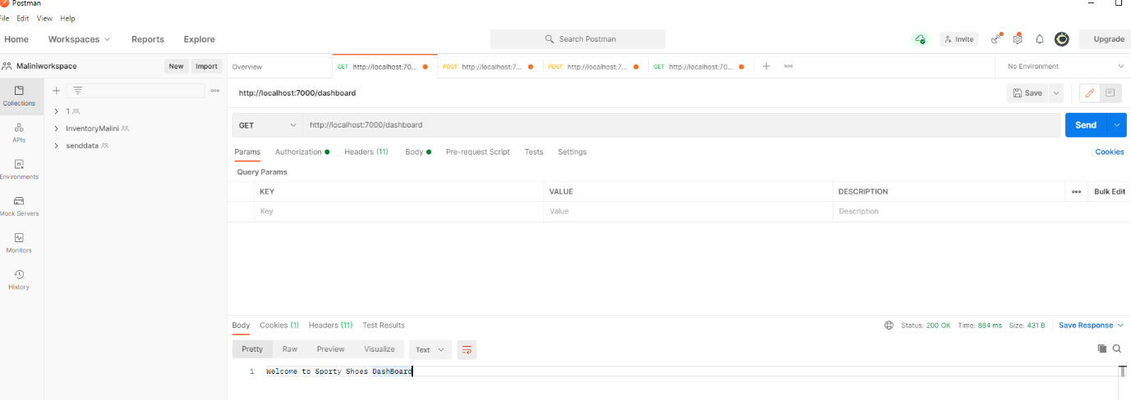

Swagger - <http://localhost:7000/swagger-ui.html#!/sporty45dash45board45controller/dashboardUsingGET>

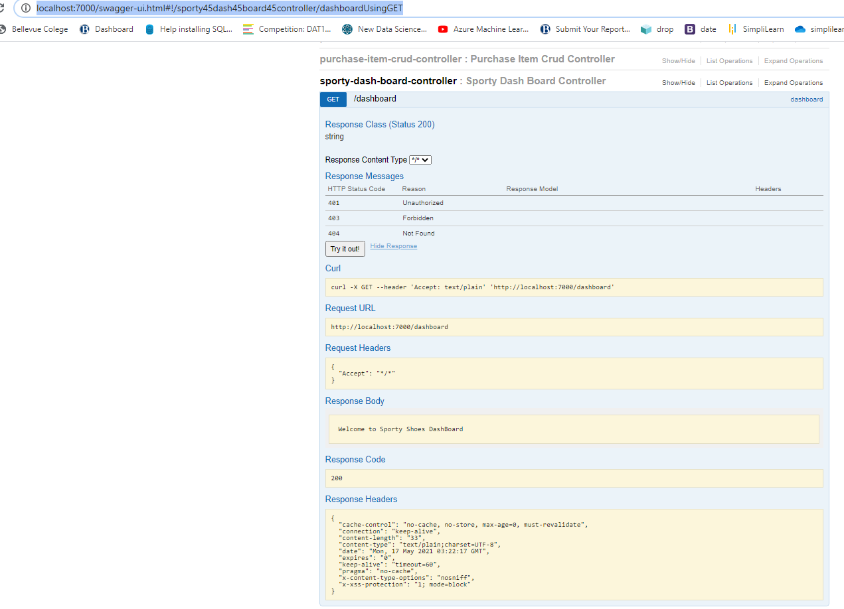

**CreateUsers: PostMan – EndPoint-** http://localhost:7000/user

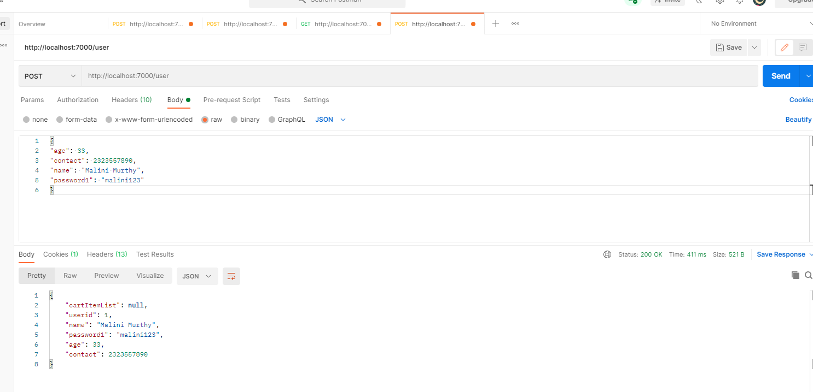

**Users created through Swagger-**

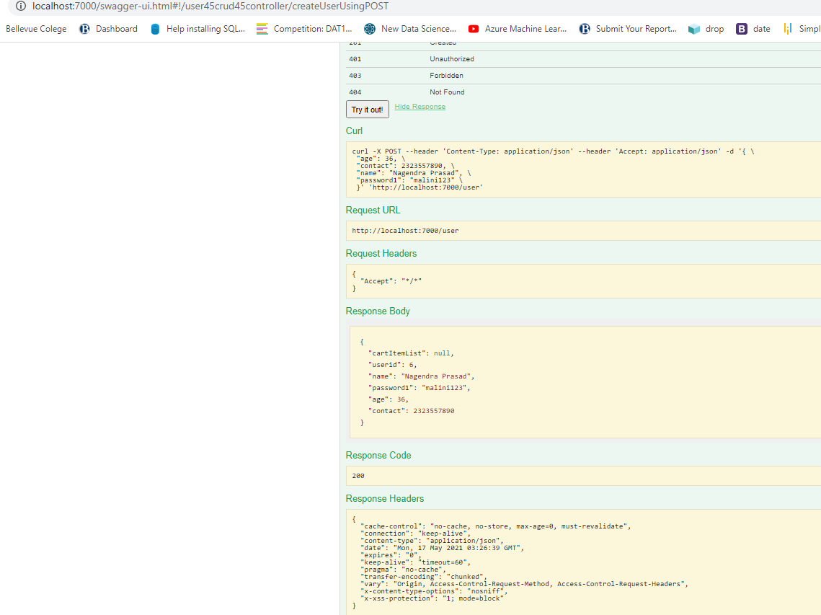

**Users Created in H2 DataBase-**

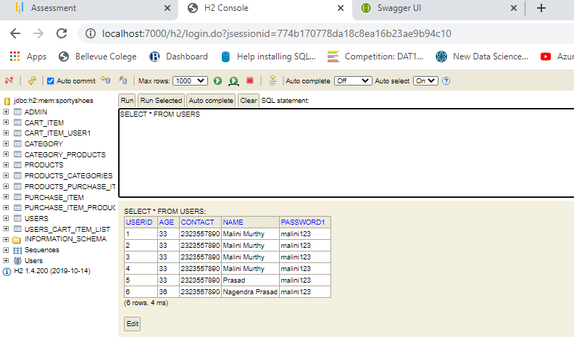

**List Allusers - Both swagger and postman**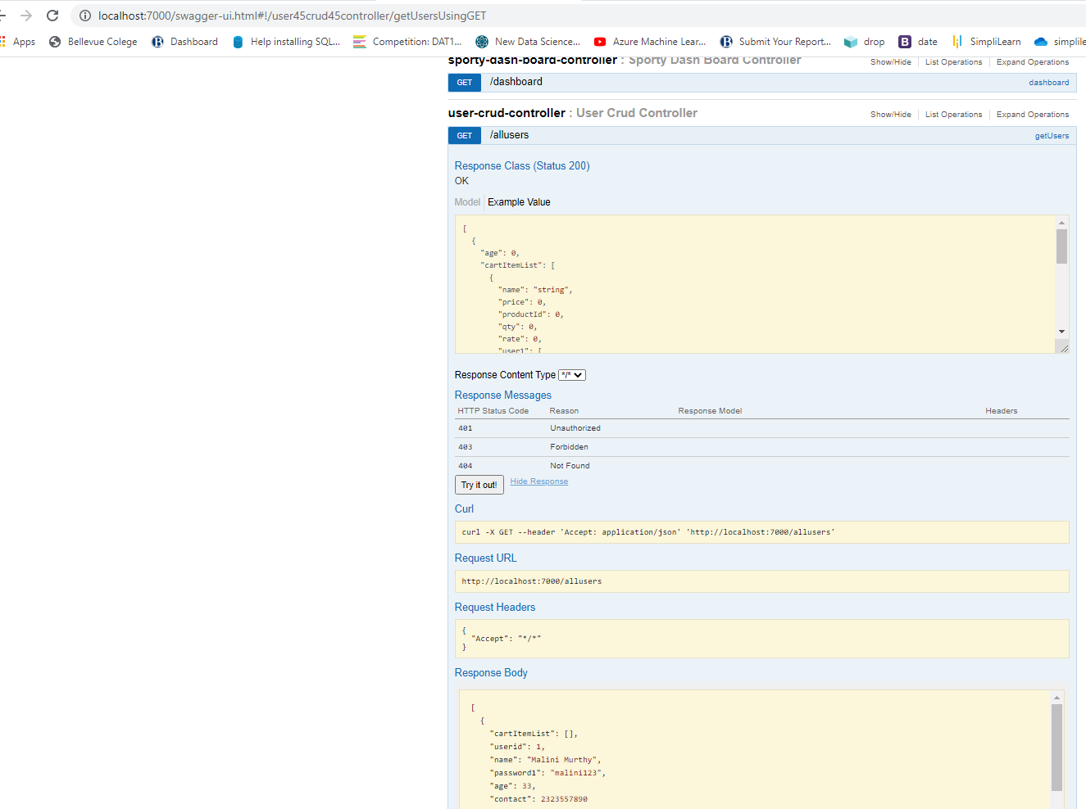

<http://localhost:7000/allusers>

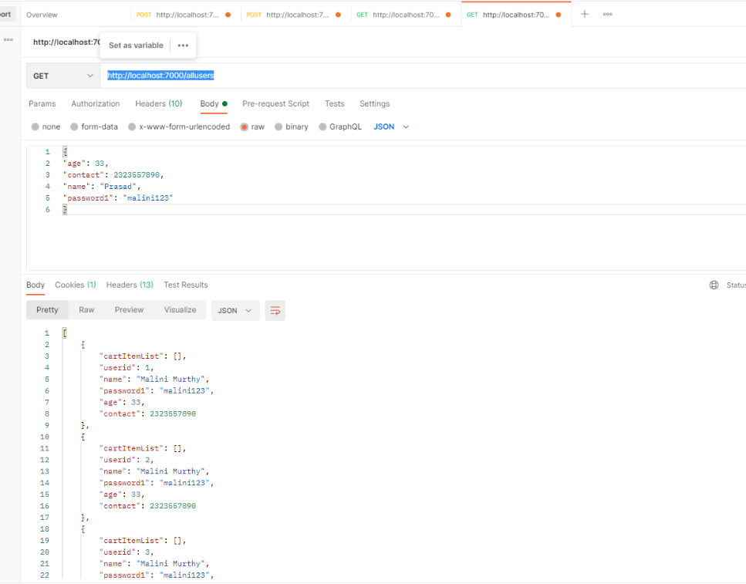

**All the following screen shots cover the required functionalities below:**

**The admin should be able to change his password if he wants, he should be able to:**

● Manage the products in the store including categorizing them  
● Browse the list of users who have signed up and be able to search users  
● See purchase reports filtered by date and category

**● Browse the list of users who have signed up and be able to search users**

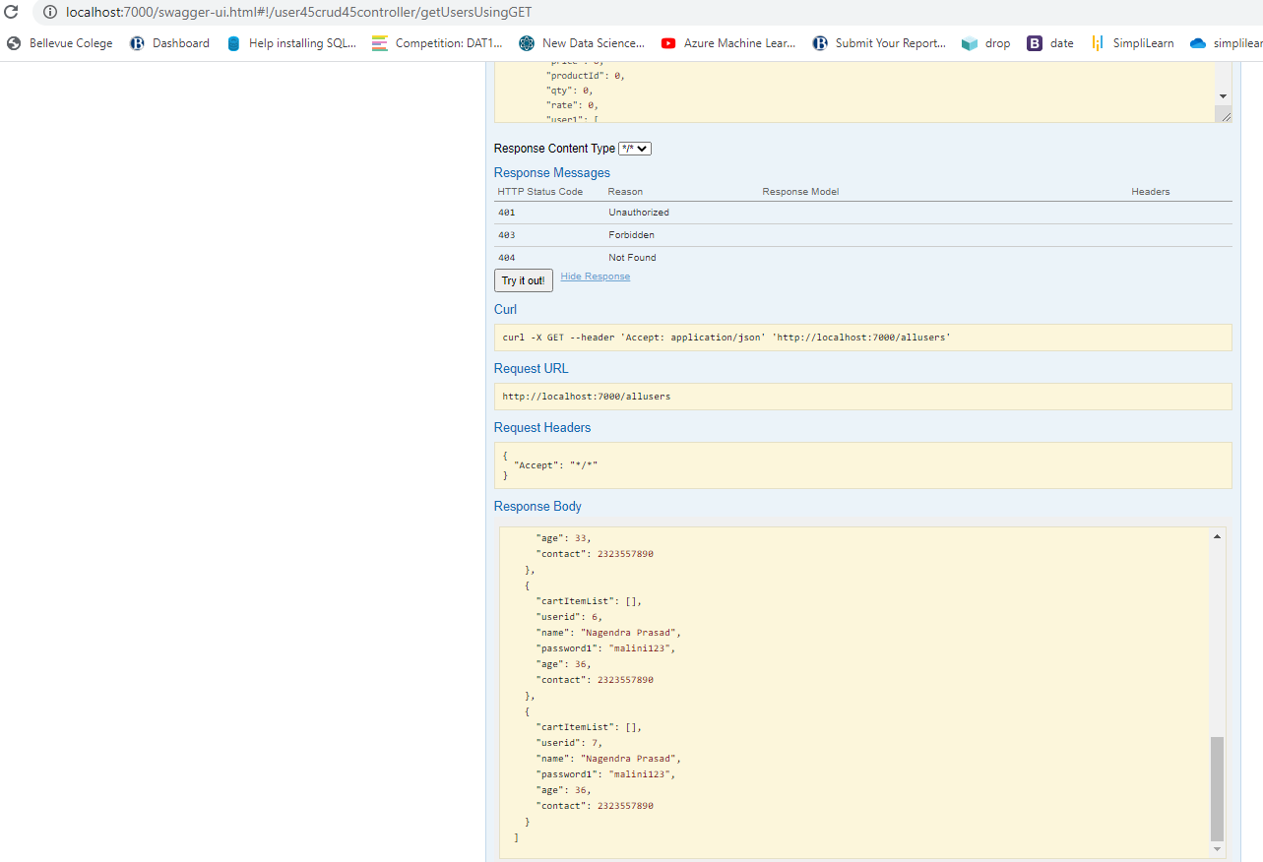

**Creating Product-** <http://localhost:7000/product>

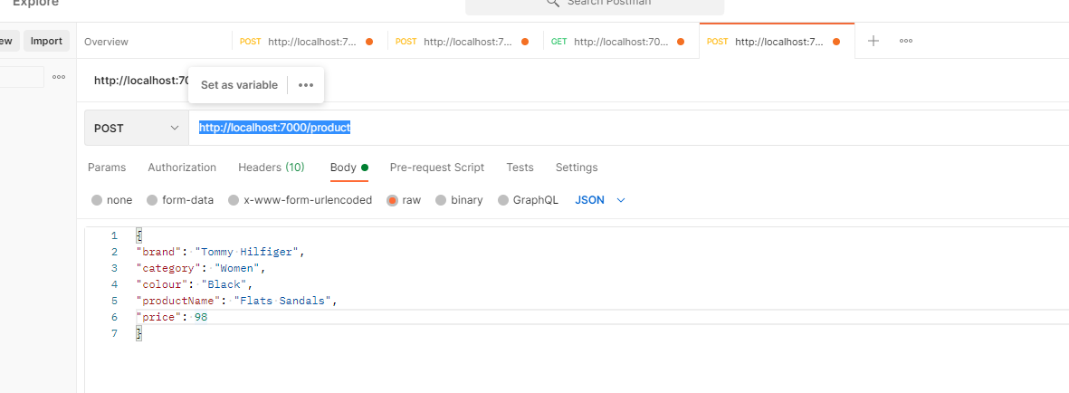

**Products with Category inserted:**

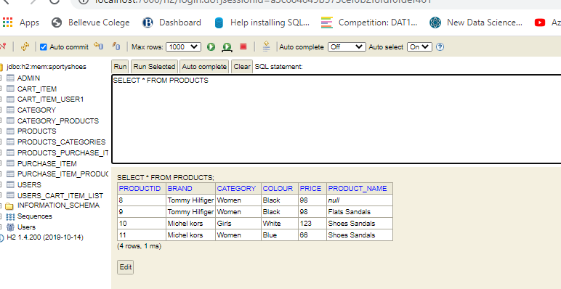

* **Get All Products By Category:**
* **Manage the products in the store including categorizing them**

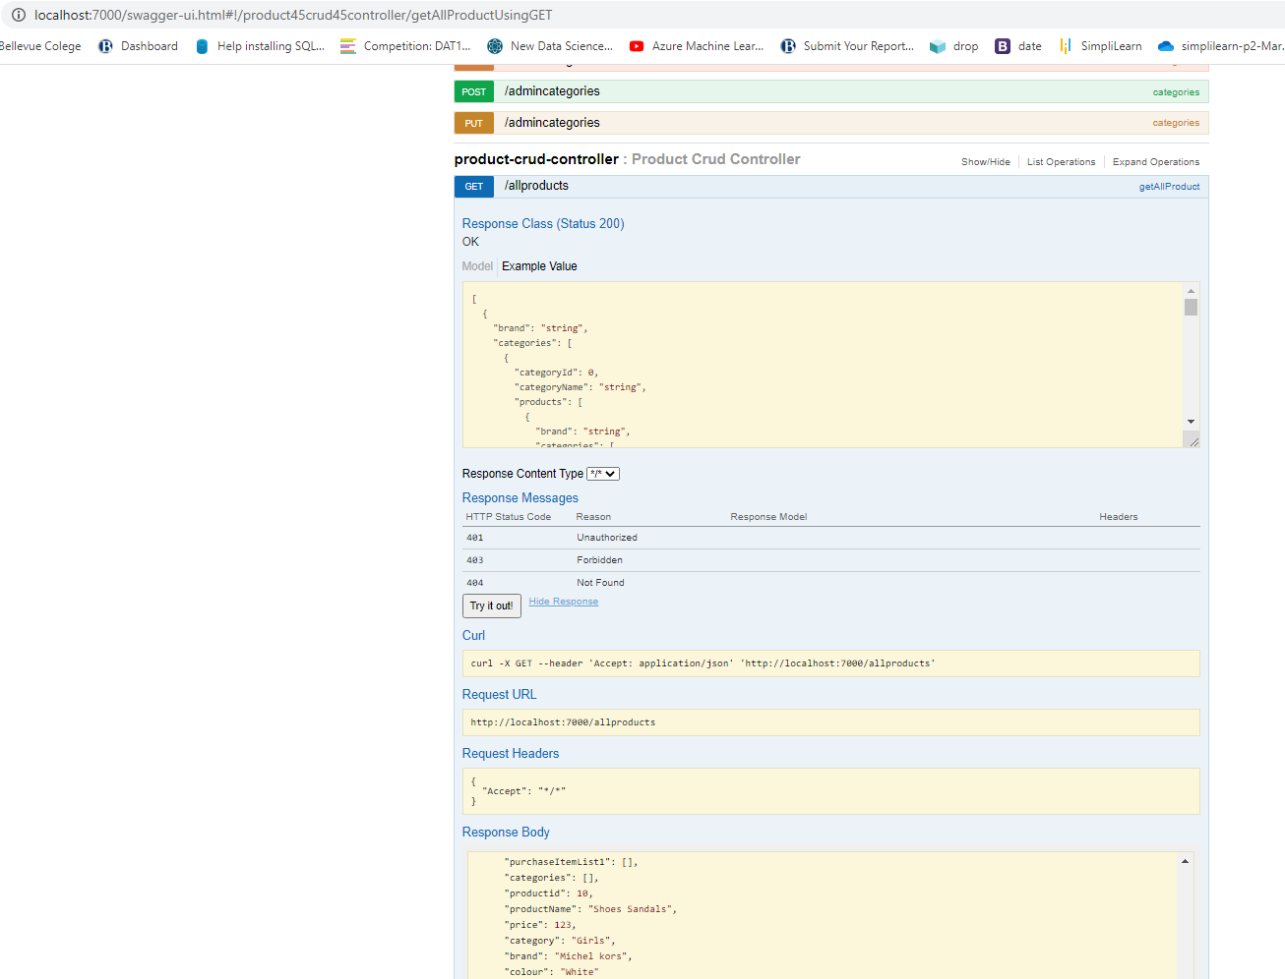

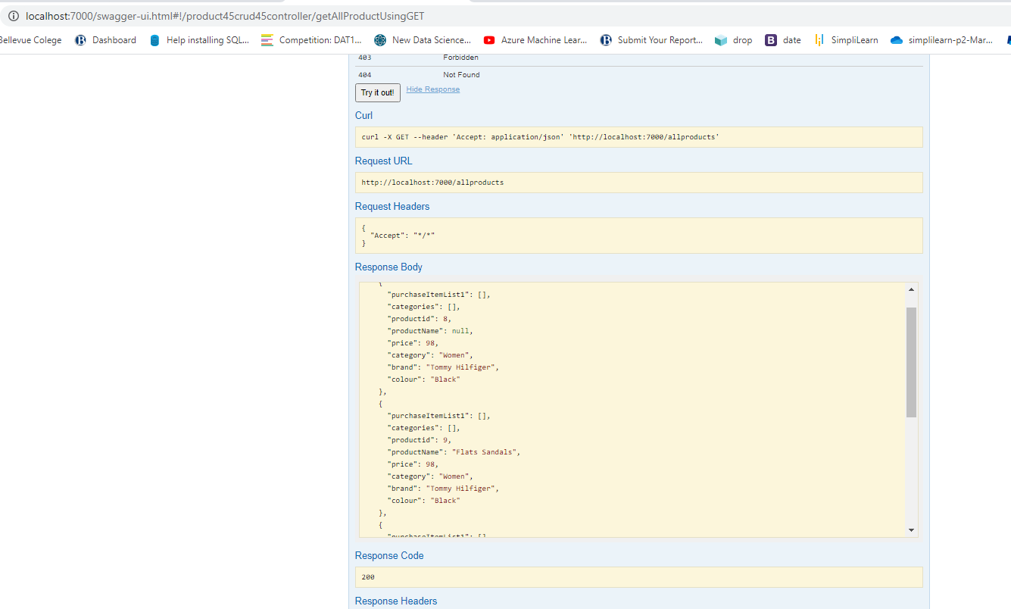

**Pruchase items -**   
<http://localhost:7000/purchaseitem> - Endpoint

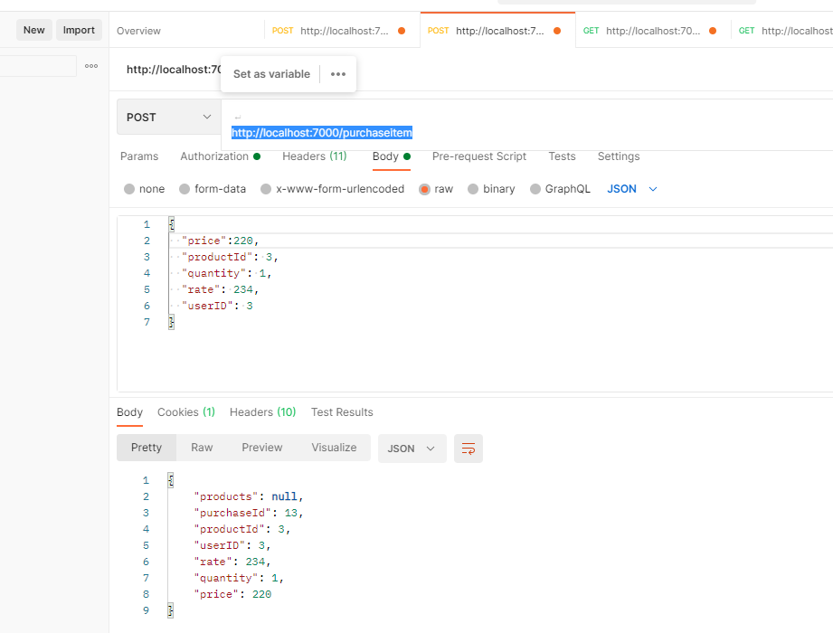

**● See purchase reports filtered by date and category**

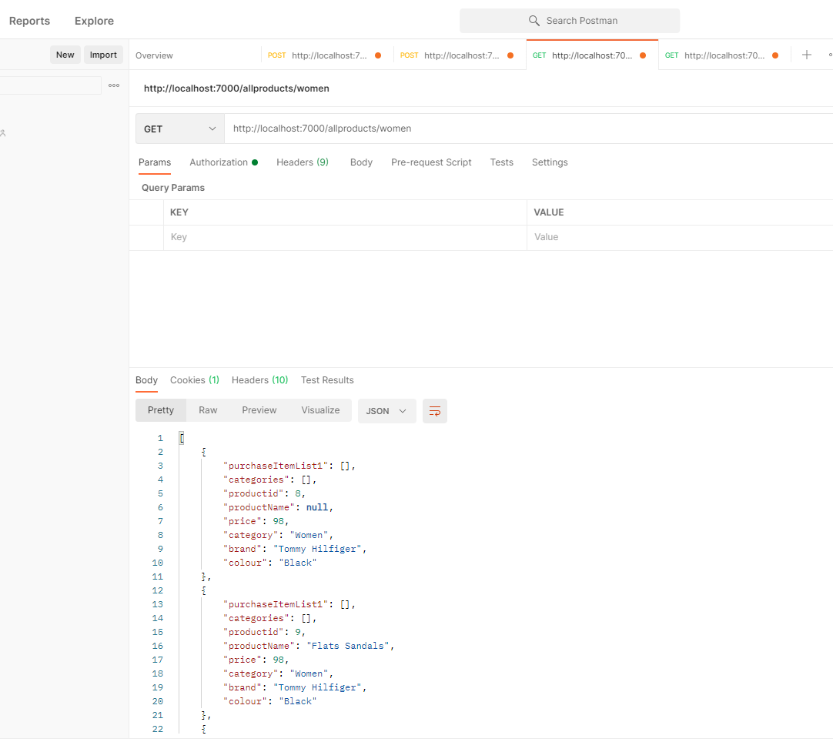

**See All Purchases in Swagger:**

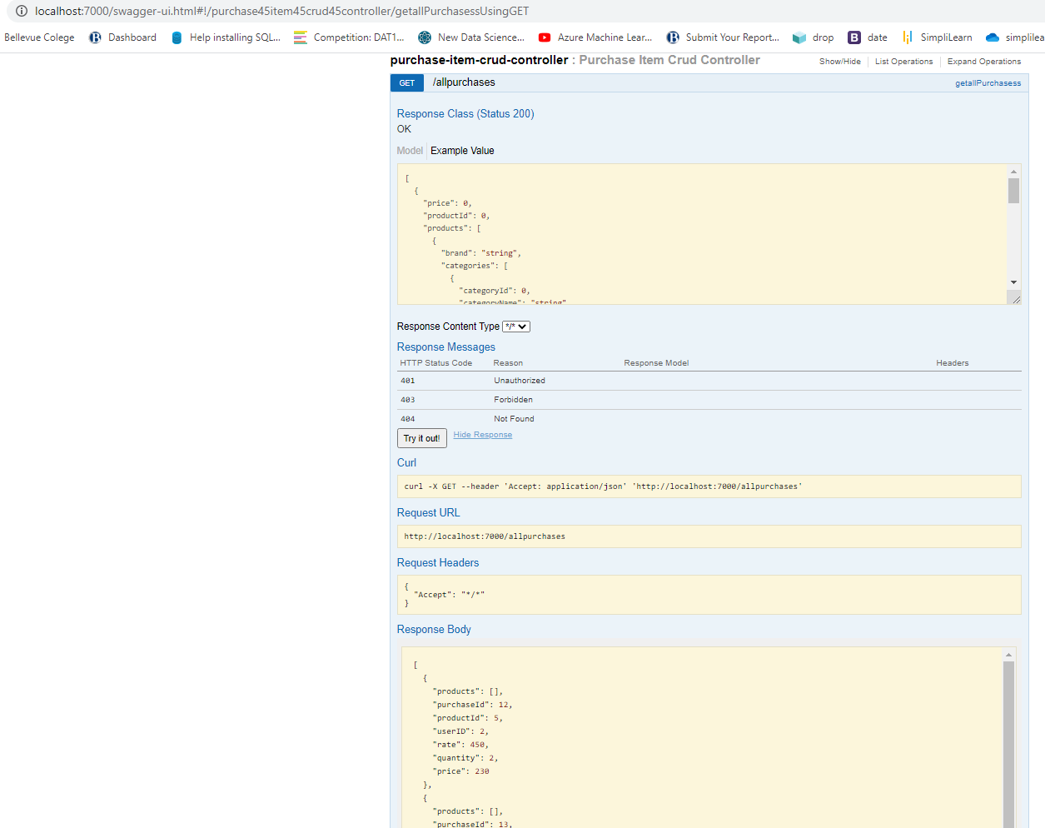

* **The admin should be able to change his password if he wants**

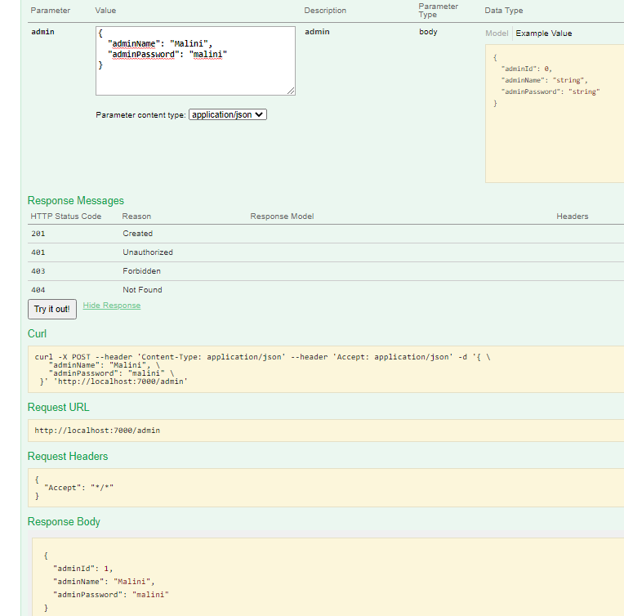

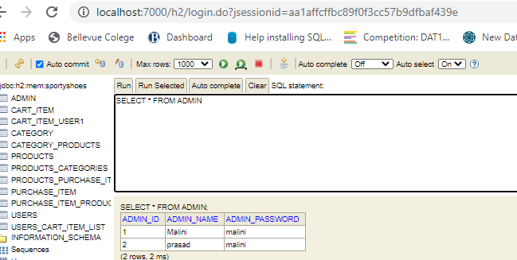

* **The admin should be able to change his password if he wants**
* **Admin Password Updated:**

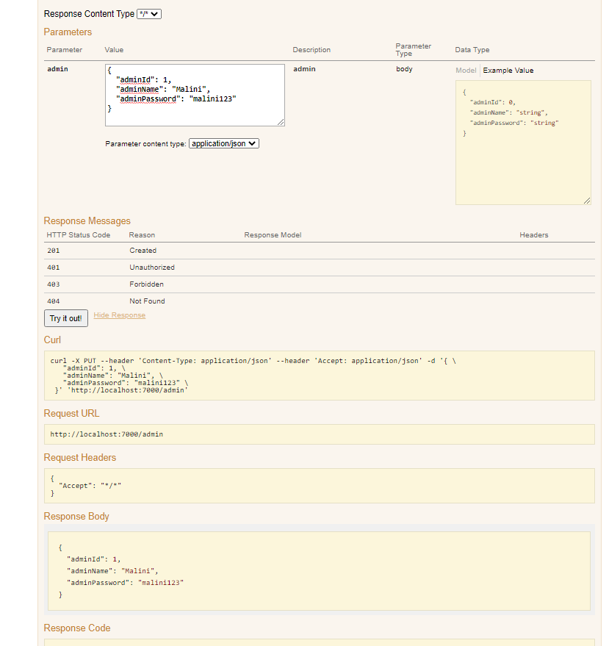

**Admin Password Updated in database:**

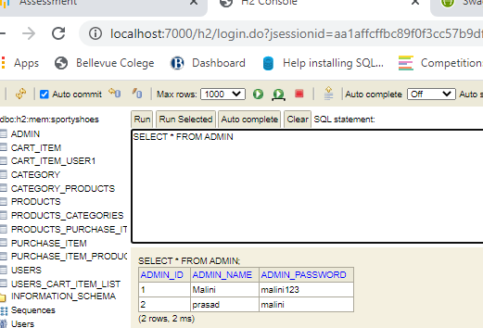

**Swagger Screens:**

1. **Admin and Catogories Endpoints**

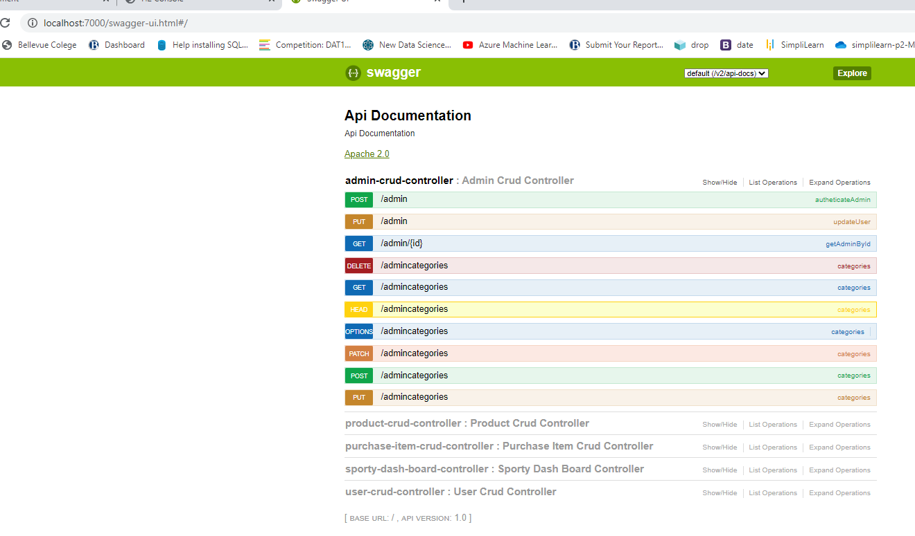

## [product-crud-controller](http://localhost:7000/swagger-ui.html#!/product45crud45controller) : Product Crud Controller

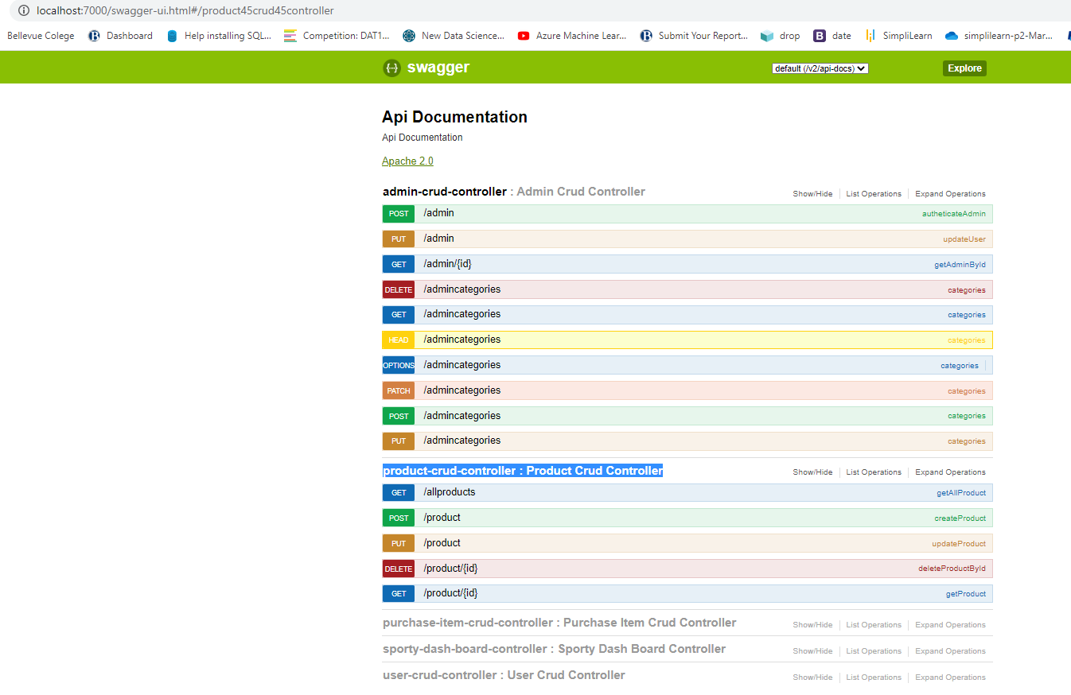

## [purchase-item-crud-controller](http://localhost:7000/swagger-ui.html#!/purchase45item45crud45controller) : Purchase Item Crud Controller

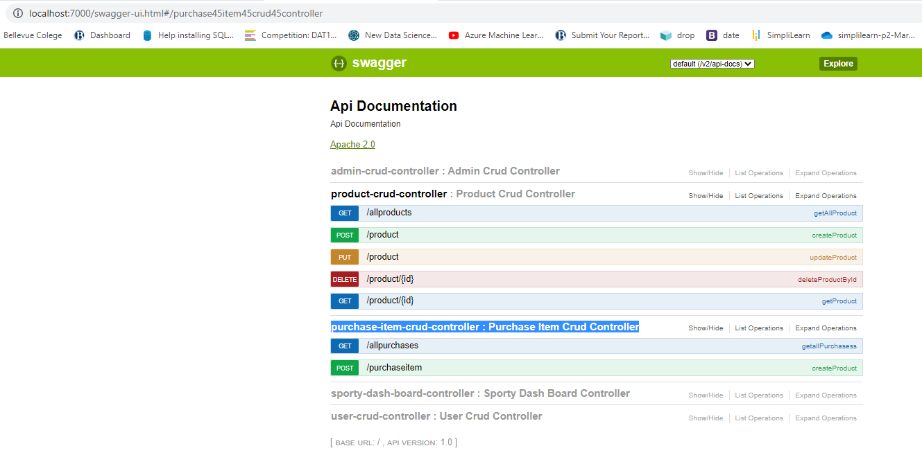

## [sporty-dash-board-controller](http://localhost:7000/swagger-ui.html#!/sporty45dash45board45controller) : Sporty Dash Board Controller

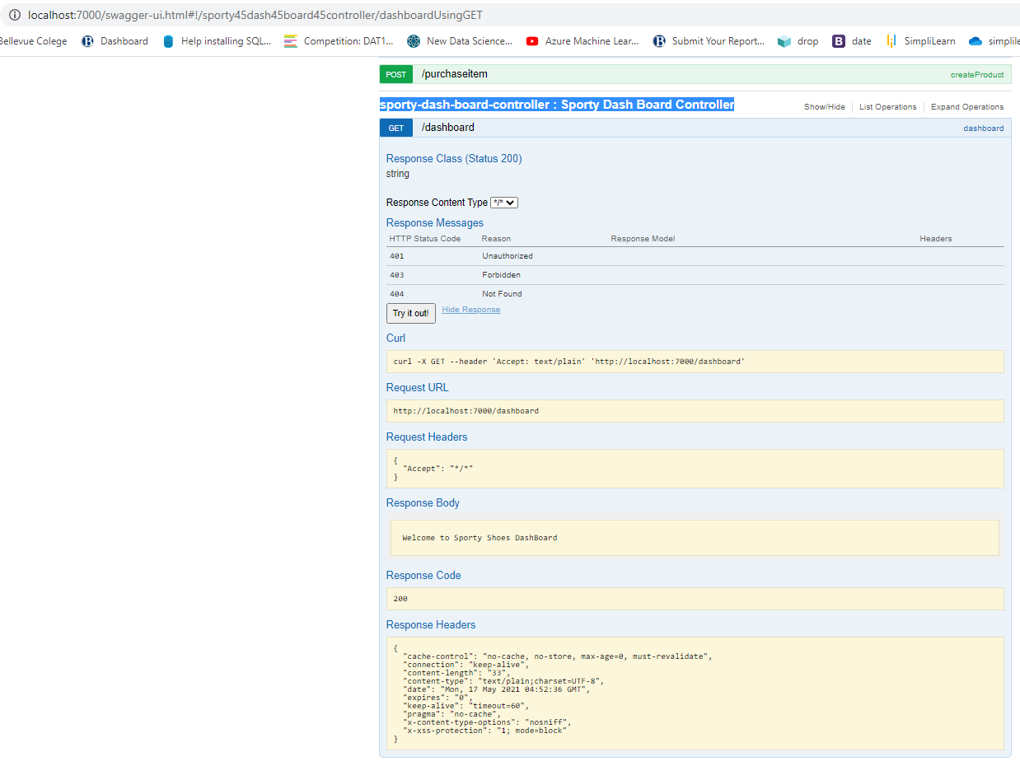

## [user-crud-controller](http://localhost:7000/swagger-ui.html#!/user45crud45controller) : User Crud Controller

