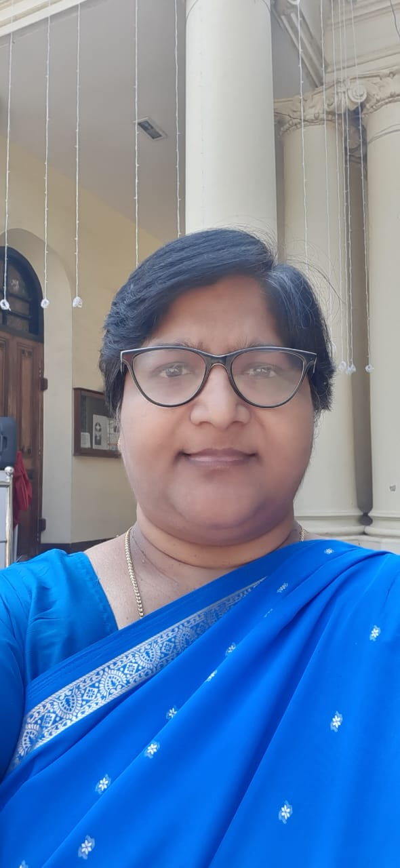
|213412|1142

about me
1424

Work Experience
141-142
ss

Skills
- skill

