personal expense tracker program

user manual

# Selecting the database

When you first use the program, after you click a button for the first time (any button) you will be prompted to choose a database. Select PersonalExpenses.accdb.

# adding an entry to the program

If any transaction has occurred, click the button “Add Entry” to add the transaction to the database.

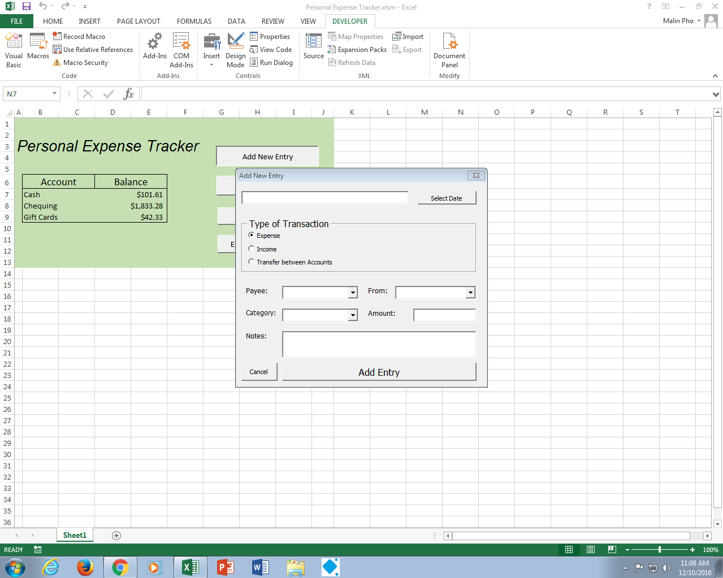

## Notes:

### ensure that all fields are filled in before adding an entry, if a field is blank, the program will let you know you’re missing a field

### do not write any dollar signs in the amount input text box

### the notes option of the pop-up is optional

### you cannot type in a category for your transaction, refer to #3 of the manual

### you can type any name in the Payee list

# adding a new category for transactions

Currently, you can only pick from the expense and income categories listed in the database. If there is a category that you want to add, use this feature.

This category will be added to the database and if it is an expense category, added to the graph you can export to Word.

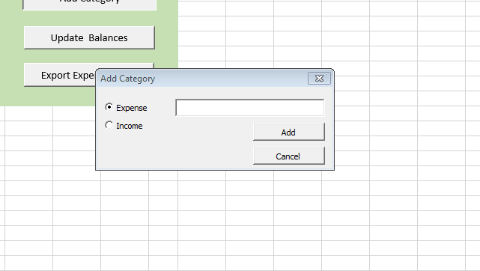

# updating the balance of assets

After adding an entry, to see your new balance simply click “Update Balances.” The values of your assets will then change on the worksheet if an entry was added.

# exporting your expenses to a column graph

To visually see the proportion of money you have spent on one category compared to another, choose this option. A word document will be created with the graph. Save it if you would like to keep it.

