Name: Parag Manoj Mali
Student ID: 25201859
Github :

COMP41720 Distributed Systems
LAB 4: Building a Microservices-Style Application

- INTRODUCTION
The purpose of this lab was to design, implement, containerize, and deploy a simple distributed microservices application while demonstrating architectural reasoning and understanding of trade-offs. I implemented a URL Shortening system composed of two microservices:
- Shortener-Service (generates short codes)
- Redirect-Service (resolves codes to long URLs)
The system was implemented in Java 21 using Spring Boot 3.5, containerized using Docker, and deployed on Minikube Kubernetes. The services communicate via synchronous REST, and internal service discovery is handled using Kubernetes DNS.
This report explains service boundaries, inter-service communication, deployment architecture, key trade-offs, and rationale behind the design.

- SYSTEM DESIGN & SETUP
  - ARCHITECTURE OVERVIEW
The URL Shortener consists of:
- Shortener-Service
- Accepts long URLs
- Generates random or custom short codes
- Registers them with Redirect-Service via REST

- Redirect-Service
- Stores code → long URL mappings
- Resolves incoming short codes

Both services run independently and communicate over HTTP using Kubernetes networking.

  - ARCHITECTURE DIAGRAM
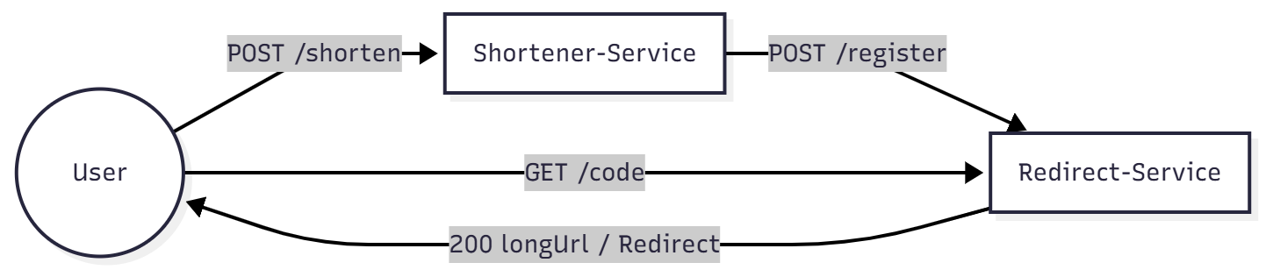Fig 1 : Architecture Diagram
  - CONTAINERIZATION
Each Service has a minimal Dockerfile:
shortener-service:

FROM eclipse-temurin:21-jdk
WORKDIR /app

COPY target/shortener-service-0.0.1-SNAPSHOT.jar app.jar

EXPOSE 8080

ENTRYPOINT ["java", "-jar", "app.jar"]

redirect-service:

FROM eclipse-temurin:21-jdk
WORKDIR /app

COPY target/redirect-service-0.0.1-SNAPSHOT.jar app.jar

EXPOSE 8080
ENTRYPOINT ["java", "-jar", "app.jar"]

Both containers were built inside Minikube's Docker environment using:
minikube docker-env
docker build -t shortener-service:1.0 .
docker build -t redirect-service:1.0 .

  - KUBERNETES DEPLOYMENT
Each service includes a Deployment + Service YML.

- shortener-service Deployment
- apiVersion: apps/v1
- kind: Deployment
- metadata:
- name: shortener-service
- spec:
- replicas: 1
- selector:
- matchLabels:
- app: shortener-service
- template:
- metadata:
- labels:
- app: shortener-service
- spec:
- containers:
- - name: shortener-service
- image: shortener-service:1.0
- imagePullPolicy: Never
- ports:
- - containerPort: 8080
- env:
- - name: REDIRECT_BASE_URL
- value: "http://redirect-service:8080"
- ---
- apiVersion: v1
- kind: Service
- metadata:
- name: shortener-service
- spec:
- selector:
- app: shortener-service
- ports:
- - port: 9090
- targetPort: 8080
- nodePort: 30080
- type: NodePort

- redirect-service Deployment:
- apiVersion: apps/v1
- kind: Deployment
- metadata:
- name: redirect-service
- spec:
- replicas: 1
- selector:
- matchLabels:
- app: redirect-service
- template:
- metadata:
- labels:
- app: redirect-service
- spec:
- containers:
- - name: redirect-service
- image: redirect-service:1.0
- imagePullPolicy: Never
- ports:
- - containerPort: 8080
- ---
- apiVersion: v1
- kind: Service
- metadata:
- name: redirect-service
- spec:
- selector:
- app: redirect-service
- ports:
- - port: 8080
- targetPort: 8080
- type: NodePort

  - SETUP & RUN INSTRUCTIONS
      - Start Minikube
minikube start
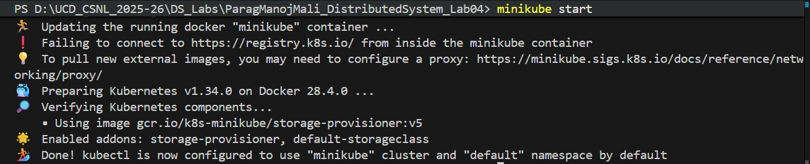

      - Build JAR’s
cd services\shortener-service
mvn clean package -DskipTests

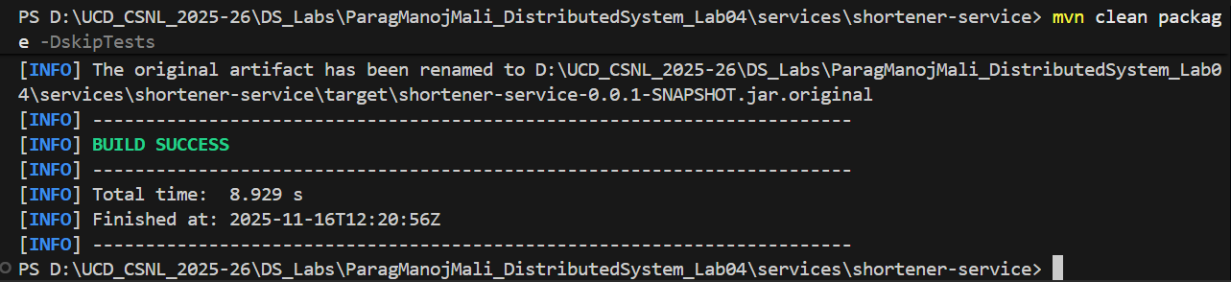

cd services\redirect-service
mvn clean package -DskipTests

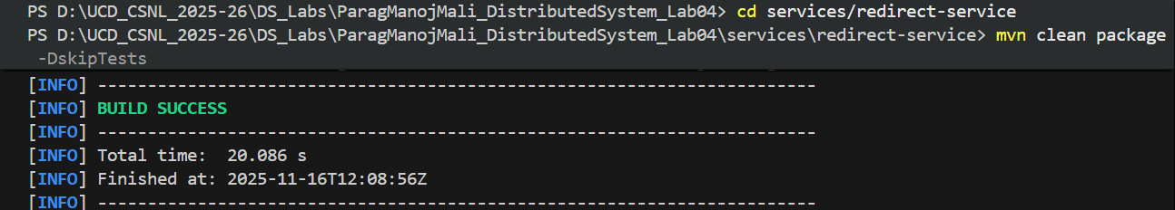

      - Build Docker images inside Minikube

& minikube -p minikube docker-env --shell powershell | Invoke-Expression

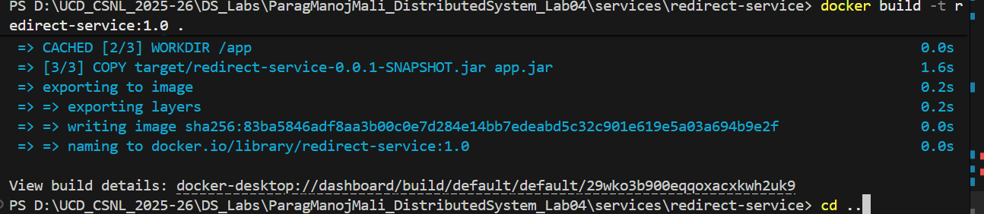
docker build -t redirect-service:1.0 .

docker build -t shortener-service:1.0 .
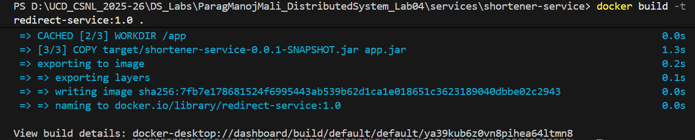
      - Apply Kubernetes manifests

kubectl apply -f redirect-deployment.yml

kubectl apply -f shortener-deployment.yml
- Access shortener-service
Shortener-service URL :
minikube service shortener-service –url

Redirect-service URL:
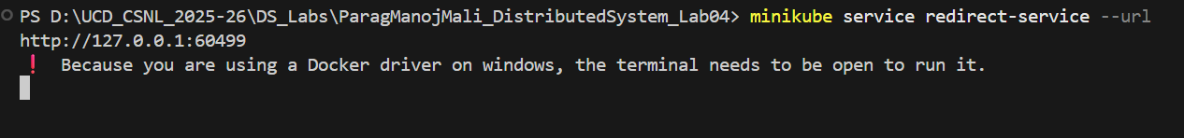
minikube service redirectr-service –url

- Test endpoints
To test the POST request:
Invoke-WebRequest -Uri "http://127.0.0.1:65004/shorten" `
>> -Method POST `
>> -ContentType "application/json" `
>> -Body "{ ""longUrl"": ""https://google.com"" }"
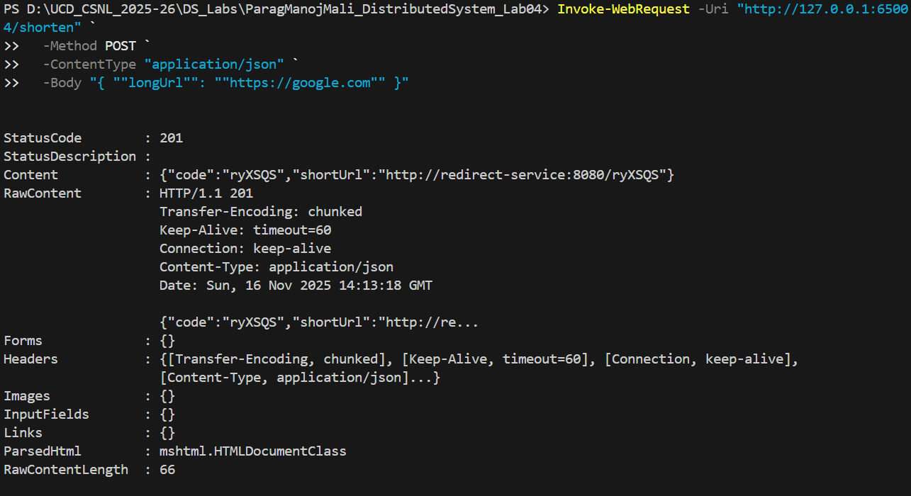
Here, we can see that code for long url is created : ryXSQS. Now testing the URL which will give the result of long URL : https://google.com
Invoke-WebRequest -Uri http://127.0.0.1:60499/ryXSQS
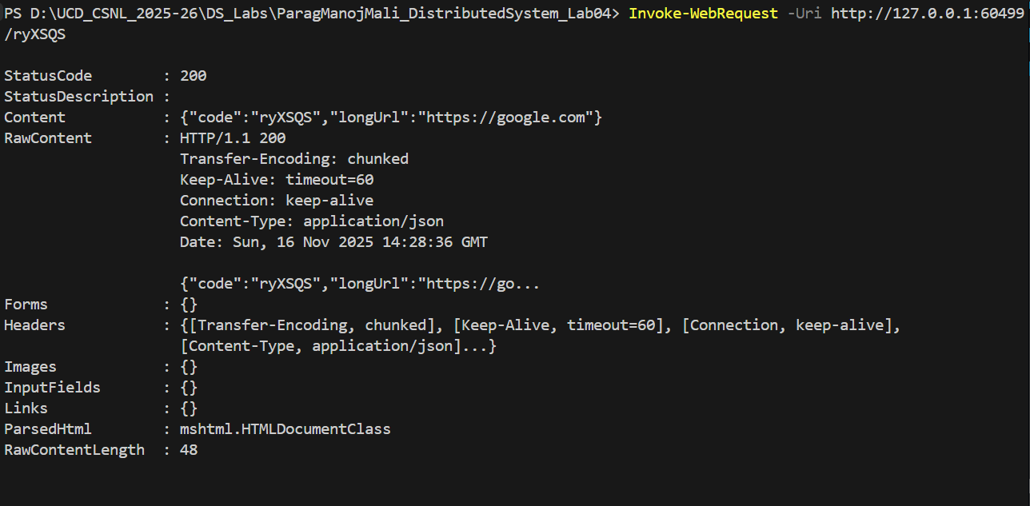
- ARCHITECTURAL ANALYSIS & JUSTIFICATION

  - Microservice Granularity
Service boundaries were split based on:
- Different scalability needs
- Different failure domains
- Different performance profiles

  - Inter-Service Communication Pattern
Synchronous REST chosen.
Positive Trade-offs:
- Simple implementation
- Strong consistency

Negative Trade-offs:
- Tight coupling
- Cascading failure risk

  - Deployment Architecture Analysis
Kubernetes provides:
- DNS discovery
- Restart automation
- Horizontal scaling
Trade-offs:
Higher operational complexity

- ARCHITECTURAL DECISION RECORDS (ADRS)
- ADR 1 – Choosing Java + Spring Boot
- ADR 2 – Choosing synchronous REST
- ADR 3 – Splitting services based on scalability needs

- CONCLUSION
This lab reinforced the importance of architectural trade-offs, microservice boundaries, communication choices, and Kubernetes orchestration.

