Practical No: 7 and 8

Online Shopping Cart

Introduction:
In online marketing, a shopping cart is a piece of e-commerce software on a web server that allows visitors to an Internet site to select items for eventual purchase, analogous to the American English term "shopping cart." In British English, it is generally known as a shopping basket, almost exclusively shortened on websites to 'basket'.

The software allows online shopping customers to accumulate a list of items for purchase, described metaphorically as “placing items in the shopping cart” or “add to cart”. Upon checkout, the software typically calculates a total for the order, including shipping and handling (i.e. postage and packing) charges and the associated taxes, as applicable.

Technologies that are used in this Shopping Cart:
- Java as programming language
- HTML, CSS, Java Script for designing web pages
- MySQL as Database

Steps and Code to create Shopping cart:
- Create Java Web Application named OnlineShopping
- Create Following CSS Files in OnlineShopping/Web Pages/css/
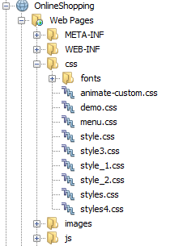

- Create a directory named “images” to store images in OnlineShopping/Web Pages
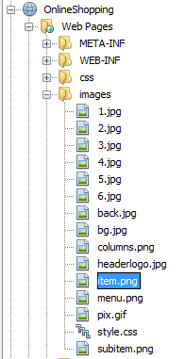

- Same as above create a “js” directory to store javascripts OnlineShopping/Web Pages
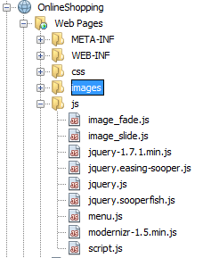
- Create a database name “OnlineShopping” and create following tables as shown:
- UserMaster:
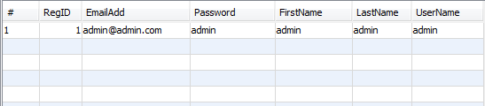

- Books
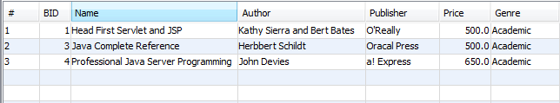

- MyCart
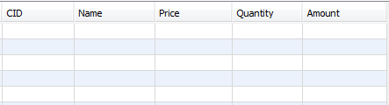

- First of all Create a basicStructure.jsp in OnlineShopping/Web Pages that will hod the basic structure of each and every jsp page and put the following code:
<html>
<div style="visibility: hidden">
<br />
<a href="http://apycom.com/">Apycom jQuery Menus</a><br />
</div>
<head>
<link rel="shortcut icon" href="images/headerlogo.jpg"/>
<link rel="stylesheet" type="text/css" href="css/style.css" />

<title></title>

<link type="text/css" href="css/menu.css" rel="stylesheet" />
<script type="text/javascript" src="js/script.js"></script>

<script type="text/javascript" src="js/menu.js"></script>
<title>Online Shopping Cart</title>
</head>
<body>
<style type="text/css">
* { margin:0;
padding:0;
}
*{
margin:0;
padding:0;
}

#wrapper{
width:960px;
margin:0 auto;
text-align:left;
}
body { background:#555 url(images/bg.jpg); }
#menu { top:-22px; }

</style>

<div id="menu">
<ul class="menu">
<li><a href="home.jsp"><span>Home</span></a>

<li><a href=" Shop.jsp" class="parent"><span>Look For BOOKS</span></a>
<div class="columns two">
<ul class="one">
<li><a><span><b><h3>Books</h3></b></span></a></li>
<li><a href="Shop.jsp" id="Academic And Professional"><span>Academic & Professional</span></a></li>
<li><a href="Shop.jsp" id="Entrance Exam"><span>Entrance Exam</span></a></li>
<li><a href="Shop.jsp" id="Literature And Fiction"><span>Literature & Fiction</span></a></li>
<li><a href="Shop.jsp" id="Children"><span>Children</span></a></li>
</ul>
</div>
</li>
&nbsp;
&nbsp;
<li class="last"><a href="viewCart.jsp"><span>View Cart</span></a></li>
<li><a ><span></span></a></li>
<li><a><span></span></a></li>
<li><a href="LogIn.jsp"><span>LogOut</span></a></li>
</ul>
</div>
</body>
</html>

- Now Create a login page named login.jsp to validate the existing user and If user is not a member of website than he/she must be register first to use the application and for both purpose the following script will be used, put following code in to it:
<html>
<head>
<meta charset="UTF-8" />
<title>Login and Registration</title>
<link rel="shortcut icon" href="images/headerlogo.jpg">
<link rel="stylesheet" type="text/css" href="css/demo.css" />
<link rel="stylesheet" type="text/css" href="css/style3.css" />
<link rel="stylesheet" type="text/css" href="css/animate-custom.css" />
</head>
<body>
<div class="container">

<div class="codrops-top">
<span class="right">
</span>
<div class="clr"></div>
</div>
<header>
<h1>Login and Registration</h1>
<nav class="codrops-demos">
</nav>
</header>
<section>
<div id="container_demo" >
<a class="hiddenanchor" id="toregister"></a>
<a class="hiddenanchor" id="tologin"></a>
<div id="wrapper">
<div id="login" class="animate form">
<form action="ValidateUser" autocomplete="on" method="POST">
<h1>Log in</h1>
<p>
<label for="username" class="uname" data-icon="u" > Your email or username </label>
<input id="username" name="txtUserName" required="required" type="text" placeholder="myusername or mymail@mail.com"/>
</p>
<p>
<label for="password" class="youpasswd" data-icon="p"> Your password </label>
<input id="password" name="txtPass" required="required" type="password" placeholder="eg. X8df!90EO" />
</p>
<p class="keeplogin">
<input type="checkbox" name="loginkeeping" id="loginkeeping" value="loginkeeping" />
<label for="loginkeeping">Keep me logged in</label>
</p>
<p class="login button">
<input type="submit" value="Login" />
</p>
<p class="change_link">
Not a member yet ?
<a href="#toregister" class="to_register">Join us</a>
</p>
</form>
</div>

<div id="register" class="animate form">
<form action="NewUser" autocomplete="on" method="POST">
<h1> Sign up </h1>
<p>
<label for="usernamesignup" class="uname" data-icon="u">First Name</label>
<input id="usernamesignup" name="txtFirstName" required="required" type="text" placeholder="John" />
</p>
<p>
<label for="usernamesignup" class="uname" data-icon="u">Last Name</label>
<input id="usernamesignup" name="txtLastName" required="required" type="text" placeholder="Smith" />
</p>
<p>
<label for="usernamesignup" class="uname" data-icon="u">Your username</label>
<input id="usernamesignup" name="txtUserName" required="required" type="text" placeholder="John.Smith.690" />
</p>
<p>
<label for="emailsignup" class="youmail" data-icon="e" > Your email</label>
<input id="emailsignup" name="txtEmailAdd" required="required" type="email" placeholder="JohnSmith690@mail.com"/>
</p>
<p>
<label for="passwordsignup" class="youpasswd" data-icon="p">Your password </label>
<input id="passwordsignup" name="txtPass" required="required" type="password" placeholder="eg. X8df!90EO"/>
</p>
<p>
<label for="passwordsignup_confirm" class="youpasswd" data-icon="p">Please confirm your password </label>
<input id="passwordsignup_confirm" name="txtCPass" required="required" type="password" placeholder="eg. X8df!90EO"/>
</p>
<p class="keeplogin">
<input type="checkbox" name="chkAgree" id="loginkeeping" value="Agreement" checked="" required="required" />
<label for="loginkeeping">Agree the terms and Conditions</label>
</p>
<p class="signin button">
<input type="submit" value="Sign up"/>
</p>
<p class="change_link">
Already a member ?
<a href="#tologin" class="to_register"> Go and log in </a>
</p>
</form>
</div>
</div>
</div>
</section>
</div>
</body>
</html>

- When user logs into his or her account there should be a home page to navigate the user for this purpose create a home.jsp page and put the following code into it:
<%@page contentType="text/html" pageEncoding="UTF-8"%>
<!DOCTYPE html>
<html>
<head>
<script type="text/javascript" src="js/modernizr-1.5.min.js"></script>
<link rel="stylesheet" type="text/css" href="css/style.css" />
<script type="text/javascript" src="js/modernizr-1.5.min.js"></script>
<title>Online shopping</title>
</head>
<body>
<%@include file="basicStructure.jsp" %>
<h2><center><h2>One Shop Stop for Books!!</h2></center></h2> <br><br/>
<div id="site_content">
<div id="sidebar_container">
<div class="sidebar">
<h1>Latest Books</h1>
<h2>New Releases</h2>
<p>We've redesigned our own website. Take a look around and let us know what you think.</p>
</div>

<div class="sidebar">
<h1>Contact Us</h1>
<p>We'd love to hear from you. Complete our <a href="Contact.jsp">contact form</a>.</p>
</div>
</div>
<div id="content">
<ul class="slideshow">
<li class="show"><img width="706" height="316" src="images/1.jpg" alt="image one" /></li>
<li><img width="706" height="316" src="images/2.jpg" alt="image two" /></li>
<li><img width="706" height="316" src="images/3.jpg" alt="image three" /></li>
<li><img width="706" height="316" src="images/4.jpg" alt="image four" /></li>
<li><img width="706" height="316" src="images/5.jpg" alt="image five" /></li>
</ul>
<div id="content_item">

</div>
</div>
</div>
<footer>
<p><a href="home.jsp">Home</a> </p>

</footer>
<p>&nbsp;</p>
<p>&nbsp;</p>
</div>
<script type="text/javascript" src="js/jquery.js"></script>
<script type="text/javascript" src="js/jquery.easing-sooper.js"></script>
<script type="text/javascript" src="js/jquery.sooperfish.js"></script>
<script type="text/javascript" src="js/image_fade.js"></script>
<script type="text/javascript">
$(document).ready(function() {
$('ul.sf-menu').sooperfish();
});
</script>
</body>
</html>

- If user wants to shop something for this purpose there should be a page as well for this create a page name shop.jsp and put the following code into it:
<%@ page import="java.sql.*" %>
<%@ page import="java.io.*" %>
<html>
<head>
<title>Online Shopping</title>
<link rel="stylesheet" href="css/style_2.css">
</head>
<body>
<%@include file="basicStructure.jsp"%>
<%
try {
Statement prmt;
ResultSetMetaData rsmd = null;
ResultSet rs;
Connection con = null;
Class.forName("com.mysql.jdbc.Driver").newInstance();
con = DriverManager.getConnection("jdbc:mysql://localhost:3306/onlineshopping", "root", "");

prmt = con.createStatement();

rs = prmt.executeQuery("select *from books");

%>
<div class="plans">
<%
while (rs.next()) {

%>

<div class="plan">

<form action="AddToCartServlet" method="post">
<%
int id=rs.getInt(1);
String bookName=rs.getString(2);
String author=rs.getString(3);
String publisher=rs.getString(4);
double price=rs.getFloat(5);
String genre=rs.getString(6);
%>
<h3 class="plan-title"><%= bookName%></h3>
<p class="plan-price"><%= price%> <span class="plan-unit">Per Copy</span></p>
<ul class="plan-features">
<center>Author<span class="plan-unit"><%= author%></span></center>
<center>Publisher<span class="plan-unit"> <%= publisher%> </span></center>
<center>Genre<span class="plan-unit"><%= genre%></span></center>
<center> Quantity:<input type="text" name="txtQuantity" size="5" value="1"></center>
</ul>
<input type="hidden" name="txtHidden" value="<%=id%>" >
<center><input type="submit" value="Add to Cart" class="plan-button"></center>
</form>
</div>

<%
}
%>
</div>
<%
con.close();
} catch (Exception ex) {
out.println("Unable to connect to database.");
}
%>
<footer>
<p><a href="home.jsp" >Home</a</p>
</footer>
<p>&nbsp;</p>
<p>&nbsp;</p>
</body>
</html>

- For Viewing the cart of the user he/she must have a page that will show the cart details for this create a page name viewCart.jsp and put following code into it:
<%@ page import="java.sql.*" %>
<%@ page import="java.io.*" %>
<html>
<head>
<title>Online Shopping</title>
<link rel="stylesheet" href="css/style_2.css">
</head>
<body>
<%@include file="basicStructure.jsp"%>
<h2><center><h2>You have Following in you Cart</h2></center></h2>
<%
try {
Statement prmt;
ResultSetMetaData rsmd = null;
ResultSet rs;
Connection con = null;
Class.forName("com.mysql.jdbc.Driver").newInstance();
con = DriverManager.getConnection("jdbc:mysql://localhost:3306/onlineshopping", "root", "");
prmt = con.createStatement();

rs = prmt.executeQuery("select *from mycart");
//out.print(rs);
%>
<div class="plans">
<%
while (rs.next()) {
%>
<div class="plan">
<form action="RemoveFromCartServlet" method="post">
<h3 class="plan-title"><%= rs.getString(2)%></h3>
<b>Total</b><p class="plan-price"><%= rs.getFloat(5)%> <span class="plan-unit"></span></p>
<ul class="plan-features">

<center>Quantity<span class="plan-unit"> <%= rs.getInt(4)%> </span></center>
<center>Per Copy<span class="plan-unit"><%= rs.getFloat(3)%></span></center>
</ul>
<input type="hidden" name="txtHidden" value="<%= rs.getInt(1) %>" >
<center><input type="submit" value="Remove" class="plan-button"></center>
</form>
</div>
<%
}
%>
</div>
<%
con.close();
} catch (Exception ex) {
out.println("Unable to connect to database.");
}
%>
<footer>
<p><a href="home.jsp" >Home</a> </p>
</footer>
<p>&nbsp;</p>
<p>&nbsp;</p>
</body>
</html>

- After doing all the designing now it time to code some java classes and servlets
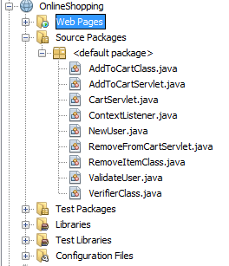

- Create a ValidateServlet for authentication of user for this write following code into servlet:
import java.io.IOException;
import java.io.PrintWriter;
import javax.servlet.RequestDispatcher;
import javax.servlet.ServletException;
import javax.servlet.http.HttpServlet;
import javax.servlet.http.HttpServletRequest;
import javax.servlet.http.HttpServletResponse;

public class ValidateUser extends HttpServlet {

protected void processRequest(HttpServletRequest request, HttpServletResponse response)
throws ServletException, IOException {

response.setContentType("text/html;charset=UTF-8");
PrintWriter out = response.getWriter();
try {
String userName=request.getParameter("txtUserName");
String password=request.getParameter("txtPass");

if(VerifierClass.checkUser(userName, password))
{
RequestDispatcher rd= request.getRequestDispatcher("home.jsp");
rd.forward(request, response);
}
else
{
out.println("<script>alert('Wrong password or username');</script>");
RequestDispatcher rd=request.getRequestDispatcher("LogIn.jsp");
rd.include(request, response);
}

} finally {
out.close();
}
}

@Override
protected void doGet(HttpServletRequest request, HttpServletResponse response)
throws ServletException, IOException {
processRequest(request, response);
}

@Override
protected void doPost(HttpServletRequest request, HttpServletResponse response)
throws ServletException, IOException {
processRequest(request, response);
}

@Override
public String getServletInfo() {
return "Short description";
}

}

- If user is not registered the new account must be create for this create another servlet NewUser and put following code:

import java.io.IOException;
import java.io.PrintWriter;
import java.util.logging.Level;
import java.util.logging.Logger;
import javax.servlet.RequestDispatcher;
import javax.servlet.ServletException;
import javax.servlet.http.HttpServlet;
import javax.servlet.http.HttpServletRequest;
import javax.servlet.http.HttpServletResponse;

public class NewUser extends HttpServlet {

protected void processRequest(HttpServletRequest request, HttpServletResponse response)
throws ServletException, IOException, InstantiationException {
response.setContentType("text/html;charset=UTF-8");
PrintWriter out = response.getWriter();

String userName = request.getParameter("txtUserName");
String firstName = request.getParameter("txtFirstName");
String lastName = request.getParameter("txtLastName");
String password = request.getParameter("txtPass");
String cPassword = request.getParameter("txtCPass");
String eMail = request.getParameter("txtEmailAdd");

try {

{
int c = VerifierClass.newUser(userName, firstName, lastName, password, eMail);
if (c > 0) {
out.println("<script>alert('Successfull Registration please login');</script>");
RequestDispatcher rd = request.getRequestDispatcher("LogIn.jsp");
rd.include(request, response);
} else {
out.println("<script>alert('Something went wrong');</script>");
}
}
} finally {
out.close();
}
}

@Override
protected void doGet(HttpServletRequest request, HttpServletResponse response)
throws ServletException, IOException {
try {
processRequest(request, response);
} catch (InstantiationException ex) {
Logger.getLogger(NewUser.class.getName()).log(Level.SEVERE, null, ex);
}
}

@Override
protected void doPost(HttpServletRequest request, HttpServletResponse response)
throws ServletException, IOException {
try {
processRequest(request, response);
} catch (InstantiationException ex) {
Logger.getLogger(NewUser.class.getName()).log(Level.SEVERE, null, ex);
}
}

@Override
public String getServletInfo() {
return "Short description";
}// </editor-fold>

}

- For both above servlet to function properly we must have java class for this create a class named Varfier.java and put the code into it:

import java.sql.*;

public class VerifierClass {

public static boolean checkUser(String userName, String password) {
Connection con;
PreparedStatement pst;
ResultSet rs;
boolean flag = false;
try {
Class.forName("com.mysql.jdbc.Driver").newInstance();
con = DriverManager.getConnection("jdbc:mysql://localhost:3306/onlineshopping", "root", "");
pst = con.prepareStatement("select *from usermaster where userName=? and password=?");
pst.setString(1, userName);
pst.setString(2, password);
rs = pst.executeQuery();
flag = rs.next();
} catch (ClassNotFoundException e) {
System.out.println(e);
} catch (InstantiationException e) {
System.out.println(e);
} catch (IllegalAccessException e) {
System.out.println(e);
} catch (SQLException e) {
System.out.println(e);
}
return flag;
}

public static int newUser(String userName, String firstName, String lastName, String password, String eMail) throws InstantiationException {
Connection con = null;
PreparedStatement stm = null;
ResultSet rs;
try {
Class.forName("com.mysql.jdbc.Driver").newInstance();
con = DriverManager.getConnection("jdbc:mysql://localhost:3306/onlineshopping", "root", "");
String sql;
sql = "INSERT INTO usermaster(EmailAdd,Password,FirstName,LastName,UserName) VALUES(?, ?, ?, ?, ?)";
stm = con.prepareStatement(sql);
stm.setString(1, eMail);
stm.setString(2, password);
stm.setString(3, firstName);
stm.setString(4, lastName);
stm.setString(5, userName);

int c = stm.executeUpdate();
if (c > 0) {
return 1;
} else {
return 0;
}

} catch (ClassNotFoundException e) {
System.out.println(e);
} catch (SQLException e) {

} catch (IllegalAccessException e) {
System.out.println(e);
}
return 1;
}
}

- After logged into the account user have to see the items or add them to the cart for this purpose create a servlet AddToCartServlet and put following code:
/*
* To change this license header, choose License Headers in Project Properties.
* To change this template file, choose Tools | Templates
* and open the template in the editor.
*/

import java.io.IOException;
import java.io.PrintWriter;
import java.util.logging.Level;
import java.util.logging.Logger;
import static javax.management.Query.or;
import javax.servlet.RequestDispatcher;
import javax.servlet.ServletException;
import javax.servlet.http.HttpServlet;
import javax.servlet.http.HttpServletRequest;
import javax.servlet.http.HttpServletResponse;

public class AddToCartServlet extends HttpServlet {

protected void processRequest(HttpServletRequest request, HttpServletResponse response)
throws ServletException, IOException, InstantiationException {
response.setContentType("text/html;charset=UTF-8");
PrintWriter out = response.getWriter();
try {
int id=Integer.parseInt(request.getParameter("txtHidden"));
int q=Integer.parseInt(request.getParameter("txtQuantity"));

if(q<1)
{
out.println("<script>alert('Please Provide correct quantity');</script>");
RequestDispatcher rd = request.getRequestDispatcher("Shop.jsp");
rd.include(request, response);
}
else
{
int c = AddToCartClass.addToCart(id,q);
if (c > 0) {
out.println("<script>alert('Successfull Added to Cart');</script>");
RequestDispatcher rd = request.getRequestDispatcher("Shop.jsp");
rd.include(request, response);
} else {
out.println("<script>alert('Item could not added to cart);</script>");
}
}

} finally {
out.close();
}
}

@Override
protected void doGet(HttpServletRequest request, HttpServletResponse response)
throws ServletException, IOException {
try {
processRequest(request, response);
} catch (InstantiationException ex) {
Logger.getLogger(AddToCartServlet.class.getName()).log(Level.SEVERE, null, ex);
}
}

@Override
protected void doPost(HttpServletRequest request, HttpServletResponse response)
throws ServletException, IOException {
try {
processRequest(request, response);
} catch (InstantiationException ex) {
Logger.getLogger(AddToCartServlet.class.getName()).log(Level.SEVERE, null, ex);
}
}

@Override
public String getServletInfo() {
return "Short description";
}

}

- Now for the previous servlet to work properly we must have a class that add items into the database for this purpose create a java class named AddToCartClass and put following code:

import java.io.*;
import java.sql.Connection;
import java.sql.DriverManager;
import java.sql.PreparedStatement;
import java.sql.ResultSet;
import java.sql.SQLException;
import java.sql.Statement;

public class AddToCartClass {

public static int addToCart(int id, int quantity) throws InstantiationException {

Connection con;
PreparedStatement stm;
Statement st;
ResultSet rs;
try {
Class.forName("com.mysql.jdbc.Driver").newInstance();
con = DriverManager.getConnection("jdbc:mysql://localhost:3306/onlineshopping", "root", "");

st = con.createStatement();
String sql = "Select *from books where bid='" + id + "'";
rs = st.executeQuery(sql);
rs.next();

String bookName = rs.getString(2);
double price = rs.getFloat(5);
double amount = price * quantity;

String sql1 = "INSERT INTO mycart(Name,Price,Quantity,Amount) VALUES(?, ?, ?, ?)";
stm = con.prepareStatement(sql1);
stm.setString(1, bookName);
stm.setDouble(2, price);
stm.setInt(3, quantity);
stm.setDouble(4, amount);

int c = stm.executeUpdate();
if (c > 0) {
return 1;
} else {
return 0;
}

} catch (ClassNotFoundException e) {
System.out.println(e);
} catch (IllegalAccessException e) {
System.out.println(e);
} catch (InstantiationException e) {
System.out.println(e);
} catch (SQLException e) {
System.out.println(e);
}
return 1;
}

}

- Now after adding if user wants to remove some unwanted item user must have that facility for this purpose create a servlet named RemoveFromCartServlet and put the following code into it:
import java.io.IOException;
import java.io.PrintWriter;
import javax.servlet.RequestDispatcher;
import javax.servlet.ServletException;
import javax.servlet.http.HttpServlet;
import javax.servlet.http.HttpServletRequest;
import javax.servlet.http.HttpServletResponse;

public class RemoveFromCartServlet extends HttpServlet {

protected void processRequest(HttpServletRequest request, HttpServletResponse response)
throws ServletException, IOException {
response.setContentType("text/html;charset=UTF-8");
PrintWriter out = response.getWriter();
try {
int id=Integer.parseInt(request.getParameter("txtHidden"));
int c = RemoveItemClass.removeItem(id);
if (c > 0) {
out.println("<script>alert('Item Successfull Removed From Cart');</script>");
RequestDispatcher rd = request.getRequestDispatcher("viewCart.jsp");
rd.include(request, response);
} else {
out.println("<script>alert('Item could not removed from cart);</script>");
}
} finally {
out.close();
}
}

@Override
protected void doGet(HttpServletRequest request, HttpServletResponse response)
throws ServletException, IOException {
processRequest(request, response);
}

@Override
protected void doPost(HttpServletRequest request, HttpServletResponse response)
throws ServletException, IOException {
processRequest(request, response);
}

@Override
public String getServletInfo() {
return "Short description";
}

}

- For above servlet to work properly create a java class name RemoveItemClass and put the following code into it:

import java.sql.Connection;
import java.sql.DriverManager;
import java.sql.PreparedStatement;
import java.sql.ResultSet;
import java.sql.SQLException;
import java.sql.Statement;

public class RemoveItemClass {

public static int removeItem(int id) {
Connection con;
PreparedStatement stm;
Statement st;
ResultSet rs;
try {
Class.forName("com.mysql.jdbc.Driver").newInstance();
con = DriverManager.getConnection("jdbc:mysql://localhost:3306/onlineshopping", "root", "");
String sql = "Delete from mycart where CID='"+id+"'";
stm = con.prepareStatement(sql);
int c = stm.executeUpdate();
if (c > 0) {
return 1;
} else {
return 0;
}
} catch (ClassNotFoundException e) {
e.printStackTrace();
} catch (IllegalAccessException e) {
e.printStackTrace();
} catch (InstantiationException e) {
e.printStackTrace();
} catch (SQLException e) {
e.printStackTrace();
}
return 1;
}
}

- Now you DD will look like as follows:

<?xml version="1.0" encoding="UTF-8"?>
<web-app version="2.5" xmlns="http://java.sun.com/xml/ns/javaee" xmlns:xsi="http://www.w3.org/2001/XMLSchema-instance" xsi:schemaLocation="http://java.sun.com/xml/ns/javaee http://java.sun.com/xml/ns/javaee/web-app_2_5.xsd">
<servlet>
<servlet-name>ValidateUser</servlet-name>
<servlet-class>ValidateUser</servlet-class>
</servlet>

<servlet>
<servlet-name>NewUser</servlet-name>
<servlet-class>NewUser</servlet-class>
</servlet>

<servlet>
<servlet-name>ContextListener</servlet-name>
<servlet-class>ContextListener</servlet-class>
</servlet>

<servlet>
<servlet-name>AddToCartServlet</servlet-name>
<servlet-class>AddToCartServlet</servlet-class>
</servlet>

<servlet>
<servlet-name>RemoveFromCartServlet</servlet-name>
<servlet-class>RemoveFromCartServlet</servlet-class>
</servlet>

<servlet-mapping>
<servlet-name>ValidateUser</servlet-name>
<url-pattern>/ValidateUser</url-pattern>
</servlet-mapping>

<servlet-mapping>
<servlet-name>NewUser</servlet-name>
<url-pattern>/NewUser</url-pattern>
</servlet-mapping>

<servlet-mapping>
<servlet-name>ContextListener</servlet-name>
<url-pattern>/ContextListener</url-pattern>
</servlet-mapping>

<servlet-mapping>
<servlet-name>AddToCartServlet</servlet-name>
<url-pattern>/AddToCartServlet</url-pattern>
</servlet-mapping>

<servlet-mapping>
<servlet-name>RemoveFromCartServlet</servlet-name>
<url-pattern>/RemoveFromCartServlet</url-pattern>
</servlet-mapping>

<session-config>
<session-timeout>
30
</session-timeout>
</session-config>
<welcome-file-list>
<welcome-file>LogIn.jsp</welcome-file>
</welcome-file-list>
</web-app>

- Run the Application:
- Loads up the login page:
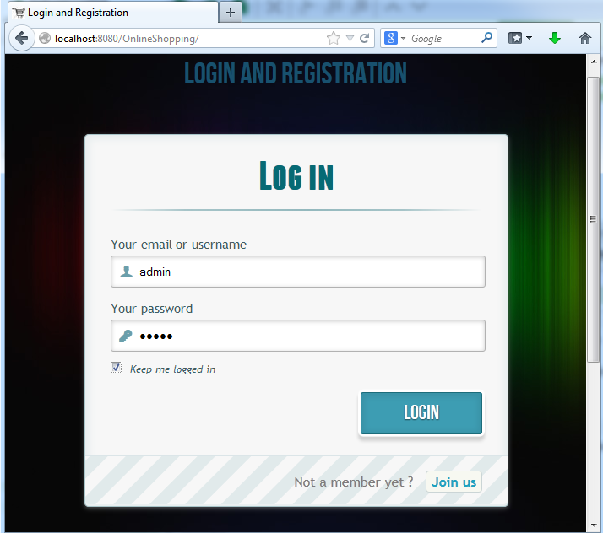

- If username or password or both doesn’t matches in the database following message will appear:
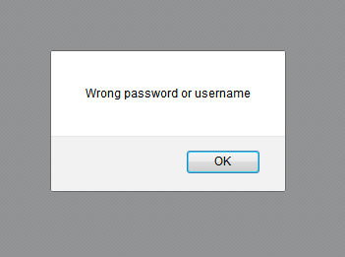
- If user is not a member then he/she must register for that clicking on the link “join us” will redirect you to the sign up page:
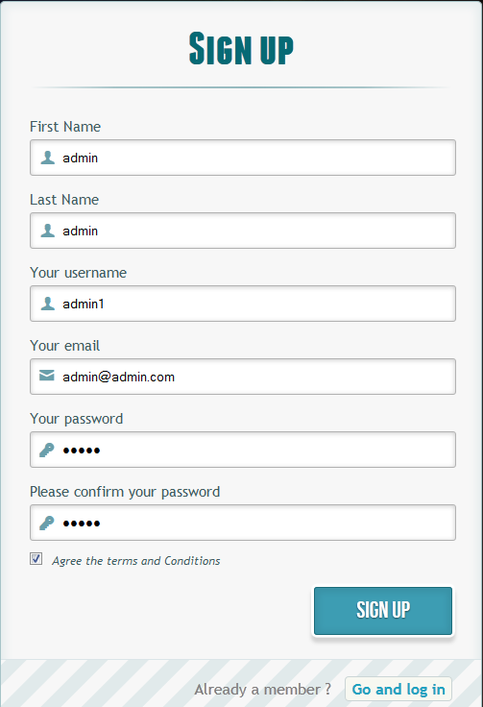
- On Successful Registration following message will appear :
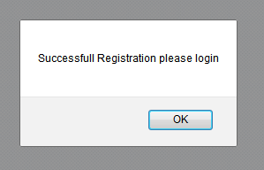

- Home Page:
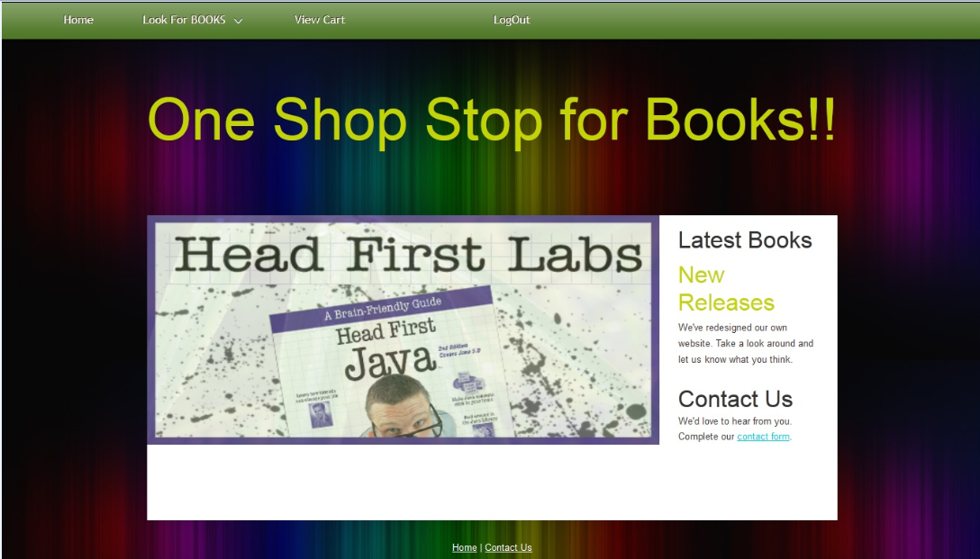

- By Clicking on Look for BOOKS will let you to the shop.jsp
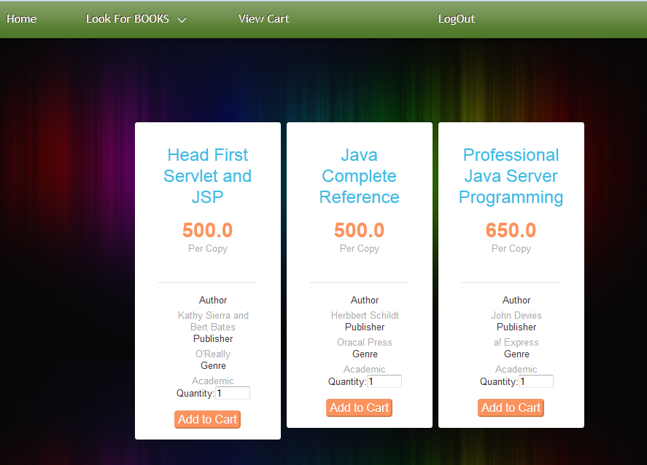
- Clicking on Add to cart will give you following message:

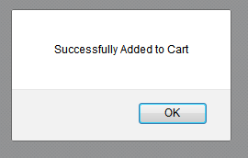

- If you Forget to mention about the quantity following message will appear:
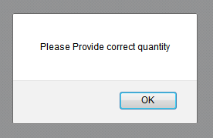

- After Adding items to cart user can view his/her cart by clicking on the View Cart link:
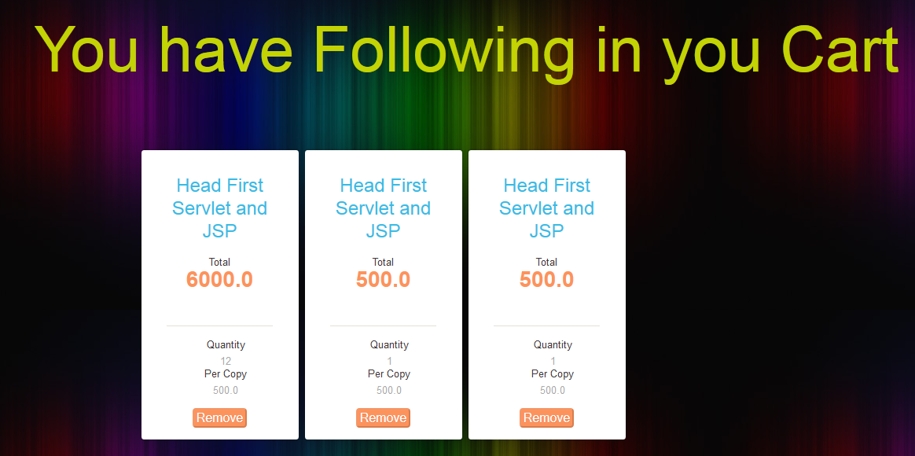

- User can remove the item from cart by clicking Remove that will generate the following output:
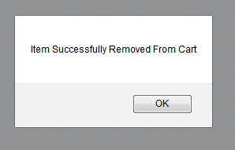

- By clicking LogOut user will successfully logs out of the account

