**Q) Create a Linear Regression Model using Python/R to predict home prices using Boston Housing Dataset**

**(https://www.kaggle.com/c/boston-housing). The Boston Housing dataset contains information about various houses in Boston through**

**different parameters. There are 506 samples and 14 feature variables in this dataset.**

**The objective is to predict the value of prices of the house using the given features**

**----------------------------------------------------------------------------------------------------------------------------------**

Import libraries

In [1]: **import** pandas **as** pd

**import** numpy **as** np **import** matplotlib.pyplot **as** plt **import** seaborn **as** sns **from** sklearn.model_selection **import** train_test_split **from** sklearn.linear_model **import** LinearRegression **from** sklearn.metrics **import** mean_squared_error, mean_absolute_error **from** sklearn.preprocessing **import** StandardScaler

In [2]: boston **=** pd**.**read_csv(r"C:\Users\aades\Desktop\Data Science Um\boston.csv") boston**.**head()

# Out[2]: CRIM ZN INDUS CHAS NOX RM AGE DIS RAD TAX PTRATIO B LSTAT MEDV

|  |  |  |  |  |  |  |  |  |  |  |  |  |  |  |
| --- | --- | --- | --- | --- | --- | --- | --- | --- | --- | --- | --- | --- | --- | --- |
| **0** 0.00632 | | 18.0 2.31 | | 0 0.538 | | 6.575 | 65.2 4.0900 | | 1 296 15.3 396.90 | | | | 4.98 | 24.0 |
| **1** | | 0.02731 | 0.0 | 7.07 | 0 | 0.469 | 6.421 | 78.9 | 4.9671 | 2 | 242 | 17.8 | 396.90 | 9.14 | 21.6 | |
| **2** | | 0.02729 | 0.0 | 7.07 | 0 | 0.469 | 7.185 | 61.1 | 4.9671 | 2 | 242 | 17.8 | 392.83 | 4.03 | 34.7 | |
| **3** | | 0.03237 | 0.0 | 2.18 | 0 | 0.458 | 6.998 | 45.8 | 6.0622 | 3 | 222 | 18.7 | 394.63 | 2.94 | 33.4 | |
| **4** | | 0.06905 | 0.0 | 2.18 | 0 | 0.458 | 7.147 | 54.2 | 6.0622 | 3 | 222 | 18.7 | 396.90 | 5.33 | 36.2 | |

In [3]: x = boston.drop(columns=["MEDV"], axis=1) y = boston.MEDV

In [4]: x**.**head()

# Out[4]: CRIM ZN INDUS CHAS NOX RM AGE DIS RAD TAX PTRATIO B LSTAT

|  |  |  |  |  |  |  |  |  |  |  |  |  |  |
| --- | --- | --- | --- | --- | --- | --- | --- | --- | --- | --- | --- | --- | --- |
| **0** 0.00632 | | 18.0 2.31 | | 0 0.538 | | 6.575 | 65.2 4.0900 | | 1 296 15.3 396.90 | | | | 4.98 |
| **1** | | 0.02731 | 0.0 | 7.07 | 0 | 0.469 | 6.421 | 78.9 | 4.9671 | 2 | 242 | 17.8 | 396.90 | 9.14 | |
| **2** | | 0.02729 | 0.0 | 7.07 | 0 | 0.469 | 7.185 | 61.1 | 4.9671 | 2 | 242 | 17.8 | 392.83 | 4.03 | |
| **3** | | 0.03237 | 0.0 | 2.18 | 0 | 0.458 | 6.998 | 45.8 | 6.0622 | 3 | 222 | 18.7 | 394.63 | 2.94 | |
| **4** | | 0.06905 | 0.0 | 2.18 | 0 | 0.458 | 7.147 | 54.2 | 6.0622 | 3 | 222 | 18.7 | 396.90 | 5.33 | |

In [5]: x**.**shape, y**.**shape

|  |  |
| --- | --- |
| Out[5]: | ((506, 13), (506,)) |
|  |  |

In [6]: x**.**info()

<class 'pandas.core.frame.DataFrame'>

RangeIndex: 506 entries, 0 to 505

Data columns (total 13 columns):

# Column Non-Null Count Dtype --- ------ -------------- ----- 0 CRIM 506 non-null float64

1. ZN 506 non-null float64
2. INDUS 506 non-null float64
3. CHAS 506 non-null int64
4. NOX 506 non-null float64
5. RM 506 non-null float64
6. AGE 506 non-null float64
7. DIS 506 non-null float64
8. RAD 506 non-null int64
9. TAX 506 non-null int64
10. PTRATIO 506 non-null float64
11. B 506 non-null float64
12. LSTAT 506 non-null float64 dtypes: float64(10), int64(3) memory usage: 51.5 KB

|  |  |  |  |  |  |  |  |  |
| --- | --- | --- | --- | --- | --- | --- | --- | --- |
| x**.**describe() |  |  |  |  |  |  |  |  |
| **CRIM** | **ZN** | **INDUS** | **CHAS** | **NOX** | **RM** | **AGE** | **DIS** | **RAD** |

In [7]:

Out[7]:

**count** 506.000000 506.000000 506.000000 506.000000 506.000000 506.000000 506.000000 506.000000 506.000000

|  |  |  |  |  |  |  |  |  |  |
| --- | --- | --- | --- | --- | --- | --- | --- | --- | --- |
| **mean** | 3.613524 | 11.363636 | 11.136779 | 0.069170 | 0.554695 | 6.284634 | 68.574901 | 3.795043 | 9.549407 |
| **std** | 8.601545 | 23.322453 | 6.860353 | 0.253994 | 0.115878 | 0.702617 | 28.148861 | 2.105710 | 8.707259 |
| **min** | 0.006320 | 0.000000 | 0.460000 | 0.000000 | 0.385000 | 3.561000 | 2.900000 | 1.129600 | 1.000000 |
| **25%** | 0.082045 | 0.000000 | 5.190000 | 0.000000 | 0.449000 | 5.885500 | 45.025000 | 2.100175 | 4.000000 |
| **50%** | 0.256510 | 0.000000 | 9.690000 | 0.000000 | 0.538000 | 6.208500 | 77.500000 | 3.207450 | 5.000000 |
| **75%** | 3.677083 | 12.500000 | 18.100000 | 0.000000 | 0.624000 | 6.623500 | 94.075000 | 5.188425 | 24.000000 |
| **max** | 88.976200 | 100.000000 | 27.740000 | 1.000000 | 0.871000 | 8.780000 | 100.000000 | 12.126500 | 24.000000 |

In [8]: y**.**info()

<class 'pandas.core.series.Series'>

RangeIndex: 506 entries, 0 to 505

Series name: MEDV

Non-Null Count Dtype

-------------- -----

506 non-null float64 dtypes: float64(1) memory usage: 4.1 KB

In [9]: y**.**describe()

Out[9]: count 506.000000 mean 22.532806 std 9.197104 min 5.000000 25% 17.025000

50% 21.200000 75% 25.000000 max 50.000000 Name: MEDV, dtype: float64

In [10]: x**.**isnull()**.**sum()

|  |  |
| --- | --- |
| Out[10]: | CRIM 0  ZN 0  INDUS 0  CHAS 0  NOX 0  RM 0  AGE 0  DIS 0  RAD 0  TAX 0  PTRATIO 0  B 0  LSTAT 0 dtype: int64 |

In [11]: y**.**isnull()**.**sum()

|  |  |
| --- | --- |
| Out[11]: | 0 |

In [12]: df **=** x df["target"] **=** y df**.**head()

# Out[12]: CRIM ZN INDUS CHAS NOX RM AGE DIS RAD TAX PTRATIO B LSTAT target

|  |  |  |  |  |  |  |  |  |  |  |  |  |  |  |  |  |
| --- | --- | --- | --- | --- | --- | --- | --- | --- | --- | --- | --- | --- | --- | --- | --- | --- |
| **0** 0.00632 | | 18.0 | | 2.31 | 0 0.538 | | 6.575 | 65.2 4.0900 | | 1 296 | | | 15.3 396.90 | | 4.98 | 24.0 |
| **1** | | 0.02731 | 0.0 |  | 7.07 | 0 | 0.469 | 6.421 | 78.9 | 4.9671 | 2 | 242 |  | 17.8 | 396.90 | 9.14 | 21.6 | |
| **2** | | 0.02729 | 0.0 |  | 7.07 | 0 | 0.469 | 7.185 | 61.1 | 4.9671 | 2 | 242 |  | 17.8 | 392.83 | 4.03 | 34.7 | |
| **3** | | 0.03237 | 0.0 |  | 2.18 | 0 | 0.458 | 6.998 | 45.8 | 6.0622 | 3 | 222 |  | 18.7 | 394.63 | 2.94 | 33.4 | |
| **4** | | 0.06905 | 0.0 |  | 2.18 | 0 | 0.458 | 7.147 | 54.2 | 6.0622 | 3 | 222 |  | 18.7 | 396.90 | 5.33 | 36.2 | |

**Considering only 'RM' and 'LSTAT' by considering correlation and multi-collinearity of other**

# Features

In [13]: df = df[['RM', 'LSTAT', 'target']]

In [14]: x = df[['RM', 'LSTAT']]

y = df['target']

Scale the data

In [15]: scaler **=** StandardScaler()

In [16]: x = scaler.fit_transform(x)

**Split the data**

x_train, x_test, y_train, y_test = train_test_split(x, y, test_size=0.3, shuffle=True)

x_train.shape, x_test.shape, y_train.shape, y_test.shape

((354, 2), (152, 2), (354,), (152,))

**Linear Regression Modelling**

model = LinearRegression(n_jobs=-1)

model.fit(x_train, y_train)

 LinearRegression

LinearRegression(n_jobs=-1)

**Make predictions**

In [21]: y_pred **=** model**.**predict(x_test)

In [22]: mean_absolute_error(y_test, y_pred)

|  |  |
| --- | --- |
| Out[22]: | 3.855448758403843 |

In [23]: mean_squared_error(y_test, y_pred)

|  |  |
| --- | --- |
| Out[23]: | 30.827415858815243 |
|  |  |

In [26]: import pandas as pd

import seaborn as sns

import matplotlib.pyplot as plt

# Assuming x_train[0], x_train[1], and y_train are your variables

# Create a DataFrame containing your variables

data = {'x1': x_train[:,0], 'x2': x_train[:,1], 'y': y_train}

df = pd.DataFrame(data)

# Plot the regression line for y vs x1 and x2

sns.lmplot(x='x1', y='y', data=df, ci=None, scatter_kws={"s": 80}, line_kws={"color": "red"})

sns.lmplot(x='x2', y='y', data=df, ci=None, scatter_kws={"s": 80}, line_kws={"color": "blue"})

plt.show()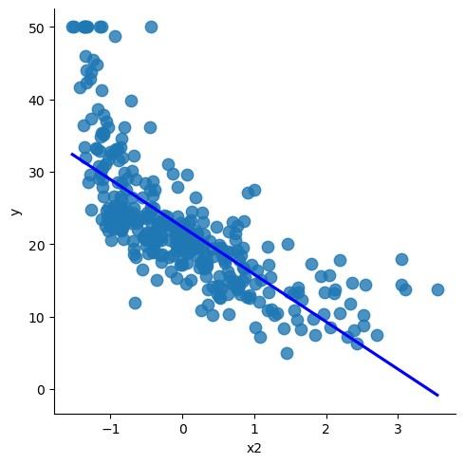

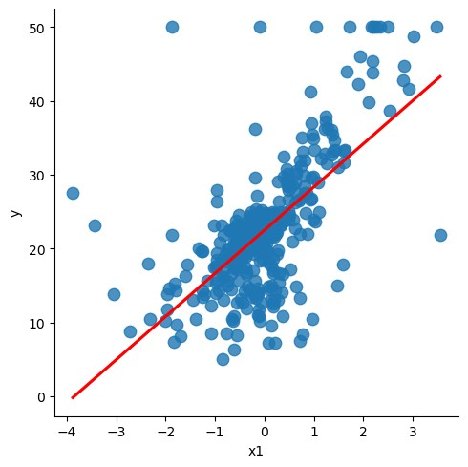

In [27]: df.head()

Out[27]: **x1 x2 y**

**109** -0.079260 0.406075 19.4

|  |  |  |  |
| --- | --- | --- | --- |
| **245** | -0.968247 | 0.813980 | 18.5 |
| **374** | -3.058221 | 3.548771 | 13.8 |
| **151** | -1.254603 | 0.087880 | 19.6 |
| **145** | -0.220301 | 2.123203 | 13.8 |