**1. Implement logistic regression using Python/R to perform classification on Social_Network_Ads.csv dataset.**

**Compute Confusion matrix to find TP, FP, TN, FN, Accuracy, Error rate, Precision, Recall on the given dataset**

**Import all the required Python Libraries.**

In [1]: **import** numpy **as** np

**import** pandas **as** pd

In [2]: df **=** pd**.**read_csv('Social_Network_Ads.csv')

In [3]: df**.**head()

**1) Implement logistic regression using Python/R to perform classification on**

**Social_Network_Ads.csv dataset.**

# Out[3]: User ID Gender Age EstimatedSalary Purchased

|  |  |  |  |  |  |  |
| --- | --- | --- | --- | --- | --- | --- |
| **0** | 15624510 | Male | 19 | 19000 | | 0 |
| **1** | | 15810944 | Male | 35 | 20000 |  | 0 | |
| **2** | | 15668575 | Female | 26 | 43000 |  | 0 | |
| **3** | | 15603246 | Female | 27 | 57000 |  | 0 | |
| **4** | | 15804002 | Male | 19 | 76000 |  | 0 | |
|  | |  |  |  |  |  |  | |

In [4]: df**.**info()

<class 'pandas.core.frame.DataFrame'>

RangeIndex: 400 entries, 0 to 399 Data columns (total 5 columns):

# Column Non-Null Count Dtype --- ------ -------------- ----- 0 User ID 400 non-null int64

1. Gender 400 non-null object
2. Age 400 non-null int64
3. EstimatedSalary 400 non-null int64 4 Purchased 400 non-null int64 dtypes: int64(4), object(1) memory usage: 15.8+ KB

In [5]: df**.**describe()

# Out[5]: User ID Age EstimatedSalary Purchased

|  |  |  |  |  |
| --- | --- | --- | --- | --- |
| **count** | 4.000000e+02 | 400.000000 | 400.000000 | 400.000000 |
| **mean** | | 1.569154e+07 | 37.655000 | 69742.500000 | 0.357500 | |
| **std** | | 7.165832e+04 | 10.482877 | 34096.960282 | 0.479864 | |
| **min** | | 1.556669e+07 | 18.000000 | 15000.000000 | 0.000000 | |
| **25%** | | 1.562676e+07 | 29.750000 | 43000.000000 | 0.000000 | |
| **50%** | | 1.569434e+07 | 37.000000 | 70000.000000 | 0.000000 | |
| **75%** | | 1.575036e+07 | 46.000000 | 88000.000000 | 1.000000 | |
| **max** | | 1.581524e+07 | 60.000000 | 150000.000000 | 1.000000 | |
|  | |  |  |  |  | |

In [6]: X **=** df[['Age', 'EstimatedSalary']]

Y **=** df['Purchased']

In [7]: **from** sklearn.model_selection **import** train_test_split

X_train, X_test, Y_train, Y_test **=** train_test_split(X, Y, test_size **=** 0.25, random_state print(f'Train Dataset Size - X: {X_train**.**shape}, Y: {Y_train**.**shape}') print(f'Test Dataset Size - X: {X_test**.**shape}, Y: {Y_test**.**shape}')

Train Dataset Size - X: (300, 2), Y: (300,)

Test Dataset Size - X: (100, 2), Y: (100,)

In [8]: **import** matplotlib.pyplot **as** plt **import** seaborn **as** sns **from** sklearn.linear_model **import** LogisticRegression lm **=** LogisticRegression(random_state **=** 0, solver**=**'lbfgs' ) lm**.**fit(X_train, Y_train) predictions **=** lm**.**predict(X_test)

**2) Compute Confusion matrix to find TP, FP, TN, FN, Accuracy, Error rate,**

**Precision, Recall on the given dataset.**

**Confusion matrix**

In [9]: **from** sklearn.metrics **import** classification_report cm **=** classification_report(Y_test, predictions) print('Classification report : \n', cm)

Classification report :

precision recall f1-score support

0 0.68 1.00 0.81 68 1 0.00 0.00 0.00 32

accuracy 0.68 100 macro avg 0.34 0.50 0.40 100 weighted avg 0.46 0.68 0.55 100

|  |
| --- |
| **from** sklearn.metrics **import** classification_report, confusion_matrix conf_matrix **=** confusion_matrix(Y_test, predictions) plt**.**figure(figsize**=**(8, 6)) sns**.**heatmap(conf_matrix, annot**=True**, fmt**=**'d', cmap**=**'Blues', cbar**=False**) plt**.**xlabel('Predicted labels') plt**.**ylabel('True labels') plt**.**title('Confusion Matrix') plt**.**show() |

In [10]:

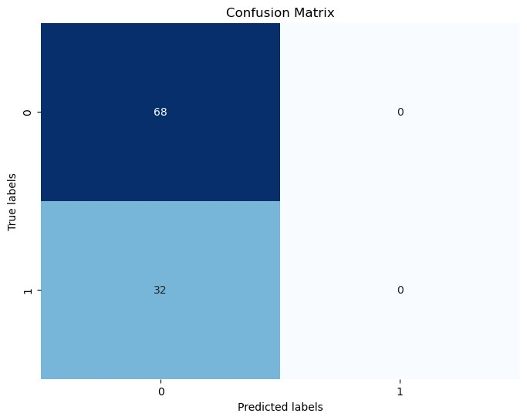

|  |
| --- |
| y_pred **=** lm**.**predict(X_test) cm **=** confusion_matrix(Y_test, y_pred)  TN **=** cm[0, 0]  FP **=** cm[0, 1]  FN **=** cm[1, 0] TP **=** cm[1, 1] accuracy **=** (TP **+** TN) **/** float(TP **+** TN **+** FP **+** FN) error_rate **=** (FP **+** FN) **/** float(TP **+** TN **+** FP **+** FN) precision **=** TP **/** float(TP **+** FP) recall **=** TP **/** float(TP **+** FN) print("\nPerformance Metrics:") print("True Positives (TP):", TP) print("False Positives (FP):", FP) print("True Negatives (TN):", TN) print("False Negatives (FN):", FN) print("Accuracy:", accuracy) print("Error Rate:", error_rate) print("Precision:", precision) print("Recall:", recall) |

In [12]:

Performance Metrics:

True Positives (TP): 0

False Positives (FP): 0

True Negatives (TN): 68

False Negatives (FN): 32

Accuracy: 0.68

Error Rate: 0.32

Precision: nan

Recall: 0.0