**1.Extract Sample document and apply following document preprocessing methods: Tokenization, POS Tagging, stop words removal, Stemming and Lemmatization.**

**2.Create representation of document by calculating Term Frequency and Inverse Document Frequency.**

# Sample Sentences



Sample_Sentences **=** "I played the play playfully as the players were playing in the play with playfullness"

Tokenization



[nltk_data] Downloading package averaged_perceptron_tagger to

[nltk_data] C:\Users\aades\AppData\Roaming\nltk_data...

[nltk_data] Package averaged_perceptron_tagger is already up-to- [nltk_data] date!

**import** nltk nltk**.**download('averaged_perceptron_tagger')

True



**from** nltk.tokenize **import** sent_tokenize



sentences **=** sent_tokenize(Sample_Sentences)



['I played the play playfully as the players were playing in the play with playfullness']

sentences

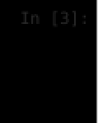

**from** nltk **import** word_tokenize, sent_tokenize sentences **=** sent_tokenize(Sample_Sentences)

tokenized_words **=** [word_tokenize(sentence) **for** sentence **in** sentences] print('sentences words: ',sentences )

print('Tokenized words:', tokenized_words)

sentences words: ['I played the play playfully as the players were playing in the play with playfullness'] Tokenized words: [['I', 'played', 'the', 'play', 'playfully', 'as', 'the', 'players', 'were', 'playing', 'in', ' the', 'play', 'with', 'playfullness']]

# POS Tagging

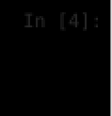

**from** nltk **import** pos_tag

tokenized_words **=** word_tokenize(Sample_Sentences) pos_tags **=** pos_tag(tokenized_words) print("Tagging Parts of Speech:", pos_tags)

Tagging Parts of Speech: [('I', 'PRP'), ('played', 'VBD'), ('the', 'DT'), ('play', 'NN'), ('playfully', 'RB'), (

'as', 'IN'), ('the', 'DT'), ('players', 'NNS'), ('were', 'VBD'), ('playing', 'VBG'), ('in', 'IN'), ('the', 'DT')

, ('play', 'NN'), ('with', 'IN'), ('playfullness', 'NN')]

# Stop-Words Removal

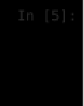

**from** nltk.corpus **import** stopwords

stop_words **=** set(stopwords**.**words('english'))

filtered_tokens **=** [word **for** word **in** tokenized_words **if** word**.**lower() **not in** stop_words] print("Filtered Tokens after Stop Words Removal:", filtered_tokens)

Filtered Tokens after Stop Words Removal: ['played', 'play', 'playfully', 'players', 'playing', 'play', 'playful lness']

# Stemming

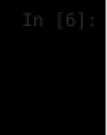

**from** nltk.stem **import** PorterStemmer

stemmer **=** PorterStemmer()

stemmed_tokens **=** [stemmer**.**stem(word) **for** word **in** filtered_tokens] print("Stemmed Tokens:", stemmed_tokens)

Stemmed Tokens: ['play', 'play', 'play', 'player', 'play', 'play', 'playful']

# Lemmatization

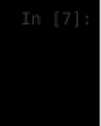

**from** nltk.stem **import** WordNetLemmatizer

lemmatizer **=** WordNetLemmatizer()

lemmatized_tokens **=** [lemmatizer**.**lemmatize(word) **for** word **in** filtered_tokens] print("Lemmatized Tokens:", lemmatized_tokens)

Lemmatized Tokens: ['played', 'play', 'playfully', 'player', 'playing', 'play', 'playfullness']

# 2) Create representation of document by calculating Term Frequency and Inverse Document Frequency.



preprocessed_text **=** ' '**.**join(lemmatized_tokens)

Preprocessed Text: played play playfully player playing play playfullness TF-IDF Representation:

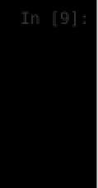

**from** sklearn.feature_extraction.text **import** TfidfVectorizer

tfidf_vectorizer **=** TfidfVectorizer()

tfidf_representation **=** tfidf_vectorizer**.**fit_transform([preprocessed_text])

print("Preprocessed Text:", preprocessed_text) print("\nTF-IDF Representation:") print(tfidf_representation**.**toarray())

[[0.66666667 0.33333333 0.33333333 0.33333333 0.33333333 0.33333333]]