**1.Use the inbuilt dataset 'titanic'. The dataset contains 891 rows and contains information about the passengers who boarded the unfortunate Titanic ship. Use the Seaborn library to see if we can find any patterns in the data.**

**Write a code to check how the price of the ticket (column name: 'fare') for each passenger is distributed by plotting a histogram.**

**-------------------------------------------------------------------------------------------------------------------------------------------**



**import** pandas **as** pd

**import** numpy **as** np

**import** matplotlib.pyplot **as** plt

**import** seaborn **as** sns

**import** warnings warnings**.**filterwarnings('ignore')



df **=** sns**.**load_dataset('titanic')

|  |  |  |  |  |  |  |  |  |  |  |  |  |  |  |  |  |
| --- | --- | --- | --- | --- | --- | --- | --- | --- | --- | --- | --- | --- | --- | --- | --- | --- |
| df**.**head() |  | | | | | | | | | | | | | | | |
| **survived** | **pclass** | **sex** | **age** | **sibsp** | **parch** | **fare** | **embarked** | **class** | **who** | **adult_male** | **deck** | **embark_town** | **alive** | **alone** |  |
| **0** 0 | 3 | male | 22.0 | 1 | 0 | 7.2500 | S | Third | man | True | NaN | Southampton | no | False |  |
| **1** 1 | 1 | female | 38.0 | 1 | 0 | 71.2833 | C | First | woman | False | C | Cherbourg | yes | False |  |
| **2** 1 | 3 | female | 26.0 | 0 | 0 | 7.9250 | S | Third | woman | False | NaN | Southampton | yes | True |  |
| **3** 1 | 1 | female | 35.0 | 1 | 0 | 53.1000 | S | First | woman | False | C | Southampton | yes | False |  |
| **4** 0 | 3 | male | 35.0 | 0 | 0 | 8.0500 | S | Third | man | True | NaN | Southampton | no | True |  |



df**.**info()

<class 'pandas.core.frame.DataFrame'> RangeIndex: 891 entries, 0 to 890 Data columns (total 15 columns):

# Column Non-Null Count Dtype



|  |  |  |  |  |  |  |
| --- | --- | --- | --- | --- | --- | --- |
| 0 |  | survived | 891 | non-null |  | int64 |
| 1 |  | pclass | 891 | non-null |  | int64 |
| 2 |  | sex | 891 | non-null |  | object |
| 3 |  | age | 714 | non-null |  | float64 |
| 4 |  | sibsp | 891 | non-null |  | int64 |
| 5 |  | parch | 891 | non-null |  | int64 |
| 6 |  | fare | 891 | non-null |  | float64 |
| 7 |  | embarked | 889 | non-null |  | object |
| 8 |  | class | 891 | non-null |  | category |
| 9 |  | who | 891 | non-null |  | object |
| 10 |  | adult_male | 891 | non-null |  | bool |
| 11 |  | deck | 203 | non-null |  | category |
| 12 |  | embark_town | 889 | non-null |  | object |
| 13 |  | alive | 891 | non-null |  | object |
| 14 |  | alone | 891 | non-null |  | bool |

dtypes: bool(2), category(2), float64(2), int64(4), object(5) memory usage: 80.7+ KB



(891, 15)

df**.**shape



13365

df**.**size

1. Use the inbuilt dataset 'titanic'. The dataset contains 891 rows and contains information about the passengers who boarded the unfortunate Titanic ship. Use the Seaborn library to see if we can find any patterns in the data.

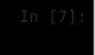

sns**.**pairplot(df , hue **=** 'survived') plt**.**show()

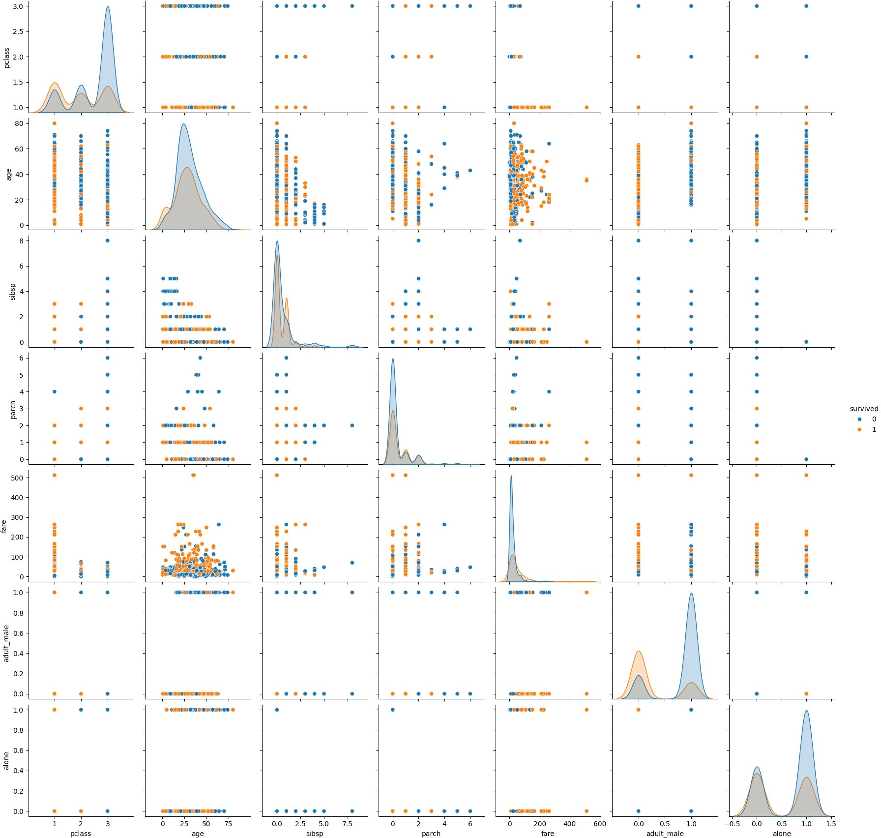

People who paid high fare had slightly more chnace of survival also people who where younger had slightly more chance of survival

1. Write a code to check how the price of the ticket (column name: 'fare') for each passenger is distributed by plotting a histogram.

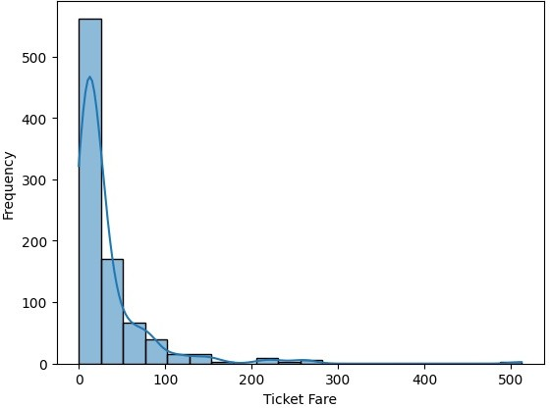



plt**.**xlabel('Ticket Fare') plt**.**ylabel('Frequency') sns**.**histplot(df['fare'] , kde**=True**, bins**=**20) plt**.**show()