**Software Requirement Specifications (SRS)**

**“Trip Management System”**

Guided by,

Mr. S. C. Sagare

Assistant Professor,

Department of Computer Science and Engineering,

Kolhapur Institute of Technology’s College of Engineering, Kolhapur

Semester - VII, A.Y. 2022-23



**Group 06:**

* B04 Om Sanjay Phatak [1920000033]
* B07 Pratham Mohan Patil [1920000074]
* B08 Vinayak Prakash Mali [1920000078]

**Table of Contents**

1. **Introduction 4-6**
   1. Purpose…………………………………………………………… 4
   2. Scope…………………………………………………...………… 4
   3. Goal…………………………….………………………………… 4
   4. References……………………………...………………………… 5
   5. Technologies…………………………………………………...… 5
   6. System Interfaces………………………………………………… 5
   7. Communication Protocol………………………………………… 6
   8. Product Features…………………………….…………………… 6
   9. Assumptions & Dependencies…....……………………………… 6
   10. Apportioning of Requirements…………………………………... 6
2. **System Requirements & Analysis 7-8**
   1. Client View Functionality………………………………………... 7
   2. Admin View Functionality………………………………...……... 8
3. **Functional Requirements 8-9**
   1. Administrator Aspect……………………………………………... 8
   2. Employee Aspect………………………………..………………... 8
   3. Client Aspect……………………………………………………... 9
   4. Analysis…………………………………………………………... 9
4. **Non- Functional Requirements 9-10**
   1. Security Requirements…………………….……………………... 9
   2. Portability Requirements…………………….…………………... 10
5. **Software System Attributes 10**
   1. Maintainability…………………………………………………... 10
   2. Reliability………………………………....……………………... 10
6. **Technologies 10**
7. **Software Requirements 11**
8. **Hardware Requirements 11**
9. **Case Diagram 12-15**
   1. Customer (Client) ………………….…………………………... 12
   2. Employee (Driver) ………………...….………………………... 13
   3. Administrator………………….………………………………... 14

**1.**  **Introduction:**

**Problem Statement:** To design and implement a database for the ‘Trip Management System’.

* 1. **Purpose**

In today’s era, everyone wants convenience and comfort in daily life activities but everywhere it is not possible. Travelling is also a major part of day-to-day activities and in the same case, people want the same comfort assistance throughout the whole journey. The objective of the ‘Trip Management System’ is to automate vehicle rental and reservation. So, customers do not need to call & spend unnecessary time in order to reserve their preferred vehicle. It is a web application that lets you book taxis for inter-city and intra-city travel purposes using your login credentials and provides you the best service that will make your journey more luxurious. The users will be provided with a provision login to the systems so they can check the status of their journey. The taxi driver will be provided with a provision login to the system. So, they can check reservations, update their availability status, and also, they can see their daily, monthly, and yearly fair earnings.

**1.2 Scope**

This project’s aim is to automate the system, calculating the fare, collecting fare, collecting all necessary information of the client and then serving the client. The data used by the system is stored in a database that will be the centre of all information held by clients and employees and the base for the remainder of the process after the initial application has been made. This enables things to be simplified and considerably quickened, making the jobs of the people involved easier. It supports the current process but centralizes it and makes it possible for decisions to be made earlier and easier way.

**1.3 Goal**

The main goal of the system is to automate the process carried out in the organization with improved performance and realize the vision of online booking. Some of the goals of the system are listed below:

* Manage a large number of client details.
* Manage all details of clients who registered and requested for getting the service.
* Create employee accounts and maintain the data effectively.
* View all the details of the clients and employees (drivers).
* Showing available vehicles to book for the client.
* Calculating and showing the fare to the client before booking.
* Create statistical reports to facilitate the finance department’s work.
* Getting a rating from the client to facilitate a reward facility.

**1.4 References**

<http://msdn.microsoft.com/en>[-us/library/ms130214](http://msdn.microsoft.com/en-us/library/ms130214)

[http://www.chambers.com.au/glossary/software_requirements_specificat ion.php](http://www.chambers.com.au/glossary/software_requirements_specificat%20ion.php)

<https://www.coursehero.com/file/68257404/srs>[-online-taxi-bookingdoc/](https://www.coursehero.com/file/68257404/srs-online-taxi-bookingdoc/)

**1.5 Technologies**

* Google Chrome/ Microsoft Edge
* Microsoft Windows 7/8/10
* For internal communication with the client; email is used.
* HTML: Used for the development and maintenance of the group web page.
* Oracle Express Edition

**1.6 System Interfaces**

* Client on the Internet: Web Browser, Operating System (any)
* Web Server: Apache, Operating System (any)
* Database Server: Oracle Express Edition, Operating System (any)
* Development End: HTML, Oracle Express Edition, OS (Windows), Web Server.

**1.6.1 Hardware Interfaces**

* Server-side hardware
* Communication hardware to serve client requests
* Client-side hardware
* Communication hardware to communicate with the server.

**1.6.2 Software Interfaces**

* 1. Server-side software:
     + Web server software
     + Server-side scripting tools: Node.js
     + Database tools: Oracle Express Edition
     + Compatible operating system: Windows
     + Web browser supporting JavaScript
  2. Third Party Software Interfaces:
     + Bootstrap

**1.7 Communication Protocol**

1. Server-side protocols:
   * HTTP incoming request
   * HTTPS incoming request if secure gateway is implemented
2. Client-side protocols:
   * HTTP outgoing request
   * HTTPS outgoing request if secure gateway is implemented

**1.8 Product Features**

Some of the features are identified for the software. They are listed below:

* Calculate Fare: The client must be available to check the fare they should pay for the vehicles.
* Rating: The administrator should be able to see the rating given by each client so that he can get appropriate rewards according to it.

**1.9 Assumptions and Dependencies**

* Vehicles are already purchased and available for use.
* Roles and responsibilities are already established.
* Administrator is already created.

**1.10 Apportioning of Requirements**

It is possible in the future that a few additional features be implemented into this system.

**Management System**:

This will allow the system to manage effectively the other resources in the easiest way.

**Training Facility**:

This will allow effectively train the staffs and improve the quality of service in the company.

**2.**  **System Requirements and Analysis:**

The following sections will introduce the numerous requirements of the system from the point of view of different users and will introduce a number of decisions that have been made regarding implementation.

These sections also attempt to somewhat describe the role of each user group in the system, discussing their individual roles through the functions they can perform.

**User Interface**:

The user interface for this system will have to be simple and clear. Most importantly, the ages must be easy to read, easy to understand and accessible. The colour scheme should be appropriate to provide familiarity with the company and there should be no contrast issues.

* 1. **Client View Functionality:**

**Registration and Login System:**

Clients will carry out their own registration, providing the system with a way to associate a user to their request(s). This will enable the system to display personalized information when the user logs in and certain information, such as name and address, to be added to each booking request automatically...

**Globalization Support:**

**List of Locale:**

The system will be in US English, although the application and their options will be in US English. Hence the application and their options are to be in Unicode format.

**Content to be localized:**

The following table lists all the possible area in the system and also mentions whether that area should support Globalization.

**Booking System:**

The booking process will be as straightforward as possible, using an intuitive form layout, with the necessary information being completed in stages.

**Update Details:**

Employees and clients will all have the ability to update their personal details at any time. Clients, however, will also be able to update their booking details. After the user has confirmed the update, an e-mail is dispatched with the original and new details as

confirmation. The only time a booking will be locked for editing will be when an employee is employed to serve the client.

* 1. **Admin View Functionality:**

**Check Ratings**:

The administrator will be able to check the ratings given by the clients.

**Manage User Portfolio**:

The administrator will provide access to new users and shall be able to delete the employees no longer working for the organization.

**System Statistics**:

If the administrator so wishes, they should be able to view statistics gathered by the system regarding bookings. These statistics should be displayed on a page with individually expandable sections, such as extending the number of bookings from the past year to the past two years.

**Report Generation**:

Generate reports based on the selected criteria.

**3. Functional Requirements:**

The system should satisfy the following requirements:

* 1. **Administrator Aspect:**
  2. Perform weekly roster of Employees
  3. Print reports annually, weekly, and daily
  4. Check ratings
  5. View user portfolio
  6. Changing the super password.
  7. **Employee Aspect:**
  8. Logging into the system.
  9. To check their rosters.
  10. Maintain daily logs
  11. Select availability.
  12. Check online bookings
  13. Withdraw money from CBS to the driver’s wallet
  14. **Client Aspect:**
  15. Add money from CBS to the client’s wallet
  16. Make a booking
  17. Check their booking status
  18. Fair calculation
  19. Trip history
  20. Give rating to a trip
  21. **Analysis:**
  22. Authenticating users based on username and password.
  23. Keeping session track of user activity.
  24. Add money from CBS to wallet
  25. Recording client’s request for booking.
  26. Booked trip payment transfer to CBS
  27. Booked trips shows to driver.
  28. Payment transfer from CBS to driver’s wallet
  29. Keeping history of trip bookings.
  30. Keeping record of ratings received from the clients.

**4. Non-Functional Requirements:**

Some Performance requirements identified is listed below:

1. The database shall be able to accommodate a minimum of 10,000 records of clients.
2. The software shall support use of multiple users at a time.
3. There are no other specific performance requirements that will affect development.

* 1. **Security Requirements:**

Some of the factors that are identified to protect the software from accidental or malicious access, use, modification, destruction, or disclosure are described below. Specific requirements in this area could include the need to: Utilize certain cryptographic techniques Keep a specific log or history of data sets, assign certain functions to different modules, restrict communications between some areas of the program, and check data integrity for

critical variables. Later, the version of the software will incorporate encryption techniques in the user/license authentication process. The software will include an error-tracking log that will help the user understand what error occurred when the application crashed along with suggestions on how to prevent the error from occurring again. Communication needs to be restricted when the application is validating the user or license. (i.e., using https).

* 1. **Portability Requirements:**

Some of the attributes of software that relate to the ease of porting the software to other host machines and/or operating systems. This may include: Apache is used to develop the product. So, it is easiest to port the software in any environment.

**5. Software System Attributes:**

There are a number of attributes of software that can serve as requirements. It is important that required attributes are specified so that their achievement can be objectively verified. The following items provide a partial list of examples. The input system will allow for inputting numbers, operands, special symbols, and letters of the alphabet.

* 1. **Maintainability:**

The user will be able to reset all options and all stored user variables.

* 1. **Reliability:**

Some of the attributes identified for the reliability are listed below:

* All data storage for user variables will be committed to the database at the time of entry.
* Data corruption is prevented by applying the possible backup procedures and techniques.

**6. Technologies:**

This section lists all the technologies for the web-based system.

* JavaScript scripting for server-side scripting as it has a very strong support for XML and Oracle Express Edition.
* XML as database format: The database’s performance requirements are not very high and the ability to have custom fields in case the application form needs to add more than the expected requirement. This is limited in any other database

management system where we have to first specify the maximum number of fields.

**7. Software Requirements**:

* Google Chrome
* Microsoft Edge
* Safari or any other modern Web Browser

**8. Hardware Requirements:**

The recommended hardware specified by the respective software would suffice the needs.

The memory and processing power needed would increase as the number of users increased. The estimated hardware requirements are as specified:

.

* 1. **Server:**

The minimum hardware as recommended by all of the software required on the server side says web server, operating system, and development software.

* Processing speed of 1.6 GHz
* 1 GB of RAM Network interface

* 1. **Client:**

The minimum hardware as recommended by all of the software required on the client side says web browser and operating system.

* Minimum hardware depending on the operating system used
* True colour visual display unit
* User peripherals for better interaction

**9. Case** **Diagrams:**

* 1. **Customer (Client):**

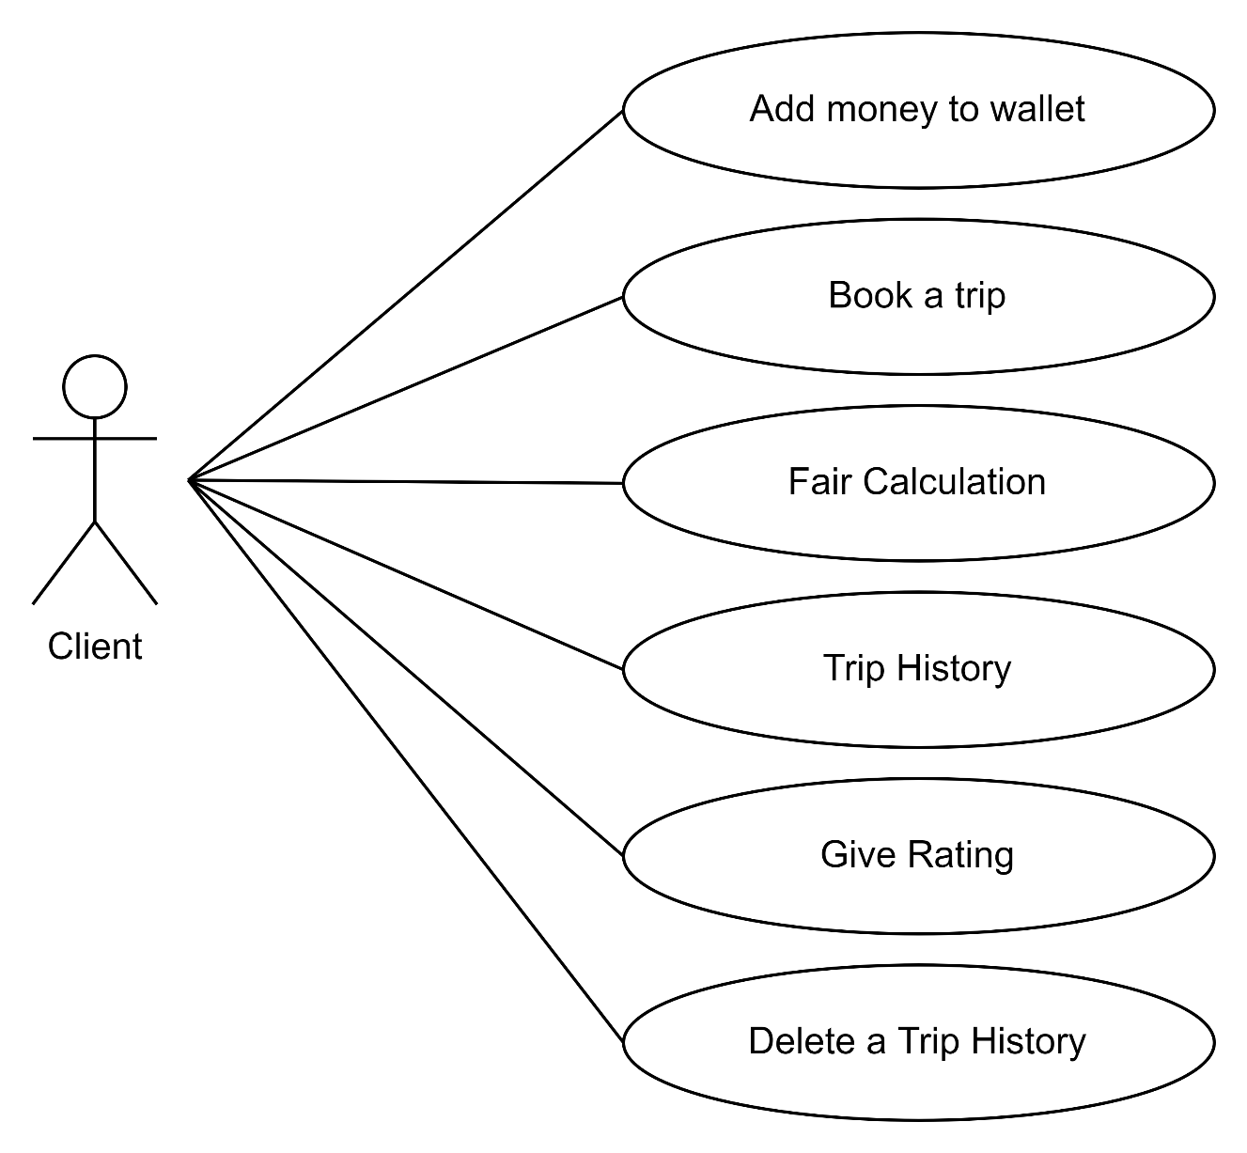

* 1. **Employee (Driver):**

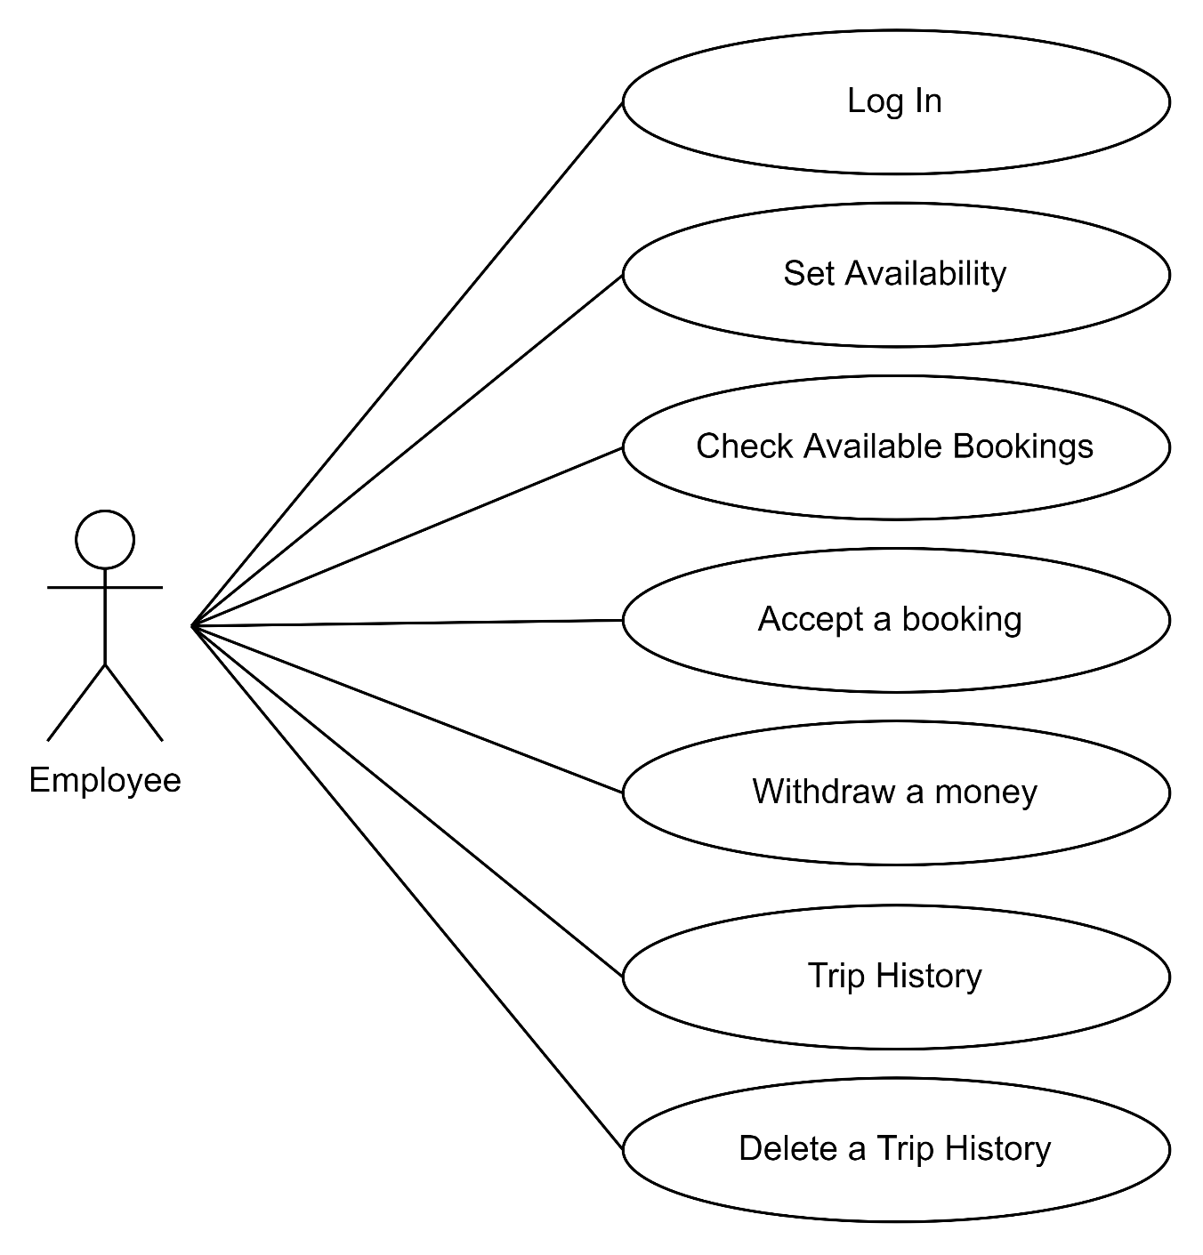

* 1. **Administrator:**

