

**Resources for**

**Innovations in Engineering**

A four-week course developed by

Dr. M. Ali Yousuf

to be offered to high-ability school students in Pakistan

Last updated: 3/14/2017

Contents

**Course Outline** 2

**Conceptual Guideline** 2

**Syllabus** 3

**Textbook** 3

**Lab Supplies** 3

**Prototyping Material** 4

**Weekly Lectures** 4

**Additional Chapters from the book (not covered)** 7

**Alternative Design Approaches** 8

**Project Ideas** 8

Biomedical Engineering Projects 8

Robotics Projects 8

Miscellaneous Projects 9

Additional Resources for Projects 9

**Microcontrollers and Related Stuff** 9

**Free Software for Engineering Design** 10

**Places to buy parts** 10

**Learning to write / document your work** 11

**Course Outline**

In this course students will be introduced to the process of engineering design through multiple short projects. Lectures will cover topics from Electrical design, mechanical design and structural design. Supplementary topics from physics and engineering will be added to provide enough basis to start real design work. These topics include electric and electronic circuits, microcontroller programming, 2D and 3D drawings, team building and brainstorming. In addition, students will use CAD software and other computer applications, such as word processors and spreadsheets.

**Conceptual Guideline**

There is a difference between scientific method and engineering design process and it is important to understand it.   
**Purpose:** The purpose in science is to **discover and understand** the natural world where as in engineering it is the **creation of a solution** to a specific problem.   
**Goal:** The goal in science is to **add to our collective knowledge** and understadning of the natural world. In engineering it is to **create a cost effective, workable solution.**   
The following diagram shows the scientific method vs engineering design process:

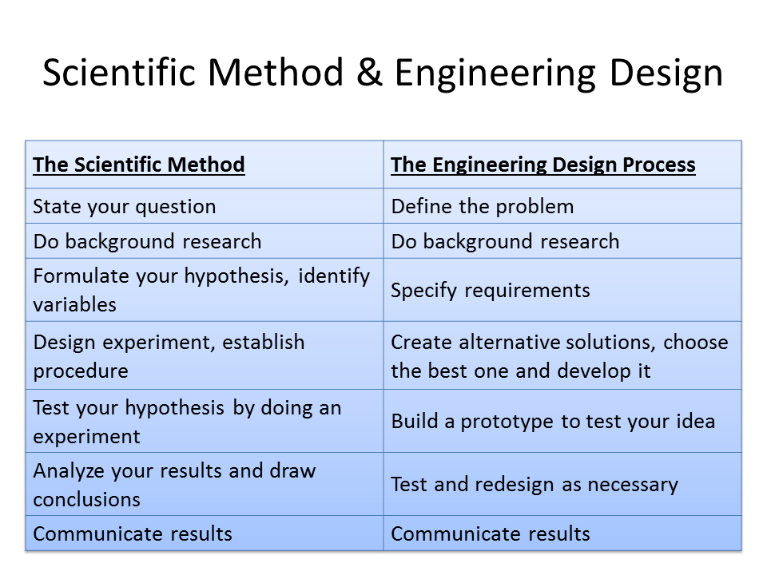

**Syllabus**

The actual syllabus will be managed by the course instructor but here is a guideline. Instructors are advised not go more than 20% away from this plan.

**Textbook**

We'll be using the following book as our main text:

* [Engineering Design: An Introduction by John R. Karsnitz](http://www.amazon.com/gp/product/1111645825/ref=ox_sc_act_title_2?ie=UTF8&psc=1&smid=ATVPDKIKX0DER)
* [Workbook for Karsnitz/O'Brien/Hutchinson's Engineering Design: An Introduction, 2nd by John R. Karsnitz](http://www.amazon.com/gp/product/1111645841/ref=ox_sc_act_title_1?ie=UTF8&psc=1&smid=ATVPDKIKX0DER)

There are some supplementary books / online books which can also be used. These will soon appear here.

**Lab Supplies**

We have a large collection of supplies in the lab which can be issued to you at the beginning of a workshop:

* [Arduino Uno Ultimate Starter Kit -- Includes 72 page Instruction Book by Vilros](http://www.amazon.com/Arduino-Ultimate-Starter-page-Instruction/dp/B00BT0NDB8/ref=sr_1_2?ie=UTF8&qid=1431483656&sr=8-2&keywords=the+arduino+starter+kit).
* [The Arduino Starter Kit (Official Kit from Arduino with 170-page Arduino Projects Book)](http://www.amazon.com/Arduino-Starter-Official-170-page-Projects/dp/B009UKZV0A/ref=sr_1_1?ie=UTF8&qid=1431483656&sr=8-1&keywords=the+arduino+starter+kit)

Don’t know where to buy them?

* Check out the web site of Arduino official distributor in Pakistan, <http://www.roboticspk.com/robotics-store/arduino>
* Here is another site in Pakistan, <https://www.olx.com.pk/all-results/q-arduino-uno/>

**Prototyping Material**

Ever wondered what are the material avaialble to make prototypes. Well, check these websites:

* [IdeasUploaded](http://ideasuploaded.com/2011/05/31/how-to-make-an-invention-prototype-cheaply/)

**Weekly Lectures**

|  |  |  |
| --- | --- | --- |
| **Week** | **Topics to be covered** | **PowerPoint Presentations / Links / Videos / Simulations** |
| 1 | Scientific Method vs Engineering Design Process | Science, Engineering and Design! Video 1: [What are Engineering and Science?](https://youtu.be/t3Z2DZIUT2U) (There are multiple videos in this series)  Science, Engineering and Design! Video 2: [Engineering Design Process](https://youtu.be/5Dp2qHz8r2U)  Ch 01 - Technology The Human-Designed World  Ch 02 - The Process of Design  (Get a copy of the powerpoint presentations from Ali) |
| 2 | Building Teams - Generating Ideas | Science, Engineering and Design! Video 3: [Art in Engineering](https://youtu.be/sFDPzmtIqkk)  Science, Engineering and Design! Video 4: [Prototyping](https://www.youtube.com/watch?v=xglG_jGEvNQ&feature=youtu.be)  Ch 03 - Development of the Team  Ch 04 - Generating and Developing Ideas  (Get a copy of the powerpoint presentations from Ali) |
| 3 | Introduction to Electrical Circuits | If you are new to circuits and need to understand basics like current, resistance, etc, use this online simulations at PhET Simulations at: <https://phet.colorado.edu/en/simulations/category/physics/electricity-magnets-and-circuits>  In particular see the following:  Battery-Resistor Circuit  Battery Voltage  [Ohm's Law](https://phet.colorado.edu/en/simulation/ohms-law)  Resistance in a Wire  [Circuit Construction Kit (DC)](https://phet.colorado.edu/en/simulation/circuit-construction-kit-dc)  John Travoltage  [Capacitor Lab](https://phet.colorado.edu/en/simulation/capacitor-lab)  [Circuit Construction Kit (AC+DC)](https://phet.colorado.edu/en/simulation/circuit-construction-kit-ac-virtual-lab)  Announce Project 1 |
| 4 | Introduction to Arduino - Part 1 | Tutorial 01 for Arduino: Getting Acquainted with Arduino There are at least 15 videos in this series. All very useful.  <https://www.youtube.com/watch?v=fCxzA9_kg6s&feature=youtu.be>  Arduino Video Tutorial 01: Get to know your Tools with Arduino CEO Massimo Banzi There are at least 10 videos in this series. All very useful. <https://www.youtube.com/watch?v=2X8d_r0p92U&feature=youtu.be> |
| 5 | Basic Engineering Drawings (2D and 3D), color, texture, etc | [Introduction To Engineering Drawing](https://www.youtube.com/watch?v=z4xZmBpXIzQ%20)  [How to Draw with One Point Perspective](https://www.youtube.com/watch?v=7ZYBWA-ifEs)  [How To Draw A City Using Two Point Perspective](https://www.youtube.com/watch?v=yNq78n02fMQ)  Ch 05 - Drawing to Develop Design Ideas  (Get a copy of the powerpoint presentations from Ali) |
| 6 | Technical Drawing using Isometric Grid Paper | [I Love Isometric Dot Paper](https://www.youtube.com/embed/Kh5yXhVxgMQ)  Ch 08 - Technical Drawing  (Get a copy of the powerpoint presentations from Ali) |
| 7 | CAD Designing Software | Introduction to Open SCAD, <http://www.openscad.org/documentation.html>  Open SCAD Tutorial #1  Also see OpenSCAD Tutorials, <http://www.makerbot.com/tutorials/openscad-tutorials/> |
| 8 | Structural Systems (Stress, Strain, Bridges, etc) | Ch 11 - Designing Structural Systems  [What is Structural Engineering?](https://www.youtube.com/watch?v=od_MpNUzeCE%20)  Designing Structural Systems, [Brief Introduction to Bridges](http://pages.jh.edu/~maliyou1/EGRD.html)  [Stress and Strain](https://www.youtube.com/watch?v=JA5nTvEU3MA)  Student presentations on Project 1 and Final Feedback  (Get a copy of the powerpoint presentations from Ali)  Start of Project 2 |
| 9 | Simple Mechanical Systems | Ch 12 - Designing Mechanical Systems (Get a copy of the powerpoint presentations from Ali)  Supplementary topic: Mechanical Actuation Systems.ppt |
| 10 | The Science Behind Electrical Systems | Ch 13 - Designing Electrical Systems (Get a copy of the powerpoint presentations from Ali)  Supplementary topic: Electrical Actuation Systems.ppt |
| 11 | Circuit Desinging Software | Fritzing, <http://fritzing.org/download/>  123D Circuits, <http://123d.circuits.io/> |
| 12 | Arduino - Part 2  End of Project 2 | Students may choose a new project or continue building this one to next phase (plan to be approved by teacher) |
| 13 | Arduino - Part 3 | (Get a copy of the powerpoint presentations from Ali) |
| 14 | Ergonomics | Ch 15 - Human Factors in Design and Engineering  (Get a copy of the powerpoint presentations from Ali) |
| 15 | Arduino - Part 4 |  |
| 16 | End of Final Project 2 |  |

**Additional Chapters from the book (not covered in this course)**

|  |  |  |
| --- | --- | --- |
| 17 | Ch 06 - Reverse Engineering |  |
| 18 | Ch 07 - Investigation and Research for Design and Development |  |
| 19 | Ch 09 - Testing and Evaluating |  |
| 20 | Ch 10 - Manufacturing |  |
| 21 | Ch 14 - Designing Pneumatic Systems |  |
| 22 | Ch 16 - Math and Science Applications |  |
| 23 | Ch 17 - Design Styles |  |
| 24 | Ch 18 - Graphics and Presentation |  |

**Alternative Design Approaches**

* TRIZ/TIPS: Theory of Inventive Problem Solving, developed by Genrich Altshuller in Russia, <http://www.mazur.net/triz/>
* Axiomatic Design: Developed by Suh at MIT, is a systems design methodology using matrix methods to systematically analyze the transformation of customer needs into functional requirements, design parameters, and process variables. [Book by Suh](https://smile.amazon.com/Axiomatic-Design-Applications-MIT-Pappalardo-Engineering/dp/0195134664/ref=sr_1_1?s=books&ie=UTF8&qid=1489286682&sr=1-1&keywords=Axiomatic+Design)

**Project Ideas**

## Biomedical Engineering Projects

* [DIY Blood Pressure Monitor](http://makezine.com/projects/make-29/diy-blood-pressure-monitor/) (advanced) [What will you need to learn? Mechanical: Yes, Electronics: Yes, Programming: Yes]
* [Arduino from Scratch - Digital Thermometer](http://www.instructables.com/id/Arduino-from-Scratch-Digital-Thermometer/?ALLSTEPS) [What will you need to learn? Mechanical: No, Electronics: Yes, Programming: Yes]
* [Medical and Health Related Projects with Arduino](http://medicarduino.net/)
* [FlexVolt - An EMG Sensor For Physical Therapy and Biohacking](http://www.flexvoltbiosensor.com/)
* [Biomedical Sensor Applications with Arduino](http://www.cooking-hacks.com/documentation/tutorials/ehealth-biometric-sensor-platform-arduino-raspberry-pi-medical)

## Robotics Projects

* [Building a Simple Arduino Robot](http://makezine.com/projects/building-a-simple-arduino-robot/)
* [Lego Bookreader: Digitize Books With Mindstorms and Raspberry Pi](http://makezine.com/projects/lego-bookreader-digitize-books-with-mindstorms-and-raspberry-pi/)

## Miscellaneous Projects

* [Cloud Starter](http://littlebits.cc/kits/cloudbit-starter-kit) - This bundle includes the new cloudBit plus 5 other favorite prototyping modules; everything you need to create internet-connected devices in seconds. Recreate the most popular smart devices, use littleBits to prototype the next billion dollar idea, or invent a project that solves your own, unique problem.
* [Arduino project ideas](http://playground.arduino.cc/projects/ideas)
* For more project ideas, see [Tech Briefs - Create the Future Design Contest](http://contest.techbriefs.com/)
* [Van De Graff Generator](http://rimstar.org/equip/build_make_van_de_graaff.htm)

## Additional Resources for Projects

* [Mechatronics Resources](http://www.engr.colostate.edu/~dga/mechatronics/resources.html)
* [Microcontroller interfacing circuits (for PICAXE)](http://www.picaxe.com/docs/picaxe_manual3.pdf)
* [What's a Microcontroller? Parts Kit and Text (BASIC Stamp based)](https://www.parallax.com/product/28152)
* [Arduino Home Page](http://www.arduino.cc/)
* [Arduino Programming Notebook](http://playground.arduino.cc/uploads/Main/arduino_notebook_v1-1.pdf)
* [Arduino Language Reference](http://www.ele.uri.edu/courses/ele205/ELE205Lab/ELE205_Lab_files/Arduino%20-%20Reference.pdf)
* [Arudino resources from University of Minnesota](https://sites.google.com/a/umn.edu/me2011/arduino)
* [How to run a simple SIMULINK program on Arduino Uno](http://makerzone.mathworks.com/resources/install-support-for-arduino/)
* [MATLAB & Simulink project resources for Arduino (Advanced)](http://makerzone.mathworks.com/arduino/)
* [RetroBSD](https://hackaday.io/project/5891-unix-on-your-breadboard) is a version of 2.11BSD Unix for microcontrollers. It can run on PIC32 in only 128 kbytes of RAM. The operating system includes not only a set of basic Unix utilities, but also a C compiler, assembler, linker, libraries and include files sufficient to develop user applications directly on the target processor. Cross-compile is possible as well.

**Microcontrollers and Related Stuff**

Many of these sites provide not just the microcontroller but sensors, gears, motors, etc too.

* Arduino: A low cost product with unlimited potential, <https://www.arduino.cc/>
* PICAXE: Developed in UK, very easy to program. Check out their interfacing circuits too, <http://www.picaxe.com/>
* PIC Microcontroller: A major manufacturer of microcontrollers. You can get free samples from their website provided you have a .edu email account. PICAXE and BasicStamp are basically PICs too.
* BASIC Stamp: A very easy to use, yet extremly powerfull microcontroller packaged with other hardware. Of particular interest are their educational kits, <https://www.parallax.com/catalog/microcontrollers/basic-stamp>
* Ada Fruit: Another low cost option like Arduino, <https://www.adafruit.com/>
* Raspberry Pi: Much more than a microcontroller - it runs on Linux! <https://www.raspberrypi.org/>

**Free Software for Engineering Design**

Some require local installation, others are online only.

* Autodesk 123D, <http://www.123dapp.com/>
* Fritzing for Circuits, <http://fritzing.org/home/>
* OpenSCAD, <http://www.openscad.org/>
* Fusion 360, [http://www.autodesk.com/](http://www.autodesk.com/products/fusion-360/overview?utm_campaign=fusion_banner_2&utm_medium=direct&utm_source=blog&utm_content=webpage&utm_term=pathfinder)
* Electronics from beginner to pro, [Autodesk Circuits](https://circuits.io/)

**Places to buy parts**

* McMaster-CARR, <http://www.mcmaster.com/>
* Grainger, <http://www.grainger.com/>
* Pololu Robotics, <https://www.pololu.com/>
* Robot Shop, <http://www.robotshop.com/>

**Learning to write / document your work**

Every project must be documented. Writing engineering reports is an art which you learn through practice and by reading other reports. Here is a PowerPoint presentation on the subject, [Writing Engineering Reports](https://owl.english.purdue.edu/owl/resource/647/01/)

You must also learn how to give proper references to a book, an online magazine or a newspaper, etc. The Imperial College of London has a good page on how to write referencs, [http://www3.imperial.ac.uk/library/subjectsandsupport/referencemanagement/vancouver/references](http://www3.imperial.ac.uk/library/subjectsandsupport/referencemanagement/vancouver/references/)