First, we find the 8 lines equation:

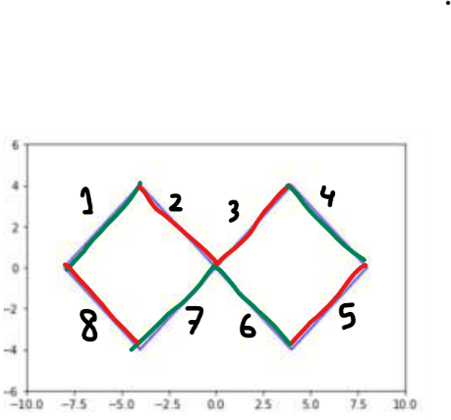

Left graph

Points: (-8,0) & (-4, -4)

x2 = ((-8- -4)/ (0-4)) x1 +c

x2 = -x1 +c, we substitute by -8 for x1 and 0 for x2 we get 0 = 8 + c 🡪 c = -8

we get: x2 = -x1 -8 ->

0 = -x1 -x2 -8

we do the same thing to get the rest of equations.

Points: (-8,0) & (-4, 4)

x2 = x1 + 8 ->

0 = x1 -x2 +8

Points: (-4, 4) & (0, 0)

x2 = -x1

0 = -x1 -x2

Points: (-4, -4) & (0, 0)

x2 = x1

0 = x1 -x2

right graph

Points: (8,0) & (4, -4)

x2 = x1 -8

0 = x1 -x2 -8

Points: (8,0) & (4, 4)

x2 = -x1 +8

0 = -x2 -x1 +8

Points: (4,4) & (0, 0)

x2 = x1

Points: (4, -4) & (0, 0)

x2 = -x1

Then we AND them. Since we have two common equation. So we have 6 perceptron at layer 2 and 2 in layer 3.

now let’s represent these equations in the graph

