King Fahd University of Petroleum and Minerals

Information and Computer Science Department

**ICS-431 Operating Systems**

Lab Quiz 02

Section 51

Preliminaries

1. Upload the folder Q2 into your CS50 IDE.
2. To upload, use the file menu as shown here:

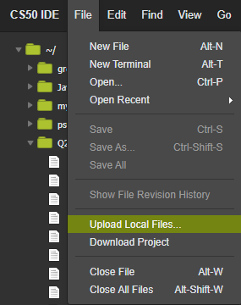

1. Your folder ‘Q2’ should have a total of 21 files:

10 files of the form source-document#####.txt

10 files of the form unsure-document#####.txt

1 file text.c

1. Compile and execute the program text.c and observe the output.

**Objective**:

The purpose of this program is to generate text analysis (basic) using threads. For this purpose the program opens up each of the sources files i.e. source-document#####.txt, as well as unsure-document#####.txt and finds and calculates:

* Total number of characters in all the source and unsure files
* Number of alphanumeric characters (i.e. A-Za-z0-9) in all source and unsure files
* Number of non-alphanumeric characters in each of the source and unsure files

using pthreads.

Your output should be of the form:

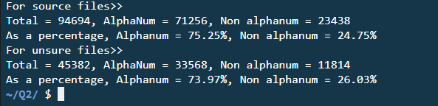

What you have to do is:

Edit the file text.c to

1. Provide the code for calling 20 Pthreads, each one with a filename in the main function
2. Provide the code for finding text statistics as shown above in the function textAnalysis
3. Give final statistics in the main function as shown above.

Time: 2 hours

Submission: Just provide your CS50 IDE Link.

Quiz is Open Book