To install the software you have to add MyDB as OCBD in your computer to do that follow these steps:

1. Go to control panel then Administrative Tools

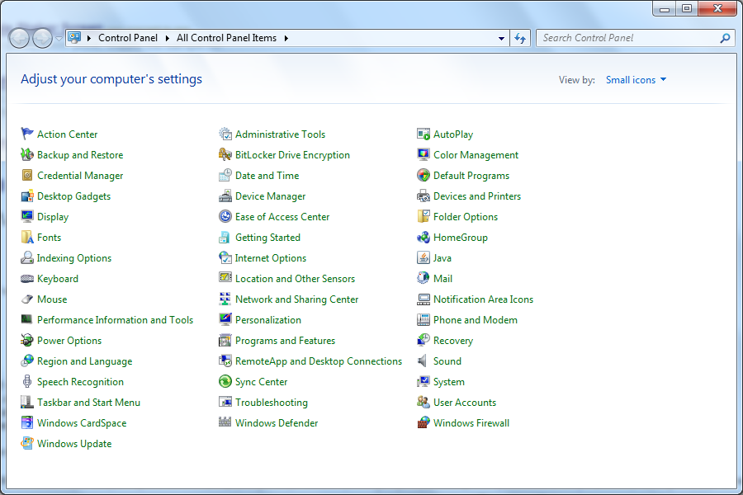

1. Select Data Sources (ODBC)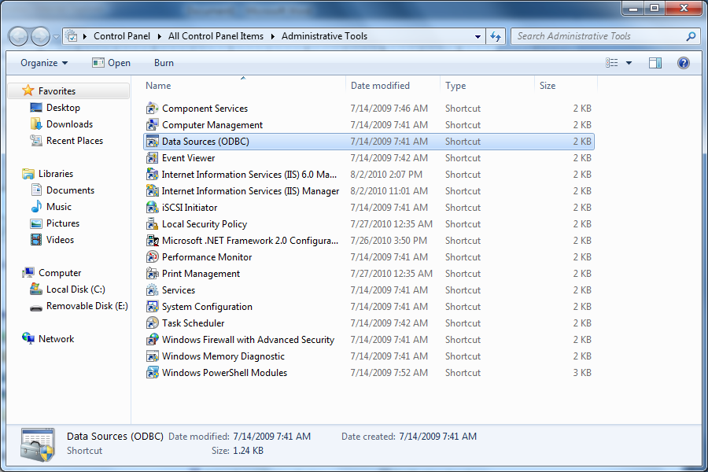
2. From add select Driver do Microsoft Access (\*.mdb) then Finish.

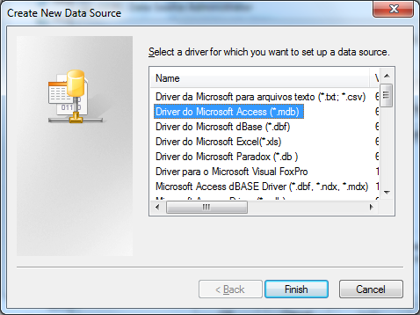

1. Another window will appear to configure the connection. In the Data Source Name type (MyDB)

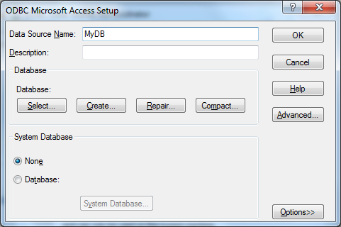

Then Click on Select and browse to the database file attached with the software

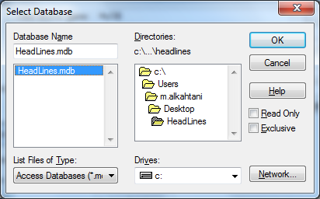

Then Click on OK and Click on OK in the setup window

You should see your connection listed with the other ODBC connections

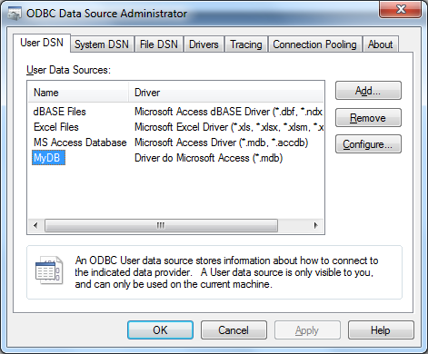

Add some record to the database then the software should run

