Sixth Sense Technology

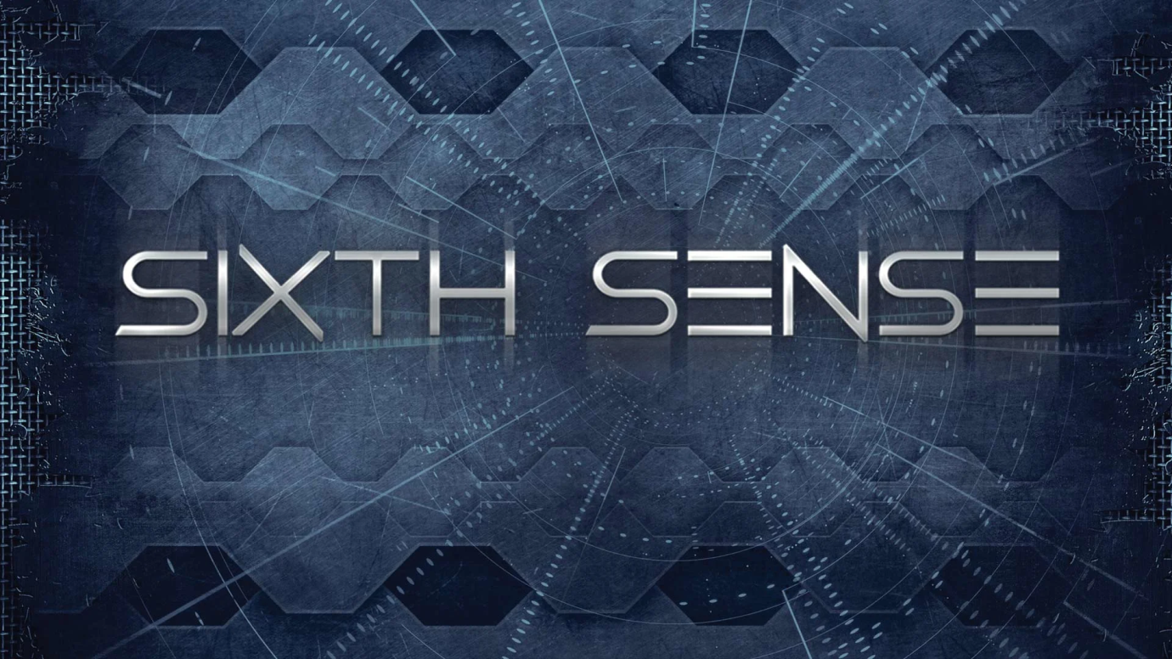

It’s the beginning of a new era of technology where engineering will reach new milestones. Just like in the science fiction movies where display of computer screen appears on walls, commands are given by gestures, the smart digital environment which talks to us to do our work and so on, these all will be possible very soon. You imagine it and **sixth sense technology** will make it possible. Isn’t it futuristic? Now it’s time for sci-fi movie directors to think ahead because the technology shown in there fiction movies soon will become household stuff. Before few years back it was considered to be supernatural or tantalizing imagination. But now it has been made possible. Thanks to Pranav Mistry, a genius who introduced mankind to this futuristic technology.

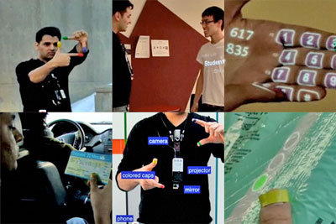

*Fig. 1: A Representational Image of Sixth Sense Technology*

**What is sixth sense?**  
*Sixth Sense is a wearable gestural interface that enhances the physical world around us with digital information and lets us use natural hand gestures to interact with that information*. It is based on the concepts of augmented reality and has well implemented the perceptions of it. Sixth sense technology has integrated the real world objects with digital world. The fabulous **6th sense technology** is a blend of many exquisite technologies. The thing which makes it magnificent is the marvelous integration of all those technologies and presents it into a single portable and economical product. It associates technologies like hand [gesture recognition](https://www.engineersgarage.com/articles/gesture-recognition-technology), image capturing, processing, and manipulation, etc. It superimposes the digital world on the real world.

Sixth sense technology is a perception of augmented reality concept. Like senses enable us to perceive information about the environment in different ways it also aims at perceiving information. Sixth sense is in fact, about comprehending information more than our available senses. And today there is not just this physical world from where we get information but also the digital world which has become a part of our life. This digital world is now as important to us as this physical world. And with the internet the digital world can be expanded many times the physical world. God hasn’t given us sense to interact with the digital world so we have created them like smart phones, tablets, computers, laptops, net books, PDAs, music players, and others gadgets. These gadgets enable us to communicate with the digital world around us.

But we’re humans and our physical body isn’t meant for digital world so we can’t interact directly to the digital world. For instance we press keys to dial a number; we type text to search it and so on. This means for an individual to communicate with the digital world he/she must learn it. We don’t communicate directly and efficiently to the digital world as we do with the real world. The sixth sense technology is all about interacting to the digital world in most efficient and direct way. Hence, it wouldn’t be wrong to conclude sixth sense technology as gateway between digital and real world.  Before Wear Ur World (WuW) came there were other methods like [speech recognition](https://www.engineersgarage.com/articles/speech-recognition) software, touch recognition etc., which empowered us with direct interfacing.

This WuW or sixth sense device invented by Pranav Mistry is a prototype of next level of digital to real world interfacing. It comprises of a camera, a projector, a mobile cum computing device and colored sensors which are put on the fingers of a human being. The device efficiently senses the motion of the colored markers. Using them it provides us the freedom of directly interacting with the digital world. This technology enables people to interact in the digital world as if they are interacting in the real world.

**Why choose sixth sense technology?**

Humans take decisions after acquiring inputs from the senses. But the information we collect aren’t enough to result in the right decisions. But the information which could help making a good decision is largely available on internet. Although the information can be gathered by connecting devices like computers and mobiles but they are restricted to the screen and there is no direct interaction between the tangible physical world and intangible digital world. This sixth sense technology provides us with the freedom of interacting with the digital world with hand gestures. This technology has a wide application in the field of [artificial intelligence](https://www.engineersgarage.com/articles/artificial-intelligence). This methodology can aid in synthesis of bots that will be able to interact with humans.

**Working**

**How does sixth sense works?**

The sixth sense technology uses different technologies like gesture recognition, image processing, etc. At present the commercial product isn’t launched but the prototype is prepared. The sixth sense prototype is made using very common and easily available equipments like pocket projector, a mirror, mobile components, color markers and a camera.

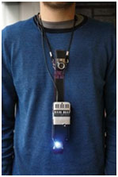

*Fig. 2: Image Showing Sixth Sense Technology Prototype Equipped With Pocket Projector, Mobile Components, Mirror, Color Markers, and Camera*

The projector projects visual images on a surface. This surface can be wall, table, book or even your hand. Thus, the entire world is available on your screen now. When user moves their hands to form different movements with colored markers on the finger tips, the camera captures these movements. Both the projector and the camera are connected to the mobile computing device in the user’s pocket. Recognition is made using computer vision technique. These markers act as visual tracking fiducials. The software program processes this video stream data and interprets the movements into gestures. The gestures are different from one another and are assigned some commands. These gestures can act as input to application which is projected by the projector. Since, the projector is aligned downwards for compactness; therefore images would be formed at the user’s feet if mirror wasn’t used. The mirror reflects the image formed by the projector to front. The entire hardware is fabricated in the form of a pendent. The entire product cost around $ 350 and that also because of projector. It works very similar like a touch screen phone with entire world as the screen.

**Evolution of Sixth Sense Technology**

Steve Mann is considered as the father of Sixth Sense technology who made a wearable computer in 1990. He implemented the Sixth Sense technology as the neck worn projector with a camera system. He was a media lab student at that time. Then his work was carried forward by Pranav Mistry, an Indian research assistant in MIT Media Lab. He came up with exciting new applications from this technology. Sixth sense technology was developed at media labs in MIT and coined as Wear Ur World (WUW). The inventors have filed patent under the name Wear Ur World (WUW) in February 2010.

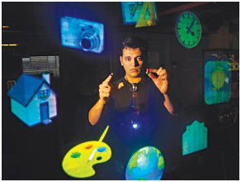

*Fig. 3: Image Showing Pranav Mistry Introducing New Applications from Sixth Sense Technology*

“Rather than waiting for that time to come, I want people to make their own system. Why not?,” Mistry says in an article on Rediff Business. “People will be able to make their own hardware. I will give them instructions how to make it. And also provide them key software…give them basic key software layers…they will be able to build their own applications. They will be able to modify base level and do anything”.

So it can be expected that the software will be [open source](https://www.engineersgarage.com/articles/open-source-software-history-advantages) and there will be a wide market of apps too.

**Application**

**Applications**  
**Fingers as brush:**The user can draw anything on paint with the help of his fingers. This drawing can be 3D also. Hence, no need to use mouse.

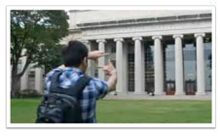

*Fig. 4: Image Showing User Capturing Photo Using Fingers with Sixth Sense Technology*

**Capture photos with fingers:** using the fingers the user can capture photos hence, no need to carry an additional gizmo. The box created by the fingers act as frame for capturing photo.

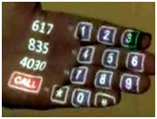

*Fig. 5: Image Showing Dialer Projected on Palm to Make Calls Using Sixth Sense Technology*

**Palm is the new dialer:** this technology enables the user to call

without using the dialer. The dialer will be projected on palm and the user can dial the number using other hand.

**Read Books easily:**Check out the ratings of the Book you are going to buy, it checks the ratings from the internet. And another amazing thing is that it reads the book for you.

**Video Newspapers:**like the video newspapers of Harry Potter this technology identifies the news headline and then projects the relevant video.



*Fig. 6: Image Showing Checking the Flight Status Using Sixth Sense Technology*

**Check your Flight Status:** Just place the ticket in front of the projector and it checks its status from the internet.

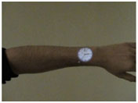

*Fig. 7: Image Showing Clock Projected On the User’s Hand Through Sixth Sense Technology*

**Clock:** the user just needs to make gesture of clock and the watch will be projected on the user’s hand.

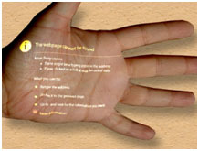

*Fig. 8: Image Showing Possibility to Access Internet On Any Surface Through Sixth Sense Technology*

**Access anywhere internet:**the users can browse internet  on any surface even on their palm.

**Conclusion**

This technology has seamless applications. This can be used as a replacement of the 5th senses for handicapped peoples. This can provide easy control over machineries in industry. This will have different application for different developers just depending upon how he imagines and what he wants. So, considering its widespread applications the inventor Pranav Mistry has decided to make its software open source. This will enable individuals to make their own application depending upon needs and imagination. As this technology will emerge may be new devices and hence forth new markets will evolve. Some existing devices and technologies will be discontinued but one thing is guaranteed it will write a new chapter in history of science and technology.